ARDIAR

Sardar Patel Institute of Technoioğy Bhavan's Campus, Munshi Nagar, Andheri (West), Mumbai-400058, India (Autonomous College Affiliated to University of Mumbai) End Semester Examination

Max. Marks: 100 Class: F.Y.MCA Course Code:MC507

May 2024

Duration: 3.00 hrs Semester: II

Name ofthe Course: Design and Analysis of Algorithms Instruction: (1) All questions are compulsory (2) Draw neat diagrams

(3) Assume suitable data if necessary

Branch: M.C.A.

Q. No.

Questions

Max. Mark

CO-BL

S

QI What do you understand by Divide and Conquer approach? Compare Merge and Quick sort. Describe the best worst and average case for both the algorithm.

20 CO2-4

a. If Merge sort is applied on the given input array: 85 24 63 45 17 31 96 50

what will be two halves for the last merge call? Solve it by drawing MergeSort treе

b. Solve the following using Quick sort considering the first element as pivot element

54 26 93 17 77 31 44 55 20

What will be the two halves in the last sort? Q2 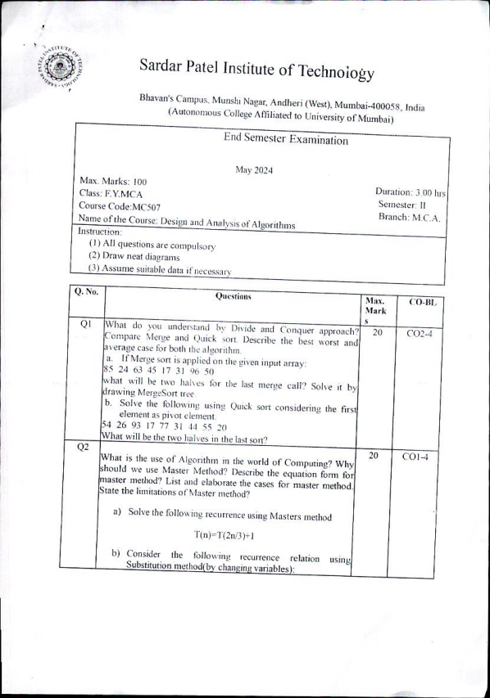

What is the use of Algorithm in the world of Computing? Why should we use Master Method? Describe the equation form for master method? List and elaborate the cases for master method. State the limitations of Master method? a) Solve the following recurrence using Masters method

T(n)=T(2n/3)+1

b) Consider the following recurrence relation using Substitution method(by changing variables):

20 CO1-4

Q3 T(n)=2T(Vn) + logn 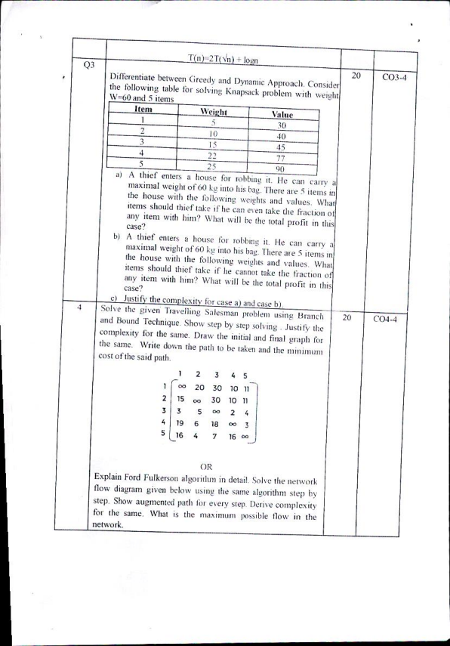

Differentiate between Greedy and Dynamic Approach. Consider the following table for solving Knapsack problem with weight and 5 items

W=60

Item Weight Value 1 5

30 2

10 40 3

15 45 4

22 77 5 25 90 a) A thief enters a house for robbing it. He can carry a maximal weight of 60 kg into his bag. There are 5 items in the house with the following weights and values. What items should thief take if he can even take the fraction of any item with him? What will be the total profit in this case? b) A thief enters a house for robbing it. He can carry a maximal weight of 60 kg into his bag. There are 5 items in the house with the following weights and values. What items should thief take if he cannot take the fraction of any

case? item with him? What will be the total profit in this c) Justify the complexity for case a) and case b).

4 Solve the given Traveiling Salesman problem using Branch and Bound Technique. Show step by step solving. Justify the complexity for the same. Draw the initial and final graph for the same. Write down the path to be taken and the minimum cost of the said path.

1 2 3 4 5

20 CO3-4 20 CO4-4

1

00 20 30 10 11

2 15 00 30 10 11 3 3 5 00 2 4 4 19 6 18 3

5 16 4

7 16 00 OR

Explain Ford Fulkerson algorithm in detail. Solve the network flow diagram given below using the same algorithm step by step. Show augmented path for every step. Derive complexity for the same. What is the maximum possible flow in the network.

6/0

0/8 B

0/2

Q5A Q5B

0/7 T 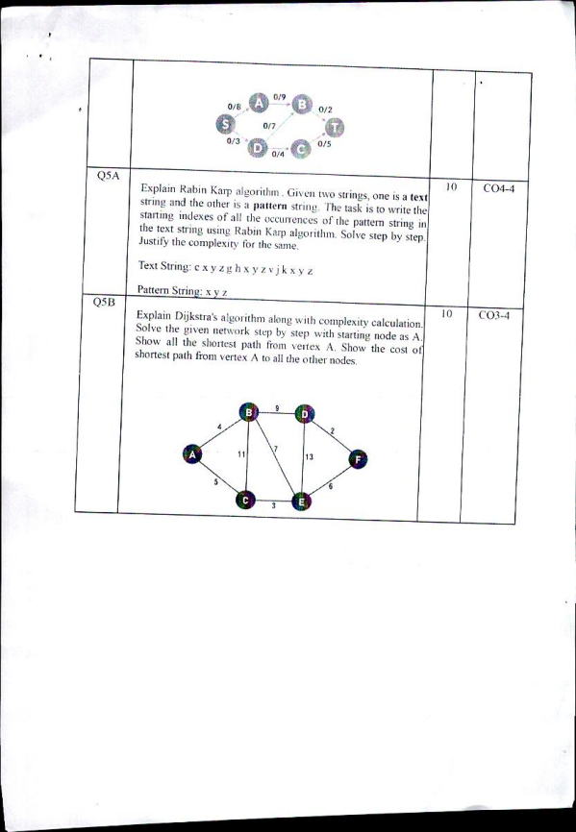

0/3 0/5

0/4

Explain Rabin Karp algorithm. Given two strings, one is a text string and the other is a pattern string. The task is to write the starting indexes of all the occurrences of the patterm string in the text string using Rabin Karp algorithm. Solve step by step. Justify the complexity for the same. Text String:cxyzghx y z vj kxy z

Pattern String: x y z

Explain Dijkstra's algorithm along with complexity calculation. Solve the given network step by step with starting node as A. all the shortest path from vertex A. Show the cost of shortest path from vertex A to all the other nodes.

Show

10 CO4-4 10 CO3-4

B

9

11 13 F

5

6

3

E