Assumptions (Description)

* The college app will be used by undergraduate students across years 1–4.
* The app will run on Android and iOS and needs to be simple and low-friction.
* Authentication is done with college email/SSO.
* Students have intermittent connectivity on campus; offline-first or caching for schedules/menus is helpful.
* Notifications must be opt-in and grouped to reduce noise.

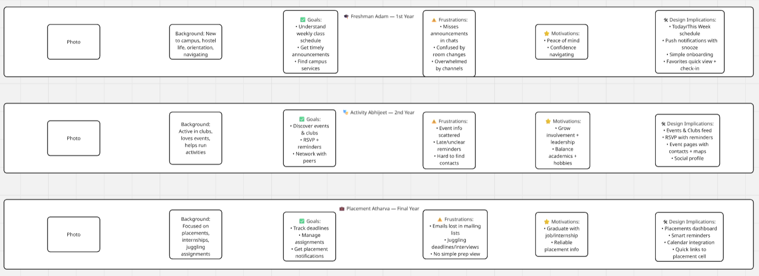

1. **What is a User Persona?** A user persona is a fictional, research-based representation of a key user group. It summarizes demographics, behaviors, goals, frustrations, and motivations to help the design team keep real user needs in focus while making product decisions.
2. **Why is it important to create a Persona?** Personas help teams empathize with users, prioritize features based on real needs, reduce assumptions, communicate target audiences clearly across stakeholders, and make trade-offs (e.g., which notification style or feature set matters most) more defensible.
3. **How many personas do you need to create normally in a project?** Typically 2–5 primary personas are recommended. Two may be too few for diverse products; more than five often dilutes focus. Aim for a small set of clear, research-backed personas that cover the major user segments and their distinct goals.