HS321

GROUP PROJECT

**GENERAL ANALYSIS OF THE INDIAN STOCK MARKET**

1. Introduction

The Indian Stock Market in often portrayed as a hub of financial activity which stands as a testament to the nation’s economic growth. The Indian Stock Market is one of the largest and the fastest-growing emerging markets globally, attracting domestic and internation investors alike.

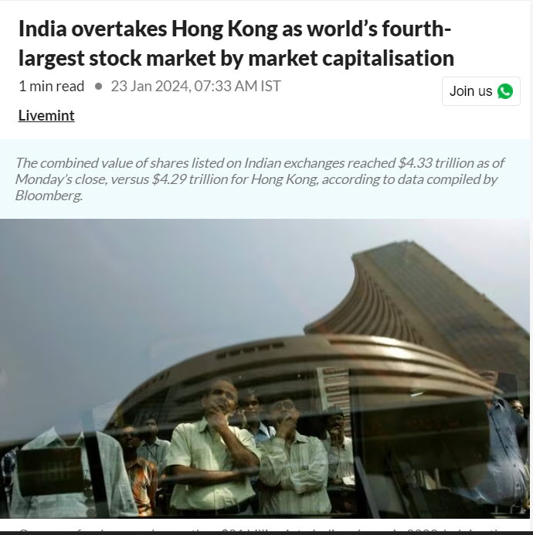

In Jan 2024 the combined value of shares listed on the Indian Exchanges reached a total Market Cap of staggering **4.33 Trillion Dollars**. In Feb 2024, the Market was valued at 4,681 Biilion USD, comapared to 266.29 Billion USD in Jan 2004

That is a total growth of 1759.77%, and that speak volumes about how the Indian Stock Market is playing a pivotal role in shaping the country’s Economic Landscape.

* 1. The Indian Exchanges

Majority of the trading in the Indian stock market takes on two major exchanges:

* Bombay Stock Exchange
* National Stock Exchange

As of Jan. 30 2024, the BSE had **5315** listed firms, whereas NSE had **2266** as of Dec 31 2023.

BSE is the older amongst the two and is the oldest Stock Exchange in Asia but NSE is the largest by Volume

* 1. The Indices

In a stock exchange, indices are measures or benchmarks that represent the performance of a group of stocks or securities traded on that exchange. These indices are used to gauge the overall performance of the market, track trends, and serve as reference points for investors, fund managers, and analysts.

India has 2 main Indices:

* NIFTY50(NSE)
* SENSEX(BSE)

For our Analysis in this project, firstly we are going to take NIFTY50 to calculate and analyse the general trends of the Indian Stock Market

* 1. Why NIFTY50?

The question arises, How can we analyse the whole market on the basis of one index, and even if we can, why NIFTY50 only and not SENSEX.

The reasons are as follows:

* Representative Sample: The NIFTY 50 index represents a diversified portfolio of the top 50 actively traded stocks listed on the National Stock Exchange (NSE) of India. These companies come from various sectors such as banking, information technology, pharmaceuticals, consumer goods, and more. Therefore, analyzing the NIFTY 50 gives you exposure to a broad image of the Indian economy.
* Market Benchmark: The NIFTY 50 is widely regarded as the benchmark index for the Indian equity market. It serves as a measure of the overall market sentiment and performance. Investors often compare their portfolio returns with the returns of the NIFTY 50 to assess their investment performance relative to the broader market.
* Liquidity and Visibility: NIFTY 50 stocks are among the most liquid and actively traded securities in the Indian market. They attract significant investor interest and attention, leading to ample liquidity and price discovery. Analyzing the performance of such highly liquid stocks provides more reliable insights into market trends and investor behavior.
* Sectoral Representation: The NIFTY 50 covers a wider range of sectors compared to the SENSEX, which is heavily skewed towards a few sectors such as finance, energy, and information technology. By choosing the NIFTY 50, you gain exposure to sectors like consumer goods, pharmaceuticals, automobiles, and others, providing a more comprehensive view of the Indian economy and market trends.
* Market Capitalization: The NIFTY 50 is a market-capitalization-weighted index, meaning that larger companies have a greater influence on the index's movements. This reflects the market's overall capitalization and investor sentiment towards larger companies. In contrast, the SENSEX is price-weighted, where the movement of higher-priced stocks has a more significant impact on the index, regardless of their market capitalization.
* Wider Investor Base: The NIFTY 50 is more widely followed by domestic and international investors, fund managers, and analysts compared to the SENSEX. As a result, movements in the NIFTY 50 are often perceived as more representative of overall market sentiment and trends.

Hence, due to all the above listed reasons, we have arrived to the conclusion of performing a major part of our analysis on the basis of NIFTY50

1. NIFTY50: an in-depth look
   1. 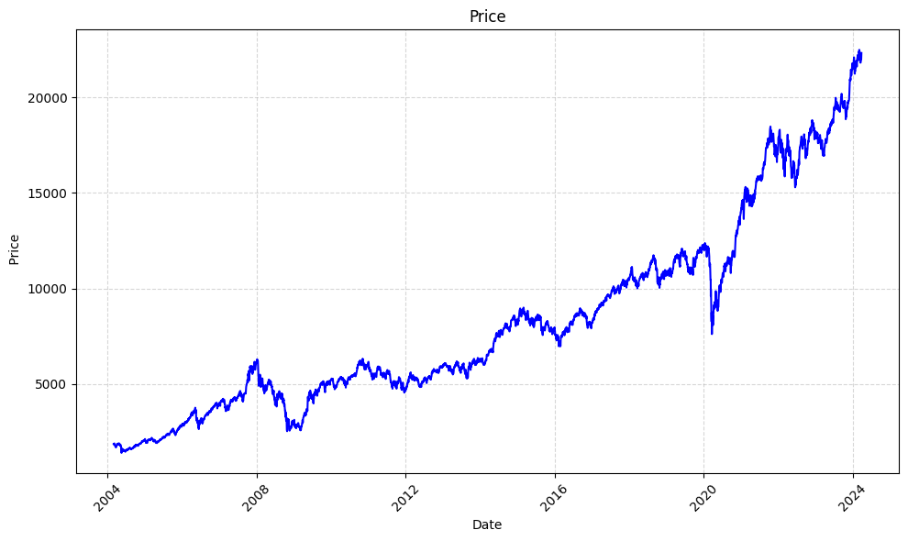General and Long-term trends:

Above is the price action chart for NIFTY50 over the last 20 years.

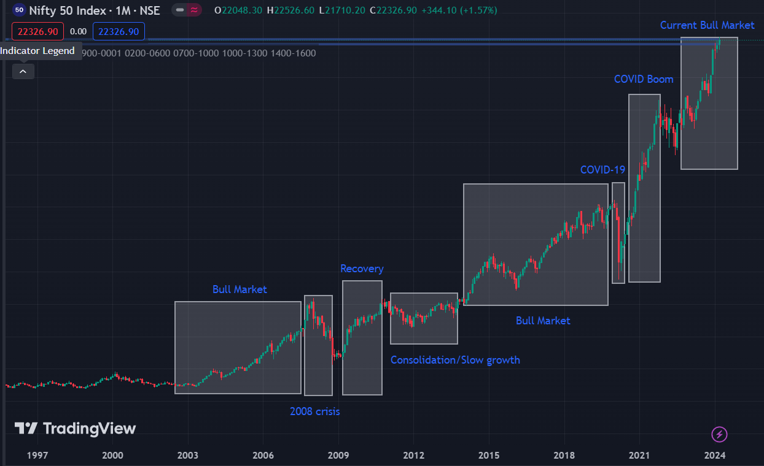Now, this is how we can observe the High- Level trends in the market

Let’s discuss all of it one by one:

* **2003-2008 Bull Market:**

The major reasons for this trend are:

* Economic Reforms and Growth: The Indian economy underwent significant structural reforms in the early 2000s, including liberalization, privatization, and globalization. These reforms led to increased foreign investment, improved business confidence, and robust economic growth. Rapid GDP expansion fueled corporate earnings growth, driving stock prices higher.
* Global Economic Expansion: The early to mid-2000s was a period of global economic expansion, with many economies experiencing strong growth. India, as an emerging market, benefited from favorable global economic conditions, increased trade, and higher demand for exports. Positive global sentiment and liquidity inflows into emerging markets supported the bull market in Indian equities.
* Corporate Earnings Growth: Corporate earnings of Indian companies, particularly those represented in the NIFTY 50 index, experienced robust growth during this period. Strong revenue growth, improved profitability, and favorable business conditions across various sectors contributed to higher earnings per share (EPS) and enhanced investor confidence.
* **2008 Financial crisis and the market crash:**
  + The financial crisis of 2008 was triggered by the bursting of the housing bubble in the United States, leading to widespread mortgage defaults and a liquidity crunch in the banking system. This crisis quickly spread to global financial markets, causing a severe downturn in economic activity worldwide**.**
  + The financial crisis led to a sharp contraction in global trade, investment, and consumer spending. Stock markets around the world experienced significant declines as investors panicked and sought to reduce their exposure to risky assets.
  + The financial crisis also led to a credit crunch in global financial markets, with banks becoming reluctant to lend due to concerns about counterparty risk and liquidity. This credit squeeze had a cascading effect on businesses and consumers, leading to lower economic growth and corporate earnings.
  + While the global financial crisis played a significant role in the crash of the NIFTY 50 in 2008, there were also domestic factors at play. These included concerns about inflation, high interest rates, fiscal deficits, and political uncertainty, which added to investor unease and contributed to the sell-off in Indian equities.
* **2009-2011 recovery**
* In response to the financial crisis, governments and central banks around the world implemented massive stimulus measures to revive economic growth and stabilize financial markets. These measures included interest rate cuts, liquidity injections, and fiscal stimulus packages. The global economy gradually began to recover, boosting investor confidence and driving a rebound in stock markets worldwide, including in India.
* Central banks, including the Reserve Bank of India (RBI), adopted accommodative monetary policies to support economic recovery. The RBI slashed interest rates and implemented liquidity-enhancing measures to stimulate credit growth and investment. Lower interest rates made borrowing cheaper, encouraged consumer spending and business investment, and boosted corporate earnings, driving stock prices higher.
* India's economic fundamentals improved during this period, supported by strong domestic consumption, infrastructure development, and investment inflows.
* **2012-2014 consolidation**
* The years 2013 and 2014 were marked by global economic uncertainty, with concerns over factors such as slowing growth in emerging markets, geopolitical tensions, and the tapering of quantitative easing by the U.S. Federal Reserve. These uncertainties weighed on investor sentiment and contributed to a cautious approach towards equities.
* Emerging markets, including India, experienced heightened volatility during this period. Factors such as capital outflows, currency depreciation, and policy uncertainty in emerging economies added to the risk aversion among investors. India, in particular, faced challenges such as a widening current account deficit, high inflation, and political uncertainty ahead of the general elections in 2014.
* **2015-2019 Bull Market**
* The Indian economy witnessed notable reforms and policy initiatives during this period, aimed at boosting economic growth, improving business environment, and attracting investments. Initiatives such as the Goods and Services Tax (GST) implementation, Insolvency and Bankruptcy Code (IBC), and efforts to improve ease of doing business enhanced investor confidence and laid the groundwork for sustainable growth.
* India maintained its position as one of the fastest-growing major economies in the world during the 2015-2019 period. The country's GDP growth remained robust, supported by factors such as urbanization, demographic dividend, infrastructure development, and increasing consumer spending. Strong economic fundamentals provided a favorable backdrop for corporate earnings growth and investor optimism.
* Foreign institutional investors (FIIs) continued to show confidence in the Indian economy and equity markets, contributing to significant capital inflows during the bull market phase.
* **COVID crash**
* Foreign institutional investors (FIIs) continued to show confidence in the Indian economy and equity markets, contributing to significant capital inflows during the bull market phase.
* To curb the transmission of the virus, many countries, including India, imposed nationwide lockdowns and strict quarantine measures. These lockdowns resulted in the closure of businesses, factories, schools, and public spaces, leading to a significant contraction in economic activity and a sharp decline in consumer spending.
* The rapid escalation of the COVID-19 pandemic created uncertainty and fear among investors, who were concerned about the potential impact on global economic growth, corporate earnings, and financial stability.
* Stock markets around the world experienced steep declines as investor sentiment deteriorated sharply in response to the COVID-19 pandemic. The NIFTY 50 index was no exception, witnessing a rapid sell-off as investors liquidated their holdings amid fears of a global recession and financial instability.
* **COVID Boom**
* Central banks and governments around the world responded swiftly to the economic fallout from the pandemic with unprecedented monetary and fiscal stimulus measures. Central banks slashed interest rates to near-zero levels, implemented quantitative easing programs, and provided liquidity support to stabilize financial markets. Governments rolled out massive fiscal stimulus packages to support businesses, households, and healthcare systems. The magnitude and speed of policy support helped restore confidence and liquidity in financial markets, driving a rapid rebound in asset prices.
* The announcement of several COVID-19 vaccine candidates in late 2020 and early 2021 brought optimism that an end to the pandemic was in sight. Positive vaccine trial results and regulatory approvals boosted investor confidence and fueled hopes of a swift economic recovery. Investors priced in expectations of widespread vaccination, reopening of economies, and a return to pre-pandemic levels of activity, leading to a surge in stock prices, particularly in sectors hit hardest by the pandemic such as travel, hospitality, and retail.
* Technology and growth-oriented companies, which had benefited from the shift to remote work, online shopping, and digital services during the pandemic, continued to outperform. These companies demonstrated strong earnings growth and business resilience amid the crisis, attracting investor capital and driving market indices higher. The dominance of technology stocks in major indices further fueled the COVID boom.
  1. The Market Returns

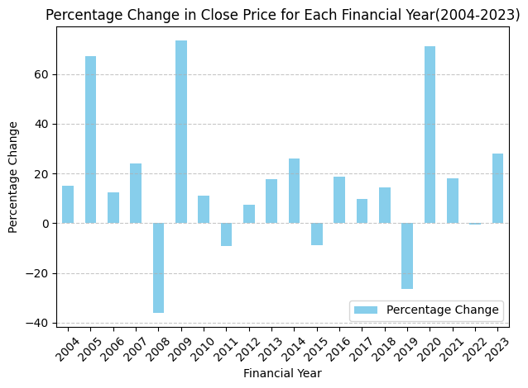

* The Average Return is **14.039%** in each financial year
* Minimum return = -**36.209%**
* Maximum return = **73.5%**
* Annualized returns = **12.036%**
* Compound Annual Growth: CAGR measures the average annual growth rate of an investment over a specified period of time.

5-year return= **13.08%**

10-year return = **9.09%**

20-year return = **6.67%**

* P/E ratio over time:

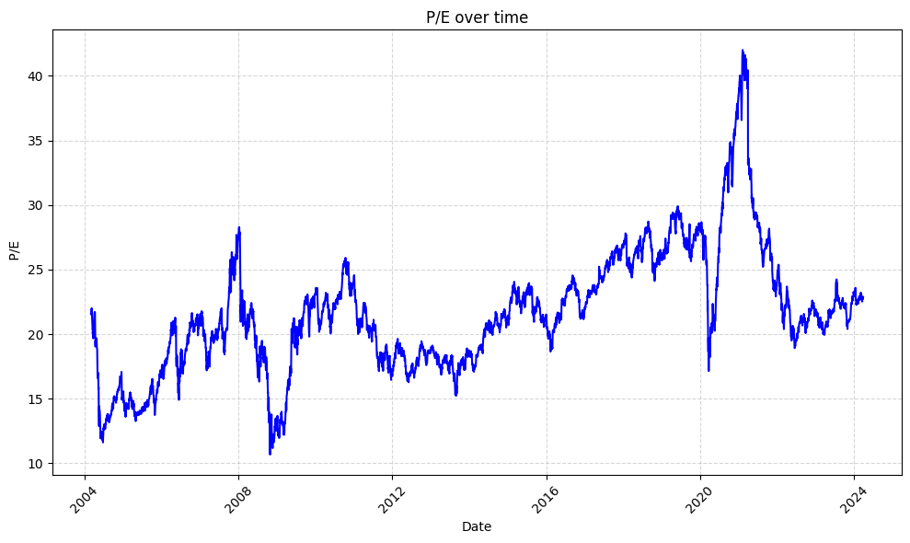

* The P/E ratio is calculated by dividing the current price of the index by its earnings per share
* A high P/E ratio suggests that the index may be overvalued, while a low P/E ratio may indicate undervaluation. Changes in the P/E ratio over time can signal shifts in market sentiment and expectations about future earnings growth.
* Mean P/E ratio of NIFTY50 in past 20 years is 21.66, Over the last ten years, the average PE ratio of Nasdaq has been 28.24, and that of SnP500 is 33.7.

A lower P/E ratio for the NIFTY 50 compared to other indices may indicate relative attractiveness.

* **Dividend Yield% over time**

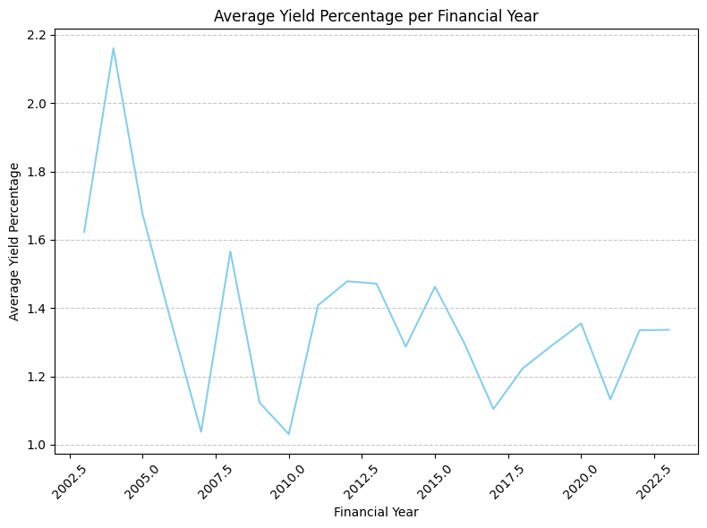

* A higher Div Yield% indicates that investors can potentially earn a greater income from holding the NIFTY 50 index relative to its current price. This may be attractive for income-seeking investors who prioritize dividend income
* We observe that even though the Dividend percentage is oscillating, it has decreased considerably after the early 2000s
* Changes in the Div Yield% over time may reflect shifts in market sentiment and economic conditions. For example, during periods of economic uncertainty or market volatility, companies may increase dividend payouts to provide stability and attract investors seeking income. Hence, we observe the increase in the dividend payouts during the 2008 crisis.
* The Div Yield% graph can offer insights into the valuation of the NIFTY 50 index. A declining Div Yield% may suggest that stock prices are rising faster than dividend payouts, potentially indicating overvaluation. We observe here that even thought the percentage oscillates it is stable around the zone of 1.2-1.4 in the later years, Indicating a stable market
  1. NIFTY50 vs GDP

The GDP growth of India can be visualised as:

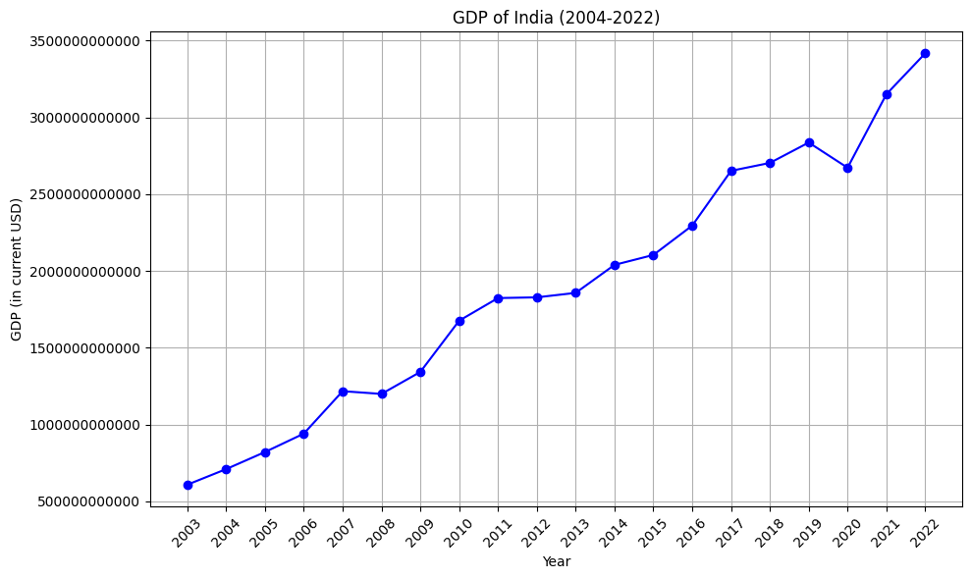

India’s GDP has been on a steady rise for the past 20 years

* Average GDP growth is **9.86%**
* Currently the GDP of India is Close to **3.5 trillion USD** which was just **607 Billion USD** in 2003-04
* GDP Growth Rate Trends (5-year intervals):

**2004-09: 14.986084174236154,**

**2009-14:9.487669032737085,**

**2014-19: 7.9117012147245775,**

**2019-2023: 5.099537679913636**

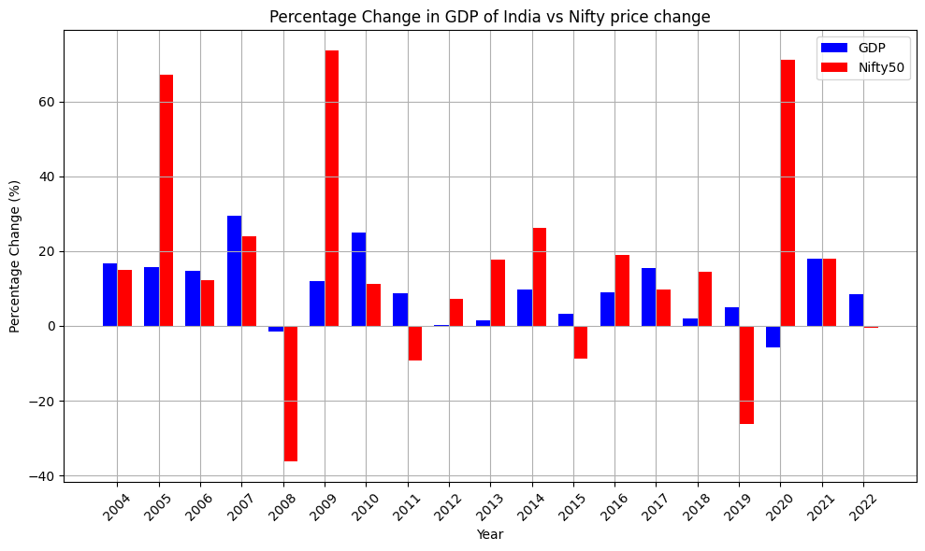When we compare the percentage change in GDP with the percentage change in Nifty50, we get:

From the graph we observe that the Nifty50 Prices are loosely related to the GDP change of the nation

* We observe that, except the Covid year, if the GDP change isn’t big or isn’t positive, the returns from NIFTY50 declines severly
* In the years with GDP change more than 15%, NIFTY50 always gave Positive returns
* A positive correlation between GDP growth and NIFTY 50 price change suggests that economic expansion tends to coincide with stock market gains. When GDP grows, it often reflects increased corporate earnings, consumer spending, and business investments, which can drive stock prices higher. The correlation between GDP and NIFTY50 returns is **0.15**
* There may be periods when GDP growth and NIFTY 50 price change diverge. For example, during economic downturns, GDP may contract while stock prices continue to rise or remain relatively stable. This could occur due to factors such as investor sentiment, monetary policy, corporate performance, or global market trends.
  1. NIFTY50 and Inflation rates

The Inflation rate in india can be observed to be changing as:

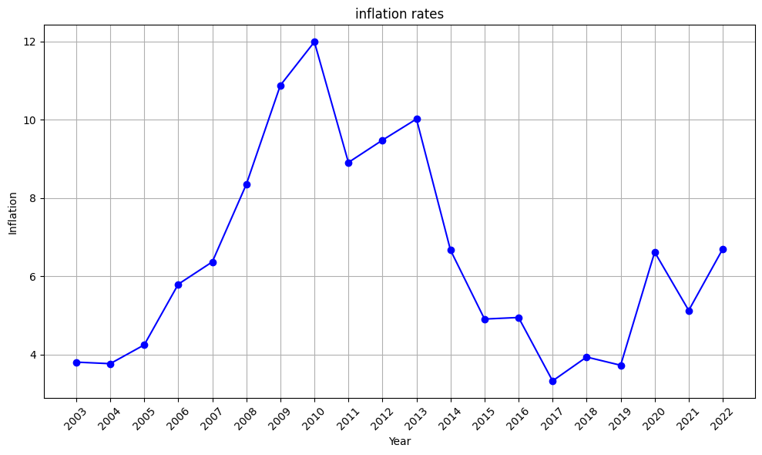The percentage change can be viewed as:

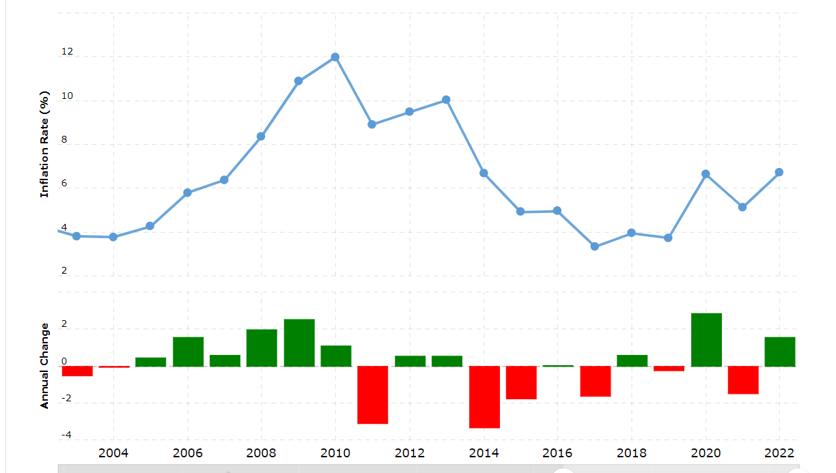

* Periods of low or declining inflation alongside stock market gains may indicate favorable economic conditions and investor optimism, hence we observe the Bull run in the 2015-2019 period
* Observing periods of high or rising inflation alongside stock market declines may suggest that inflationary pressures are negatively impacting investor sentiment and stock prices, which can be seen in the 2011 range when the market was consolidating the inflation was at it’s maximum.
* Moderate inflation may be conducive to economic growth and corporate profitability, supporting stock prices.

True returns of NIFTY50 adjusted for inflation is as follows:

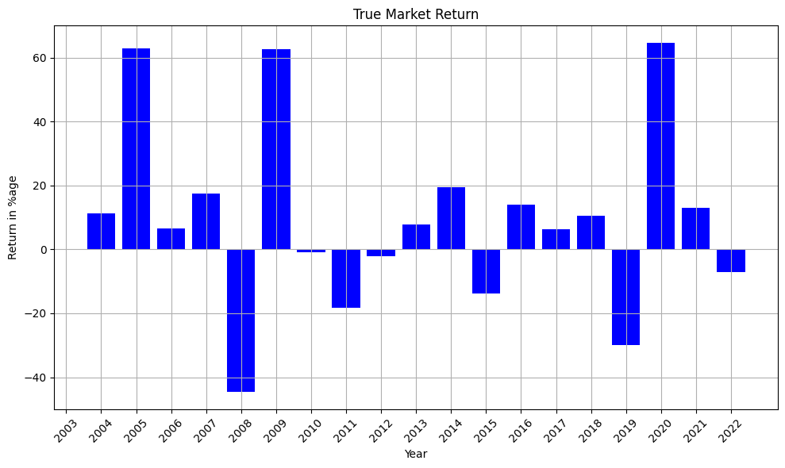

After adjusting for inflation, the returns are:

* Average Return: **9.45%**
* Total Return: **179.55%**
* Minimum Return: **-44.55%**
* Maximum Return: **64.51%**
* Standard Deviation: **28.319%**
  1. NIFTY50 and RBI Interest Rates

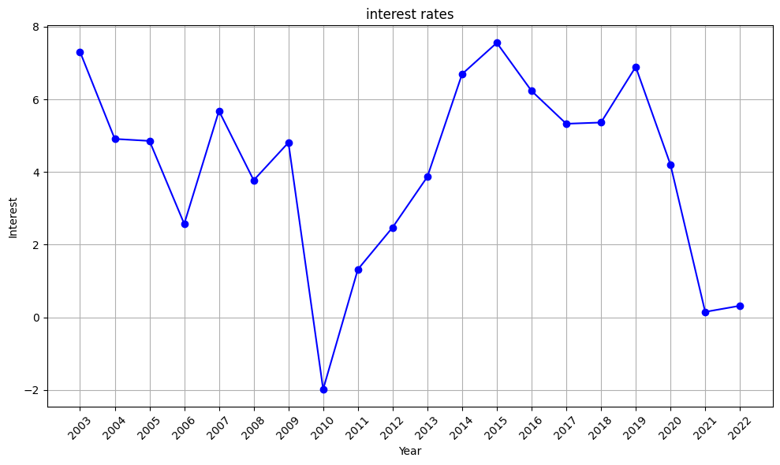

* Lower Interest Rates: A decrease in interest rates tends to make borrowing cheaper, encouraging businesses and consumers to invest and spend more. This increased economic activity can lead to higher corporate profits, which generally supports higher stock prices.
* Higher Interest Rates: Conversely, an increase in interest rates can raise borrowing costs, potentially slowing down economic growth and corporate earnings. This dampen investor sentiment and lead to lower stock prices.
* We can observe a general Inverse relationship between interest rates and the return of NIFTY50. When interest rates are low, investors may seek higher returns in the stock market, leading to higher stock returns and similarily, rising interest rates may lead to lower stock returns as investors may shift towards fixed-income securities offering higher yields.
* We observe that the lowest interest rate was during the time the time of recovery from the 2008 crisis which must’ve been one of the major factors helping in the recovery of the financial systems.
  1. NIFTY50 vs SnP500

The S&P 500 index is widely regarded as one of the most important stock market indices globally due to several key factors:

* Broad Representation: The S&P 500 consists of 500 of the largest publicly traded companies in the United States, spanning various sectors of the economy. This broad representation makes it a comprehensive barometer of the overall health and performance of the U.S. stock market.
* Market Capitalization Weighting: The index is weighted by market capitalization, meaning that companies with higher market values have a greater impact on the index's movements. As a result, changes in the stock prices of the largest companies within the S&P 500 can significantly influence the index's overall performance.
* Investor Confidence: The S&P 500 is widely tracked by investors, analysts, and market participants as a benchmark for evaluating investment performance and market trends. It serves as a key indicator of investor confidence and sentiment in the U.S. economy and financial markets.

Let’s Look at relative return of SnP 500 and Nifty50:

(Next Page)

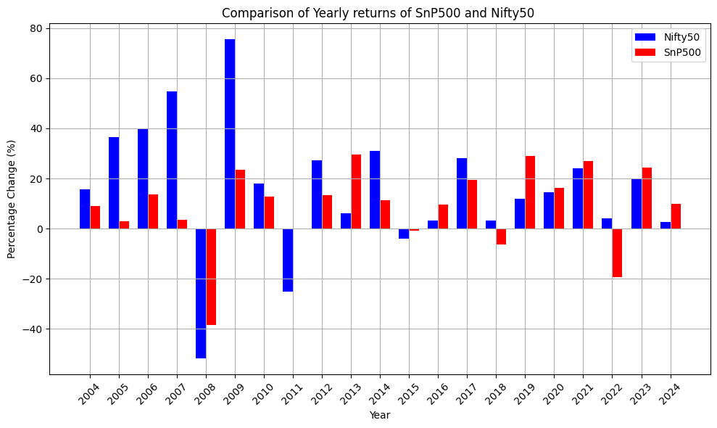

* Between the two indices we observe a correlation of 0.583
* With a correlation coefficient of 0.58, we can infer that movements in the S&P 500 index's returns explain approximately 58% of the variability in the Nifty50 index's returns. This means that changes in the S&P 500 returns may provide some predictive power or insight into the direction of Nifty50 returns
* We observe that a negative change in SnP500 indicates a Negative return or close to small returns from NIFTY50
* **100 rupees invested in SnP500 2004 will be 471.80133 rupees today**
* **100 rupees invested in Nifty50 2004 will be 1205.2429 rupees today**
* Nifty50 outperforms SnP by nearly **3x,** with **155% more profit** generation
  1. Sector-Wise Analysis of NIFTY50

The NIFTY 50 index involves companies from various sectors, offering exposure to different segments of the economy. By analyzing the performance of individual sectors within the index, we can gain insights into sector-specific trends, dynamics, and opportunities.

Let’s take a look at how the weightage of each industry changed:

**2002:**

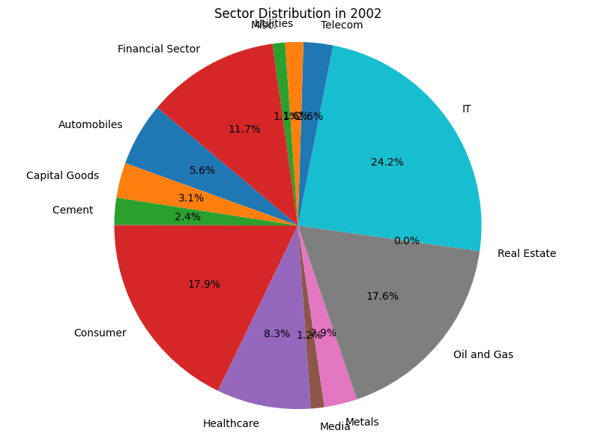.

**2004:**

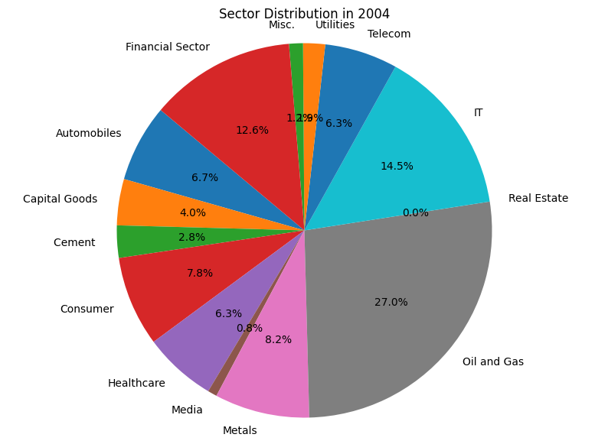.

**2008**

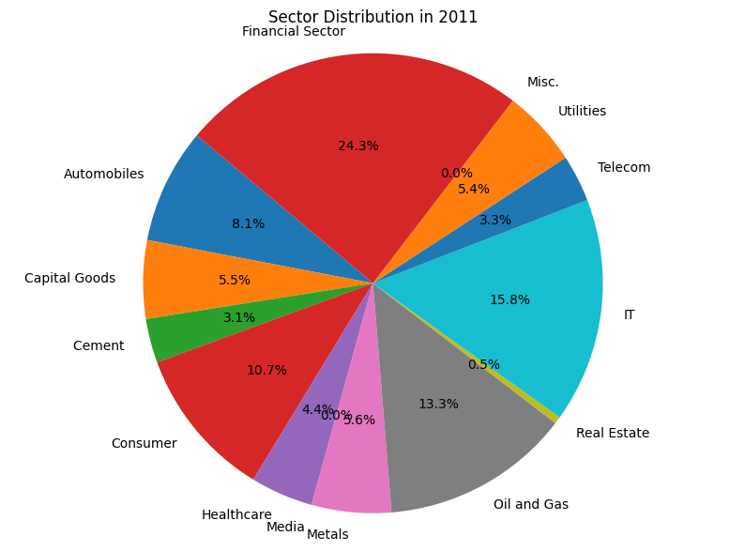**.**

**2014**

**.**

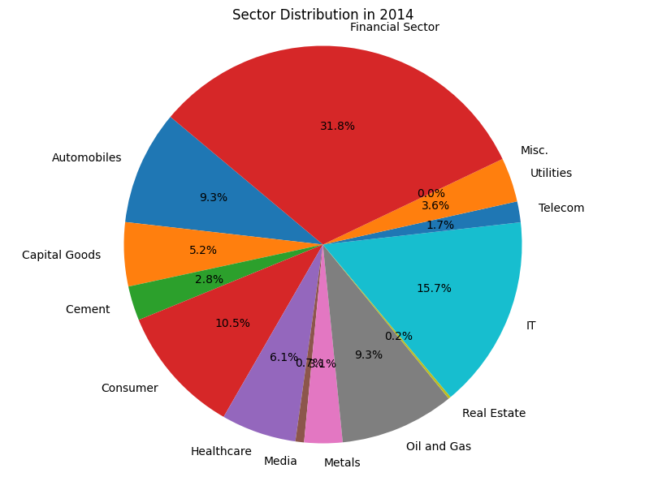

**2017**

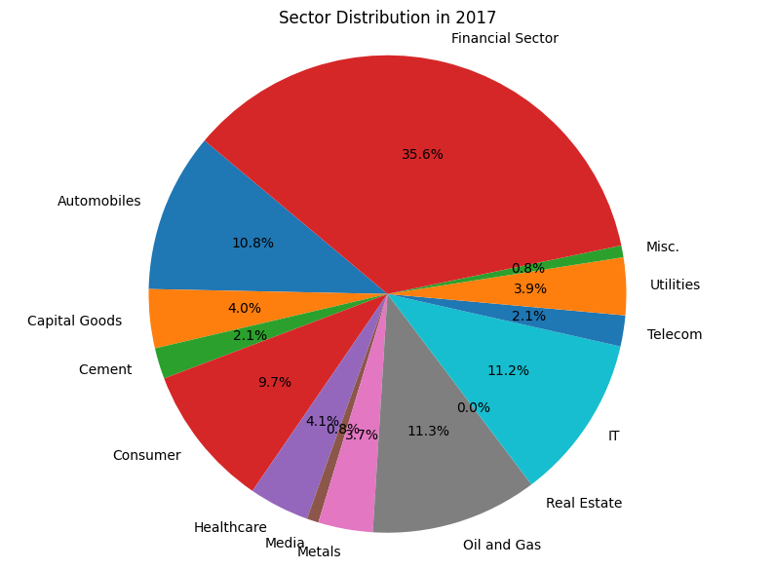**.**

**2021**

**.**

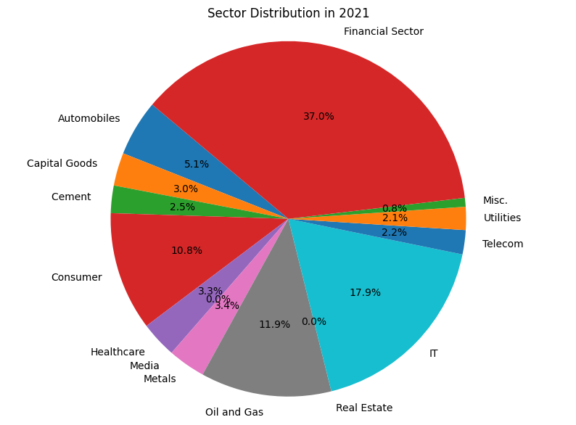

**2024**

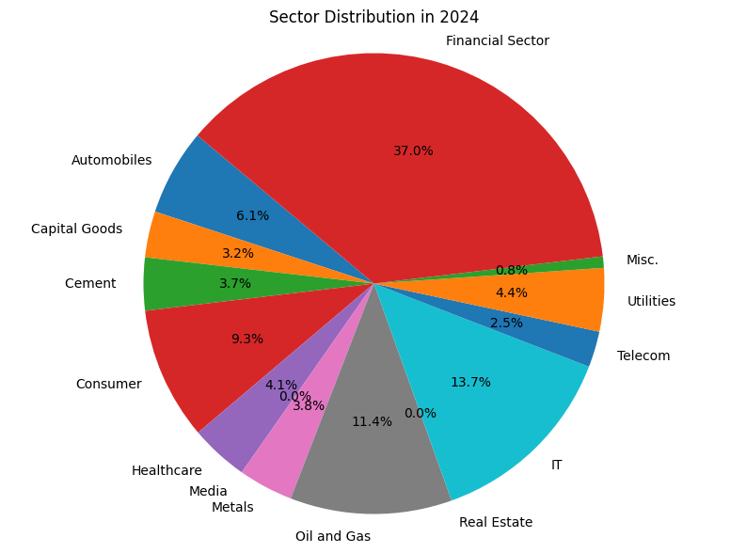**.**

From all the pie charts above we observe certain trends in some sectors, let’s look at them more closely:

* **Financial Sector**

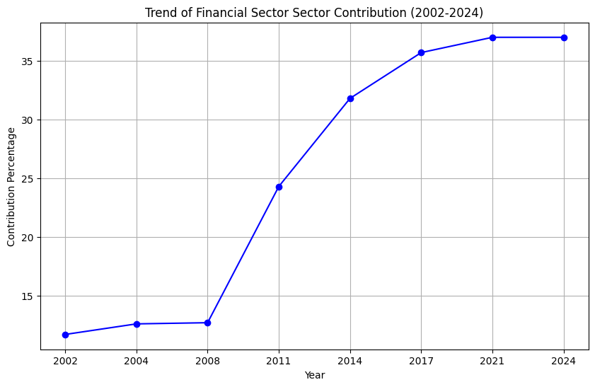

* We observe that the financial sector started growing in percentage to become the sector with highest contribution in after 2008, which might be because of the following reasons:
* Recovery from the Financial Crisis: After the global financial crisis of 2008, the financial sector underwent significant restructuring, consolidation, and regulatory reforms to stabilize the financial system. As the economy recovered from the crisis, financial institutions gradually regained profitability and investor confidence, leading to a resurgence in their market capitalization.
* Expansion of Financial Services: In the years following the financial crisis, the financial sector witnessed expansion and diversification of financial services. Banks, insurance companies, asset management firms, and other financial institutions introduced innovative products and services, expanded their geographic presence, and capitalized on emerging trends such as digital banking and fintech.
* Monetary Policy Support: Central banks around the world, including the Reserve Bank of India (RBI), implemented accommodative monetary policies post-2008 to stimulate economic growth and support financial stability. Measures such as interest rate cuts, liquidity injections, and regulatory interventions provided crucial support to the financial sector, bolstering market sentiment and driving up market capitalization.
* Mergers and Acquisitions: The post-crisis period saw a wave of mergers and acquisitions (M&A) activity in the financial sector as stronger institutions acquired weaker ones or consolidated their market positions. M&A deals contributed to the concentration of market capitalization among a smaller number of larger financial firms, leading to a higher aggregate market cap in the Nifty50 index.
* Rise of Non-Banking Financial Companies (NBFCs): The emergence and growth of NBFCs as key players in the financial sector also contributed to the increase in market capitalization post-2008. NBFCs expanded their lending and investment activities, tapping into underserved market segments and driving up their market valuations.
* **IT sector:**

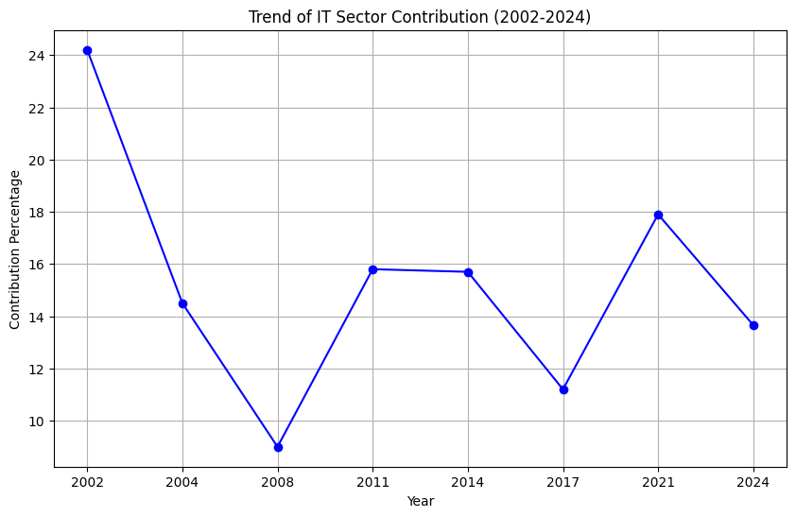**.**

* We observe that the contribution of IT sector declining before 2008, this might be because in the early 2000s the Dot Com bubble burst happened which led to normalisation of the overvalued stocks from the IT sector, Hence the decline in the contribution.
* Then after the 2008 crisis, the contribution recovered
* Between 2014 and 2017 we observe another decline, this might be due to:
  + - Currency Fluctuations: During this period, the Indian rupee experienced significant fluctuations against major currencies, particularly the U.S. dollar. The IT sector, which earns a significant portion of its revenue in foreign currencies, including the U.S. dollar, is sensitive to currency movements. A strengthening rupee reduces the rupee value of foreign earnings for IT companies, impacting their revenues and profitability.
    - Technology Disruptions: Rapid advancements in technology, including cloud computing, automation, and artificial intelligence, disrupted traditional IT business models during this period. Indian IT companies faced increased competition from global tech giants and startups offering innovative solutions and services
* **Telecom Sector:**

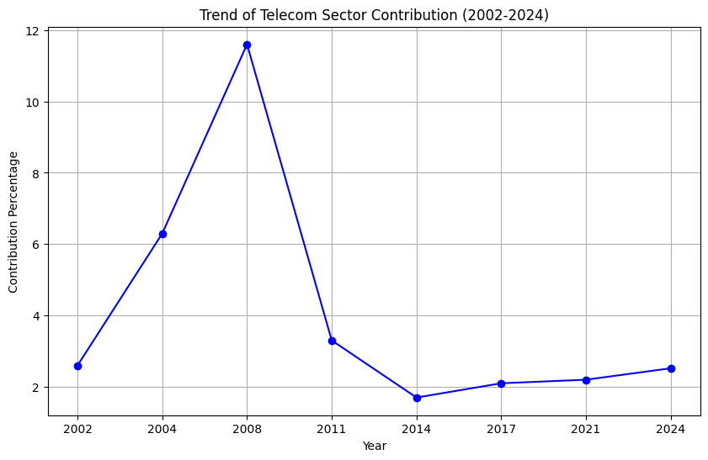**.**

* We observe two major patterns here, firstly the rapid increase from 2002-2008, and then a rapid decline from 2008-2017
* The growth from 2002-2008 can be adhered to:
* Market Liberalization and Regulatory Changes:

During the early 2000s, the Indian government implemented significant reforms to liberalize and deregulate the telecom sector. These reforms aimed to promote competition, attract investment, and expand access to telecommunications services across the country.

The introduction of the New Telecom Policy (NTP) in 1999 and subsequent policy measures allowed for increased private sector participation, including the entry of new players and foreign investments.

The competitive landscape of the telecom industry changed dramatically as new telecom operators entered the market, leading to increased competition, innovation, and expansion of services. This period saw the emergence of several new players offering mobile, broadband, and value-added services.

* Mobile Revolution (2002-2008):

The period between 2002 and 2008 witnessed a mobile revolution in India, characterized by exponential growth in mobile phone penetration and subscriber base.

Factors such as declining handset prices, innovative pricing strategies, and aggressive marketing campaigns by telecom operators led to a surge in mobile phone adoption across urban and rural areas.

The availability of affordable mobile services and the introduction of prepaid plans made mobile telephony accessible to a large segment of the population, driving unprecedented growth in subscriber numbers.

* The Decline can be explained as:
* Regulatory Uncertainty and Policy Issues (2008-2014):

The rapid growth of the telecom sector during the early 2000s was followed by a period of regulatory uncertainty and policy issues, particularly after the 2G spectrum allocation scam in 2008.

The 2G spectrum scam exposed irregularities in the allocation of telecom licenses and spectrum, leading to legal battles, regulatory investigations, and policy paralysis in the sector.

The uncertainty surrounding spectrum allocation, licensing norms, and regulatory environment created a challenging business environment for telecom operators, hampering their expansion plans and investment decisions.

* Intense Competition and Price Wars (2008-2014):

The telecom industry became increasingly competitive during the period from 2008 to 2014, with multiple players vying for market share.

Intense competition led to aggressive pricing strategies, tariff wars, and declining average revenue per user (ARPU) for telecom operators. This intensified pressure on profitability and strained the financial health of telecom companies.

Consolidation efforts within the industry, including mergers and acquisitions, were driven by the need to achieve economies of scale, enhance network efficiency, and mitigate competitive pressures.

* **Automobile Sector**
* 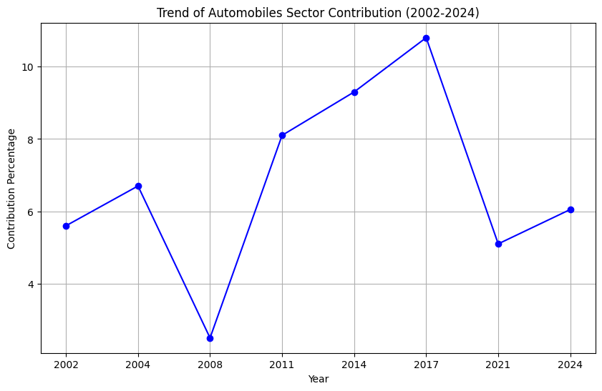The Growth from 2008 to 2017 can explained by:
* Economic Growth and Rising Income Levels:

During this period, India experienced significant economic growth, accompanied by rising income levels and increasing consumer spending power.

Higher disposable incomes and improved living standards led to greater demand for automobiles, including passenger cars, two-wheelers, and commercial vehicles.

* Urbanization and Infrastructure Development:

Rapid urbanization and infrastructure development, especially in Tier II and Tier III cities, increased the demand for automobiles as individuals sought better mobility solutions for commuting and transportation.

Improved road networks, highways, and urban infrastructure projects further facilitated the growth of the automotive sector by enhancing connectivity and accessibility.

* Government Policies and Incentives:

The Indian government introduced various policy measures and incentives to promote the automotive industry, encourage domestic manufacturing, and attract foreign investments.

Initiatives such as the Automotive Mission Plan, National Electric Mobility Mission Plan, and Faster Adoption and Manufacturing of Electric Vehicles (FAME) scheme aimed to boost domestic production, innovation, and adoption of cleaner and more fuel-efficient vehicles.

* The rapid decline from 2017 to 2021 can be explained as:
* Economic Slowdown and Market Challenges:

The Indian economy faced headwinds during this period, including economic slowdowns, liquidity constraints, and subdued consumer sentiment. Factors such as demonetization, the implementation of the Goods and Services Tax (GST), and the COVID-19 pandemic adversely impacted consumer spending and purchasing power.

Reduced consumer confidence and uncertainty about economic prospects dampened demand for automobiles, leading to lower sales volumes and revenue for automotive manufacturers.

* Policy Changes and Regulatory Challenges:

The automotive sector grappled with regulatory challenges and policy changes, including stricter emission norms, safety regulations, and changes in taxation policies.

Implementation of Bharat Stage VI (BS-VI) emission norms in April 2020 necessitated significant investments in technology upgrades and compliance measures, increasing manufacturing costs for automakers.

* Disruption Due to COVID-19 Pandemic:

The outbreak of the COVID-19 pandemic in 2020 disrupted global supply chains, manufacturing operations, and consumer demand, leading to production shutdowns, supply shortages, and dealership closures in the automotive sector.

Lockdown measures, travel restrictions, and economic uncertainty resulted in a sharp decline in vehicle sales and production, exacerbating the challenges faced by automotive manufacturers and suppliers.

* **Oil and Gas sector:**

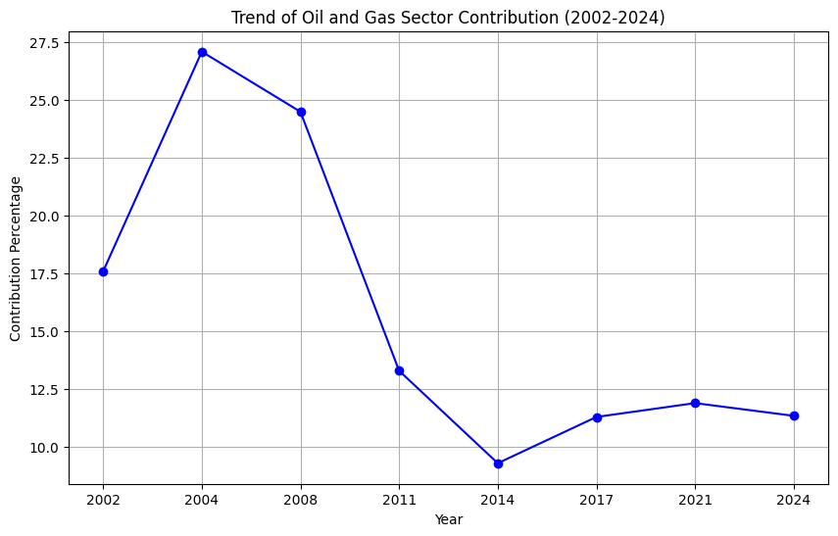

* The downfall can be explained by Global Oil Price Volatility:

Oil and Gas sector experienced significant volatility in global oil prices. Fluctuations in oil prices, influenced by factors such as geopolitical tensions, supply-demand dynamics, and macroeconomic conditions, impacted the revenue and profitability of oil companies.

Periods of high oil prices, such as during the mid-2000s and early 2010s, led to increased exploration and production activities, driving investments in the sector. However, subsequent downturns in oil prices, particularly during the global financial crisis of 2008 and the oil price collapse of 2014-2016, adversely affected the financial performance of oil companies.

1. Volatility Analysis of the Indian Stock Market

Volatility in a stock market refers to the degree of variation or dispersion in the prices of financial instruments, such as stocks, over a specific period of time. It measures the rate at which the price of a security fluctuates, indicating the level of uncertainty or risk associated with the investment.

* 1. Analysis using VIX

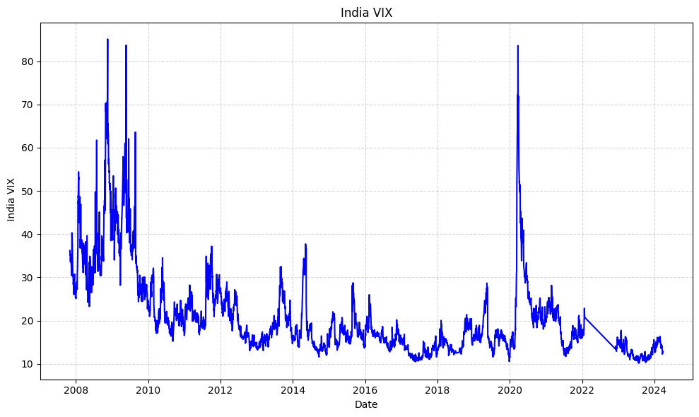

* Increasing VIX score signifies rising uncertainty among investors, It suggests that investors are willing to pay higher premiums for options contracts as they seek protection against sharp price movements or market downturns. It may signal potential downside risks or increased market turbulence, prompting investors to adopt risk-off strategies, reduce leverage, or hedge their positions.
* Decreasing VIX scores generally indicate declining expectations of market volatility and increasing investor confidence or complacency. A declining VIX may coincide with periods of market stability, optimism, or bullish sentiment, often during periods of economic expansion, positive earnings reports, or accommodative monetary policies
* We observe major increase in the VIX levels during 2008 Subprime Mortgage crisis and during COVID market crash, which signifies the uncertainty over the stock price in the Indian market.
* We also observe that In general the volatility of the market is low, indicating a strong and relatively stable market
  1. Analysis using Bollinger Bands

Bollinger Bands are a technical analysis tool that consists of a moving average line and upper and lower bands based on standard deviations from the moving average. Widening bands indicate increasing volatility, while narrowing bands suggest decreasing volatility.

* **On NIFTY50**

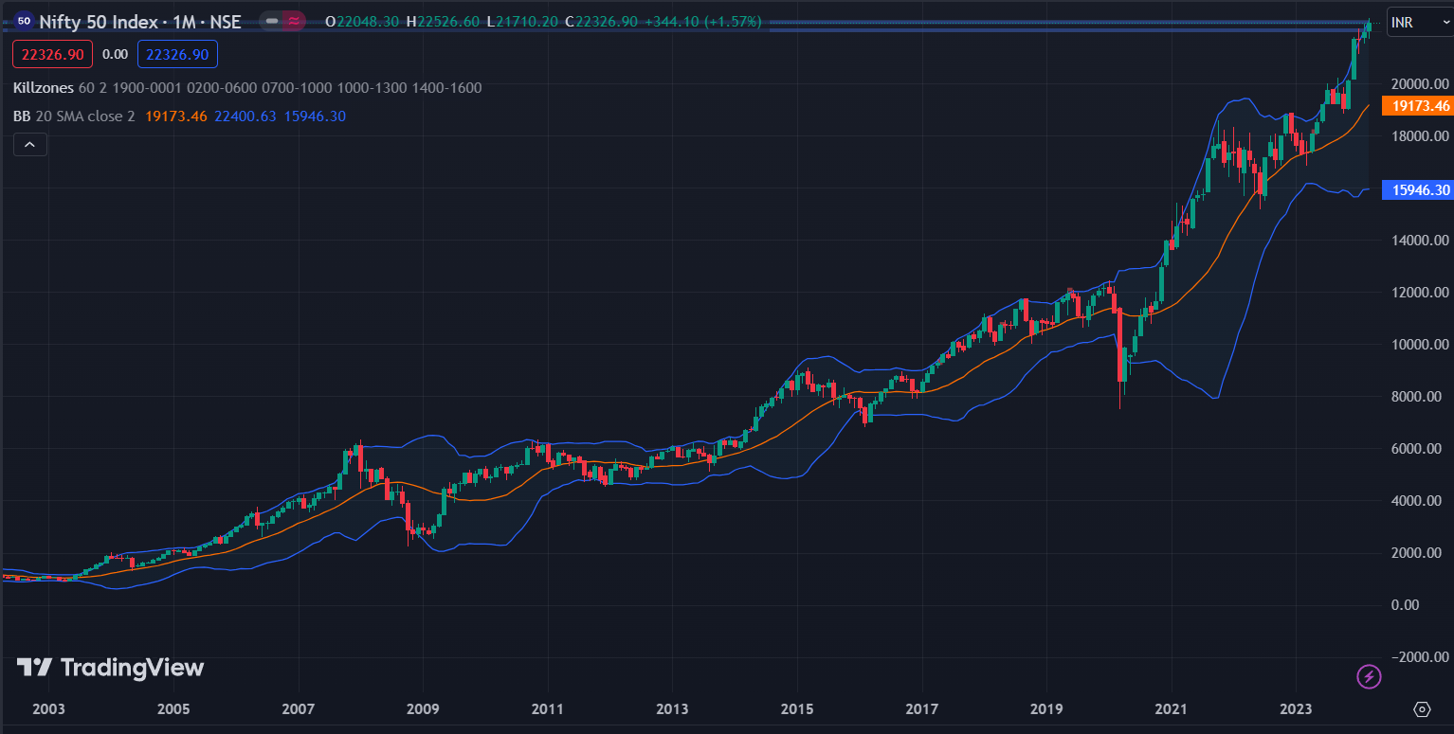

* As we can see in this that the market seems to be relatively more volatile currently with highest volatility being in the year 2021-2022
* From 2011-2015, the market volatility was low
* From 2017-2020 the market was moderately volatile
* **On SENSEX**

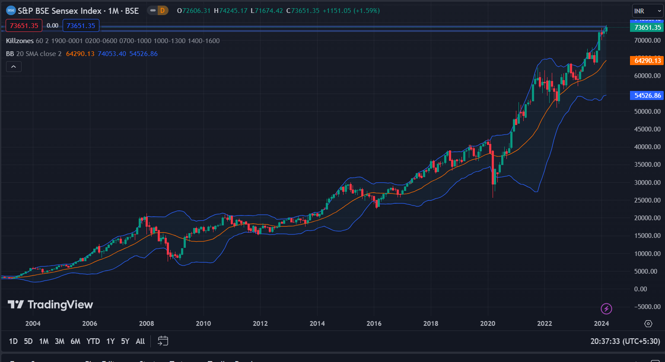**.**

A similar pattern can be observed in the sensex data too

* 1. Analysis using ATR(Average True Range)
* The Average True Range (ATR) measures the average range between high and low prices over a specified period, typically 14 days by default.
* A higher ATR value indicates greater volatility, while a lower ATR value suggests lower volatility.
* **On NIFTY50**

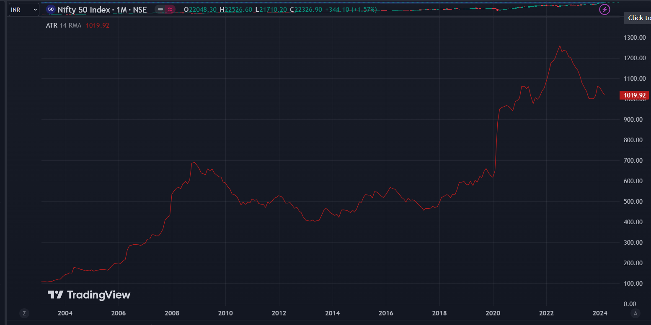

* We can see the rise of ATR in 2021, the ATR confirms our bias derived from the Bollinger Bands
* We can also observe the rise in ATR during 2008-09 time period
* **On SENSEX**
* 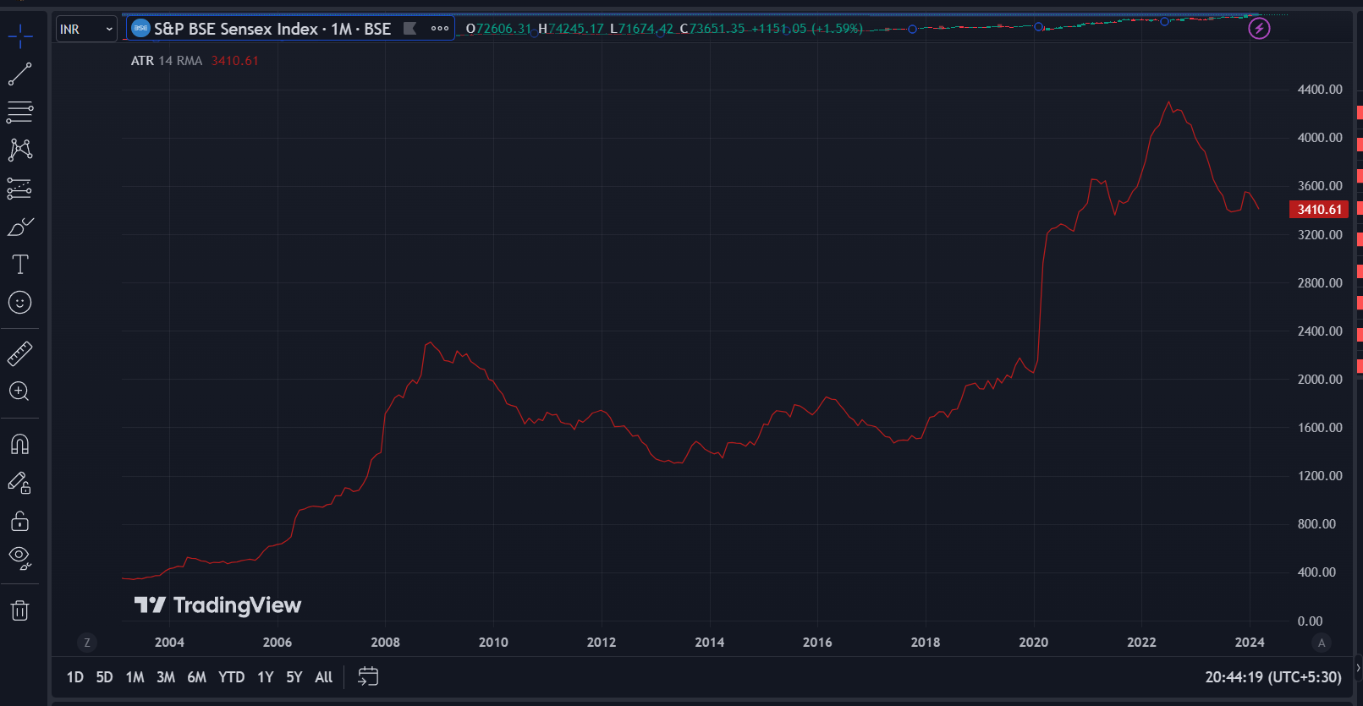We can observe a very similar pattern for SENSEX too

1. 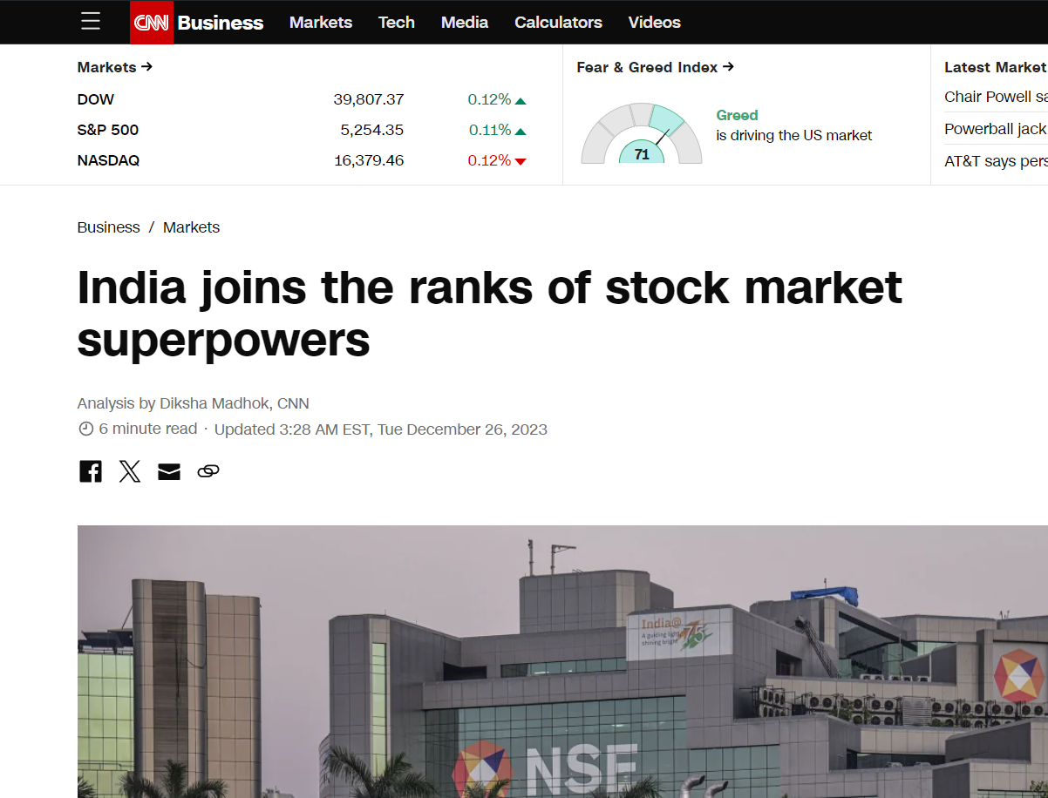Future Analysis of Indian Stock Market

There are several factors that the bullish move by the Indian supermarket will continue in the coming decades, some of them are listed below:

* **India has 4th Largest Stock Market in the world**

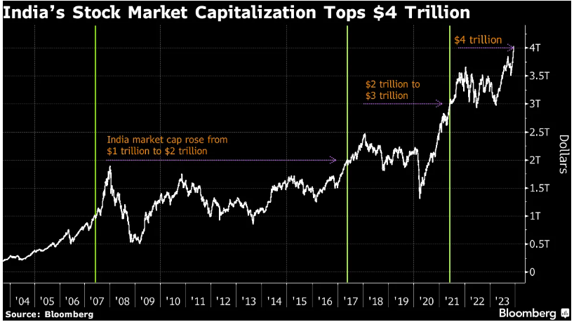

* **One of the fastest growing economies in the world**

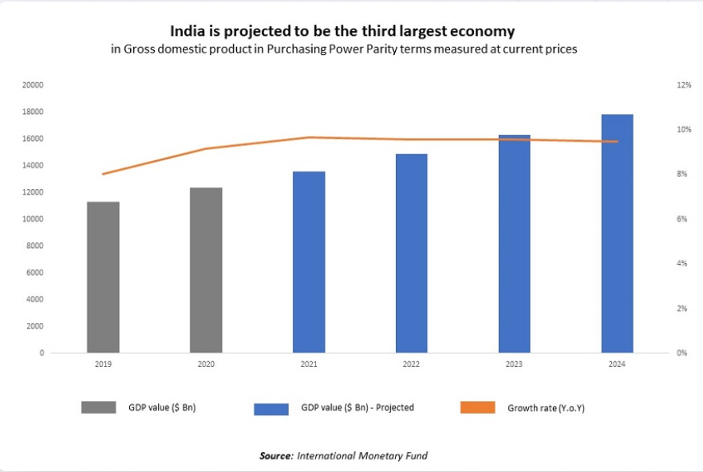

* **Largest youth population in the world**
* The population of India is expected to rise from 121.1 Cr to 152.2 Cr during 2011-36 an increase of 25.7% in 25 years.

Source: National Commission on Population, Ministry of Health & Family Welfare

* India has its largest ever adolescent and youth population. It will continue to have one of the youngest populations in the world till 2030.

Source: United Nations Population Fund

* India has the third-largest group of scientists and technicians in the world.

Source: All India Management Association, The Boston Consulting Group

* By 2030, it is estimated that around 42% of India’s population would be urbanised from 31% in 2011.

Source: World Bank

* 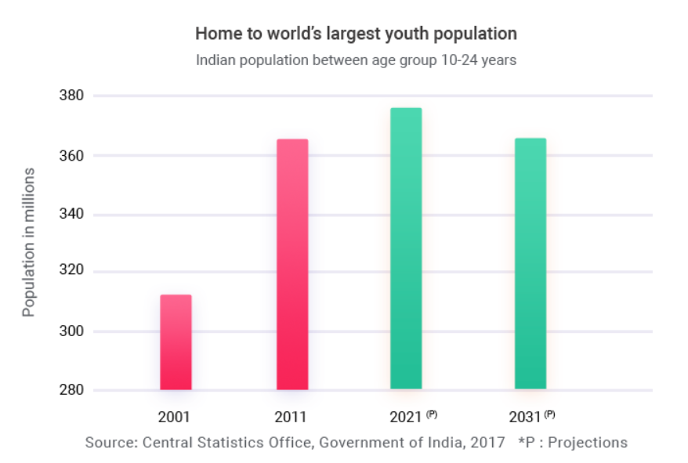**Infrastructure Effect**
* **Hon'ble Finance Minister Smt. Nirmala Sitharaman announced the National Infrastructure Pipeline first-of-its-kind initiative to provide world-class infrastructure across the country.**
  + **The NIP will attract investments into infrastructure and will be crucial for attaining the target of becoming a $5 Tn economy by FY 2025.**
  + **Nearly 7,000 projects across different sectors costing above INR 100 Cr per project and totaling INR 111 Lakh Cr have been identified.**
  + **Sectors such as Energy (24%), Roads (18%), Urban (17%) and Railways (12%) amount to around 71% of the projected infrastructure investments in India.**  
    Source: Department of Economic Affairs, Ministry of Finance and [*India Investment Grid*](https://www.investindia.gov.in/india-investment-grid)
* **An equity infusion of INR 6,000 Cr has been made in the National Investment and Infrastructure Fund (NIIF) Infrastructure Debt Financing Platform to attract debt and equity investments in infrastructure.**  
  Source: Prime Minister's Office, Ministry of Finance
* **India Industrial Land Bank (IILB), a GIS-based portal, is a repository of all industrial infrastructure-related information containing approximately 4,000 industrial parks mapped across an area of 5.5 Lakh Ha of land.**  
  Source: Ministry of Commerce & Industry
* **Rising Global Competitiveness**
* India ranks 40th on the Global Competitiveness Index 2023.   
  Source: *International Institute for Management Development*
* India jumps 6 places to Rank 38 in World Bank’s Logistics Performance Index 2023.   
  Source: *World Bank*
* 1.35 Bn Indians are covered under Aadhar Scheme, one of the world’s largest social security program.   
  Source: *Press Information Bureau, Government of India*
* Pradhan Mantri Jan Dhan Yojana, a formalization of savings scheme under which 500 Mn bank accounts have been opened with savings amounting to INR 2,03,505 Cr.   
  Source: *Ministry of Finance, Government of India*
* Goods and Services Tax (GST), the biggest tax reforms since independence, paves way for a common national market by integrating various indirect taxes.  
  Source: *Government of India*

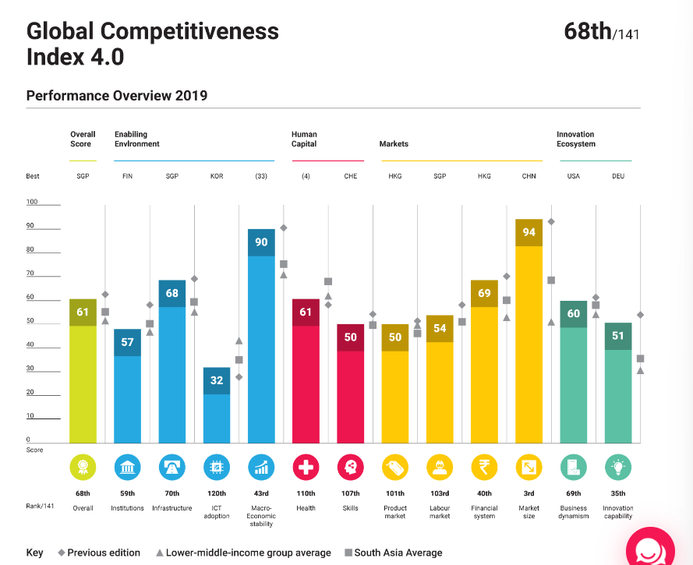**.**

1. Sector-Wise Performance Analysis of Indian Stock Market

5.1 Percent change in the past 10-years

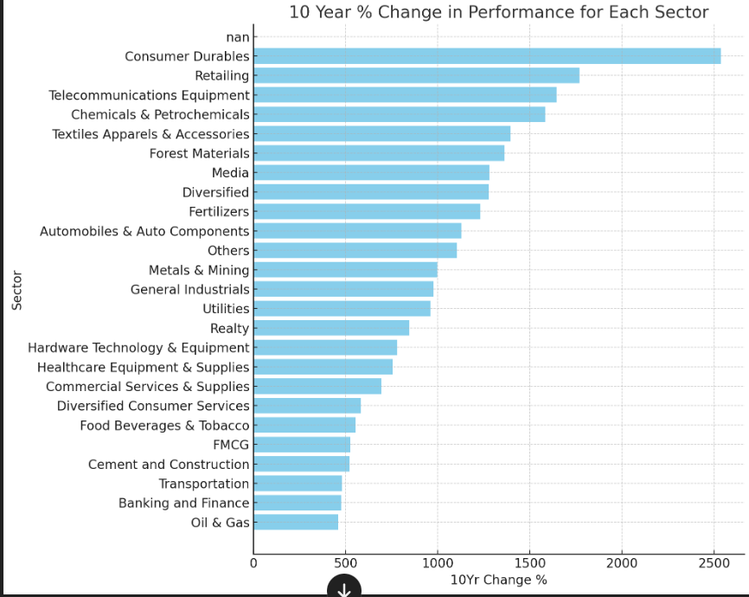.

* We observe that Oil and Gas industry changed the least, while Consumer Durables was the best performing sector

5.2 No. of Companies

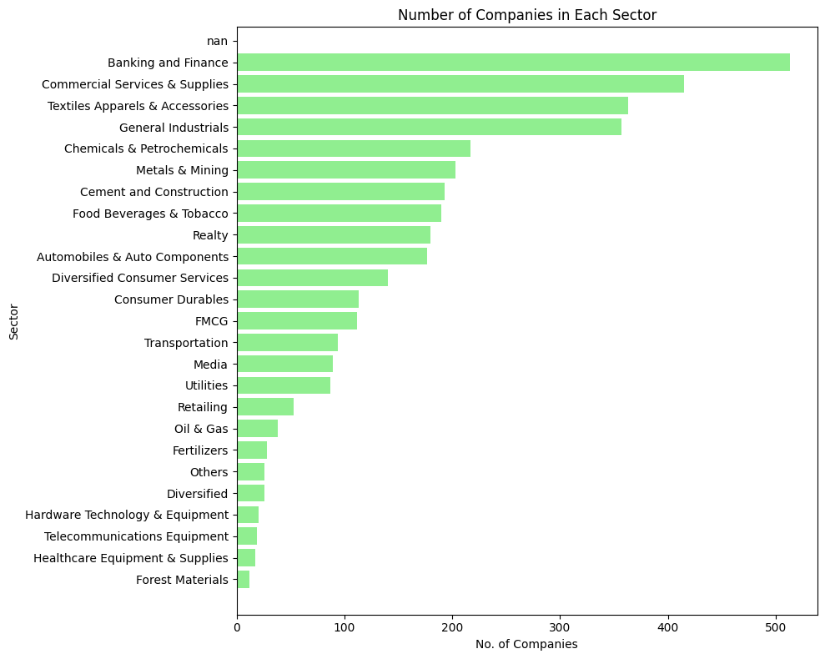

5.3 Return on Equity

Return on Equity (ROE) is a financial ratio that measures the ability of a company to generate profits from its shareholders' equity. It is expressed as a percentage and is calculated by dividing the net income by the shareholders' equity. Essentially, ROE indicates how well a company uses the investments made by its shareholders to generate earnings growth.

The formula for ROE is:

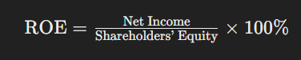

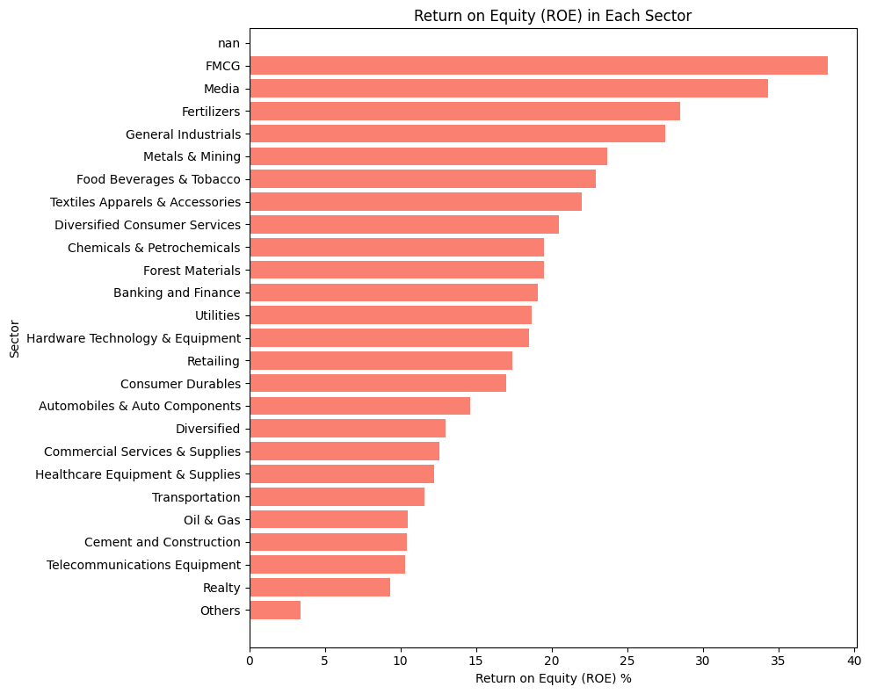

5.4 Return on Capital Employed(ROCE)

Return on Capital Employed (ROCE) is a financial metric that measures a company's profitability and the efficiency with which its capital is used. In essence, ROCE indicates how well a company is generating profits from its capital employed, which includes both equity and debt. It's a particularly useful metric for comparing the performance of companies in capital-intensive sectors such as utilities and manufacturing

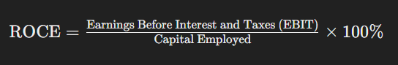

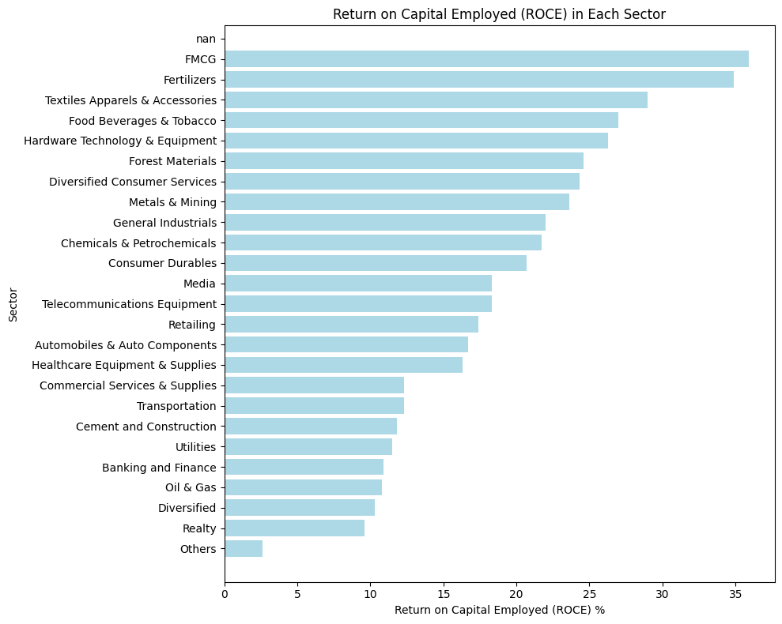

5.5 Advances to Decline ratio

The Advances to Declines Ratio is a market breadth indicator used to gauge the overall health and direction of the market. It compares the number of stocks (or entities within a sector, in this context) that have advanced (closed higher) in price against those that have declined (closed lower). This ratio can provide insights into whether the broader market or a particular sector is leaning towards bullish or bearish sentiment.

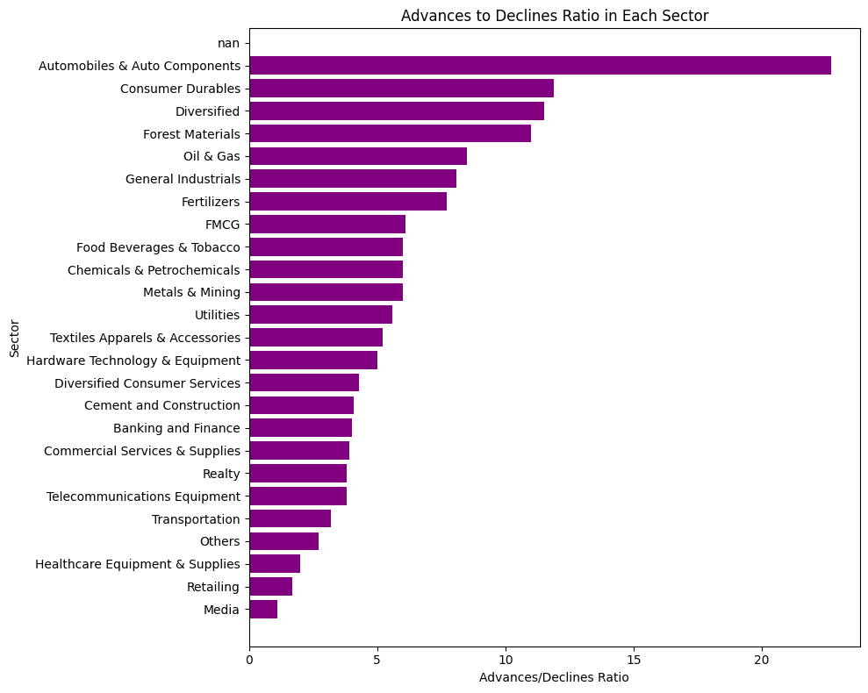

1. Conclusions

In this report we took a deep and general look into the Indian Stock Market studying the behaviour of the most important indices and their long-term behaviour in the past 20 years and the price data in relation with variables like GDP of the country, Inflation, Interest rates, Global Indices. Then we looked at how the most traded and blue-chip stocks changed over time affecting and changing the face of NIFTY and in-turn the Indian Stock Market. Then we took a look at volatility of the Indian stock market to get a taste of how stability of the market has been changing over time. Then we looked into the factors that could drive Indian Stock Markets even higher in the coming future and why should we invest in it. Finally, we took a broader look at how each sector performed based on the data from past 1 decade, which can help us to figure out which sectors are on rise and are the best to invest in.

1. References:

<https://www.niftyindices.com/reports/historical-data>

[https://www.wsj.com/market-data/quotes/index/IN/NATIONAL STOCK EXCHANGE OF INDIA/NIFTY50/historical-prices](https://www.wsj.com/market-data/quotes/index/IN/NATIONAL%20STOCK%20EXCHANGE%20OF%20INDIA/NIFTY50/historical-prices)

<https://www.livemint.com/market/stock-market-news/nifty-50-vs-gdp-of-india-why-experts-see-more-rally-in-indian-stock-market-explained-with-5-crucial-reasons-11709365830102.html>

<https://data.worldbank.org/indicator/NY.GDP.MKTP.CD>

<https://www.livemint.com/market/ipo/srm-contractors-ipo-gmp-subscription-status-to-allotment-date-how-to-check-allotment-status-online-11711694819520.html>

<https://marcellus.in/blogs/nifty-indian-gdp-a-complete-breakdown-in-relationship/>

[https://tradethatswing.com/average-historical-stock-market-returns-for-sp-500-5-year-up-to-150-year-averages/ - :~:text=Last%2020%20Years-,The%20historical%20average%20yearly%20return%20of%20the%20S%26P%20500%20is,including%20dividends)%20is%206.96%25.filter=history&frequency=1d&includeAdjustedClose=true](%20https://tradethatswing.com/average-historical-stock-market-returns-for-sp-500-5-year-up-to-150-year-averages/%20-%20:~:text=Last%2020%20Years-,The%20historical%20average%20yearly%20return%20of%20the%20S%26P%20500%20is,including%20dividends)%20is%206.96%25.filter=history&frequency=1d&includeAdjustedClose=true)

<https://www.moneycontrol.com/india/stockmarket/sector-classification/marketstatistics/nse/automobile-ancillaries.html?classic=true>

[https://www.forbesindia.com/article/explainers/nifty-50-stocks-list-weightage-sectors/85791/1 - :~:text=The%20index%20encompasses%20various%20sectors,on%20the%20NSE%20in%20India.](https://www.forbesindia.com/article/explainers/nifty-50-stocks-list-weightage-sectors/85791/1#:~:text=The%20index%20encompasses%20various%20sectors,on%20the%20NSE%20in%20India.)

<https://www.motilaloswal.com/site/rreports/HTML/636416100418275289/index.htm>

<https://www.samco.in/indian-stock-market-indices/nse/india-vix-live-share-price-today>

<https://trendlyne.com/equity/sector-industry-analysis/reports/>

<https://www.investindia.gov.in/why-india>

[https://in.tradingview.com/ - main-market-summary](https://in.tradingview.com/#main-market-summary)