Practical No. 6
Aim: Practical of MongoDB.
Step 1: To download MongoDB community server, visit its official website -> menu -> community server and download it from there and install it.
Step 2: After installation, go to MongoDB directory as shown below and copy its path.
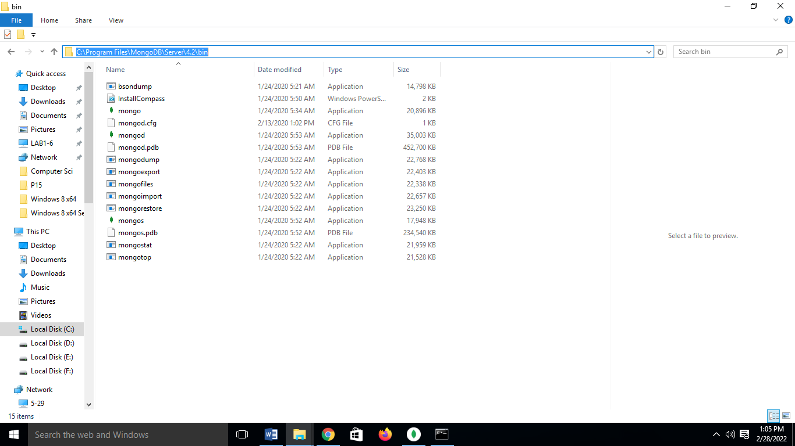

Step 3: Open command prompt, run as administrator. Type cd and paste that path and hit enter.
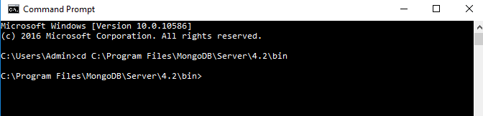

Step 4: Type command mongo this will start the mongodb shell.
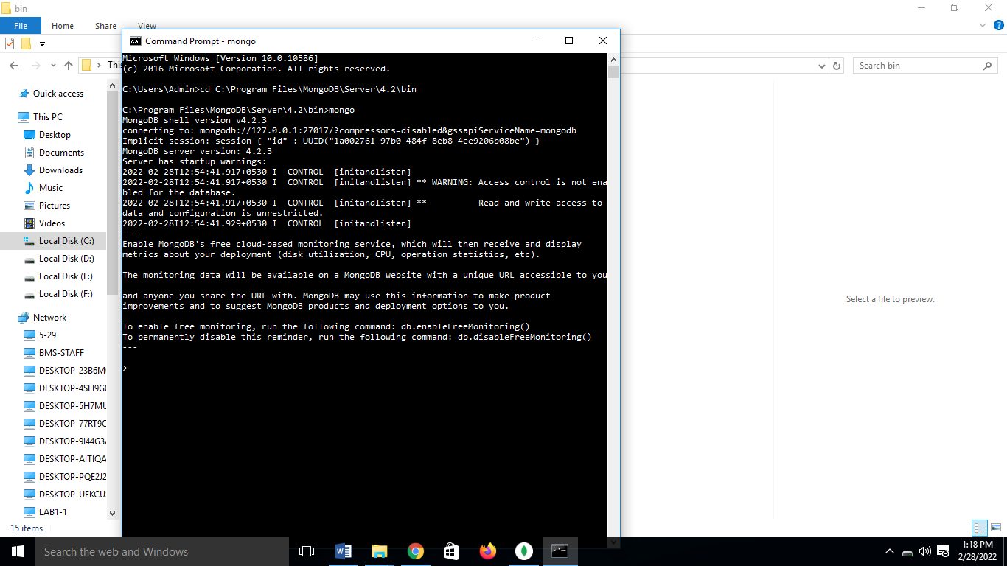

Step 5: Type following commands:
1) db - to see current database
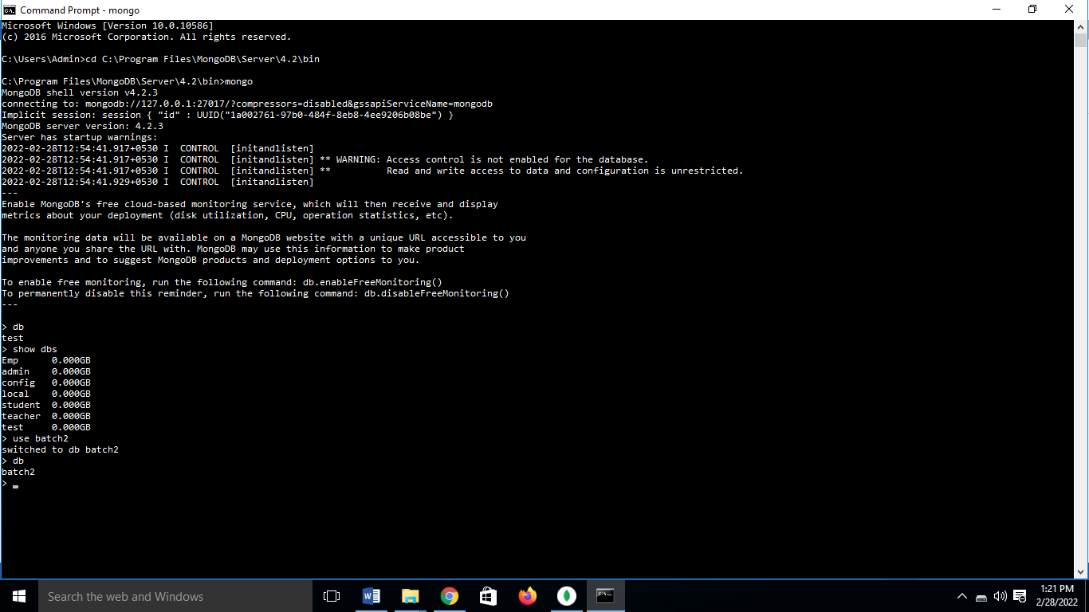
2) show dbs to display available database
3) To Create database – use database
Now current database will be batch2
If again type show dbs – it will not show name of batch2 database because data is not insert into it.
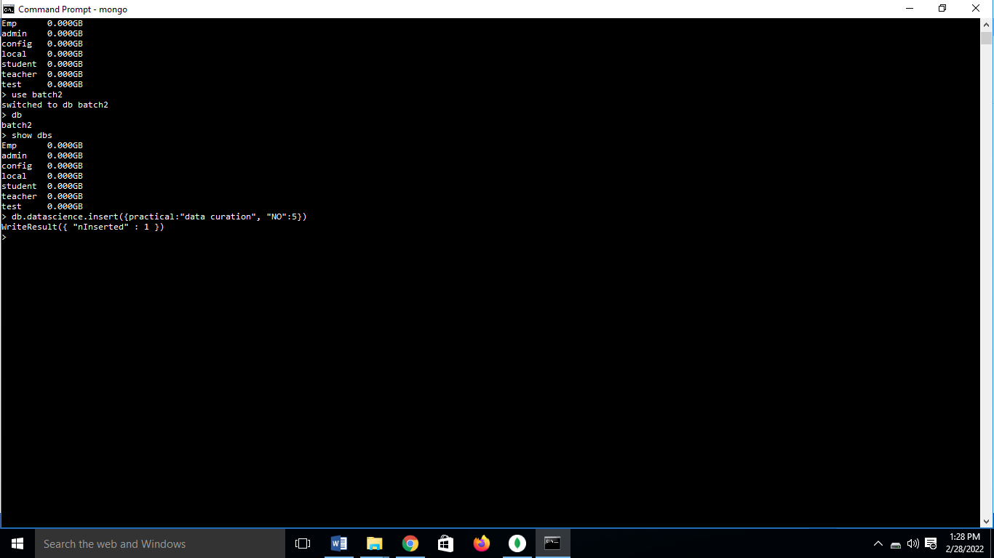
4) To create collection we can use the command “db.collection_name.insert({key_value pairs})”.

Now if you type command show dbs, this time it will show our database name.
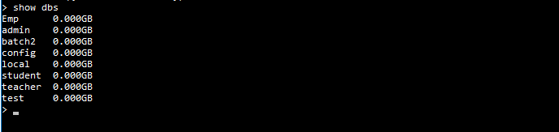

5) Drop/delete database. If we directly enter db.dropDatabse() it will delete current database.
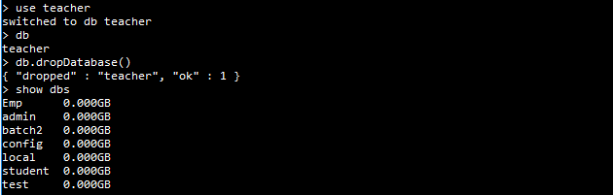
Insert data in data collection
6) To see the records within collection we can use following command: “db.collection_name.find()”.
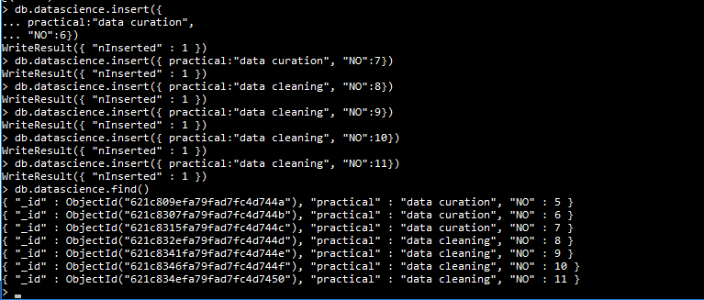
7) To create collections with options before inserting data use command “db.createCollection(“collection_name”).
8) To drop a collection we use command : “db.collection_name.drop()”.
9) To insert values into collection we use command:
“db.collection_name.insert({key_value pairs})”.
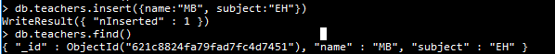

10) To display data in json format.
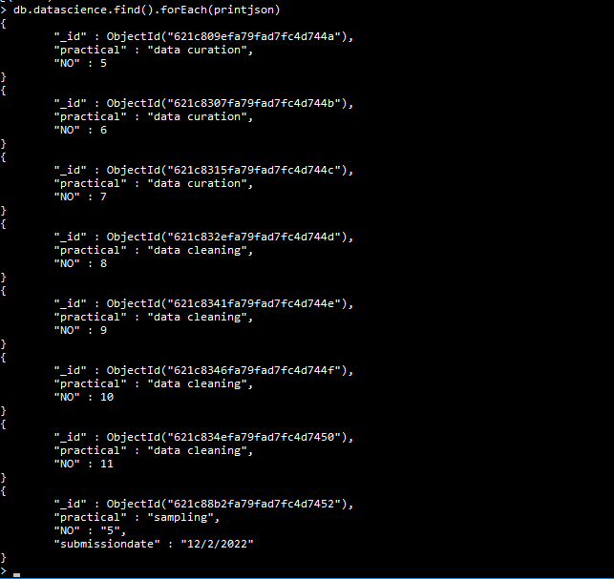

11) To fetch specific data based on criteria,
we use command: “db.collection_name.find({key-value pair}).pretty()”.
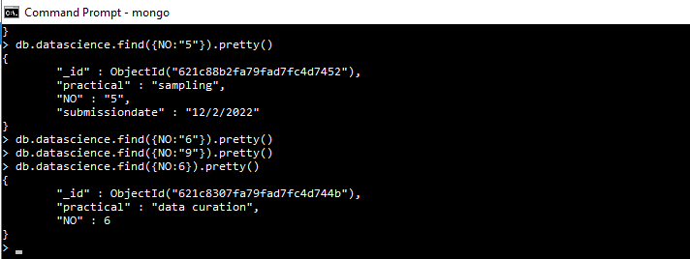
12) Greater
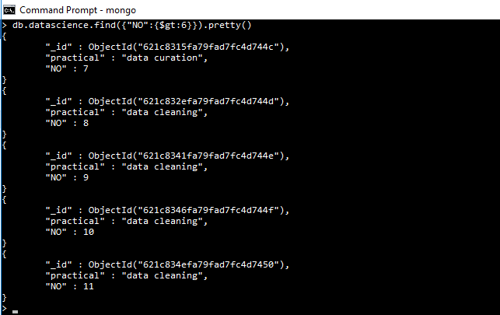
13) less
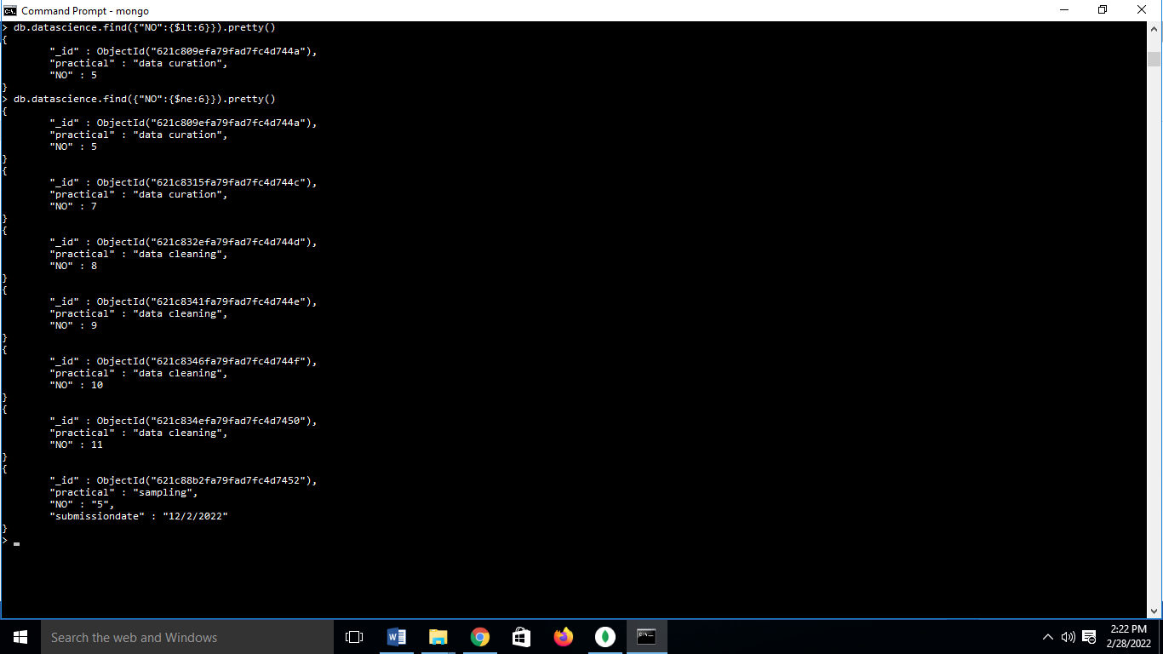

14) Not equal to

15) To update we use command: “db.collection_name.update({key_value condition}, {$set:{key-value pair}})”.
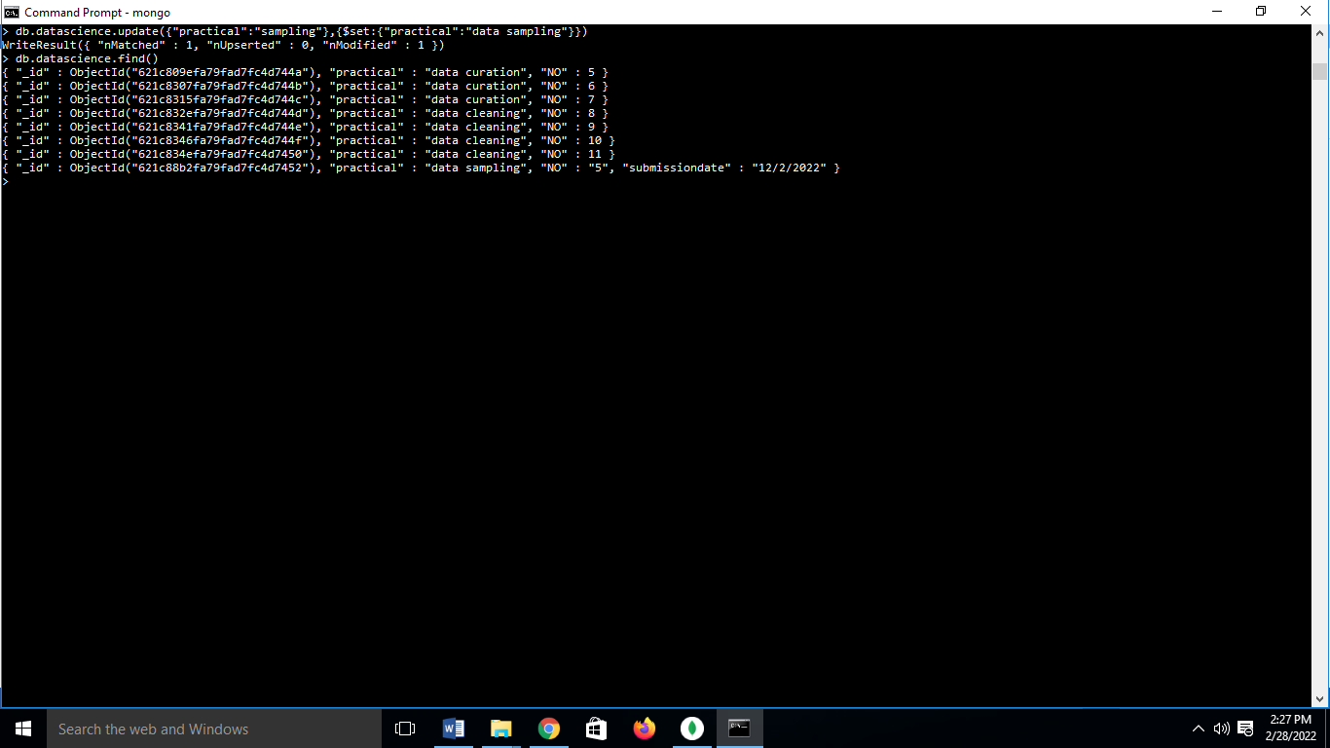
16) We can remove a record from a collection using command: “db.collection_name.remove({key-value pair condition})”.
17) To remove all the records use command: ”db.collection_name.remove({})”.
18) To insert multiple records in collection we must create an array of records and pass that array as parameter to command: “db.collection_name.insert(array_name)”.
To enter multiple data create array using - []
Var varname = [{: },{: },{: },…];
db.collection_name.insert(varname)
19) To limit records we need to use command “db.collection_name.find().limit(num_records)”.
20) To skip records use command: “db.collection_name.find().limit(num_records).skip(num_records).pretty()”.
21)To fetch a specific field

21) To sort the data: 1 will sort it in ascending order and -1 will sort it in descending order.
22) To create the index:
23) To find the index:

24) To drop the index:
25) To drop all the indexes:

