**Practical No. 7**

**Aim:** Practical of Time series analysis

1) The AirPassenger dataset in R provides monthly totals of US airline passengers, from 1949 to 1960. This dataset is already of a time series class therefore no further class or date manipulation is required.

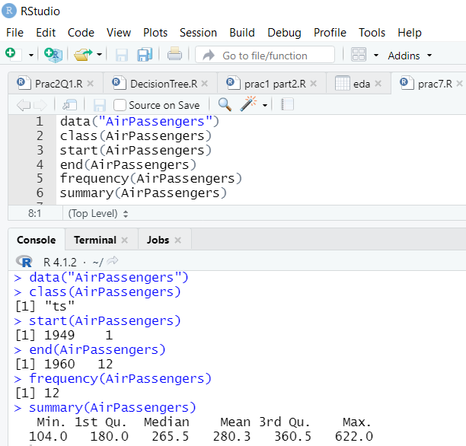

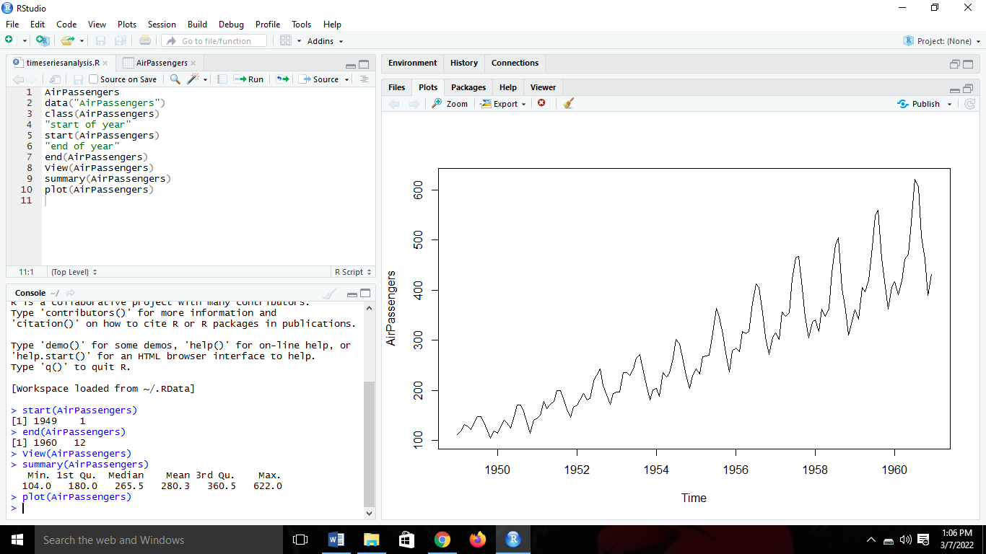

2) From the following plot we can say that the passenger numbers increase over time with each year in linear form.

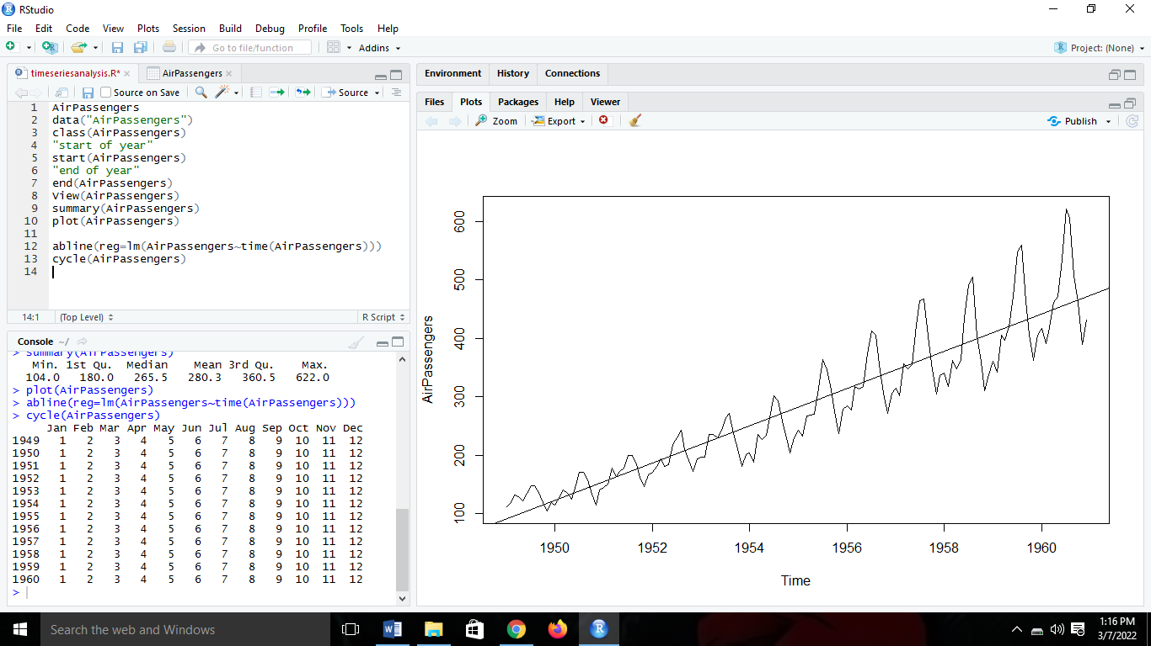

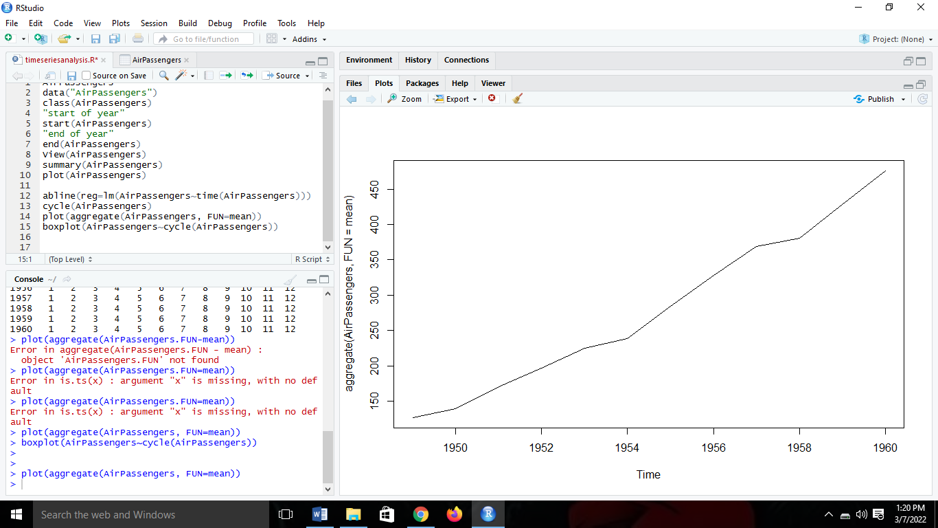



3) In the boxplot there are more passengers travelling in months 7 and 8 with higher means and higher variances than the other months.

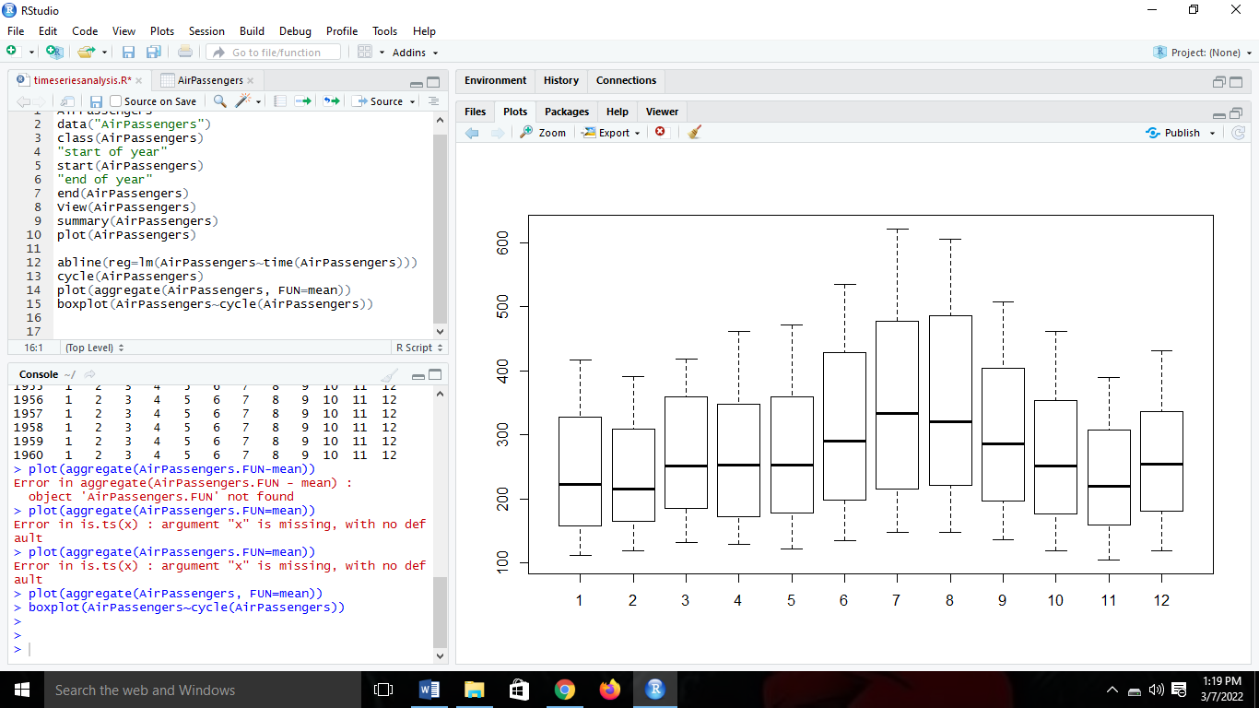



4) To make the variance stationary we will use the Autocorrelation Function (acf).

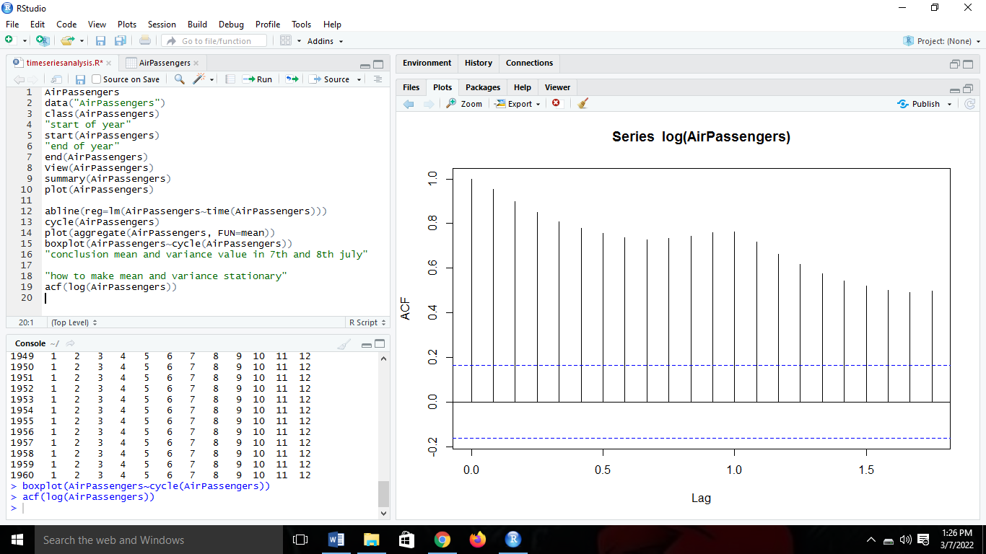



5) We can see that the acf of the residuals is centered around 0.

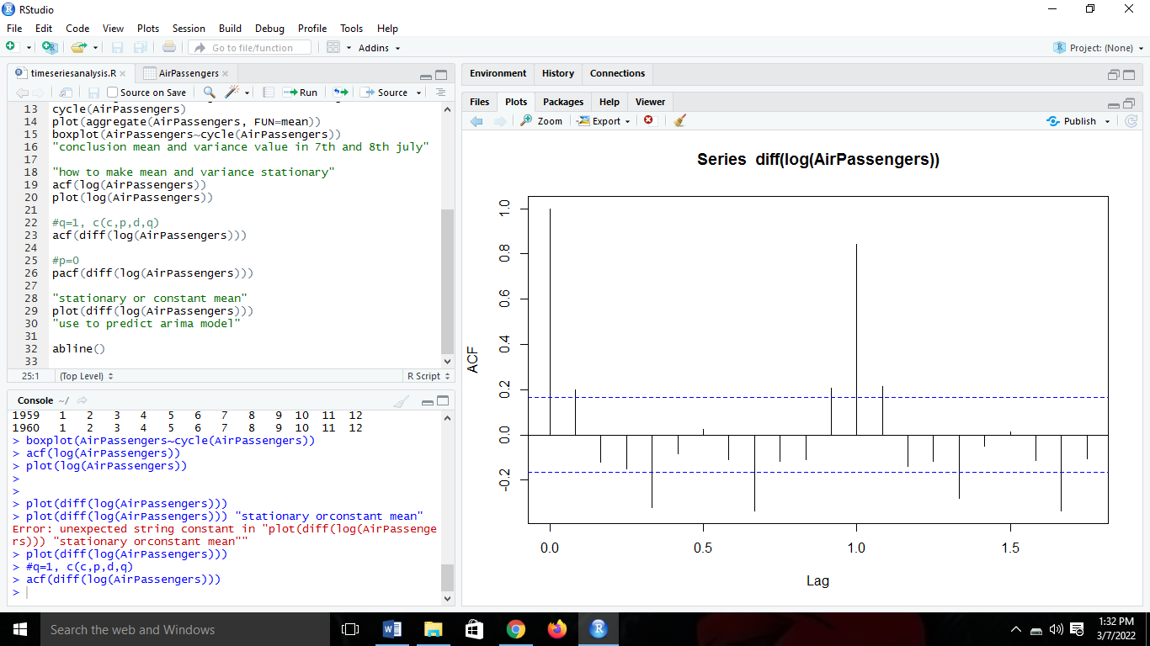



6) Partial acf(Autocorrelation Function).

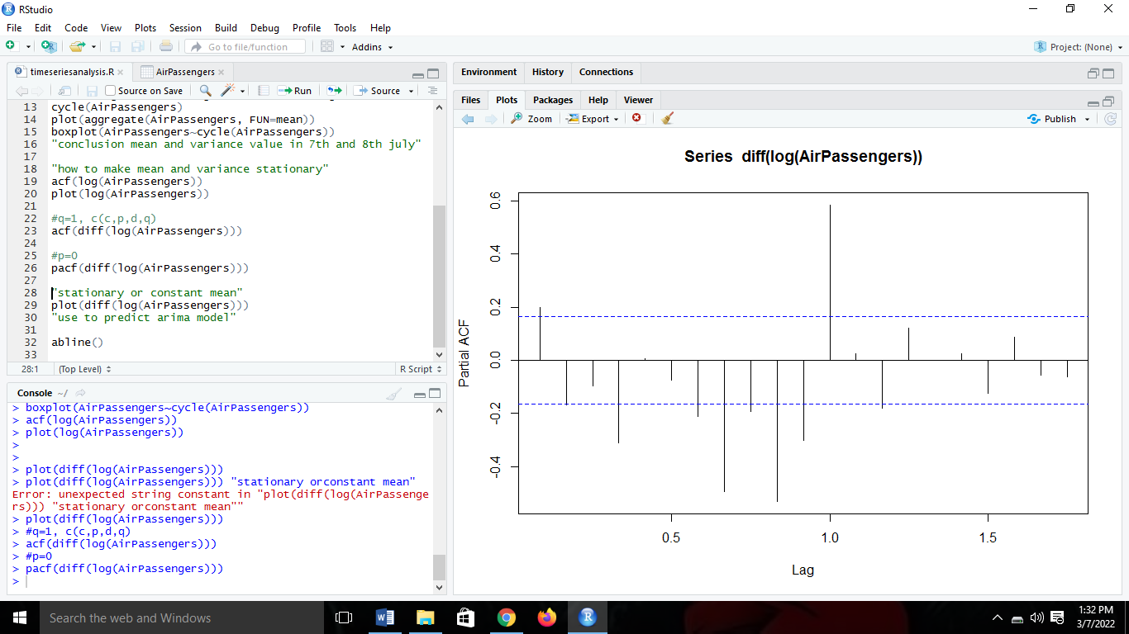



7) From the following plot we can say that the Means and variance are stationary.

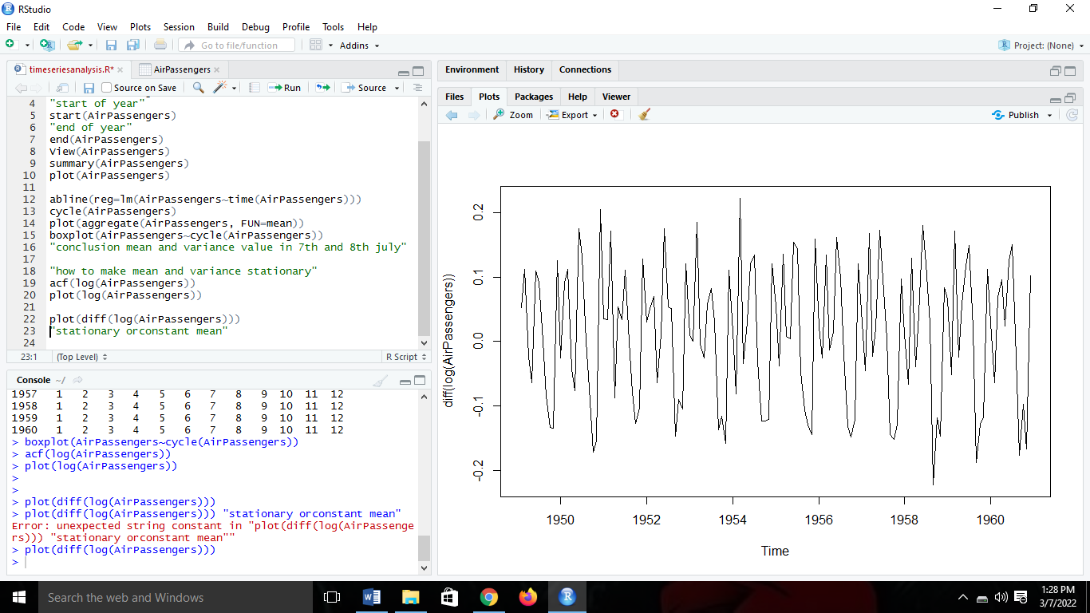



8) ARIMA Model fitting.

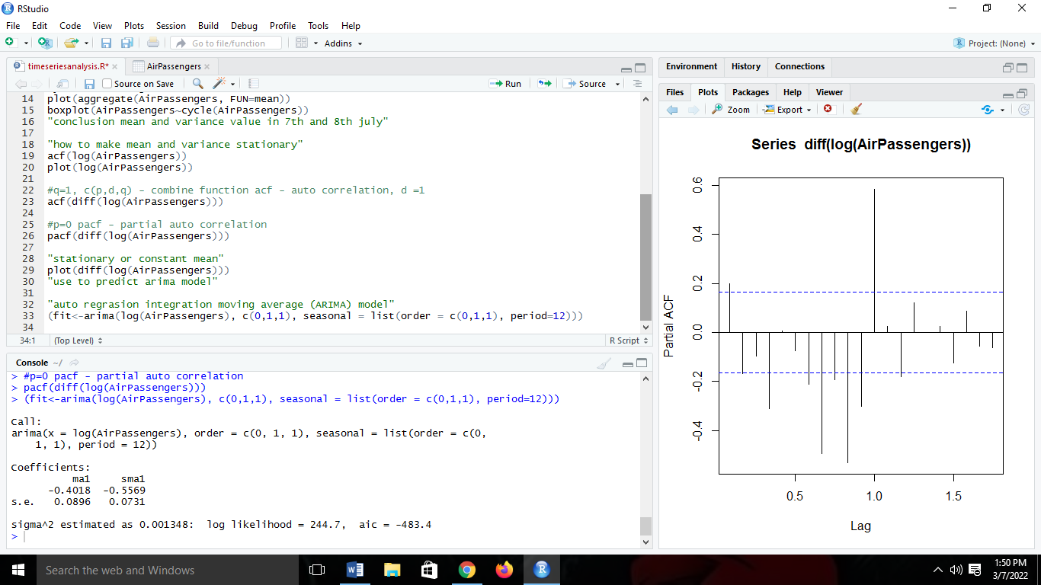

9) In the following data we can see the prediction value for the next 10 year. Which is from Year 1961 to 1970. In the graph the dotted lines represent that value is increasing in linear form for the next 10 year as well.

