# Criterion B: Design

## Part A – General Flow

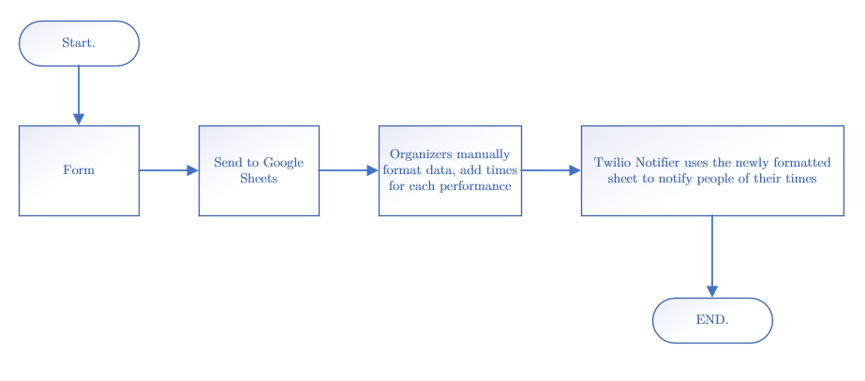

Figure 1: A general flow of my entire application.

## Part B – Web Form

|  |  |
| --- | --- |
| **INPUT DATA**   * Team Name * Email * A summary of what they're performing * Phone Number (this is important for later; make sure to ask the users to save their phone numbers as +1xxxxxxxxxx) * Category of group   + Classical Dance   + Normal Dance   + Classical Vocal   + Normal Vocal * Age group (can be one of four categories)   + Sub-junior -- up to 7 years   + Junior -- 7-12 years   + Teen -- age 13-18 years   + Adult -- age 19+ years | **EXAMPLE**   * The A Team * [example@gmail.com](mailto:example@gmail.com) * +11234567890 * Classical Dance * Sub-junior – up to 7 years |

There will be a function checking if all the responses have been filled correctly/at all; however, PRIORITIZE the phone number response; if the user fills this in wrong, the Twilio text sender will not work without me manually changing the numbers to fit the format that works for Twilio. Therefore, if a user fills out the phone number entry in the form using a form like (425)533-3641, I will ask them to fill out the form using the correct number format.

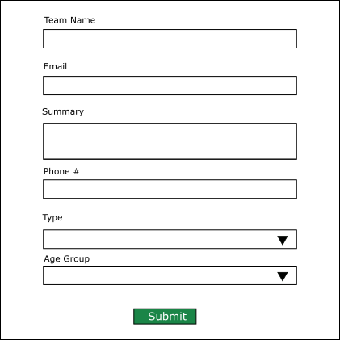In order to make the filling of the form as easy as possible, I will add some CSS to make the form easily readable and fillable.

Figure 2: A mockup of my web form

*NOTE: There will be a shadow around the black border, but I couldn’t figure out how to add it in in Inkscape.*

The Google Sheet where the FormData will be inputted into will be structured like so:

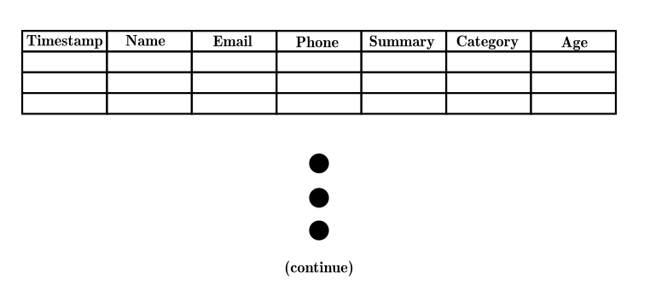

Figure 3: Spreadsheet structure for form

The processes of the web form will be like so:

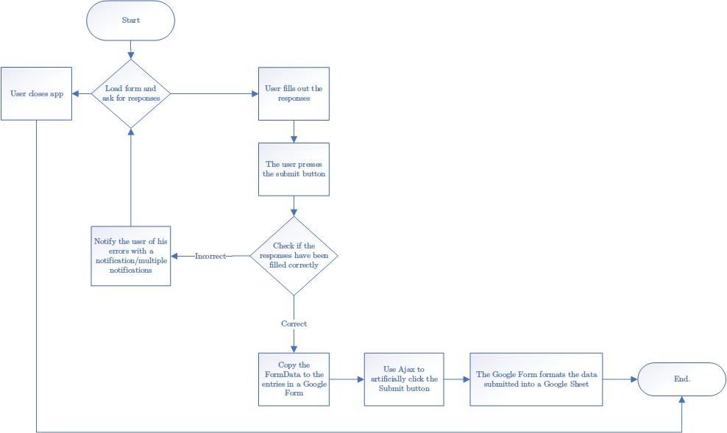

Figure 4: The process diagram for the web form

**Part C – Twilio Notifier**

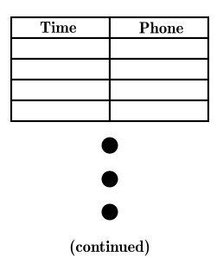The notifier will depend on a human-made spreadsheet (for now). One column will detail the times the organizers come up with for the performers, the other column will provide the phone numbers of each performers, like so:

Figure 5: An illustration of what the spreadsheet for the Twilio notifier should look like

This program will run on my machine, so there is no need to develop a front-end, unless my client would like it later. In that case, I could perhaps make a countdown until the next text sent and a display of the people who have had texts sent to.

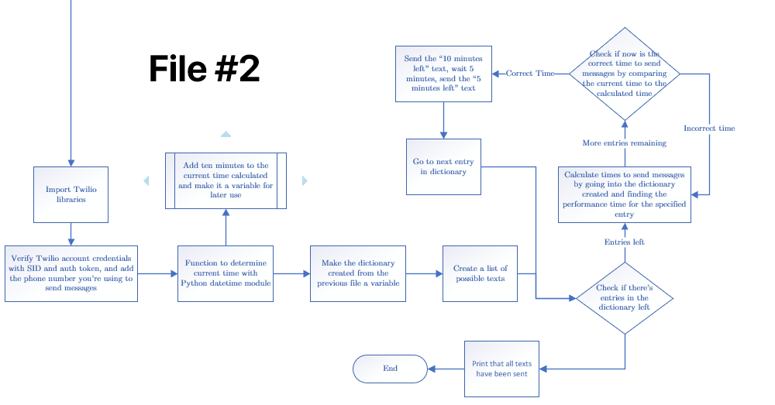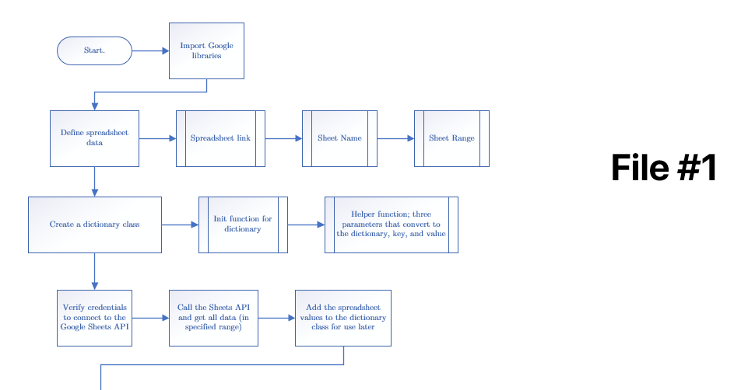

Figure 6: A flowchart for the first part of the Twilio notifier

Figure 7: A flowchart for the second part of the Twilio notifier

## Part D – Testing

|  |  |
| --- | --- |
| *Testing Action* | *Testing Result* |
| Fill out the form except for the team name | Notification should pop up saying that you forgot the team name |
| Fill out the form except for the email | Notification should pop up saying you forgot the email |
| Fill out the form but put the email incorrectly | Notification should pop up saying your email format is wrong |
| Fill out the form but don’t put enough characters in the summary | Notification should pop up asking you for information about your team |
| Fill out the form but don’t put the phone | Notification should pop up asking you to fill out the phone number |
| Fill out the form but don’t put the phone number in the correct format (+1xxxxxxxxxx) | Notification should pop up asking you to refill the phone number entry using the correct format |
| Press the submit button | Notification asking you to confirm your submission |
| Press the confirmation notification | Application should copy the form data, put it into a google form, and click the google form submit button |
| Open up Google Sheet of responses | Sheet should have all responses in the correct columns and should be easily readable. |
| Run Twilio program at a time not specified in the Google Sheet | The program should print “Waiting 60 seconds to check if it’s the correct time to send a notification…” |
| Run Twilio program at the time specified in the Google Sheet | The program should send the first message and print “Message 1 sent!”. It should then wait five minutes, send the second message, and print “Message 2 sent!” It should then go to the beginning of the loop and print “Waiting 60 seconds to check if it’s the correct time to send a notification…” |
| Run Twilio program off of a spreadsheet with only 1 entry (at the right time) | The program should go through the same steps listed in the cell above, but after it should say, “All texts sent.” |