Q1. Missing value handled by substituting the average of that particular feature in other states belonging to that particular region (class).

In case all the missing values in a particular group corresponding to a feature were missing, they were substituted by the overall mean across all states and union territories for that feature.

Q2. Top-5 states/union territories that are representative of India

1. Without normalising:

[1] "Maharashtra"

[1] "Tamil Nadu"

[1] "Uttar Pradesh"

[1] "Karnataka"

[1] "Gujarat"

1. With normalizing:

[1] "Mizoram"

[1] "Chandigarh"

[1] "Tamil Nadu"

[1] "Lakshadweep"

[1] "Meghalaya"

Q3.

|  |  |  |  |  |  |  |  |
| --- | --- | --- | --- | --- | --- | --- | --- |
|  | **nsdp_const** | **nsdp_cur** | **gdp_const** | **gdp_cur** | **growth_ rate** | **sex_ratio** | **child_sex_ ratio** |
| **nsdp_const** | 1.000 | 0.999 | 1.000 | 1.000 | 0.030 | -0.061 | -0.285 |
| **nsdp_cur** | 0.999 | 1.000 | 0.999 | 1.000 | 0.018 | -0.052 | -0.284 |
| **gdp_const** | 1.000 | 0.999 | 1.000 | 0.999 | 0.034 | -0.064 | -0.283 |
| **gdp_cur** | 1.000 | 1.000 | 0.999 | 1.000 | 0.022 | -0.054 | -0.283 |
| **growth_rate** | 0.030 | 0.018 | 0.034 | 0.022 | 1.000 | -0.540 | 0.109 |
| **sex_ratio** | -0.061 | -0.052 | -0.064 | -0.054 | -0.540 | 1.000 | 0.482 |
| **child_sex_ratio** | -0.285 | -0.284 | -0.283 | -0.283 | 0.109 | 0.482 | 1.000 |
| **dropout_rate** | -0.355 | -0.358 | -0.355 | -0.359 | 0.228 | -0.038 | 0.430 |
| **enrolment_ratio** | -0.349 | -0.349 | -0.349 | -0.348 | -0.238 | 0.205 | 0.087 |
| **enrolment_ratio_h** | -0.193 | -0.185 | -0.194 | -0.186 | -0.228 | 0.197 | 0.019 |
| **literacy_rate_7** | -0.069 | -0.075 | -0.067 | -0.072 | -0.183 | 0.110 | 0.081 |
| **toilet_boy** | 0.465 | 0.472 | 0.461 | 0.469 | -0.108 | 0.219 | -0.241 |
| **toilet_girl** | 0.466 | 0.472 | 0.462 | 0.469 | -0.017 | 0.223 | -0.160 |
| **drinking_water** | 0.464 | 0.467 | 0.461 | 0.465 | 0.007 | 0.156 | -0.237 |
| **electricity** | 0.541 | 0.540 | 0.539 | 0.539 | 0.062 | 0.021 | -0.348 |
| **computer** | 0.352 | 0.344 | 0.353 | 0.346 | 0.062 | 0.001 | -0.243 |

|  |  |  |  |  |  |  |  |  |  |
| --- | --- | --- | --- | --- | --- | --- | --- | --- | --- |
|  | **dropout_ rate** | **enrolment_ratio** | **enrolment_ ratio_highr** | **literacy_ rate_7** | **toilet_boy** | **toilet_girl** | **drinking_ water** | **electricity** | **computer** |
| **nsdp_const** | -0.355 | -0.349 | -0.193 | -0.069 | 0.465 | 0.466 | 0.464 | 0.541 | 0.352 |
| **nsdp_cur** | -0.358 | -0.349 | -0.185 | -0.075 | 0.472 | 0.472 | 0.467 | 0.540 | 0.344 |
| **gdp_const** | -0.355 | -0.349 | -0.194 | -0.067 | 0.461 | 0.462 | 0.461 | 0.539 | 0.353 |
| **gdp_cur** | -0.359 | -0.348 | -0.186 | -0.072 | 0.469 | 0.469 | 0.465 | 0.539 | 0.346 |
| **growth_rate** | 0.228 | -0.238 | -0.228 | -0.183 | -0.108 | -0.017 | 0.007 | 0.062 | 0.062 |
| **sex_ratio** | -0.038 | 0.205 | 0.197 | 0.110 | 0.219 | 0.223 | 0.156 | 0.021 | 0.001 |
| **child_sex_ratio** | 0.430 | 0.087 | 0.019 | 0.081 | -0.241 | -0.160 | -0.237 | -0.348 | -0.243 |
| **dropout_rate** | 1.000 | -0.259 | -0.065 | -0.335 | -0.279 | -0.194 | -0.154 | -0.534 | -0.494 |
| **enrolment_ratio** | -0.259 | 1.000 | 0.517 | 0.536 | -0.278 | -0.348 | -0.434 | -0.096 | 0.000 |
| **enrolment_ratio_h** | -0.065 | 0.517 | 1.000 | 0.277 | -0.139 | -0.174 | -0.293 | 0.058 | 0.071 |
| **literacy_rate_7** | -0.335 | 0.536 | 0.277 | 1.000 | -0.249 | -0.356 | -0.487 | 0.176 | 0.431 |
| **toilet_boy** | -0.279 | -0.278 | -0.139 | -0.249 | 1.000 | 0.951 | 0.849 | 0.658 | 0.453 |
| **toilet_girl** | -0.194 | -0.348 | -0.174 | -0.356 | 0.951 | 1.000 | 0.904 | 0.673 | 0.388 |
| **drinking_water** | -0.154 | -0.434 | -0.293 | -0.487 | 0.849 | 0.904 | 1.000 | 0.561 | 0.265 |
| **electricity** | -0.534 | -0.096 | 0.058 | 0.176 | 0.658 | 0.673 | 0.561 | 1.000 | 0.799 |
| **computer** | -0.494 | 0.000 | 0.071 | 0.431 | 0.453 | 0.388 | 0.265 | 0.799 | 1.000 |

Conclusion:

Economy – All the four variables are extremely highly correlated (correlation > 0.999) among themselves. Therefore if we were to select feature naively based on just correlations without further analysis, it would be wise to select one of these four features viz. nsdp_const, nsdp_cur, gdp_const, gdp_cur, as they are highly representative of each other. Moreover, all other features have approximately the same correlation with these four features.

Demography – We see a moderately negative correlation between sex_ratio and growth_rate while a slight positive correlation between child_sex_ratio which might be indicative of female feticide in the recent past in places where the growth rate is high but a recent change in the conditions thereby improving the sex ratio in childs, maybe due to drives undertaken to curb the problem of female feticide thereby educating new younger parents.

Education – Features representing facilities in schools such as toilets, drinking water, electricity and computers are moderately positively correlated among themselves which should be quite obvious.

Q4. Using multiclass relief algorithm, we got the following results:

Economy:

nsdp_const **nsdp_cur** gdp_const **gdp_cur**

-0.006396032 0.006762507 -0.008579350 0.005273463

Demography:

**growth_rate** sex_ratio **child_sex_ratio**

0.05349169 0.04747105 0.16283239

Education:

dropout_rate **enrolment_ratio** enrolment_ratio_h

-0.16429372 0.07727160 -0.04787824

literacy_rate_7 toilet_boy toilet_girl

-0.44605781 -0.13081380 -0.22768003

drinking_water electricity **computer**

-0.30363478 -0.08183553 0.10566383

Across categories:

nsdp_const **nsdp_cur** gdp_const

0.22657712 0.23464358 0.22373391

**gdp_cur**  growth_rate sex_ratio

0.23285845 0.08475644 0.04331105

child_sex_ratio dropout_rate enrolment_ratio

0.17498036 0.03714870 0.01392531

enrolment_ratio_h literacy_rate_7 toilet_boy

0.10687115 -0.02315977 0.01443851

toilet_girl drinking_water electricity

-0.00863802 -0.01882878 0.05312635

computer

0.03300127

Across categories (after removing highly correlated variables)

**gdp_cur** growth_rate **child_sex_ratio**

0.264311035 0.067028271 0.165895347

dropout_rate enrolment_ratio electricity

0.038764105 -0.002362554 0.057691158

Q5. Scatter Plots

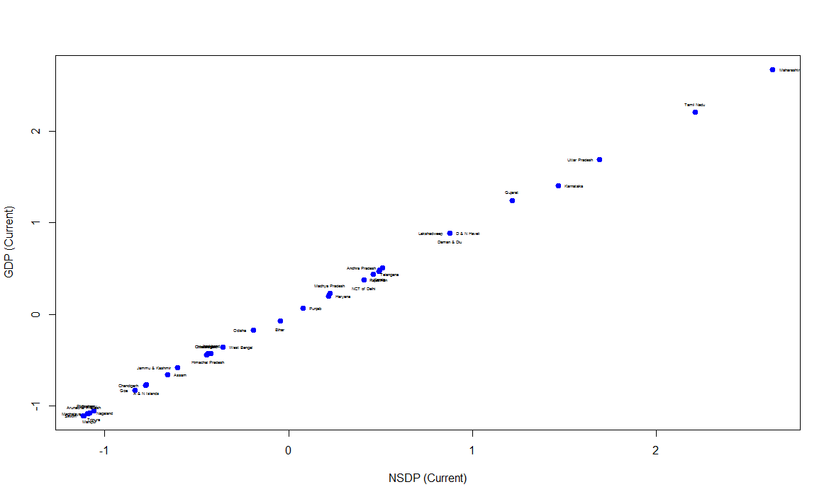

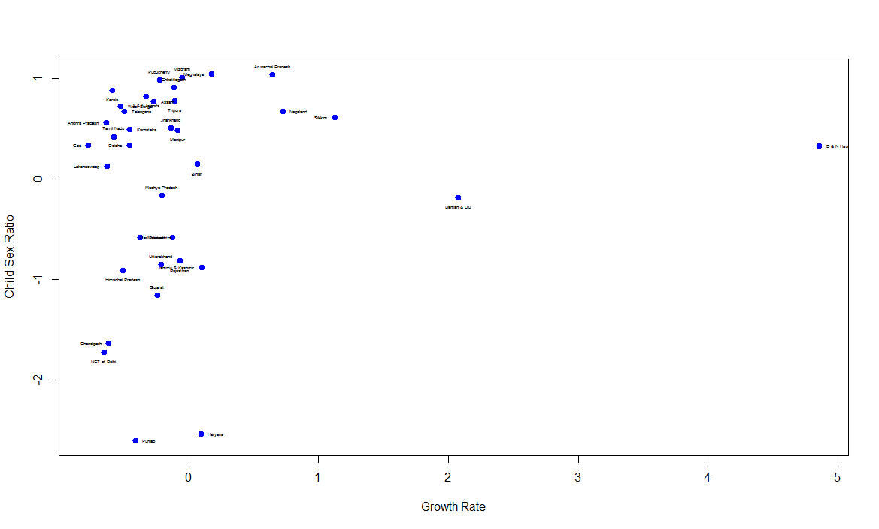

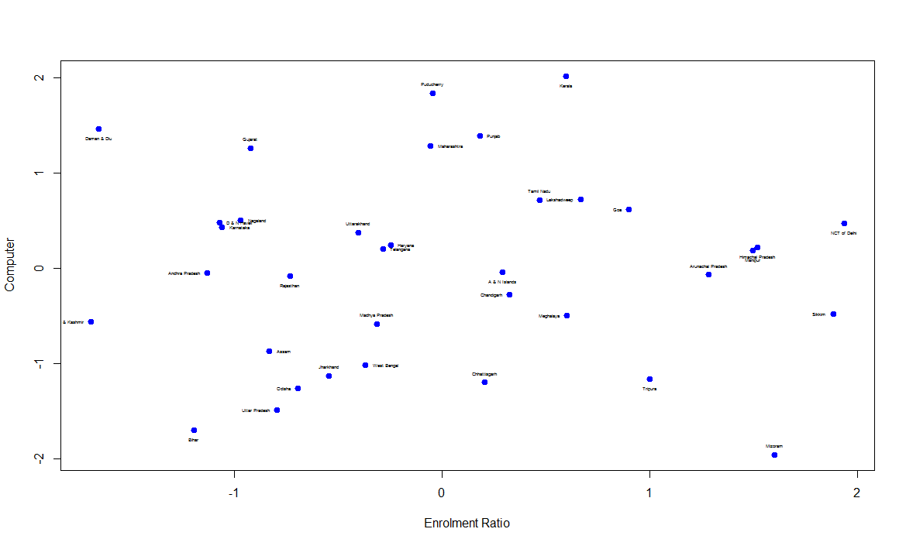 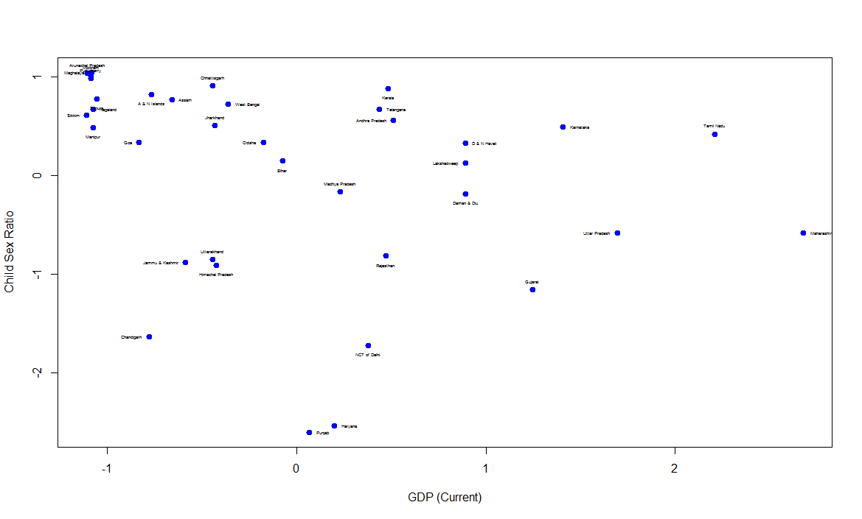

Quantile-quantile plots

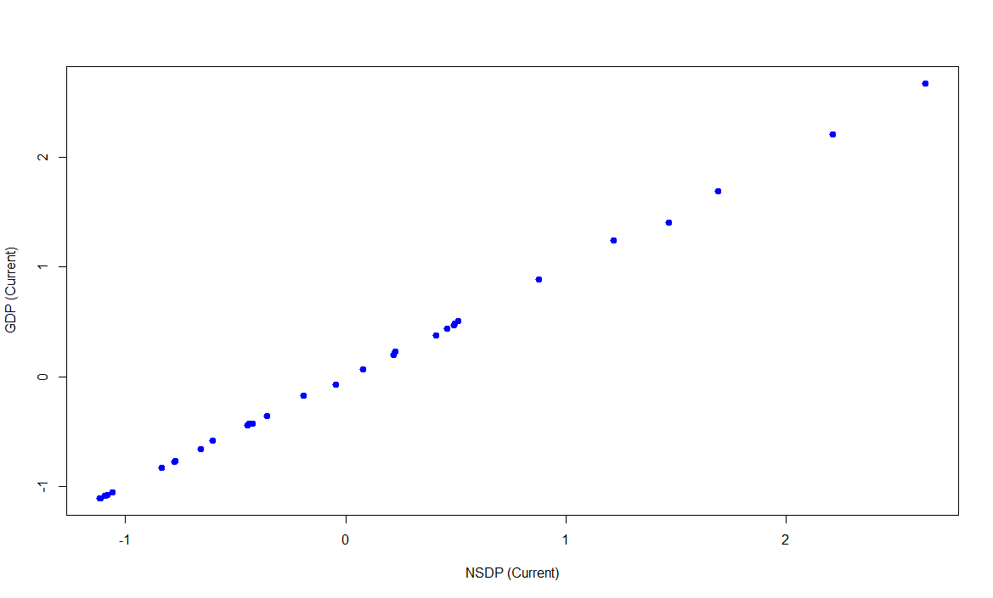

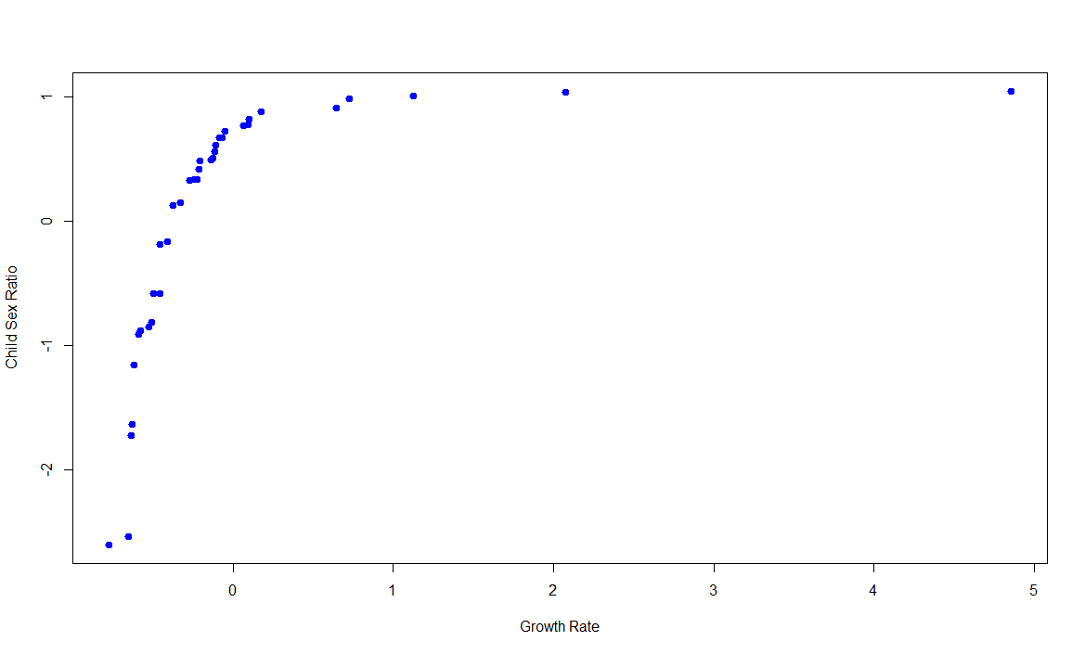

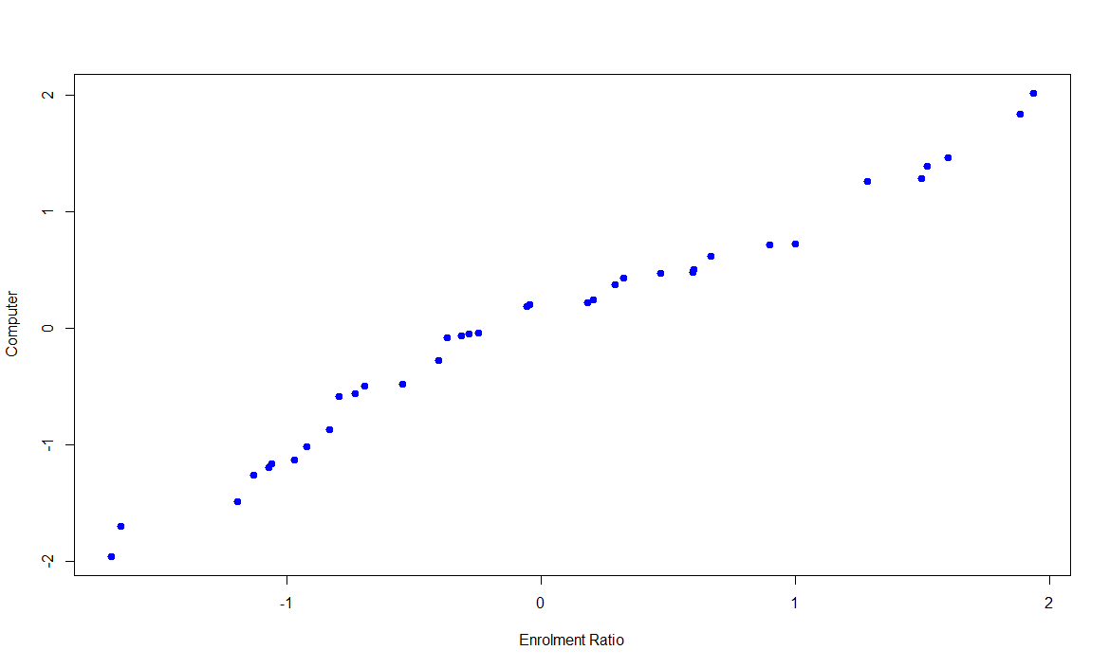

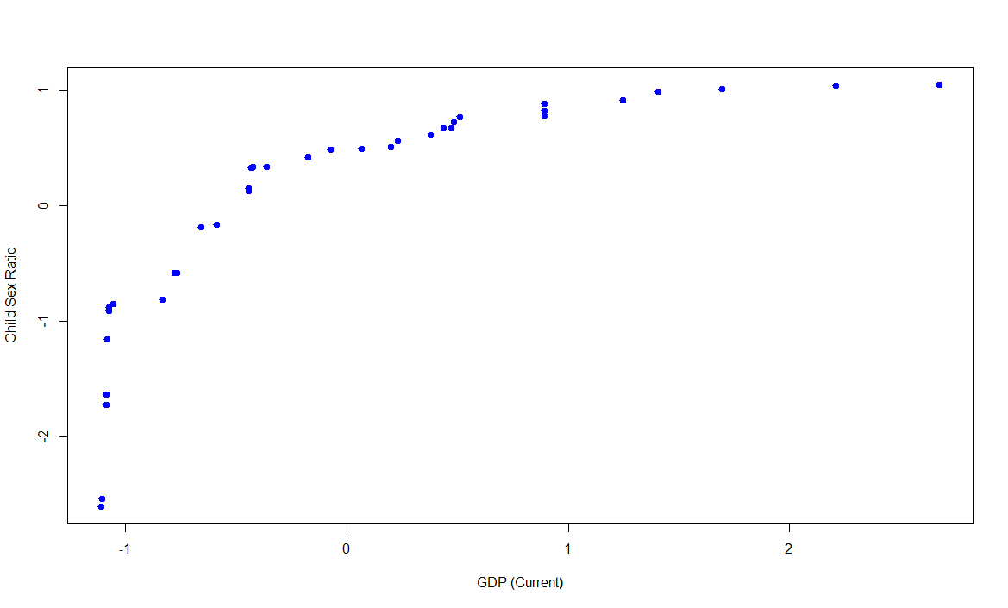

Q6. Intuitive Partitioning

gdp_cur:

5th percentile: 19405 = low

95th percentile: 818216 = high

Minimum: 14523

Maximum: 1040211

Rounding yields low’ = 0, high’ = 840000

1st level (4) partitions: (1, 210000), (210001, 420000), (420001, 630000), (630001, 840000)

Since max > high’, new interval: (840001, 1050000)

2nd level partitions: (1, 70000), (70001, 140000), … (770001, 840000) and (840001, 1050000)

child_sex_ratio

5th percentile: 849 = low

95th percentile: 967 = high

Minimum: 822

Maximum: 969

Rounding yields low’ = 800, high’ = 1000

1st level (4) partitions: (800, 850), (851, 900), (901, 950), (951, 1000)

1st interval adjusted to (822, 850)

2nd level partitions: (822, 840), (841, 850), (851, 860) … (961, 970)