Appendix:

Embedded Scientific Application Partnership (SAP) Proposals

in the Accelerator Community Code Development and Discovery project

The UPIC Framework
Victor Decyk (UCLA)

HEP Accelerators and the Applied Partial Differential Equations Center (APDEC)
Phil Colella (LBNL)

High Performance Parallel Data Management and Analysis Tools for Beam Dynamics Modeling

Cristina Siegerist, E. Wes Bethel (LBNL)

Advanced Visualization Methods for Accelerator Modeling

Kwan-Liu Ma (University of California at Davis)

Quantitative Visualization Applied to Accelerator Physics

James Ahrens (LANL)

Computational Quality-of-Service Enabled Beam Dynamics Modeling
Doug Dechow (Tech-X Corporation); Lois Curfman McInnes, Boyana Norris (ANL)

SAP Proposal: The UPIC Framework
Victor Decyk (UCLA)

Physics Collaborators: Warren Mori (UCLA), Rob Ryne (LBNL)

Prior Accomplishments. We investigated the applicability of design patterns for scientific
programming in Fortran95. We determined that some are very useful in building and interfacing between complex codes, and we implemented a number of useful patterns in Fortran95. A paper has been prepared for publication [Decyk06, Decyk97]. We also added new capabilities to the UPIC Framework [Decyk04]: (1) we added dynamic load balancing for 2D and 3D codes using dimension – 1 decompositions; (2) we implemented open boundary conditions in 3D and designed a simple interface to incorporate a parallel plasma component using this solver into MaryLie; and (3) we implemented fast sine and cosine transforms for Dirichlet boundary conditions. These enhancements improve the field solver in QuickPIC [Huang06], which dominates many calculations.

Proposed Work:
Motivation. The major use of the UPIC Framework for this project is to support electron cloud and advanced accelerator modeling through the QuickPIC code. We intend in this proposal to improve QuickPIC’s single node performance, possibly by as much as a factor of 10, and its parallel scalability by another factor of 50. Currently, single node performance is dominated by the data transpose in the global Poisson solver, which is FFT based. The performance suffers from short messages that are latency dominated.

Approach. To improve the latency, we intend to combine multiple single FFTs in to one multi-dimensional FFT and to introduce a mixed shared/distributed programming model to have fewer but larger messages. In addition, some of the FFTs can be eliminated and replaced by local finite-differences. For scalability, the most important new capability needed to improve performance is to support pipelining, where different time steps can be running simultaneously. This work should allow QuickPIC to scale to 1000 nodes. Beyond 1000 nodes, benchmarks with the framework indicate that the major component needing improvement is the particle manager, which has been developed to handle very general situations that rarely occur. We will develop a special variant of the particle manager that optimizes the most general case. In addition, to effectively utilize more than 1000 processors, careful attention must be paid to small deviations from load balancing.
To enhance the general usability of the UPIC Framework, other types of solvers will also be added to UPIC (and hence to QuickPIC) In particular, we will collaborate with APDEC in coupling AMR capabilities. Finally, we will leverage expertise in parallel particle codes for beam dynamics codes as well as software engineering in Fortran95 to help in the integration of other codes that use Fortran95.

Impact. This work will improve the efficiency and scalability of the UPIC Framework (and QuickPIC code) as well as increase overall capabilities via interoperability with complementary tools. These enhancements will facilitate higher fidelity accelerator simulations.

SAP Proposal: The UPIC Framework (cont.)

Milestones:
Year 1:
- Optimize single-node performance of QuickPIC.
- Develop a pipeline plasma wakefield acceleator version of QuickPIC.
- Integrate the parallel plasma component into MaryLie.
Year 2:
- Develop pipelined e-cloud and laser wakefield accelerator versions of QuickPIC.
- Improve particle manager and FFT by implementing a mixed shared/distributed memory version of important subroutines; this work should allow scaling beyond 1000 nodes.
- Integrate the AMR-PIC capabilities developed by APDEC and LBL into the UPIC Framework and QuickPIC.
Year 3:
- Implement more precise load balancing in the UPIC Framework with the goal of achieving scalability to 10,000 processors.

Year 4:
- Improve performance sufficiently to allow real time modeling of experiments.

Year 5:
- Run effectively and reliably on 10,000 processors. Determine bottlenecks, if any, for 100,000 processors.

References:

[Decyk06] V. K. Decyk and H. Gardner, Object-oriented design patterns in Fortran95, 2006, available via http://exodus.physics.ucla.edu/Fortran95/FortranPatterns.pdf , submitted to Computing in Science and Engineering.

[Decyk97] V. K. Decyk, C. D. Norton, and B. K. Szymanski, How to express C++ concepts in Fortran90, Scientific Programming, vol. 6, No. 4, IOS Press, Winter 1997, p. 363.

[Decyk04] V. K. Decyk and C. D. Norton, UCLA parallel PIC framework, Computer Phys. Comm. 164, 80 (2004).

[Huang06] C. Huang, V. K. Decyk, C. Ren, M. Zhou, W. Lu, and W. B. Mori, QuickPIC: A highly efficient particle-in-cell code for modeling wakefield acceleration in plasmas, accepted by J. Computational Phys., 2006.

SAP Proposal: HEP Accelerators and the Applied Partial Differential Equations Center (APDEC)
Phil Colella (LBNL)
Physics Collaborator: Rob Ryne (LBNL)

Prior Accomplishments. We developed new AMR-PIC algorithms for solving the Vlasov-Poisson equations. To eliminate problems we discovered regarding the generation of large self-forces generated by particles near refinement boundaries [Vay04] for standard discretizations of the boundary conditions, we used instead the newly-developed MLC solvers [McCorquodale05,McCorquodale06] to eliminate this effect. A prototype version of this capability has been introduced into the MLI beam dynamics code developed under SciDAC-1. We also developed a preliminary version of the embedded boundary compressible Navier-Stokes capability that we will use for the work on hydrodynamic modeling of capillary discharges in SciDAC-2, described below, and are in the process of validating it against gas-jet experimental data obtained by the L'Oasis group at LBNL.

Proposed Work:

Motivation. The development of new simulation tools based on adaptive mesh refinement will substantially improve the fidelity and capability of simulations of plasma-wakefield accelerators.

Approach. The APDEC Center for Enabling Technology will collaborate with the ACCDD project to develop adaptive mesh refinement tools for simulating various problems arising in the design of plasma-wakefield accelerators.

(1) We will use the embedded-boundary methods developed by APDEC under SciDAC-1 to develop multidimensional hydrodynamic models of capillary discharges [Broks05], where one or more of the parameters (radius, gas density, etc.) are varying along the length of the capillary tube. This will enable experimental designers to carefully tailor the resulting radial and axial plasma density profiles and optimize performance.

(2) We will develop AMR-PIC capabilities for modeling the laser-plasma interaction. Initially, this will involve the coupling of the existing electrostatic AMR-PIC capabilities to reduced particle models such as QuickPIC. Later in the project, we will develop AMR-PIC capabilities for full electromagnetic (Maxwell-Vlasov) problems. We will also develop high-performance fluid-Maxwell models, based on the models used by Shadwick [Shadwick02]. The new codes will provide parallel AMR versions of the existing models, thus permitting a far higher resolution and faster throughput in such calculations.

These activities will extend over the entire five-year course of SciDAC-2; APDEC will work with a postdoctoral researcher to be funded by the SAP to develop the codes described above.

Impact. The development and use of AMR-PIC methods and AMR for fluid-Maxwell models will increase the efficiency of those simulations by an order of magnitude or more, while the simulation capability for compressible flow in capillary tubes is one that is not otherwise available to this community.

SAP Proposal: HEP Accelerators and APDEC (cont.)

Milestones:

Year 1:
- Develop a compressible Navier-Stokes solver based on the AMR embedded boundary methods for capillary discharges and validate against experimental data.
- Develop an AMR-PIC suitable for use in QuickPIC.

Year 2:
- Develop an AMR fluid-Maxwell simulation capability for laser-plasma interactions.

Year 3:
- Develop an AMR Maxwell's equation solver without trapped-wave effects.
- Enhance performance of the electrostatic AMR-PIC, fluid-Maxwell modeling capabilities.

Year 4:
- Develop a prototype AMR-PIC method for Maxwell-Vlasov.

Year 5:
- Enhance performance of AMR-PIC method for Maxwell-Vlasov.

References:

[Vay04] J.-L. Vay, P. Colella, A. Friedman, D. P. Grote, P. McCorquodale, and D. B. Serafini, Implementations of mesh refinement schemes for particle-in-cell plasma simulations, Computer Physics Communications vol. 164, pp. 297-305, 2004.

[McCorquodale05] P. McCorquodale, P. Colella, G. Balls, and S. B. Baden, A scalable parallel Poisson solver with infinite domain boundary conditions, Proceedings of the 7th Workshop on High Performance Scientific and Engineering Computing, Oslo, Norway, June 14-17, 2005.

[McCorquodale06] P. McCorquodale, P. Colella, G. T. Balls, and S. B. Baden, An adaptive parallel poisson solver in three dimensions with infinite-domain boundary conditions, in preparation for the Journal of Computational Physics, 2006.

[Broks05] Broks, Garloff, and Van der Mullen, Phys Rev. E vol. 71 016401 (2005).

[Shadwick02] Shadwick, Turkington, Esarey, and Leemans, IEEE Transations on Plasma Science, vol. 30, No. 1, February 2002, pp. 38-39.

SAP Proposal: High Performance Parallel Data Management and Analysis Tools for Beam Dynamics Modeling

Cristina Siegerist, E. Wes Bethel (LBNL)
Physics Collaborators: Rob Ryne, Cameron Geddes, Eric Esarey, Ji Qiang (LBNL); Andreas Adelmann (PSI)

Prior Accomplishments. This SAP project continues an existing software engineering collaboration between the LBNL Visualization Group, the SciDAC Scientific Data Management Center, and the accelerator modeling community that produced the file format called “H5Part” [Adelmann05a, Adelmann05b, Co05, H5Parta Adelmann05a, H5Parta]. H5Part is a “veneer API” that provides a simple, easy-to-use interface to the HDF5 data I/O library [HDF5]. It has been integrated into two beam-dynamic codes thus far.

Proposed Work:

Motivation. Creating and deploying a defacto data input/output (I/O) storage format standard will benefit the accelerator modeling community by: (1) fostering interoperability of the community’s software infrastructure, particularly data analysis and visualization applications, (2) enabling high-performance, parallel I/O on modern computational platforms, (3) promoting data and software sharing across the disparate groups that comprise the community. Data I/O and formats are an integral and fundamental part of the project’s overall objective to create comprehensive computational infrastructure.

Approach. As mentioned above, H5Part is a “veneer API” that provides a simple, easy-to-use interface to the HDF5 data I/O library [HDF5]. This approach effectively insulates the application from changes in the underlying file format as it matures and is engineered for better performance and new capabilities. H5Part is written in a very flexible manner to easily accommodate new elements like structured grids and unstructured meshes. H5Part provides scalable parallel I/O for beam dynamics codes written in C, C++, and Fortran, supports platform transparency, and simplifies access to data files via mainstream visualization tools like VisIT and AVS/Express. FastBit bitmap indexing technology will be incorporated into H5Part to accelerate complex out-of-core range queries on enormous HDF5 datasets [Gosink05, Stockinger05a, Stockinger05b, DEX].

The very first task of this project is to collect data storage requirements from the code development teams in order to define a data schema that completely represents the computational meshes and any important metadata associated with a simulation run. It is important to point out that the file format is tailored for this community of scientists so as to restrict the scope of development – a bottom-up effort. It is not intended to be a broad top-down effort that solves data storage and modeling problems for multiple science communities – we are focused on common requirements of PIC codes used for beam-dynamics simulations.

Impact. A unified and stable file format facilitates interoperability across disparate research groups with different simulation implementations by allowing them to share data and software analysis tools. The file format is transparently portable across different machine architectures. The HDF5 and H5Part libraries are very portable – capable of building on a wide variety of computing platforms. H5Part will leverage years of performance tuning effort by the HDF5 group on ASCI platforms to deliver scalable parallel I/O performance to a broad range of accelerator modeling codes – thereby reducing development time and code maintenance for application groups. Finally, fast bitmap indexing will complement the capabilities of existing visualization and data analysis tools by allowing the scientist to pose complex range queries to focus the data analysis on subsets of the particles.

SAP Proposal: High Performance Parallel Data Management and Analysis Tools for Beam Dynamics Modeling Applications (cont.)

Milestones:

Year 1:
- Continue to document and refine the H5Part interface API (see [H5parta] and [H5Partb] for current documentation).
- Allocate one-on-one time with code users to ensure H5Part works efficiently with their codes and meets all of their application requirements.
- Work with the application groups to "normalize" the naming convention for the fields stored in the HDF5 file to reflect a community-wide consensus.

Year 2:
- Expand API scope to store additional attributes, such as the "input deck" and "src tarball" of the simulation that produced the results.
- Develop software and release engineering to simplify compilation on commonly used platforms.
- Continue development of new H5part readers for various visualization applications: IDL, Matlab, VisIt, ParaView.
- Engineer data format converters.

Year 3:
- Add data analysis features derived from external research projects to the H5Part format, such as FastBit accelerated range queries on large datasets.
- Support expanded remote data access via a client-server remote data interface that can push most of the data analysis capabilities into the parallel back-end. This capability has been demonstrated in the PartView [Adelmann05b] research prototype, which will be hardened for full production use.

Years 4-5:
- In the later years of the project, effort formerly focused on baseline I/O infrastructure research and development will be migrated to maintenance, performance and release engineering. The visualization and analysis effort will then enter a new stage of growth that leverages the presence of a stable data model that enables to shift the focus to the developing the statistical methods and algorithms to locate and classify features embedded in enormous datasets, and extending existing visualization tools to support these new data analysis methods.

References:

[Adelmann05a] A. Adelmann, R.D. Ryne, J. Shalf, C. Siegerist, H5Part: A portable high performance parallel data interface for particle simulations, Particle Accelerator Conference (PAC05), Knoxville TN., May 16-20, 2005, FPAT083.

[Adelmann05b] A. Adelmann, R.D. Ryne, C. Siegerist, J. Shalf, From visualization to data mining with large data sets, Particle Accelerator Conference (PAC05), Knoxville TN., May 16-20, 2005. FPAT082.

[Gosink05] L. Gosink, J. Shalf, K. Stockinger, K. Wu, W. Bethel. HDF5-FastQuery: Accelerating complex queries on HDF datasets using fast bitmap indices, part of the 2005 HDF Workshop, San Francisco CA, 30 Nov - 02 Dec 2005. HDF5-FastQuery-LBNL-59602-Abs.pdf (LBNL-59602-Abs) (Slides from presentation at the HDF workshop.)

[Stockinger05a] K. Stockinger, J. Shalf, K. Wu, W. Bethel. Query-driven visualization of large data sets. In Proceedings of IEEE Visualization 2005, pp. 167-174. Minneapolis, MN. , October 23-28, 2005. QueryDrivenVis-LBNL-57511.pdf, (LBNL-57511).

[Co05] C. Co, A. Friedman, D. Grote, J.L. Vay, W. Bethel, K. Joy. Interactive methods for exploring particle simulation data, Accepted for publication in EuroVis05. Co-EuroVis05-LBNL-55353.pdf.

[Stockinger05b] K. Stockinger, J. Shalf, W. Bethel, K. Wu. "DEX: Increasing the capability of scientific data analysis pipelines by using efficient bitmap indices to accelerate scientific visualization." 2005 Scientific and Statistical Database Management Conference (SSDBM-2005), Santa Barbara, California, June 27-29, 2005, (LBNL-57023).

[H5Parta] H5Part Website: http://vis.lbl.gov/Research/AcceleratorSAPP/index.html

[DEX] DEX Website: http://vis.lbl.gov/Research/Dex/index.html

[HDF5] HDF5 Project Website: http://hdf.ncsa.uiuc.edu/HDF5

[H5Partb] H5Part Website at the Paul Scherrer Institut in Switzerland http://people.web.psi.ch/adelmann/H5Part/doc/h5part.html

SAP Proposal: Advanced Visualization Methods for Accelerator Modeling

Kwan-Liu Ma (University of California at Davis)

Physics Collaborator: Rob. Ryne (LBNL)

Prior Accomplishments. Recently the UC Davis visualization team led by Ma has created several new techniques for visualizing electromagnetic field lines, particle data, scalar and vector field data, etc. For example, to visualize the beam dynamics simulations, we developed a hybrid visualization technique [Wilson02, Ma02] that enables the core and low density halo to be visualized simultaneously with an efficiency that allows for interactive data analysis. The needed interactivity is achieved by leveraging the speed of texture-based hardware volume rendering to represent large features and the flexibility of point-based rendering to represent fine details. The images below show three different distributions of a selected time step of the data from a simulation over 350 time steps. To visualize a large number of extremely dense field lines, we developed both a software approach [Schussman04] and a hardware accelerated approach [Schussman02]. We also developed a variety of techniques to accelerate the visualization of 3D field data [Lum04b, Fout2005, Akiba05, Akiba06, Ma05].
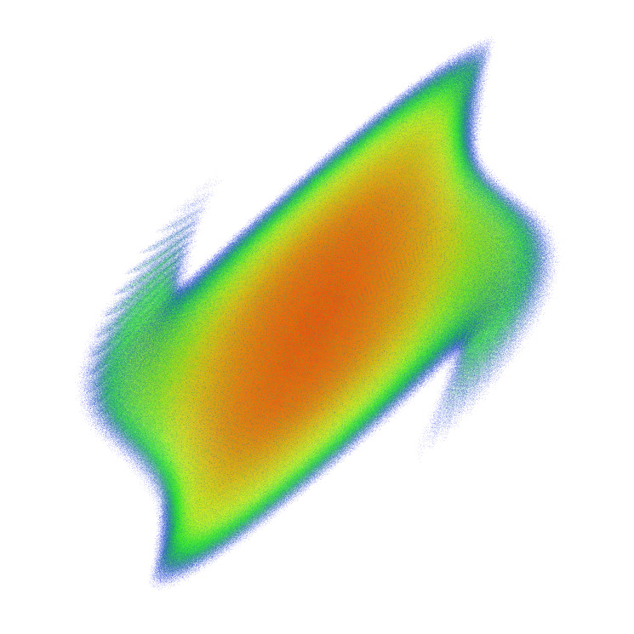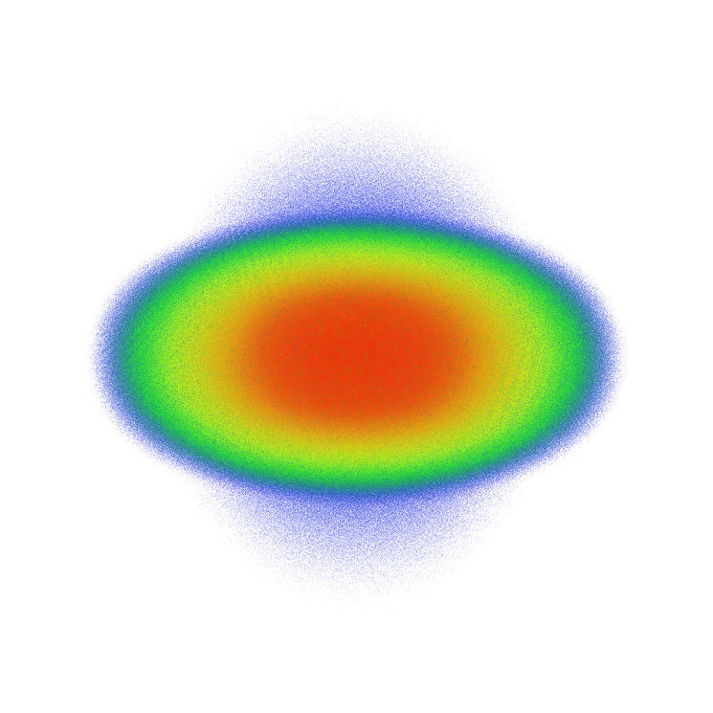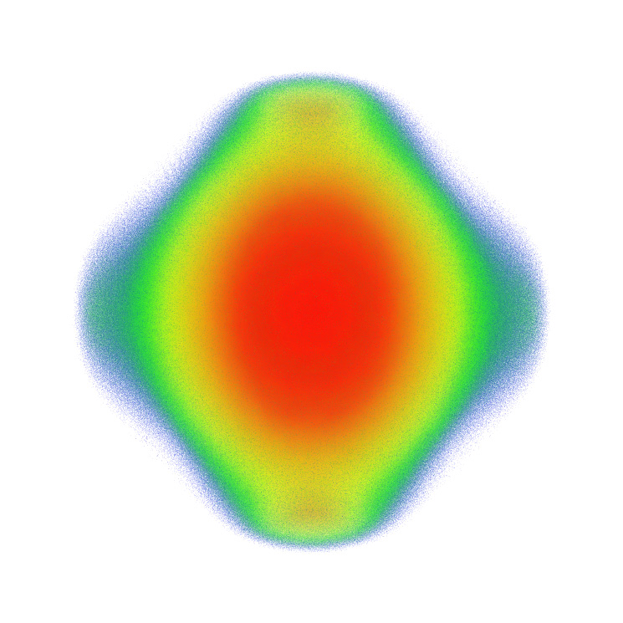

Proposed Work:

Motivation. Advanced visualization is absolutely essential for the accelerator simulation team to gain insight of phenomena that are simulated in large, complex models involving beams and plasmas. For example, large-scale beam dynamics simulations are used to understand the physics of intense beams including the important phenomena of halo formation. The large dynamic range of beam density involved (roughly six orders of magnitude) represents a challenge to scientific visualization. Visualization techniques are also needed to study the origin of halo particles. Furthermore, in the design of laser/plasma-based accelerators, visualization is needed to study the structure of the accelerating fields.

Approach. In the proposed SciDAC-2 accelerator project, the UC Davis team aims to significantly enhance 3D visualization capabilities of participating scientists and the broader accelerator simulations community. The team will develop new visualization techniques and integrate them with existing ones to build tools that allow scientists to study time-varying 3D particle data and field data on their desktop. For visualizing very large datasets, cluster computing solutions will be developed [Ma2001, Lum2002, Ma2003, Yu2004]. A strong focus will be placed on ensuring interactivity and usability to facilitate knowledge discovery from the very complex simulations. For petascale simulations, the most plausible approach is to conduct visualization calculations as much as possible during the simulation time to reduce the data that must be transferred, saved, and viewed.

Impact. The proposed research and development will lead to usable tools for the accelerator simulation community. These tools will provide application scientists interactive visualization at clarity and precision that was previously unavailable. The proposed web based collaborative visualization support will significantly improve the productivity of the whole accelerator simulation team.

SAP Proposal: Advanced Visualization Methods for Accelerator Modeling (cont.)

Milestones:

Year 1:
- Exploit the advanced features of the latest generation of graphics hardware to enhance the hybrid particle data visualization (HPDV) tool.
- Assess the usability of HPDV for deployment.

Year 2:
- Make HPDV run on cluster computers.
- Develop a time-varying field data visualization (TFDV) tool for the PIC codes with a focus on interactivity and usability.
- Develop visualization interfaces for HPDV and TFDV.

Year 3:
- Develop Web-based visualization interfaces for HPDV and TFDV.
- Make TFDV run on cluster computers.
- Design collaborative visualization support for the accelerator simulations group.

Year 4:
- Conduct usability study for the interface designs.
- Incorporate collaborative visualization support into HPDV and TFDV.

Year 5:
- Study usability of collaborative visualization.
- Experiment with coupling parallel visualization with parallel accelerator simulations.
- Investigate physically based data reduction.

References:

[Ma01] K.-L. Ma and S. Parker, Massively parallel software rendering for visualizing large-scale data sets, IEEE Computer Graphics and Applications, July/August 2001, pp. 72-83.

[Lum02] E. Lum, J. Clyne, and K.-L. Ma, A hardware-assisted scalable solution for interactive volume rendering of time-varying data, IEEE Transactions on Visualization and Computer Graphics, 8(3), 2002, pp. 286-301.

[Schussman02] G. Schussman and K.-L. Ma., Scalable Self-Orienting Surfaces: A compact, texture-enhanced representation for interactive visualization of 3D vector fields, in Proceedings of the Pacific Graphics 2002 Conference, pp. 356-365.

[Wilson02] B. Wilson, K.-L. Ma, and P. McCormick, A hardware-assisted hybrid rendering technique for interactive volume visualization, in Proceedings of 2002 Volume Visualization and Graphics Symposium, pp. 123-130.

[Ma02] K.-L. Ma, G. Schussman, B. Wilson, K. Ko, J. Qiang, and R. Ryne, Advanced visualization technology for terascale particle accelerator simulations, in Proceedings of the Supercomputing 2002 Conference, November 16-22, Baltimore, MD.

SAP Proposal: Advanced Visualization Methods for Accelerator Modeling (cont.)

[Lum02] E. Lum, J. Clyne, and K.-L. Ma, A hardware-assisted scalable solution for interactive volume rendering of time-varying data, IEEE Transactions on Visualization and Computer Graphics, Volume 8, Issue 3, 2002, pp. 286-301.

[Ma03] A. Stompel, J. Bielak, O. Ghattas, and E. Kim, Visualizing large-scale earthquake simulations, in Proceedings of the Supercomputing 2003 Conference, November 15-21.

[Lum04b] E. Lum, B. Wilson, and K.-L. Ma, High-quality lighting and efficient pre-integration for volume rendering, VisSym 2004, pp 25-34.

[Schussman04] G. Schussman and K.-L. Ma, Anisotropic volume rendering for extremely dense, thin ine data, in Proceedings of the Visualization 2004 Conference, pp. 107-114.

[Yu04] H. Yu, K.-L. Ma, and J. Welling, A parallel visualization pipeline for terascale earthquake Simulations, in Proceeding of Supercomputing 2004 Conference.

[Fout05] N. Fout, H. Akiba, K.-L. Ma, A. Lefohn, and J. Kniss, High quality rendering of compressed volume data formats, EuroVis 2005, pp. 77-84.

[Akiba05] H. Akiba, K.-L. Ma, and J. Clyne, End-to-end data reduction and hardware accelerated rendering techniques for visualizing time-varying non-uniform grid volume data, in Proceedings of Volume Graphics 2005, June 20-21, pp. 31-39.

[Ma05] K.-L. Ma, E. B. Lum, H. Yu, H. Akiba, M.-Y. Huang, M.-Y. Huang, Y. Wang, and G. Schussman, Scientific discovery through advanced visualization, Journal of Physics, Volume 16, DOE SciDAC 2005 Conference, San Francisco, CA, June 26-30, 2005.

[Akiba06] H. Akiba, N. Fout, and K.-L. Ma, Simultaneous classification of time-varying volume data based on the time histogram, in Proceedings of Eurographics Visualization Symposium, May 8-10, 2006.

SAP Proposal: Quantitative Visualization Applied to Accelerator Physics

James Ahrens (LANL)
Physics Collaborator: Rob. Ryne (LBNL)

Motivation. General-purpose visualization tools are typically weak at quantitative visualization and analysis because they provide operations that work on computational grids, not scientific features. The definition of scientific features is key to analysis. These definitions state a mapping from a computational grid to a real world feature. For accelerator physics, examples would include halo particles and trapped particles. Scientists hypothesize, compare, and reason about features, not computational grids.

Approach. The goal of this project is to add quantitative visualization and analysis support to a visualization tool in order to improve the analysis and understanding of accelerator physics simulations. Specifically, we will augment ParaView [Ahrens05], an open-source, multi-platform, parallel visualization tool for scientists. To handle extremely large datasets, ParaView runs on distributed and shared memory parallel systems and can incrementally process data. ParaView simplifies the details of configuring visualization and rendering algorithms using a graphical user interface or a scripting language. ParaView supports the day-to-day workflow and facilities issues that laboratory and academic scientists encounter, such as different display technologies and remote visualization. Our solution is a multiple step approach:
- Collaboratively identify accelerator physics features.
We will identify specific accelerator physics features to rigorously define and incorporate into ParaView. Current candidates include halo particles, trapped particles and density regions.
- Express the feature definition.
We will explore different methods for expressing the feature definition. Methods include:
  - Using existing programming languages, such as Fortran, C++ and Matlab.
  - Using new analysis programming languages such as Scout [McCormick04].
  - Using software engineering techniques such as literate programming systems [Knuth84].
- Incorporate the feature definition.
We will also explore the best way to incorporate features into ParaView.
- Create the feature-based visualization algorithms.
We will create a collection of visualization algorithms that process features directly.
5. Incorporate quantitative displays.
Traditional visualization tools do not typically contain full-featured plotting capabilities. We will integrate standard plotting packages such as gnuplot into the ParaView visualization tool to plot quantitative results about features.

Impact. We define the scientific analysis workflow as a collection of tasks: hypothesis creation, qualitative hypothesis testing, and quantitative hypothesis confirmation or refutation. By quantitatively defining accelerator physics features, such as halo particles, trapped particles, and density regions, and the visualization operations that process them, the scientific analysis workflow can be significantly improved:
- Easier hypothesis generation - Within our quantitative visualization tool, scientists are able to specifically state a hypothesis in terms of features in which they are interested.
- More effective visualization - For example, a scientist might wish to explore quantitatively the properties of the halo or emittance, and test hypotheses about them. In a standard visualization tool, in order to test this hypothesis, the scientist needs to create a visualization of a related variable that shows a related property of the halo or emittance and intuit from this result whether the hypothesis is correct. In our tool, the scientist will be able to directly create visualizations of the halo or emittance based on an analytical definition of the feature.
- More effective analysis – Within our quantitative visualization tool, there is no break between qualitative visual results obtained from the visualization tool and the generation of quantitative plots.

SAP Proposal: Quantitative Visualization Applied to Accelerator Physics (cont.)

Milestones:

Each year we will follow the approach described above for a specific accelerator physics feature. As we go, we will explore various facets of the problem, such as the best way to express features, giving more emphasis to different approaches in successive years. The long-term goal of this project is to create a collection of application-specific features for the accelerator physics community as well as to understand the best computer science methods for doing this.

Year 1:
- Identify and define halo particles.
- Express feature definition w/ existing programming languages, such as Fortran, C++ and Matlab.
- Incorporate feature definition into ParaView.
- Create halo particle based visualization algorithms.

Year 2:
- Identify and define trapped particles.
- Express the trapped particle definition and visualization algorithms using Scout and ParaView.
- Incorporate quantitative displays into ParaView.

Year 3:
- Identify and define new accelerator physics feature.
- Express the feature-definition using literate programming and incorporate into Scout/ParaView.
- Document best practices for application-specific quantitative visualization and analysis.

Year 4:

Use multiple feature definitions to build a coupled, high-level, integrated quantitative visualization and analysis accelerator physics package.

Year 5:

Support comparisons of observations and simulations using the package defined in Year 4.

References:

[Ahrens05] J. Ahrens, B. Geveci and C. Law, ParaView: An end user tool for large data visualization, Visualization Handbook, Academic Press, 2005.

[McCormick04] P. McCormick, J. Inman, J. Ahrens, G. Roth and C. Hansen, Scout: A hardware-accelerated system for quantitatively driven visualization and analysis, IEEE Visualization 2004, October 2004.

[Knuth84] D. Knuth, Literate Programming, The Computer Journal, 27(2), May 1984.

SAP Proposal: Computational Quality-of-Service Enabled Beam Dynamics Modeling
Doug Dechow (Tech-X Corporation); Lois Curfman McInnes, Boyana Norris (ANL)
Physics Collaborators: James Amundson, Panagiotis Spentzouris (FNAL)

Motivation. The parallel solution of large-scale Poisson equations constitutes a significant fraction (typically 50-90 percent) of overall simulation time for Synergia [Amundson06], which is responsible for beam dynamics modeling in this accelerator project. It is not clear a priori how to select and parameterize Synergia's current Poisson solvers optimally for a given simulation instance. Moreover, efficiently solving Poisson's equation in the presence of large disparities in length scale could benefit from considering new algorithmic ideas, such as exploiting periodicity that arises during repetitive solves. Overall simulation time could also be reduced by performance optimizations to exploit features of massively-parallel distributed memory systems such as the IBM BG/L and Cray XT3.

Approach. Motivated by these simulations, where we observe that a single tool, solver, or solution strategy cannot seamlessly span the entire spectrum of Poisson solves in accelerator applications efficiently, we propose to employ infrastructure for computational quality of service (CQoS) [McInnes06, Norris04, Hovland03], to help automate the selection and configuration of components to suit the computational conditions imposed by a simulation and its operating environment. This work, which leverages existing support within the Common Component Architecture (CCA) [CCA06, Bernholdt06a] for dynamically replacing and reconfiguring components, is a collaboration among participants in three SciDAC-2 Centers for Enabling Technology (CET) proposals: the TASCS [Bernholdt06a], TOPS [Keyes06], and PERC [Lucas06] projects.
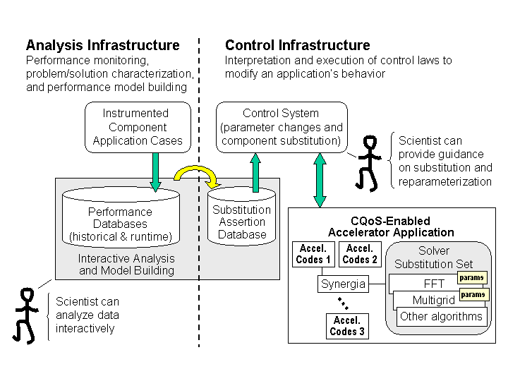
Figure 1: A CQoS-enabled accelerator application.
Figure 1 illustrates our vision of how the CQoS infrastructure will help to analyze, select, and parameterize Poisson solvers for Synergia. This diagram shows the two main facets of CQoS tools: (1) analysis infrastructure, which combines performance information and models from historical and runtime databases along with interactive analysis, including machine learning technology; and (2) control infrastructure, which encompasses decision-making components that evaluate progress based on domain-specific heuristics and metrics, along with services for dynamic component replacement. Further details are discussed in [McInnes06].

Impact. Successful completion of this work will enable computational accelerator physicists to dynamically select and configure Poisson solvers and related data mangement components as used within Synergia during long-running simulations, with a goal of significantly reducing overall time to solution.

SAP Proposal: Computational Quality-of-Service Enabled Beam Dynamics Modeling (cont.)

Milestones:

Year 1:
- Define interfaces and initial componentization of Synergia.
- Profile existing Synergia code.
- Develop solver and data mangement modules and begin to tune performance.
- Implement automatic performance monitoring proxy generation.
- Evaluate performance of different simulation scenarios.

Year 2:
- Complete development of solver and data mangement modules; continue performance tuning.
- Complete componentization of solvers and physics modules.
- Populate performance database.
- Analyze performance data for initial parameter selection.
- Implement CQoS control components for initial application configuration.

Year 3:
- Extend analysis approaches for initial parameter selection and dynamic reconfiguration of components.
- Implement CQoS control components for dynamic parameter configuration.
- Incorporate new solver and data mangement components.

Year 4:
- Incorporate analysis support for static and dynamic parameter selection and dynamic component replacement.
- Implement CQoS control components for dynamic component replacement.

Year 5:
- Complete component implementations for solvers, data management, and CQoS infrastructure.
- Complete documentation of all components and provide a users guide for running CQoS-enabled experiments.

References:

[Amundson06] J. Amundson, P. Spentzouris, J. Qiang, and R. Ryne, Synergia: An accelerator modeling tool with 3-D space charge, Journal of Computational Physics, vol. 211, pp 229-248, January 2006.

[McInnes06] L. C. McInnes, J. Ray, R. Armstrong, T. L. Dahlgren, A. Malony, B. Norris, S. Shende, J. P. Kenny, and J. Steensland, Computational quality of service for scientific CCA applications: Composition, substitution, and reconfiguration, Argonne National Laboratory preprint ANL/MCS-P1326-0206, February, 2006 via ftp://info.mcs.anl.gov/pub/tech_reports/reports/P1326.pdf.

[Norris04] B. Norris, J. Ray, R. Armstrong, L. C. McInnes, D. Bernholdt, W. Elwasif, A. Malony, and S. Shende. Computational quality of service for scientific components, in Proceedings of the International Symposium on Component-Based Software Engineering (CBSE7), Edinburgh, Scotland, 2004. Also available as Argonne National Laboratory preprint ANL/MCS-P1131-0204 via ftp://info.mcs.anl.gov/pub/tech_reports/reports/P1131.pdf.

SAP Proposal: Computational Quality-of-Service Enabled Beam Dynamics Modeling (cont.)

[Hovland03] P. Hovland, K. Keahey, L. C. McInnes, B. Norris, L. F. Diachin, and P. Raghavan. A quality of service approach for high-performance numerical components, in Proceedings of Workshop of QoS in Component-Based Software Engineering, Software Technologies Conference, Toulouse, France, 2003. Also available as Argonne National Laboratory preprint ANL/MCS-P1028-0203 via ftp://info.mcs.anl.gov/pub/tech_reports/P1028.pdf.

[CCA06] Common Component Architecture (CCA) homepage, http://www.cca-forum.org/, 2006.

[Bernholdt06a] D. Bernholdt, B. Allan, R. Armstrong, F. Bertrand, K. Chiu, T. Dahlgren, K. Damevski, W. Elwasif, T. Epperly, M. Govindaraju, D. Katz, J. Kohl, M. Krishnan, G. Kumfert, J. Larson, S. Lefantzi, M. Lewis, A. Malony, L. McInnes, J. Nieplocha, B. Norris, S. Parker, J. Ray, S. Shende, T. Windus, S. Zhou, A component architecture for high-performance scientific computing, Intl. J. High Performance Computing Applications, ACTS Collection Special Issue, in press, 2006.

[Bernholdt06b] D. Bernholdt (PI), Technology for Advanced Scientific Component Software (TASCS), SciDAC CET proposal, March 2006.

[Keyes06] D. Keyes (PI), Towards Optimal PDE Simulations (TOPS), SciDAC CET proposal, March 2006.

[Lucas06] R. Lucas (PI), Performance Evaluation Research Center (PERC)}, SciDAC CET proposal, March 2006.

