1. Using matrix operations, describe the solutions for the following family of equations:

x + 2y - 3z = 5

2x + y - 3z = 13

-x + y = -8

**Augmented Matrix →**

=

Matrix A ->

Matrix B ->

Matrix C ->

**Gaussian Elimination**

R1 + R3 and R2 -2R1 ->

1 2 -3 5

0 -3 3 3

0 3 -3 -3

1 2 -3 5

0 1 -1 -1

0 3 -3 -3

1 0 -1 7

0 1 -1 -1

0 0 0 0

Conclusion = one equation is the multiplication of another.

AB = C

B = (1/A) * C

B = A’ * C

Minors of Matrix A

1 -3 2- 3 2 1

2-3 -1 0 -1 1

2 -3 1-3 1 2

1 0 -1 0 -1 1

2-3 1-3 1 2

1-3 2-3 2 1

Cofactors of Matrix A

* 3 1 3

3 3 -3

-3 -3 -3

Adjoint of Cofactors

* 3 3 -3

1 3 -3

3 -3 -3

Determinant of Matrix A = -3

Inverse of A = 1/(-3) * Adjoint (A)

2)

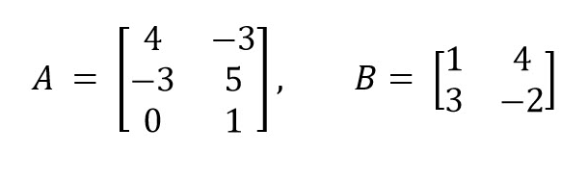

**Dimension of matrix A = (3x 2)**

**Dimension of matrix B = (2x2)**

**Final matrix C = (3 x 2)**

=

=