有限元素project2

學號:4105061124

姓名:謝昉澂

定義:

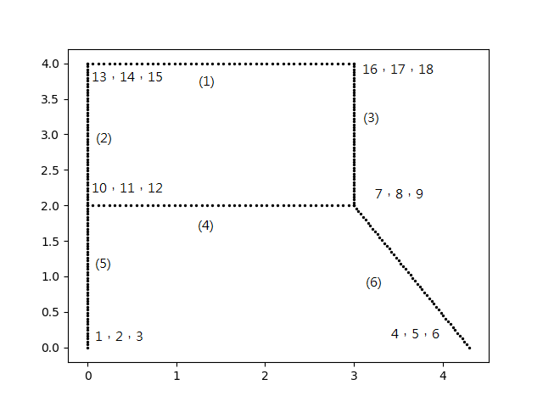

# **Question1:** orientations and stiff matrix of Bar 5 in global coordinates

Orientations of bar 5 is 90 degree。

stiff matrix of Bar 5 in global coordinates

|  |  |  |  |  |  |
| --- | --- | --- | --- | --- | --- |
| 1.02e+08 | 1.73e+02 | -1.02e+08 | -1.02e+08 | -1.73e+02 | -1.02e+08 |
| 1.73e+02 | 6.56e+09 | 2.74e+00 | -1.73e+02 | -6.56e+09 | 2.74e+00 |
| -1.02e+08 | 2.74e+00 | 1.36e+08 | 1.02e+08 | -2.74e+00 | 6.83e+07 |
| -1.02e+08 | -1.73e+02 | 1.02e+08 | 1.02e+08 | 1.73e+02 | 1.02e+08 |
| -1.73e+02 | -6.56e+09 | -2.74e+00 | 1.73e+02 | 6.56e+09 | -2.74e+00 |
| -1.02e+08 | 2.74e+00 | 6.83e+07 | 1.02e+08 | -2.74e+00 | 1.36e+08 |

# **Question2:** self-weight vectors for each bar.

|  |  |  |  |  |  |  |
| --- | --- | --- | --- | --- | --- | --- |
| bar | Global_fx1 | Global_fy1 | Global_m1 | Global_fx2 | Global_fy2 | Global_m2 |
| 1 | 0 | -7.26e+03 | -3.63e+03 | 0 | -7.26e+03 | 3.63e+03 |
| 2 | 0 | -4.84e+03 | -4.32e-05 | 0 | -4.84e+03 | 4.32e-05 |
| 3 | 0 | -4.84e+03 | -4.32e-05 | 0 | -4.84e+03 | 4.32e-05 |
| 4 | 0 | -7.26e+03 | -3.63e+03 | 0 | -7.26e+03 | 3.63e+03 |
| 5 | 0 | -4.84e+03 | -4.32e-05 | 0 | -4.84e+03 | 4.32e-05 |
| 6 | 0 | -5.77e+03 | 1.25e+03 | 0 | -5.77e+03 | -1.25e+03 |

# **Question3:** nodal deflection at all nodes

圖中變形量為實際上的1000倍。

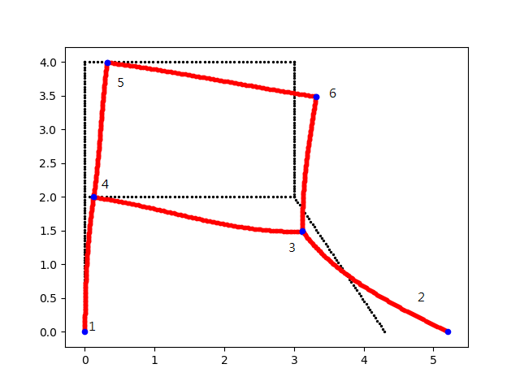

|  |  |  |  |
| --- | --- | --- | --- |
| node | Deflection x | Deflection y | Deflection θ |
| 1 | 0.000e+00 | 0.000e+00 | 0.000e+00 |
| 2 | 9.068e-04 | 0.000e+00 | 5.830e-04 |
| 3 | 1.241e-04 | -5.127e-04 | 3.256e-05 |
| 4 | 1.228e-04 | -6.354e-06 | -1.423e-04 |
| 5 | 3.184e-04 | -8.543e-06 | -1.312e-04 |
| 6 | 3.166e-04 | -5.150e-04 | -1.569e-04 |

# **Question4: determine the maxima local axial stress in bar4**

Discussion:

共考慮moment造成的軸向應力，和x方向變形造成的軸向應力。

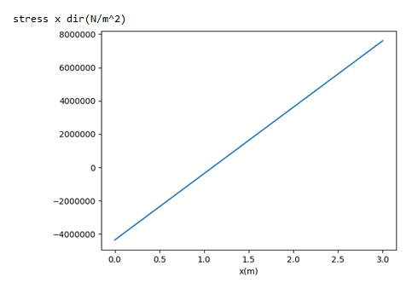

軸向應力最大值：7607603(N/m^2)

# **Question5: the value of d such that the maximum axial stress in bar 6 is minimized**

在此題中我把每個元素再細切成四段。

先用程式算出元素local的x方向軸應力，再取其中絕對值最大值，當作最大軸向應力的值，下圖為d=4.3m的情況，最大軸向應力的值為1.178e7(N/m^2)。

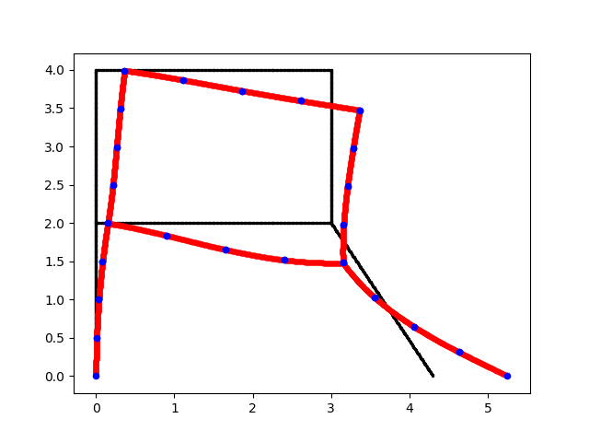

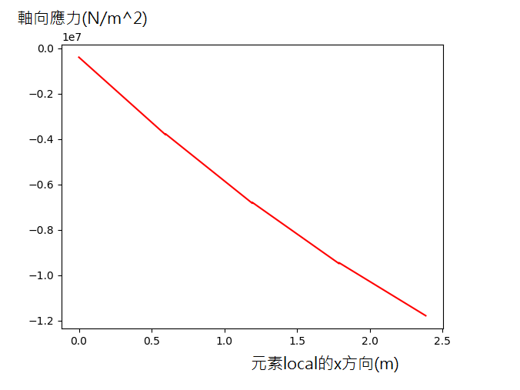

我將距離d從0到20以等間距500次分析，計算最大軸向應力的值如下圖

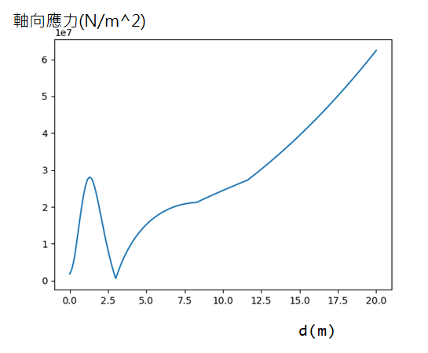

最小軸向應力值為618566N/m^2

此時d=3m

結構如下圖。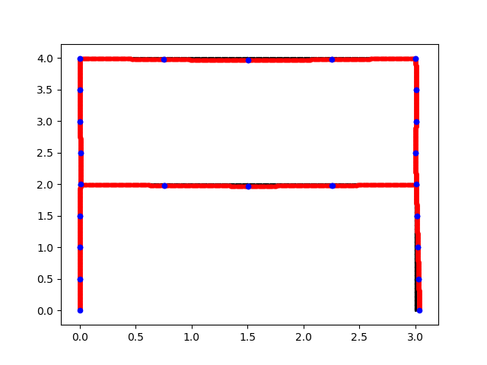

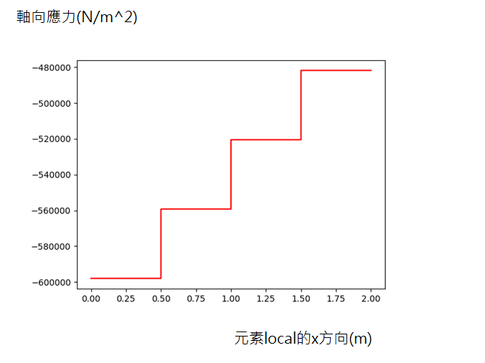

Code：

Main程式是用來解還沒有細化元素的問題。

Main2程式是用來解細化元素的問題。

Change_d_main程式是用來解第5題專用的。

其他程式都是副程式。

Main.py

import numpy as np  
from element import get_vecA, get_vecL, get_vecE, get_vecTheta, get_density, get_ele_coor  
from node import node_member  
from connectivity_matrix import get_mtxEFT  
from global_stiff_matrix import get_mtx_K_glo  
from add_BC import mtx_K_glo_add_BC  
from add_BC import vecf_add_BC  
from show_picture import show_picture  
from show_picture import beam_scatter  
from distribute_force import self_weight_ele_to_node  
from distribute_force import add_q_force_ele_to_node  
from analy_shearMoment import analy_shearMoment  
from refine_mesh_para import refine_mesh_para  
import matplotlib.pyplot as plt  
  
# exaggerating deformation  
u_mul = 1000  
  
  
def main():  
 # get element and node data  
 vecA = get_vecA()  
 vecL = get_vecL()  
 vecE = get_vecE()  
 vecTheta = get_vecTheta()  
 density = get_density()  
 N_gdof, vecFix, vecF = node_member()  
 mtxEFT = get_mtxEFT()  
 N_e = mtxEFT.shape[0]  
  
 # add force  
 vecF[17 - 1] += -5000  
  
 q_force_global = np.array([-1000.0, 0, 0])  
 vecF += add_q_force_ele_to_node(mtxEFT, 3, q_force_global, vecL, vecTheta)  
 # add self_weight  
 for N_e_i in range(N_e):  
 vecF_weight = self_weight_ele_to_node(mtxEFT, N_e_i + 1, vecA, vecL, vecTheta, density)  
 vecF += vecF_weight  
  
 # create stiff matrix  
 mtx_K_glo = get_mtx_K_glo(mtxEFT, N_gdof, N_e, vecE, vecA, vecL, vecTheta)  
  
 # add boundary condition  
 mtx_K_glo_added_BC = mtx_K_glo_add_BC(mtx_K_glo, vecFix)  
 vecF_added_bc = vecf_add_BC(vecF, vecFix)  
  
 # calculate vecU  
 inv_k = np.linalg.inv(mtx_K_glo_added_BC)  
 vecU = inv_k @ vecF_added_bc  
  
 # post process calculate external-force  
 F_ext = mtx_K_glo @ vecU  
  
 # get external-force exert on element  
 # get element deformation  
 ele_f_ext = np.zeros([N_e, 6])  
 ele_u = np.zeros([N_e, 6])  
 ele_u_no = mtxEFT  
 for i in range(N_e):  
 for j in range(6):  
 ele_u[i][j] = vecU[ele_u_no[i][j] - 1]  
 ele_f_ext[i][j] = F_ext[ele_u_no[i][j] - 1]  
  
 # analysis shear-force & moment & stress of special element  
 element_no = 4  
 xs, ys_stress_xdir_c_pos, ys_stress_xdir_c_neg = analy_shearMoment(ele_u[element_no - 1], vecTheta[element_no - 1],  
 vecE[element_no - 1],  
 vecA[element_no - 1], vecL[element_no - 1],  
 plot_picture=False)  
 if (np.max(np.abs(ys_stress_xdir_c_pos)) > np.max(np.abs(ys_stress_xdir_c_neg))):  
 ys_stress_max = ys_stress_xdir_c_pos  
 else:  
 ys_stress_max = ys_stress_xdir_c_neg  
 plt.plot(xs, ys_stress_max)  
 plt.xlabel('x(m)')  
 plt.ylabel('stress x dir(N/m^2)')  
 plt.show()  
 print(np.max(np.abs(ys_stress_max)))  
 # show origin structure  
 ele_coor = get_ele_coor()  
 show_picture(ele_coor, 'k')  
  
 # show deformation structure  
 ele_u_mul = ele_u * u_mul  
 for e_i in range(N_e):  
 ele_i_ori = ele_coor[e_i] + np.array(  
 [ele_u_mul[e_i][0], ele_u_mul[e_i][1], ele_u_mul[e_i][3], ele_u_mul[e_i][4]])  
 ele_i_L = vecL[e_i]  
 ele_i_the = vecTheta[e_i]  
 xs, ys = beam_scatter(ele_i_ori, ele_i_L, ele_i_the,  
 ele_u_mul[e_i])  
 plt.scatter(xs, ys, c='r', s=10)  
 plt.scatter(xs[0], ys[0], c='b', s=20)  
 plt.scatter(xs[-1], ys[-1], c='b', s=20)  
 plt.show()  
  
 pass  
  
  
if __name__ == '__main__':  
 main()

main2.py

import numpy as np  
from element import get_vecA, get_vecL, get_vecE, get_vecTheta, get_density, get_ele_coor  
from element import get_vecL_from_coor, get_vecTheta_from_coor  
from node import node_member  
from connectivity_matrix import get_mtxEFT  
from global_stiff_matrix import get_mtx_K_glo  
from add_BC import mtx_K_glo_add_BC  
from add_BC import vecf_add_BC  
from show_picture import show_picture  
from show_picture import beam_scatter  
from distribute_force import self_weight_ele_to_node  
from distribute_force import add_q_force_ele_to_node  
from analy_shearMoment import analy_shearMoment  
from refine_mesh_para import refine_mesh_para  
from refine_mesh_para import refine_mesh_coor  
from refine_mesh_para import record_element_NO  
import matplotlib.pyplot as plt  
  
# exaggerating deformation  
u_mul = 1000  
  
  
def main2():  
 # get element and node data  
 ele_coor = get_ele_coor()  
 vecL = get_vecL_from_coor(ele_coor)  
 vecTheta = get_vecTheta_from_coor(ele_coor)  
 vecA = get_vecA()  
 vecE = get_vecE()  
 density = get_density()  
 N_gdof, vecFix, vecF = node_member()  
 mtxEFT = get_mtxEFT()  
  
 # record element to analysis  
 record_element1 = [1]  
 record_element2 = [2]  
 record_element3 = [3]  
 record_element4 = [4]  
 record_element5 = [5]  
 record_element6 = [6]  
  
 # refine element  
  
 element_number = 6  
 refine_element_list = np.arange(1, element_number + 1)  
 refine_times = 1  
 for i in range(1,refine_times+1):  
 element_number = element_number*2  
 refine_element_list = np.hstack([refine_element_list, np.arange(1, element_number+1)])  
  
 for refine_element_NO in refine_element_list:  
 mtxEFT, vecE, vecA, vecL, vecTheta = refine_mesh_para(mtxEFT, vecE, vecA, vecL, vecTheta, refine_element_NO)  
 ele_coor = refine_mesh_coor(ele_coor, refine_element_NO)  
 # adjust F distribute  
 # Zeroing force and add force  
 vecF = np.zeros([np.max(mtxEFT)])  
 vecF[17 - 1] += -5000  
 q_force_global = np.array([-1000.0, 0, 0])  
 # record_q_force should exert on which elements  
 record_q_force_element3 = np.array([3])  
 if refine_element_NO in record_q_force_element3:  
 record_q_force_element3 = np.hstack([record_q_force_element3, refine_element_NO])  
 for q_force_element_i in record_q_force_element3:  
 vecF += add_q_force_ele_to_node(mtxEFT, q_force_element_i, q_force_global, vecL, vecTheta)  
  
 # add self_weight  
 N_e = mtxEFT.shape[0]  
 for N_e_i in range(N_e):  
 vecF_weight = self_weight_ele_to_node(mtxEFT, N_e_i + 1, vecA, vecL, vecTheta, density)  
 vecF += vecF_weight  
  
 # create stiff matrix  
 mtx_K_glo = get_mtx_K_glo(mtxEFT, np.max(mtxEFT), N_e, vecE, vecA, vecL, vecTheta)  
  
 # add boundary condition  
 mtx_K_glo_added_BC = mtx_K_glo_add_BC(mtx_K_glo, vecFix)  
 vecF_added_bc = vecf_add_BC(vecF, vecFix)  
  
 # calculate vecU  
 inv_k = np.linalg.inv(mtx_K_glo_added_BC)  
 vecU = inv_k @ vecF_added_bc  
  
 # post process calculate external-force  
 F_ext = mtx_K_glo @ vecU  
  
 # get external-force exert on element  
 # get element deformation  
 ele_f_ext = np.zeros([N_e, 6])  
 ele_u = np.zeros([N_e, 6])  
 ele_u_no = mtxEFT  
 for i in range(N_e):  
 for j in range(6):  
 ele_u[i][j] = vecU[ele_u_no[i][j] - 1]  
 ele_f_ext[i][j] = F_ext[ele_u_no[i][j] - 1]  
  
 # record element to analysis  
 record_element1 = record_element_NO(record_element1, refine_element_NO, N_e)  
 record_element2 = record_element_NO(record_element2, refine_element_NO, N_e)  
 record_element3 = record_element_NO(record_element3, refine_element_NO, N_e)  
 record_element4 = record_element_NO(record_element4, refine_element_NO, N_e)  
 record_element5 = record_element_NO(record_element5, refine_element_NO, N_e)  
 record_element6 = record_element_NO(record_element6, refine_element_NO, N_e)  
  
 # analysis shear-force & moment & stress of special element  
 analysis_element = record_element6  
 count = 0  
 for elemnet_i in analysis_element:  
 element_no = elemnet_i  
 if count == 0:  
 xs, stress_xdir_cpos, stress_xdir_cneg = analy_shearMoment(ele_u[element_no - 1], vecTheta[element_no - 1],  
 vecE[element_no - 1],  
 vecA[element_no - 1], vecL[element_no - 1],  
 plot_picture=False)  
 else:  
 xs_ = analy_shearMoment(ele_u[element_no - 1], vecTheta[element_no - 1], vecE[element_no - 1],  
 vecA[element_no - 1], vecL[element_no - 1], plot_picture=False)[0]  
 xs_ += xs[-1]  
 stress_xdir_cpos_, stress_xdir_cneg_ = analy_shearMoment(ele_u[element_no - 1], vecTheta[element_no - 1],  
 vecE[element_no - 1],  
 vecA[element_no - 1], vecL[element_no - 1],  
 plot_picture=False)[-2:]  
 stress_xdir_cpos = np.hstack([stress_xdir_cpos, stress_xdir_cpos_])  
 stress_xdir_cneg = np.hstack([stress_xdir_cneg, stress_xdir_cneg_])  
 xs = np.hstack([xs, xs_])  
 # find max axial load  
 if np.max(np.fabs(stress_xdir_cpos)) > np.max(np.fabs(stress_xdir_cneg)):  
 stress_xdir = stress_xdir_cpos  
 else:  
 stress_xdir = stress_xdir_cneg  
  
 count += 1  
 plt.plot(xs, stress_xdir, c='r')  
 plt.show()  
  
 # show origin structure  
 show_picture(ele_coor, 'k')  
  
 # show deformation structure  
 ele_u_mul = ele_u * u_mul  
 for e_i in range(N_e):  
 ele_i_ori = ele_coor[e_i] + np.array(  
 [ele_u_mul[e_i][0], ele_u_mul[e_i][1], ele_u_mul[e_i][3], ele_u_mul[e_i][4]])  
 ele_i_L = vecL[e_i]  
 ele_i_the = vecTheta[e_i]  
 xs, ys = beam_scatter(ele_i_ori, ele_i_L, ele_i_the,  
 ele_u_mul[e_i])  
 plt.scatter(xs, ys, c='r', s=10)  
 plt.scatter(xs[0], ys[0], c='b', s=20)  
 plt.scatter(xs[-1], ys[-1], c='b', s=20)  
 plt.show()  
  
  
if __name__ == '__main__':  
 main2()

change_d_main.py

import numpy as np  
from element import get_vecA, get_vecL, get_vecE, get_vecTheta, get_density, get_ele_coor_Q5  
from element import get_vecL_from_coor, get_vecTheta_from_coor  
from node import node_member  
from connectivity_matrix import get_mtxEFT  
from global_stiff_matrix import get_mtx_K_glo  
from add_BC import mtx_K_glo_add_BC  
from add_BC import vecf_add_BC  
from show_picture import show_picture  
from show_picture import beam_scatter  
from distribute_force import self_weight_ele_to_node  
from distribute_force import add_q_force_ele_to_node  
from analy_shearMoment import analy_shearMoment  
from refine_mesh_para import refine_mesh_para  
from refine_mesh_para import refine_mesh_coor  
from refine_mesh_para import record_element_NO  
import matplotlib.pyplot as plt  
  
# exaggerating deformation  
u_mul = 1000  
  
  
def main2(distance):  
 # get element and node data  
 ele_coor = get_ele_coor_Q5(distance)  
 vecL = get_vecL_from_coor(ele_coor)  
 vecTheta = get_vecTheta_from_coor(ele_coor)  
 vecA = get_vecA()  
 vecE = get_vecE()  
 density = get_density()  
 N_gdof, vecFix, vecF = node_member()  
 mtxEFT = get_mtxEFT()  
  
 # record element to analysis  
 record_element1 = [1]  
 record_element2 = [2]  
 record_element3 = [3]  
 record_element4 = [4]  
 record_element5 = [5]  
 record_element6 = [6]  
  
 # refine element  
  
 element_number = 6  
 refine_element_list = np.arange(1, element_number + 1)  
 refine_times = 1  
 for i in range(1,refine_times+1):  
 element_number = element_number*2  
 refine_element_list = np.hstack([refine_element_list, np.arange(1, element_number+1)])  
  
 for refine_element_NO in refine_element_list:  
 mtxEFT, vecE, vecA, vecL, vecTheta = refine_mesh_para(mtxEFT, vecE, vecA, vecL, vecTheta, refine_element_NO)  
 ele_coor = refine_mesh_coor(ele_coor, refine_element_NO)  
 # adjust F distribute  
 # Zeroing force and add force  
 vecF = np.zeros([np.max(mtxEFT)])  
 vecF[17 - 1] += -5000  
 q_force_global = np.array([-1000.0, 0, 0])  
 # record_q_force should exert on which elements  
 record_q_force_element3 = np.array([3])  
 if refine_element_NO in record_q_force_element3:  
 record_q_force_element3 = np.hstack([record_q_force_element3, refine_element_NO])  
 for q_force_element_i in record_q_force_element3:  
 vecF += add_q_force_ele_to_node(mtxEFT, q_force_element_i, q_force_global, vecL, vecTheta)  
  
 # add self_weight  
 N_e = mtxEFT.shape[0]  
 for N_e_i in range(N_e):  
 vecF_weight = self_weight_ele_to_node(mtxEFT, N_e_i + 1, vecA, vecL, vecTheta, density)  
 vecF += vecF_weight  
  
 # create stiff matrix  
 mtx_K_glo = get_mtx_K_glo(mtxEFT, np.max(mtxEFT), N_e, vecE, vecA, vecL, vecTheta)  
  
 # add boundary condition  
 mtx_K_glo_added_BC = mtx_K_glo_add_BC(mtx_K_glo, vecFix)  
 vecF_added_bc = vecf_add_BC(vecF, vecFix)  
  
 # calculate vecU  
 inv_k = np.linalg.inv(mtx_K_glo_added_BC)  
 vecU = inv_k @ vecF_added_bc  
  
 # post process calculate external-force  
 F_ext = mtx_K_glo @ vecU  
  
 # get external-force exert on element  
 # get element deformation  
 ele_f_ext = np.zeros([N_e, 6])  
 ele_u = np.zeros([N_e, 6])  
 ele_u_no = mtxEFT  
 for i in range(N_e):  
 for j in range(6):  
 ele_u[i][j] = vecU[ele_u_no[i][j] - 1]  
 ele_f_ext[i][j] = F_ext[ele_u_no[i][j] - 1]  
  
 # record element to analysis  
 record_element1 = record_element_NO(record_element1, refine_element_NO, N_e)  
 record_element2 = record_element_NO(record_element2, refine_element_NO, N_e)  
 record_element3 = record_element_NO(record_element3, refine_element_NO, N_e)  
 record_element4 = record_element_NO(record_element4, refine_element_NO, N_e)  
 record_element5 = record_element_NO(record_element5, refine_element_NO, N_e)  
 record_element6 = record_element_NO(record_element6, refine_element_NO, N_e)  
  
 # analysis shear-force & moment & stress of special element  
 analysis_element = record_element6  
 count = 0  
 for elemnet_i in analysis_element:  
 element_no = elemnet_i  
 if count == 0:  
 xs, stress_xdir_cpos, stress_xdir_cneg = analy_shearMoment(ele_u[element_no - 1], vecTheta[element_no - 1],  
 vecE[element_no - 1],  
 vecA[element_no - 1], vecL[element_no - 1],  
 plot_picture=False)  
 else:  
 xs_ = analy_shearMoment(ele_u[element_no - 1], vecTheta[element_no - 1], vecE[element_no - 1],  
 vecA[element_no - 1], vecL[element_no - 1], plot_picture=False)[0]  
 xs_ += xs[-1]  
 stress_xdir_cpos_, stress_xdir_cneg_ = analy_shearMoment(ele_u[element_no - 1], vecTheta[element_no - 1],  
 vecE[element_no - 1],  
 vecA[element_no - 1], vecL[element_no - 1],  
 plot_picture=False)[-2:]  
 stress_xdir_cpos = np.hstack([stress_xdir_cpos, stress_xdir_cpos_])  
 stress_xdir_cneg = np.hstack([stress_xdir_cneg, stress_xdir_cneg_])  
 xs = np.hstack([xs, xs_])  
 # find max axial load  
 if np.max(np.fabs(stress_xdir_cpos)) > np.max(np.fabs(stress_xdir_cneg)):  
 stress_xdir = stress_xdir_cpos  
 else:  
 stress_xdir = stress_xdir_cneg  
  
 count += 1  
 # plt.plot(xs, stress_xdir, c='r')  
 # plt.show()  
  
 # show origin structure  
 # show_picture(ele_coor, 'k')  
  
 # show deformation structure  
 # ele_u_mul = ele_u * u_mul  
 # for e_i in range(N_e):  
 # ele_i_ori = ele_coor[e_i] + np.array(  
 # [ele_u_mul[e_i][0], ele_u_mul[e_i][1], ele_u_mul[e_i][3], ele_u_mul[e_i][4]])  
 # ele_i_L = vecL[e_i]  
 # ele_i_the = vecTheta[e_i]  
 # xs, ys = beam_scatter(ele_i_ori, ele_i_L, ele_i_the,  
 # ele_u_mul[e_i])  
 # plt.scatter(xs, ys, c='r', s=10)  
 # plt.scatter(xs[0], ys[0], c='b', s=20)  
 # plt.scatter(xs[-1], ys[-1], c='b', s=20)  
 # plt.show()  
 return np.max(np.fabs(stress_xdir))  
  
if __name__ == '__main__':  
 distance=np.linspace(0,20,500)  
 for i in distance:  
 stress_max=main2(i)  
 if i ==0:  
 stress_maxs=np.array([stress_max])  
 else:  
 stress_maxs=np.hstack([stress_maxs,stress_max])  
 np.save('stress_maxs',stress_maxs)

connectivity_matrix.py

import numpy as np  
  
  
# connect global_vecU to element, example[x_dir1 y_dir1 theta1 x_dir2 y_dir2 theta2]  
def get_mtxEFT():  
 mtxEFT = np.array([[13, 14, 15, 16, 17, 18],  
 [10, 11, 12, 13, 14, 15],  
 [7, 8, 9, 16, 17, 18],  
 [10, 11, 12, 7, 8, 9],  
 [1, 2, 3, 10, 11, 12],  
 [4, 5, 6, 7, 8, 9]  
 ])  
 return mtxEFT  
  
# connect node to vecU  
def get_nodeANDdof_table():  
 nodeANDdof = np.array([  
 [1,2,3],  
 [4,5,6],  
 [7,8,9],  
 [10,11,12],  
 [13,14,15],  
 [16,17,18]  
 ])  
 return nodeANDdof

element.py

import numpy as np  
from math import atan2,pi  
  
'''store element parameters  
'''  
  
  
# element length  
def get_vecL():  
 vecL = np.array([3, 2, 2, 3, 2, 2.385])  
 return vecL  
  
  
# element area  
def get_vecA():  
 vecA = np.array(  
 [62500e-6, 62500e-6, 62500e-6, 62500e-6, 62500e-6, 62500e-6])  
 return vecA  
  
  
# element young's module  
def get_vecE():  
 vecE = np.array([210e9, 210e9, 210e9, 210e9, 210e9, 210e9])  
 return vecE  
  
  
# element theta of global coordinate to local coordinate (degree)  
def get_vecTheta():  
 vecTheta = np.array([0, 90, 90, 0, 90, 123.0239])  
 return vecTheta  
  
  
# element density  
def get_density():  
 return 7900  
  
  
# element global coordinate  
def get_ele_coor():  
 ele_coor = np.array([  
 [0, 4, 3, 4],  
 [0, 2, 0, 4],  
 [3, 2, 3, 4],  
 [0, 2, 3, 2],  
 [0, 0, 0, 2],  
 [4.3, 0, 3, 2]  
 ])  
 return ele_coor  
  
# element global coordinate for Q5  
def get_ele_coor_Q5(x):  
 ele_coor = np.array([  
 [0, 4, 3, 4],  
 [0, 2, 0, 4],  
 [3, 2, 3, 4],  
 [0, 2, 3, 2],  
 [0, 0, 0, 2],  
 [x, 0, 3, 2]  
 ])  
 return ele_coor  
  
# element length  
def get_vecL_from_coor(ele_coor):  
 count = 0  
 for ele in ele_coor:  
 x1 = ele[0]  
 y1 = ele[1]  
 x2 = ele[2]  
 y2 = ele[3]  
 L = ((x2 - x1) ** 2 + (y2 - y1) ** 2) ** 0.5  
 if count == 0:  
 vecL = np.array([L])  
 else:  
 vecL = np.hstack([vecL, L])  
 count += 1  
 return vecL  
  
# element theta of global coordinate to local coordinate (degree)  
def get_vecTheta_from_coor(ele_coor):  
 count = 0  
 for ele in ele_coor:  
 x1 = ele[0]  
 y1 = ele[1]  
 x2 = ele[2]  
 y2 = ele[3]  
 Theta = atan2((y2 - y1), (x2 - x1))  
 if count == 0:  
 vecTheta = np.array([Theta])  
 else:  
 vecTheta = np.hstack([vecTheta, Theta])  
 count += 1  
 return vecTheta/pi*180.0

distribute_force.py

import math  
import numpy as np  
  
  
def add_q_force(L, qx_global, theta):  
 rad = theta * 3.1415926 / 180.0  
 c = math.cos(rad)  
 s = math.sin(rad)  
 T = np.array([  
 [c, -s, 0],  
 [s, c, 0],  
 [0, 0, 1]  
 ])  
 T_t = np.array([  
 [c, s, 0],  
 [-s, c, 0],  
 [0, 0, 1]  
 ])  
 qx_local = T_t @ qx_global  
 vecf_local = L / 2 * np.array([  
 [qx_local[0]],  
 [qx_local[1]],  
 [qx_local[1] * L / 6],  
 [qx_local[0]],  
 [qx_local[1]],  
 [-qx_local[1] * L / 6],  
 ])  
 T2 = np.kron(np.eye(2, dtype=float), T)  
 vecf_global = T2 @ vecf_local  
 return vecf_global  
  
  
def self_weight_ele_to_node(mtxEFT, e_i, vecA, vecL, vectheta, density):  
 vecf_ = np.zeros([np.max(mtxEFT)])  
 node_list = mtxEFT[e_i - 1]  
 qx_global = np.array([0, -density * vecA[e_i - 1] * 9.81, 0])  
 self_weight_vecf = add_q_force(vecL[e_i - 1], qx_global, vectheta[e_i - 1])  
 count = 0  
 for node_i in node_list:  
 vecf_[node_i - 1] = self_weight_vecf[count]  
 count += 1  
 return vecf_  
  
def add_q_force_ele_to_node(mtxEFT, e_i ,qx_global,vecL, vectheta):  
 vecf_ = np.zeros([np.max(mtxEFT)])  
 node_list = mtxEFT[e_i - 1]  
 self_weight_vecf = add_q_force(vecL[e_i - 1], qx_global, vectheta[e_i - 1])  
 count = 0  
 for node_i in node_list:  
 vecf_[node_i - 1] = self_weight_vecf[count]  
 count += 1  
 return vecf_  
  
  
if __name__ == '__main__':  
 pass

global_stiff_matrix.py

import numpy as np  
import math  
  
  
def main():  
 pass  
  
  
def get_mtx_K_glo(mtxFET, N_gdof, N_e, vecE, vecA, vecL, vecTheta):  
 mtx_K_glo = np.zeros([N_gdof, N_gdof])  
 for e_i in range(N_e):  
 mtx_K_e = get_mtx_K_e(vecE[e_i], vecA[e_i], vecL[e_i], vecTheta[e_i])  
 for i in range(6):  
 for j in range(6):  
 mtx_K_glo[mtxFET[e_i, i] - 1, mtxFET[e_i, j] - 1] = mtx_K_glo[mtxFET[e_i, i] - 1, mtxFET[e_i, j] - 1] + \  
 mtx_K_e[i, j]  
  
 return mtx_K_glo  
  
  
def get_mtx_K_e(E, A, L, D):  
 R = D * 3.1415926 / 180.0  
 c = math.cos(R)  
 s = math.sin(R)  
 I = (1 / 12.0) * A * A  
 T = np.array([  
 [c, s, 0, 0, 0, 0],  
 [-s, c, 0, 0, 0, 0],  
 [0, 0, 1, 0, 0, 0],  
 [0, 0, 0, c, s, 0],  
 [0, 0, 0, -s, c, 0],  
 [0, 0, 0, 0, 0, 1]  
 ])  
 T_t = np.array([  
 [c, -s, 0, 0, 0, 0],  
 [s, c, 0, 0, 0, 0],  
 [0, 0, 1, 0, 0, 0],  
 [0, 0, 0, c, -s, 0],  
 [0, 0, 0, s, c, 0],  
 [0, 0, 0, 0, 0, 1]  
 ])  
 K_bar = E * A / L * np.array([  
 [1, -1],  
 [-1, 1]  
 ])  
 K_beam = E * I / (L ** 3) * np.array([  
 [12, 6 * L, -12, 6 * L],  
 [6 * L, 4 * L ** 2, -6 * L, 2 * L ** 2],  
 [-12, -6 * L, 12, -6 * L],  
 [6 * L, 2 * L ** 2, -6 * L, 4 * L ** 2]  
 ])  
  
 K = np.array([  
 [K_bar[0][0], 0, 0, K_bar[0][1], 0, 0],  
 [0, K_beam[0][0], K_beam[0][1], 0, K_beam[0][2], K_beam[0][3]],  
 [0, K_beam[1][0], K_beam[1][1], 0, K_beam[1][2], K_beam[1][3]],  
 [K_bar[1][0], 0, 0, K_bar[1][1], 0, 0],  
 [0, K_beam[2][0], K_beam[2][1], 0, K_beam[2][2], K_beam[2][3]],  
 [0, K_beam[3][0], K_beam[3][1], 0, K_beam[3][2], K_beam[3][3]],  
 ])  
 mtx_K_e = T_t @ K @ T  
  
 return mtx_K_e  
  
  
if __name__ == '__main__':  
 main()

node.py

import numpy as np  
  
'''store node parameters'''  
  
  
def node_member():  
 N_gdof = 18  
 vecFix = np.array([1, 2, 3, 5])  
 vecF = np.zeros([N_gdof])  
  
 return N_gdof, vecFix, vecF  
  
  
if __name__ == '__main__':  
 node_member()

refine_mesh_para.py

import numpy as np  
  
  
def refine_mesh_para(mtxEFT, vecE, vecA, vecL, vecTheta, e_i):  
 # change mtxEFT  
 mtxEFT = np.copy(mtxEFT)  
 node_max = np.max(mtxEFT)  
 element_node = mtxEFT[e_i - 1]  
 node1 = element_node[:3]  
 node2 = element_node[-3:]  
 add_node = np.array([node_max + 1, node_max + 2, node_max + 3])  
 element1 = np.hstack([node1, add_node])  
 element2 = np.hstack([add_node, node2])  
 # add element in EFT  
 mtxEFT[e_i - 1] = element1  
 mtxEFT = np.vstack([mtxEFT, element2])  
  
 # change element_para  
 vecE = np.copy(vecE)  
 vecA = np.copy(vecA)  
 vecL = np.copy(vecL)  
 vecTheta = np.copy(vecTheta)  
  
 vecL[e_i - 1] = vecL[e_i - 1] / 2.0  
  
 vecE = np.hstack([vecE, vecE[e_i - 1]])  
 vecA = np.hstack([vecA, vecA[e_i - 1]])  
 vecL = np.hstack([vecL, vecL[e_i - 1]])  
 vecTheta = np.hstack([vecTheta, vecTheta[e_i - 1]])  
  
 return mtxEFT, vecE, vecA, vecL, vecTheta  
 pass  
  
  
def refine_mesh_coor(ele_coor, ei):  
 ele_coor = np.copy(ele_coor)  
 node1_coordinate = ele_coor[ei - 1][:2]  
 node2_coordinate = ele_coor[ei - 1][-2:]  
 node3_coordinate = 0.5 * (node1_coordinate + node2_coordinate)  
  
 ele1 = np.hstack([node1_coordinate, node3_coordinate])  
 ele2 = np.hstack([node3_coordinate, node2_coordinate])  
  
 ele_coor[ei - 1] = ele1  
 ele_coor = np.vstack([ele_coor, ele2])  
  
 return ele_coor  
  
  
# record element split number  
def record_element_NO(record_elements, refine_element_NO,N_e):  
 if refine_element_NO in record_elements:  
 index=np.where(record_elements==refine_element_NO)[0][0]  
  
 record_elements.insert(index+1,N_e)  
  
 return record_elements  
  
  
if __name__ == '__main__':  
 import connectivity_matrix  
  
 vecL = np.array([3, 2, 2, 3, 2, 2.385])  
 vecA = np.array(  
 [62500e-6, 62500e-6, 62500e-6, 62500e-6, 62500e-6, 62500e-6])  
 vecE = np.array([210e9, 210e9, 210e9, 210e9, 210e9, 210e9])  
 vecTheta = np.array([0, 90, 90, 0, 90, 123.0239])  
  
 mtxEFT = connectivity_matrix.get_mtxEFT()  
 mtxEFT, vecE, vecA, vecL, vecTheta = refine_mesh_para(mtxEFT, vecE, vecA, vecL, vecTheta, 1)  
 from global_stiff_matrix import get_mtx_K_glo  
  
 mtx_K_glo = get_mtx_K_glo(mtxEFT, np.max(mtxEFT), mtxEFT.shape[0], vecE, vecA, vecL, vecTheta)  
 pass

show_picture.py

import numpy as np  
import math  
import matplotlib.pyplot as plt  
  
  
def beam_scatter(ele_ori, ele_L, ele_the, ele_u):  
 R = ele_the * 3.1415926 / 180.0  
 c = math.cos(R)  
 s = math.sin(R)  
 T = np.array([  
 [c, s, 0, 0, 0, 0],  
 [-s, c, 0, 0, 0, 0],  
 [0, 0, 1, 0, 0, 0],  
 [0, 0, 0, c, s, 0],  
 [0, 0, 0, -s, c, 0],  
 [0, 0, 0, 0, 0, 1]  
 ])  
 ele_u_e = T @ ele_u  
 v1 = ele_u_e[1]  
 the1 = ele_u_e[2]  
 v2 = ele_u_e[4]  
 the2 = ele_u_e[5]  
  
 def N1(x):  
 return (1 / ele_L ** 3) * (ele_L - x) ** 2 * (2 * x + ele_L)  
  
 def N2(x):  
 return (1 / ele_L ** 2) * (ele_L - x) ** 2 * x  
  
 def N3(x):  
 return (1 / ele_L ** 3) * (3 * ele_L - 2 * x) * x ** 2  
  
 def N4(x):  
 return (1 / ele_L ** 2) * (x - ele_L) * x ** 2  
  
 xs = np.linspace(0, ele_L, 100)  
 vs = N1(xs) * v1 + N2(xs) * the1 + N3(xs) * v2 + N4(xs) * the2  
  
 ele_the_rad = ele_the / 180.0 * 3.1415926  
  
 vs = vs - vs[0]  
  
 xs_ = xs * math.cos(ele_the_rad) - vs * math.sin(ele_the_rad)  
 vs_ = xs * math.sin(ele_the_rad) + vs * math.cos(ele_the_rad)  
  
 xs_glo = xs_ + ele_ori[0]  
 vs_glo = vs_ + ele_ori[1]  
  
 return xs_glo, vs_glo  
  
  
def make_scatter_point(p1, p2, n=50):  
 x = np.linspace(p1[0], p2[0], n)  
 y = np.linspace(p1[1], p2[1], n)  
 return x, y  
  
  
def show_picture(matrix, color):  
 ele_N = matrix.shape[0]  
 for i in range(ele_N):  
 p1x = matrix[i][0]  
 p1y = matrix[i][1]  
 p2x = matrix[i][2]  
 p2y = matrix[i][3]  
 xs, ys = make_scatter_point([p1x, p1y], [p2x, p2y])  
 plt.scatter(xs, ys, c=color, s=2)