IssueBrowser:
A Collaborative Search Environment for Domain-Specific Knowledge Acquisition via Multimedia Data
Angus Graeme Forbes^{1,2}, Monica Bulger³, Benjamin Adams², Jon Ventura², Karl Grossner⁴, Tobias Hollerer^{2,1}
¹Media Arts & Technology Program, ²Department of Computer Science, ³Department of Education, ⁴Department of Geography
University of California, Santa Barbara
angus.forbes@gmail.com, mbulger@education.ucsb.edu, badams@cs.ucsb.edu, jventura@umail.ucsb.edu, karlg@geog.ucsb.edu, holl@cs.ucsb.edu

ABSTRACT
IssueBrowser is an interactive visualization system that aims to enhance the knowledge acquisition capabilities of its users with regard to a particular knowledge domain: the 2008 Presidential Election. Our system models the search patterns of expert users who are able to traverse a range of available data to discover detailed information. IssueBrowser features a modular architecture that gathers data related to issues and/or candidates from a wide range of multimedia sources, filters out irrelevant portions of that data, and adds meta-information so that the data is usefully connected together. We present an innovative visualization system that allows users to interpret data (and connections between the data) from various perspectives and from various sources-- perspectives and sources that users might not be exposed to during a normal web search. Our layout algorithm has both temporal and spatial aspects that work together to balance simultaneously both a broad view of a range of issues as well as increasingly detailed information about particular aspects of an issue or a cluster of issues. In addition to displaying text (articles, quotes, facts) and images (video, photos), we dynamically generate charts and graphs culled from polls and other numerical data that are relevant to the currently visualized text and image/video data. Finally, we provide a novel interaction system which allows multiple users to choose collaboratively the various aspects of particular issues they are interested in exploring. Users influence the flow of new information by "pinning" particular data-- that is, forcing new queries to return data to be related to the currently selected data. IssueBrowser was designed to run as a public installation on a university campus. Our goal is to facilitate critical engagement with political issues through a multimedia collection of loosely organized data. We hope to inspire users, and especially young first-time voters, to see issues from a variety of perspectives and to inform their opinions about those issues. We conclude by describing the user study we are developing to evaluate the effectiveness of using IssueBrowser to assist this college-aged demographic in understanding the various issues in the 2008 Presidential Election.

Permission to make digital or hard copies of all or part of this work for personal or classroom use is granted without fee provided that copies are not made or distributed for profit or commercial advantage and that copies bear this notice and the full citation on the first page. To copy otherwise, or republish, to post on servers or to redistribute to lists, requires prior specific permission and/or a fee.
Conference’04, Month 1–2, 2004, City, State, Country.
Copyright 2004 ACM 1-58113-000-0/00/0004…$5.00.

Categories and Subject Descriptors
H.5.1 [Information Interfaces and Presentation]: Multimedia Information Systems - hypertext navigation, video ; H.5.4 [Hypermedia] - navigation, user issues; H.3.3 [Information Search and Retrieval] - search process, information filtering, retrieval models.
General Terms
Design, Experimentation, Human Factors.
Keywords
Knowledge acquisition, political issues, interactive multimedia interface, aggregated search, collaborative exploration.

INTRODUCTION
IssueBrowser is a novel visualization system for collaboratively exploring multimedia data related to the ongoing discussions and debates of political issues by candidates and in the media during the 2008 U.S. Presidential Election. IssueBrowser is installed on four large screens displayed near the public entrance area of a university library. The installation serves as both an artistic visualization of the issues and more importantly as an informational tool that encourages users to think critically about their own positions on public policy issues.
Over the last few decades there have been numerous attempts to visualize domain-specific multimedia data for purposes of knowledge-acquisition. In particular, a number of projects aim to present news events centered around particular themes or clusters. Galaxy of News (from 1994), an important early example of an interactive news visualization, analyzes news articles for semantic similarity and organizes those articles into a hierarchical visualization which the user can then navigate to explore a range of general to specifc concepts. More recently, a proliferation of online news aggregation and visualization systems can be found which specialize in specific forms of data analysis. The most popular of these systems, which include Google News (http://www.news.google.com), specialize in categorization based on topic. The Lydia system (http://www.textmap.com) is also designed to analyze the temporal and geographic distribution of news articles [12]. Another series of visualizations combinine news aggregator sites with spring-graph derived layouts [5]. Other innovative projects use entirely different methods to explore multimedia data. For instance, a recent project called combinFormation (presented at ACM Multimedia 2007) offers an interface that enables users to browse more diverse information than is possible via a traditional browser [9]. combinFormation differs from other systems because of its "human-in-loop" approach which allows a user to interact and influence system actions in real time. Issue Browser combines elements of these approaches to visualizing multimedia data with approaches directly informed by multimedia learning theory (see section 2).
Any display environment that visualizes large sets of data requires methods to efficiently manage screen real estate and place data objects accordingly [11]. This organization of objects on the screen can be user generated through interaction with the system, it can be algorithmically calculated through various software driven means (e.g. using interface agents), or it can be a combination of both [17]. IssueBrowser is of the third form, since it allows the user to directly manipulate the visualization through the act of "pinning" (described below) while newly generated visualization data is automatically organized on the screen through a real-time analysis of current screen usage. This system of organizing data will be described in more detail in section 3.

MULTIMEDIA LEARNING THEORY
Multimedia data has become increasingly important for users in gathering political news information. PewInternet.org conducted studies in 2005, which showed that the percentage of the US population who rely on the internet for political news rose from 18% to 29% from 2000 to 2004 and the number of registered voters who said the Internet is a primary source of presidential election news rose 50% in the same time period. They predict that this trend will continue to increase across all demographic groups as Internet usage becomes more mainstream among groups traditionally underrepresented (e.g. older Americans and a higher percentage of women). Moreover, online news content increasingly includes non-textual data, including annotations, videos, slideshows, and interactive charts [16].
As an example of how the web is used to acquire knowledge about news events and issues, we can imagine a scenario involving a typical user, Joe, and the circuitous route he takes to gather and understand information. Joe gets a message on Facebook from a friend about an interesting article on Digg. He looks at the article on Digg which points to the original source from the blog Wonkette. Embedded in the Wonkette post is a video from YouTube. Joe clicks on the video and is taken to the YouTube site where he watches the video and reads the comments beneath it. One of the comments mentions a related news report from CNN. Joe reads the CNN article but isn't familiar with one of the terms in the article. So he opens up a new tab and goes to Wikipedia to learn about it. Not completely satisfied that he understands the issue, Joe types the term in his browser's Google Toolbar and gets a list of webpages containing the term. He clicks on one of the blogs he recognizes, The Huffington Post, and reads an opinion piece analyzing a Fox News report which refers to an investigative report on the New York Times website.
Given the wealth of information available through news websites, blogs, RSS feeds, candidate websites, and YouTube videos, locating specific information about a candidate or issue can be overwhelming for most users. In fact, cognitive load theory suggests that the mind has a finite amount of resources to devote to any given learning task and too much information can hinder, rather than help, the sense-making process [13,18,19]. Expert users thus develop strategies for selecting, gathering, and filtering information [15]. These strategies include targeting useful search resources (such as databases or search engines), selecting useful texts based on relevancy, and filtering information based on level of usefulness [15]. Studies of domain experts further demonstrate that expert searches involve evaluation of information based on author, source, length, recency, and corroboration with other known sources [15,21]. Not surprisingly, domain experts typically perform more productive searches than novices, as evidenced by the quality of information gathered [4,8,10]. Likewise, users trained in expert practices of evaluating the quality of their search demonstrate improved performance on information gathering tasks [2].
Since the task of distilling large amounts of information about an issue, such as the 2008 Presidential Campaign can represent a cognitive challenge for most users, IssueBrowser seeks to simplify the process of gathering and filtering through automation. Drawing on data sources as diverse as news websites, debate transcripts, YouTube videos, Wikipedia, and candidate websites, IssueBrowser sorts information by keyword and presents it in bite-size chunks that users can then use to form an understanding of the campaign. By performing this task for the user, IssueBrowser contributes to a reduction in cognitive load. Unlike a traditional news website, IssueBrowser reduces the amount of extraneous information presented to the user, allowing the user to devote more attention to relevant materials [18,19].
IssueBrowser scaffolds information so that cognitive effort focuses primarily on critically engaging with content. Using a process of guided discovery, IssueBrowser presents a dynamic visualization of connections between topics selected by the user. In guided discovery, users select a path through an information environment that is studded with signposts to help build understanding. For example, in this installation, users may select a candidate, such as Hilary Clinton and an issue such as the Iraq war. Terms related to the Iraq war, such as foreign policy, military, etc. will appear and the user can select a term to view a graph or poll that illustrates connections between the selected topic and candidate’s quotes. As the user moves through the installation, the level of specificity increases with the goal of providing a deeper understanding of the relationship between candidate and issue. Ultimately, the installation should help the user learn about the campaign and form a meaningful mental model of the relationship between the terms viewed. This model provides a foundation for a deeper understanding by inspiring users to think critically about their beliefs and how they synthesize news data into their understanding of the political landscape.
To aid in understanding the interplay between candidates, issues, and the overall campaign, we designed IssueBrowser to follow Gee’s (2005) learning principles of fish tanks and systems thinking [6,7]. Gee suggests that learners can better understand complex systems by interacting with a simplified version that contains the key variables of the large whole (e.g., fish tank). Through this interaction, users form a basic model of understanding that they can later build upon when approaching the larger, more complex system. Similarly, Gee’s systems thinking posits that users develop a stronger understanding of a discrete concept when they see how it fits “into an overall larger system to which they give meaning” [7]. Thus, IssueBrowser promotes understanding of the overarching relationships between candidates and issues by providing information in smaller bits and visualizing these connections for its users.
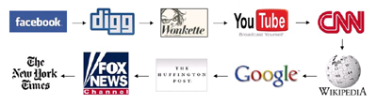 Figure 1. Users generally visit multiple sites to gather enough information to understand a news event or issue.

GATHERING AND ORGANIZING DATA
IssueBrowser gathers data about issues related to the 2008 Presidential Election from a variety of different sources. These sources include YouTube, Wikipedia, Google, Wire Service News via Yahoo's News aggregator, a collection of the speeches of the candidates, Poll data, and others. Most of this data is gathered automatically on a daily basis, though some types of data is in a form that requires custom scripts to process it. Issue Browser has a modular architecture so that data sources can be added or modified as needed. We aim to have a large sample of data from various sources and in various media so that we have an accurate representation of the range of perspectivevs on the various political issues. Table 1 lists the modules that we have written thus far.
The gathering of the data is more-or-less straightforward. However there are two primary technical issues involved in processing the data into a form that can be used by the visualization. First, we need to extract appropriate "granules" or "slices" from the data. Second, we need to link these granuales together.

Extracting Relevant Data
An important task in our gathering process is making sure that we keep only the elements of the source data that relates specifcally to a candidate or an issue. This is necessary both because of limited screen space and limited attention span. For instance, via our YouTube module, we might gather videos that are fifteen minutes long-- far too long to keep a viewer at a public installation engaged. We want to keep only the portions (sometimes lasting only twenty or thrity seconds) where a candidate describes his or her position on a particular issue. Similarly, an article about a particular event may have only a few sentences in a single paragraph about a particular candidate. We want to discard any information that is not explicitly relevant to the domain of the 2008 presidential election. The methods of extracting relevant information depend both on the media and the source. For instance, to get slices of video we rely on transcripts (if available) and speech recognition tools to recognize keywords associated with a particular issue.

Linking Data Together
We need to associate the granules of data both to candidates and to issues, and also to assign keywords/tags to the granules so that they can be related to other granules. For insatnce, to get quotes by candidates from news articles we have a simple but effective pattern matching algorithm that uses a list of keywords generated from candidate's official position on political issues which allows us to link text data to issues. We have developed the technique of assigning an "issue signature" to each granule which enables us to weave together related themes within the data. This issue signature is a vector containing a measurement for each indentified issue. The issues themselves are determined dynamically each day by running the Latent dirichlet allocation algorithm on the sum total of all the textual data collected for that day [3]. Each granual of data is then compared to each cluster to determine the measurement for each issue. Relevant portions of the "issue signature" vector are then used for comparisons between two items of data to determine how related the data is to each other in light of a subset of issues.
Table 1. Information Retrieval Modules
Module | Result | Technique
YouTube - videos | video slices featuring candidates or issues | video processing, speech recognition, text analysis
Yahoo News - articles | extract quotes by candidates talking about | text analysis, keyword analysis
Yahoo News - articles | identify sentences or paragrahs discussing issues and/or candidates | collocation analysis
Wikipedia - candidate pages | identify general facts about a candidate | collocation analysis
Wikipedia - issue pages | identify general facts about an issue | collocation analysis
Expert input | tool to let users enter in fact and associate them to a particular issue | manual entry
You Tube - comments | sample of comments about relevant videos | YouTube API
Issue Identification - candidates' speeches | clusters of words/phrases defining issues | Latent dirichlet allocation
Poll Data | statistics tagged with temporal and geospatial information | Screen scraping; scripts to extract relevant data from database tables
Google Blog Search | sample of opinions about issues and candidates from blogosphere | keyword analysis

Re-contextualizing Data
Another feature of the modular architecture is the ability to recombine two sets of data gathered from different sources and media so that are situated in relation to each other. These relationships can then be visualized in order to show connections between data that might not otherwise be recognized. For instance, we have gathered poll data from the website usaelectionpolls.com and fundraising data gathered from opensecrets.org. Even though the data is timestamped differently (poll data is conducted occasionally; fundraising data is gathered daily) we can normalize the time discrepancy in order to visualize the relationship. Furthermore, we filter out portions of the data we are not currently interested in. For instance, we can exclude one of the candidates and clamp the temporal range to a particular time frame. This ability to dynamically re-contextualize the data allows us to generate specific chart data related to information that the user is interested in (see section 4.3).
Further details of this multimedia information retrieval component of our system-- including relevant data extraction, automatic category assignment, and multimedia data analysis techniques-- are described in a forthcoming paper by the authors.

VISUALIZATION
The goals of the visualization are the follwing: to foster collaboration/communication between multiple users; to show pertinent information from different perspectives; to present information through different media; and to let users explore data that is increasingly related to a particular line of inquiry.
The visualization displays a changing set of interconnected data nodes. The visualization displays these data nodes in clusters across four screens. Within each cluster, data nodes are displayed in standard ways: videos are represented with an image; facts and quotes are represented by snippets around the text that indicates the text's primary issue; time series data (animated charts) are represented by the first instance in the series; Candidates are represented by their names and a recent image. Issues are represented with a text label. The data nodes are positioned so that each item is easy to view, and the layout attempts to keep relevant items stationary while indicating new data through movement (see section 4.4).
Multiple clusters are spread across the multiple screens. More active clusters begin to take up more screen space as new data nodes are generated, while inactive clusters eventually disappear as the inactive data nodes are removed from the visualization (see section 5). Figure 2 shows a schematic of a typical setting where three clusters (differentiated by color) are more or less evenly distributed over four screens. If no clusters are active, then the system will begin to automate a simulation of user activity in order to provide fresh content to the visualization.
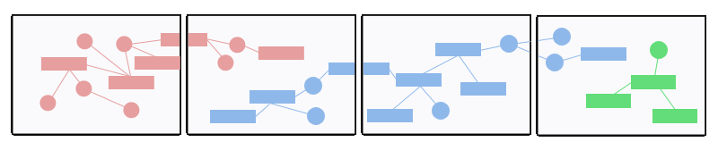
Figure 2. Span of multiple graphs over multiple screens.

Pinning/Unpinning
Wexelblat and Maes introduced the notion of an object having an "interaction history" and using this historical information to allow users to interact with the data in new way [20]. IssueBrowser similiarly includes a mechanism to allow users to mark various objects in the visualization through the process of "pinning" particular data nodes. This mechanism allows the user to contextualize newly visualizations being generated by the system.
Unlike traditional selection, in which a user chooses an item expecting to get further information about the selection, user navigation of IssueBrowser occurs through selecting data that then influences future queries. In selecting a data node the user does not know exactly which results will be returned. The user will however know that the results will be in some way related to his selection. We call this form of selection "pinning" the data. Multiple data nodes can be pinned simultaeously, and all of the pinned data will be used to retrieve new data nodes which must be related to all of the currently pinned data. Each time new data nodes appear on the screen, they serve as choice points for the user to investigate or ignore. Users can also actively "unpin" currently pinned data that they are no longer interested in.
By building up a set of pinned data nodes, users aggregrate their search interests to generate new data that becomes increasingly attenuated to a particular line of inquiry. That is, The visualization is continously generating new data at certain intervals, but this new data is thematically related, as controlled by users pinning or unpinning what they are or are not interested in. Data that is pinned will automatically become unpinned after some time amount has passed (see section 4.2).

Visualization Flow
The goal of many visual interfaces is to provide users with a wide range of data and the ability to easily drill down into more detailed information [1]. These goals can be in conflict. Simply providing more information can create a cluttered screen and lead to cognitive overload, which decreased the ability of users to make sense of the data. We want to be able to present the low-level detailed view alongside the higher-level view which serves to ground it contextually. IssueBrowser utilizes a simple flow of interaction which handles the space management of the data as well mantaining a balance between different levels of specifcity.
Each cluster begins with a single candidate or issue and then is built up in steps by both an automated retrieval process based on the pinned data (see section 4.1). The outline of the flow of each cluster in the visualization is made up of the steps outlined in Figure 3.
step 1: choose a starting data point, which is automatically pinned
step 2: create a small number of choice points related to pinned data and visualize them surrounding the pinned data point (the layout algorithm is described section 4.4)
step 3: choose one of the choice points to be pinned
step 4: if the data point is a piece of "playable" media, then start playing it (ie, video, time series chart, snippet->text)
step 5: go to step 2
Figure 3. Basic flow of visualization
Concurrently to these steps, for each data node a timer controls how long a data node remains pinned-- how long it influences the choice of new data. Once the timer runs down, the data become unpinned, and a second timer is started. When that second timer runs down the data node is removed from the display. Data that becomes unpinned can be re-pinned via user interaction. Likewise, pinned data can become unpinned via user interaction. The speed of the timer is dependent on a) how many nodes there are on the screen, and b) how many of those nodes are pinned. The visualization maintains an level of clarity. If there are lots of nodes on the screen, then the speed of the timers is increased so that nodes are removed from the display more quickly. If there are few nodes on the screen, then the speed of the timer is decreased so that nodes stay on the screen for a longer period of time.
For example, Figure 4 shows a schematic of the visualization flow at four time intervals. At t₁ a node a has been pinned and new data nodes b, c, and d is generated which are related to a. At t₂ node b is also pinned, so new data nodes e, f, and g are generated which are related to both a and b. At t₃ node f is also pinned, so new data nodes h, i, and j are generated which are related to a, b, and f. Nodes c and d have not been pinned for some time, they are scheduled for removal from the visualization. At t₄ node a becomes unpinned because enough time has passed.
Node h is pinned and some new data nodes are generated. Nodes e and g are scheduled for removal.
This example is of course simplified, in the actual visualzation a varying number of data nodes are generated asynchronously and the timing of data nodes becoming unpinned or scheduled for removal is dependent on how cluttered the screen is.

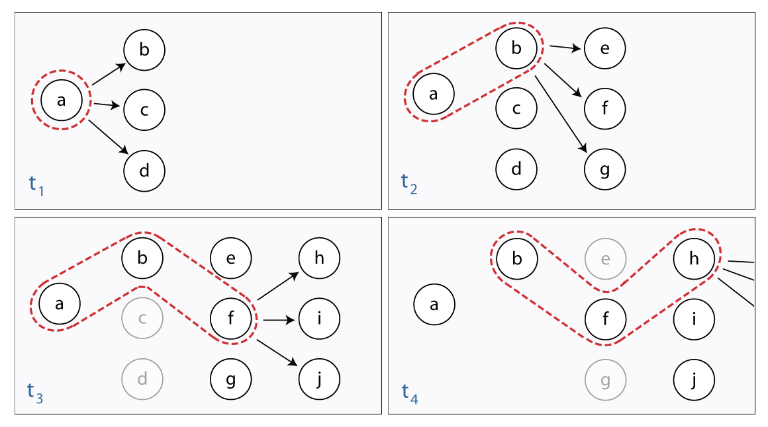
Figure 4: Schematic showing the visualization flow over four intervals of time.

Dynamic Generation of Animated Charts

In addition to displaying video and textual data that gathered from various sources, the visualization also displays charts which we have been dynamically created by filtering then recombining data from different sources (see section 3.3). In our current implementation, we visualize chart data as a animated pie chart which steps through a comparison the data at successive intervals. We are using the animated pie charts currently to display information about fundraising, about candidate popularity among different demographics, and frequency of common words and phrases in speeches over the last months of the campaign. Figure 7 shows a screenshot of the application including an animated chart.

Circular Extent Layout
Our layout algorithm highlights the ability of the visualization to present increasingly detailed information while maintaining a broad overview of the issues. The layout algorithm works in conjunction with the temporal aspect of the pinned data so that a balanced amount of information is always on the screen-- neither too sparse nor too cluttered. Our layout emphasizes the following basic principles: to never obscure data, to have information be in motion only as it appears on the screen (and otherwise to be still).
Given an ordered set of new data (related to the currently pinned data), the algorithm places the new data according to the steps outlined in Figure 5:
step 1: determine available regions to place new data
step 2: find the most appropriate region from the set of available regions
step 3: place new data inside the chosen region along a circular extent
step 4: determine if the new data fits and adjust if necessary
Figure 5: Overview of steps to position new data nodes
In step 1, we determine available regions by drawing line segments from the center of the most recently pinned data to the edge of the screen and which intersect the corners of other data nodes. Regions which do not contain or intersect the inside of other data nodes are considered to be available. In step 2 we find the most appropriate region from the set of available regions. For each available region do the following: i) draw the shortest line from the center of the most recently pinned data to one of the edge of the screen contained within the region; ii) find the midpoint of that line; iii) draw an arc through the region around the most recently pinned data with a radius of the midpoint determined in the previous step. We then use these arcs to choose the region 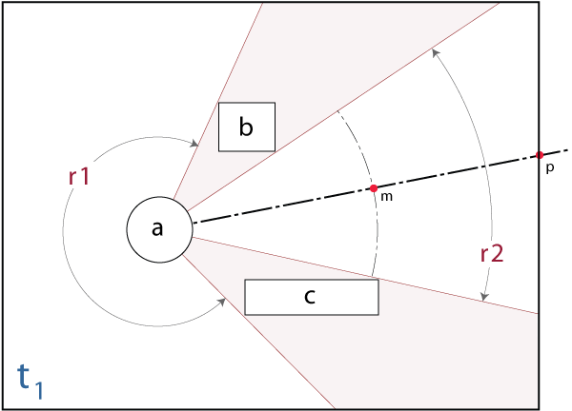
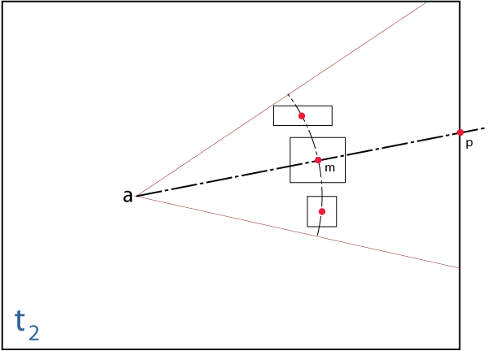
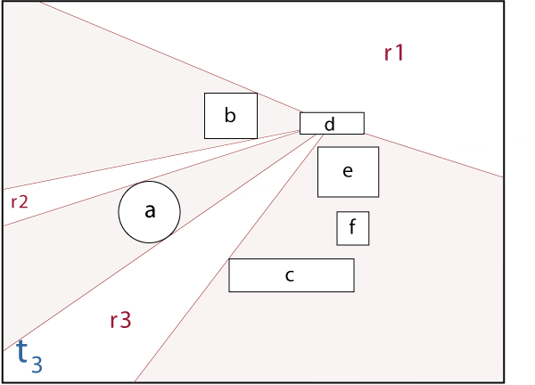
Figure 6. Schematic of layout based on circular extents.
which has the arc with the longest arc length as the most appropriate region. In step 3, we place the new data nodes inside the chosen region along the arc. First we position the center of first data node at the center of the arc. This splits the arc into two sides. Then for each remaining new data nodes, we pick the side of the arc which has the longest arc length and position the new data so that its center is along the arc and that adjoins the new data that has already been placed. The arc will continue to have two sides remaining in which to place new data. In step 4, we determine if the new data fits. If at any point during step 3 a new data node intersects one of the edges from the most recently pinned data to the bounds of the screen, then recalculate the radius of the arc by increasing it by 50% of the current radius. We then repeat step 3 to reposition the new data. If at any point during step 3 a new data node intersects the bounds of the screen, then recalculate the radius of the arc by decreasing it by 50% of the current radius and repeat step 3 to reposition the new data. If after step 3 is complete the remaining arc length on either side of placed data is greater than a specified threshold, then recalculate the radius of the arc by decreasing it by 50% of the current radius. In this case we again repeat step 3 to reposition the new data. If after a specified number of attempts to place data we have not successfully positioned the data, we can either scale the size of the data nodes, or reduced the number of data nodes to be placed by removing those with the largest width or height. Figure 6 illustrates steps 1-3.
Because there is a relationship between the number of data nodes on the screen and the speed of the timers (see section 4.2), in general the new data fits within the chosen region without needing to scale or reduce the size of the data nodes.

INTERACTION / COLLABORATION
Users interact with the visualization using a wireless Nintendo Wii controller. Pinning and unpinning data-- the only action available to the users-- occurs when a user aims the controller over a data node and holds it steady for a few seconds. Unpinned data becomes pinned and vice-versa. Pinning data nodes that are playable, such as videos and animated charts, also causes them to play. Unpinning this data while it is playing will immediately cause it to suspend playback. Similarly, textual data nodes represented by a snippet of a longer section of text data will expand to show full sentences or paragraphs when the data node is pinned. The data node will revert back to snippet form when it becomes unpinned.
We chose to to simplify the interaction as much as possible so as to encourage participation and collaboration. Recent evidence points to the conclusion that collaboration has educational benefits in terms of both increasing users' attention span (users spend more time at the installation) and capacity to learn (by introducing the added dynamic of performance and teaching) [16].
Dividing the screen real-estate into separate and unconnected areas allows users to work in isolation or in parallel to other users. For instance, one cluster can be set up to explore data related to a particular candidate and a particular issue, while a comparison is setup via a second cluster to explore data related to a second candidate and that same issue.

FUTURE WORK
In this paper we have described a public installation that required us to combine existing or create novel information retrieval and visualization methodologies In particular, we are excited about the ongoing possibilites for recombining and re-contextualizing multimedia information in ways that are both surprising and statistically significant. The main goal of this visualization application is to present multimedia data in a collaborative environment to facilate knowledge acquisition. To that end we present related choice points based on the similarity and recentness of those choice points to pinned data. However a future research goal is to find ways to present information that is both topical and surprising to a user. That is, to identify and to present information that explicitly challenges a user; that forces the user to analyze their position on an issue.
Another area of research we would like to pursue is incorporating local data sets along with the more national data sets we are collecting now. Linking political events on the national level to local events in a user's daily life would make our installation much more meaningful for a user.
IssueBrowser currently excludes all public figures except for the main presidential candidates. There are of course a large number of people who shape public policy. As we continue with this project, and especially as the 2008 Presidential Election comes to a close, we would like to begin adding in some of the other "major players" in politics. Moreover, many voices are only occasionally heard in the mainstream news sources. Including them would inrease the diversity of viewpoints and topics available via IssueBrowser. However, It is open question as to whether or not adding yet more data to our installation will help or hinder our stated goal of helping users acquire meaningful knowledge about important political issues.
We are also developing a desktop version of IssueBrowser. We plan to include more sophisticated interactions with the visualization via a mouse and keyboard and allow the user to fine tune some of the properties that control the flow and layout of the visualization as well as the parameters that control data retrieval.

Evaluation Studies
To measure the extent to which our installation enhances knowledge acquisition, we propose to compare learning outcomes under two conditions: (1) using IssueBrowser’s system of targeted information delivery, and (2) adding “noise” to IssueBrowser, such as extraneous text and images not directly related to the pinned user choice points.
It is our hypothesis that IssueBrowser reduces cognitive load by performing information gathering and filtering processes and thus reducing the feeling of information overwhelm experienced by novice users. To test this hypothesis, we will compare participant learning outcomes in the abovementioned conditions. We will measure learning outcomes through tests on knowledge retention and transfer in the domain of the 2008 Presidential campaign. We will distribute a pre-questionnaire that measures prior knowledge, subject matter interest, frequency of news website use, and technical expertise. We will then ask users to spend a specified amount of time using IssueBrowser and test their understanding of overall connections between candidates and issues. In our post-questionnaire, we will again measure their levels of interest and familiarity with the topic. We will then analyze our data to determine which factors affect participant performance.

ACKNOWLEDGMENTS
The research for this paper was made possible by a NSF IGERT grant.

REFERENCES
- Ahlberg, C. and Shneiderman, B. Visual information seeking: tight coupling of dynamic query filters with starfield displays. In Proceedings of the SIGCHI conference on human factors in computing systems (CHI '94), ACM Press, New York, NY, 1994, 313-317.
- Azevedo, R. & Cromley, J.G. 2004. Does training on self-regulated learning facilitate students’ learning with hypermedia? Journal of Educational Psychology 96 (3), 523-535.
- Blei, D. M., Ng, A. Y., and Jordan, M. I. 2003. Latent dirichlet allocation. Journal of Machine Learning Research 3 (Mar. 2003), 993-1022.
- Brand-Gruwel, S., Wopereis, I., and Vermetten, Y. 2005. Information problem solving by experts and novices: Analysis of a complex cognitive skill. Computers in Human Behavior 21, 487–508.
- Eades P., & Lin X. 2000. “Spring algorithms and asymmetry,” Theoretical Computer Science 240, (September, 2000), 379-405.
- Gee, J.P. 2003. What Video Games Have to Teach Us about Learning and Literacy. Palgrave Macmillan, New York.
- Gee, J.P. 2005. Learning by design: Good video games as learning machines. E-Learning 2, 5-16.
- Hölscher, C. and Strube, G. 2000. Web search behavior of Internet experts and newbies. Computer Networks 33, 337-346.
- Koh, E., Kerne, A., Webb, A., Damaraju, S., and Sturdivant, D. 2007. Generating views of the buzz: browsing popular media and authoring using mixed-initiative composition. In Proceedings of the ACM Conference in Multimedia (Augsburg, Bavaria, Germany, September 23-28, 2007). MM ’07. ACM, New York, 228-237.
- Lazonder, A.W. 2000. Exploring novice users’ training needs in searching information on the WWW. Journal of Computer Assisted Learning 16, 326-335.
- Li, J., Plaisant, C., and Shneiderman, B. 1998. Data object and label placement for information abundant visualizations. In Proceedings of the 1998 Workshop on New Paradigms in Information Visualization and Manipulation (Washington, D.C., United States, November 02 - 07, 1998). NPIV '98. ACM, New York, NY, 41-48.
- Lloyd, L., Kechagias, D. and Skiena, S., Lydia. 2005. A System for Large-Scale News Analysis. 12th Symp. of String Processing and Information Retrieval, (SPIRE '05), Lecture Notes in Computer Science, 3772 (2005) 161-166.
- Mayer, R.E. 2001. Multimedia learning. Cambridge University Press, New York.
- Nonaka, I.. and Takeuchi, H. 1995. The Knowledge Creating Company: How Japanese Companies Create the Dynamics of Innovation. Oxford University Press, New York.
- Pirolli, P. and Card, S. 1999. Information foraging. Psychological Review 106 (4), 643-675.
- Peltonen, P., Kurvinen, E., Salovaara, A., Jacucci, G., Ilmonen, T., Evans, J., Oulasvirta, A., and Saarikko, P. 2008 It's Mine, Don't Touch!: interactions at a large multi-touch display in a city centre. CHI 2008, 1285-1294.
- Rainie, L., Cornfield, M., and Horrigan, J. 2004. The Internet and Campaign 2004. Pew Internet and American Life Project, Washington, DC, 2005.
- Shneiderman, B. and Maes, P. 1997. Direct manipulation vs. interface agents. Interactions 4, (Nov. 1997), 42-61.
- Sweller, J. 2005. Implications of cognitive load theory for multimedia learning. In R.E. Mayer (Ed.), The Cambridge Handbook of Multimedia Learning, 19-48. Cambridge University Press, New York.
- Sweller, J. (1994). Cognitive load and theory, learning difficulty and instructional design. Learning and Instruction 4, 295-312.
- Wexelblat, A. and Maes, P. 1999. Footprints: history-rich tools for information foraging. In Proceedings of the SIGCHI Conference on Human Factors in Computing Systems: the CHI Is the Limit (Pittsburgh, Pennsylvania, United States, May 15 - 20, 1999. CHI '99. ACM, New York, NY, 270-277.
- Wineburg, S.S. (1991). Historical problem solving: A study of the cognitive process used in the evaluation of documentary and pictorial evidence. Journal of Educational Psychology 83 (1), 73-87.

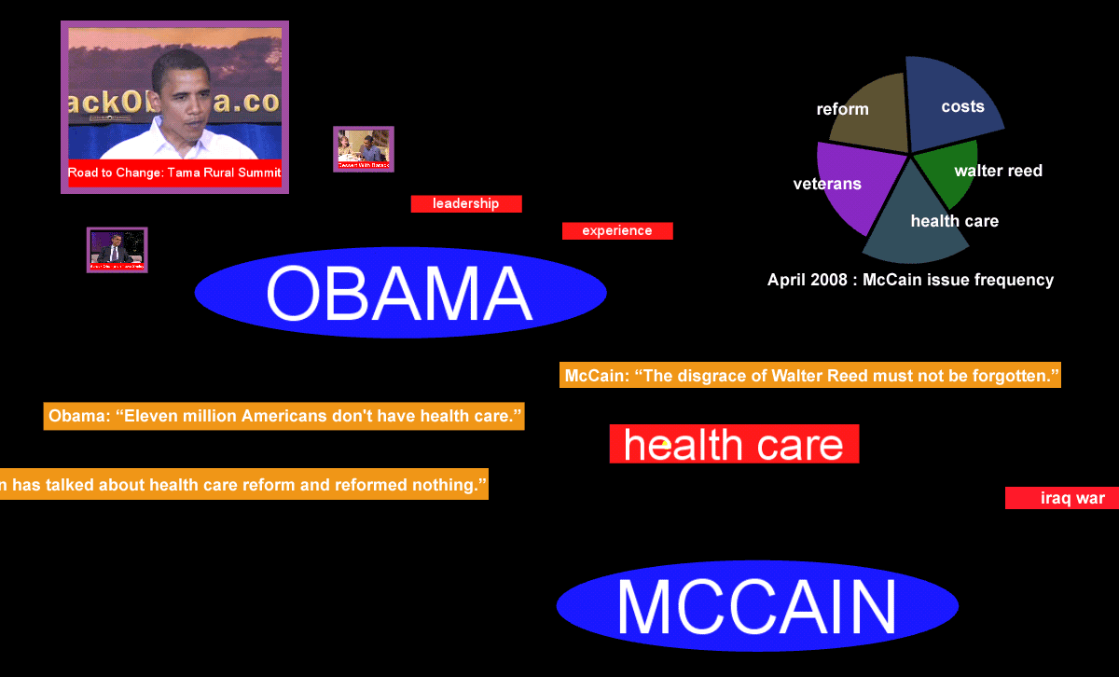
Figure 7 : Close-up of data cluster. The candidates "Obama" and "McCain" are pinned, as well as the issue "health care" and a video of Obama giving a speech.

