

Business Plan Executive summary

Confidential

This document contains confidential information and may
not be distributed beyond the authorized recipient.

Synaesthetic Software, Inc.
PMB #340, 94-98 Nassau Avenue
Brooklyn, New York 11222
Telephone: 718.302.2119 Distribution Date: _____________
www.synaesthetic.info Copy Number: _____________

EXECUTIVE SUMMARY
syn-es-the-sia n. Physiol. Sensation produced at a point other than or remote from the point of stimulation, as of a color from hearing a certain sound (fr. Gk, syn = together + aisthesis = to perceive).

OUr Mission

Synaesthetic Software is a technology development firm that was established to create educational and entertainment software applications to accelerate the music learning process. We seek to be the premier developer of music education software and music-oriented gaming technologies. Our mission is to provide easy to use performance based learning systems for people with all levels of musical skills ranging from beginners to professionals and from students to teachers. We will succeed based on our ability to deliver and license applications developed using our patent-pending analysis and feedback technologies integrated with advanced multimedia technologies to create intuitive and uniquely customized aural and visual learning experiences for each individual user.

The Company
Synaesthetic Software was founded in December, 2001 by industry veterans with a combined total of 20 years related experience in creating innovative technology solutions, software product development, music products sales and marketing. Our team’s members have diverse backgrounds and all are professionals at their trade – most have had formal music training, extensive musical performance experience and have had the privilege of sharing their knowledge as educators. All of us share the same passion of being able to empower people to pursue their creative dreams and overcome any barriers in developing their musical skills and abilities. We have leveraged all our expertise to ensure proper planning, development and positioning of our technologies and product offerings. The company and all development since it’s founding has been self-funded.

teCHNOLOGY & Patents
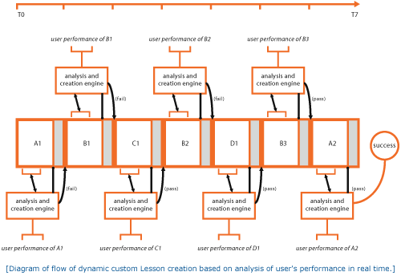
Psychological research has shown that people learn best when they are neither too frustrated nor insufficiently challenged. Our patent-pending Lesson Analyzer technology is the core of our computer-aided music education system. This core technology is the key to developing tools that accelerate conceptual comprehension in learning and technical proficiency in performing a musical piece or lesson. The initial products we are developing around this technology have the ability to hone in on the exact point of a student's problems and/or competencies, and create lessons on the fly that perfectly match the student's level of proficiency.

Cognitive science has shown that human thinking is based on the conceptual blending of metaphors. Our approach re-evaluates traditional metaphors of describing music and adapts them to the capabilities of the home computer.

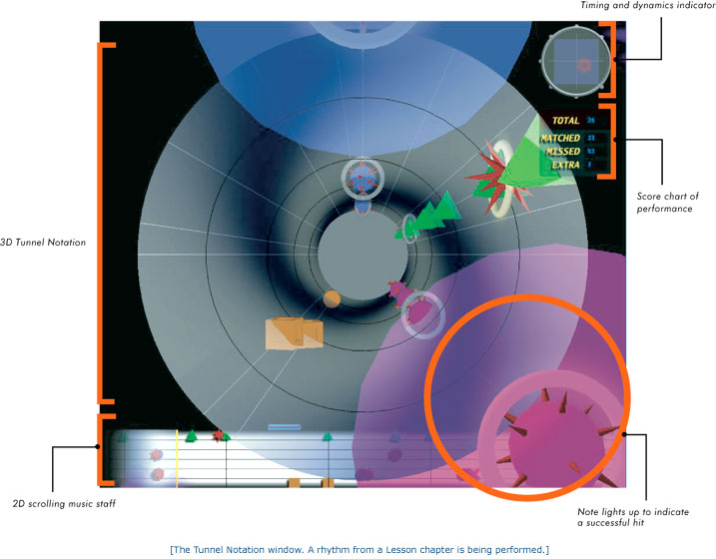

Synaesthetic Software’s Tunnel Notation ™ is an example of blending the metaphors of music notation with an approximate visual layout of the drum set, allowing a student to intuitively understand how a rhythm is to be played. An interactive three-dimensional visualization of the lessons helps the user to understand the relationship between the various musical concepts in the piece or lesson and to perform them on a musical instrument.

Synaesthetic Software originally filed for a patent on its intellectual properties in August 2002. We anticipate our patent to be granted by mid 2004 or before.

OUR Positioning
Synaesthetic Software will focus exclusively on developing the technology and applications that accelerate the musical learning and performance process. We seek position ourselves as the leading developer of accelerated learning technologies for music and music related games. Although we initially plan on distributing our products electronically one of our main business goals is to enter into publishing/distribution agreements with larger more established companies who possess the financial resources and marketing power to ensure our products reach the widest customer base possible. Additionally, we plan to demonstrate concepts and discuss development or technology licensing agreements with developers of arcade, PC and console games; musical hardware manufacturers; music and educational toy companies, universities as well as operators and developers of location based entertainment systems.
TEN-YEAR STUDY SHOWS MUSIC IMPROVES TEST SCORES

Regardless of socioeconomic background, music-making students get higher marks in standardized tests.

UCLA professor, Dr. James Catterall, led an analysis of a U.S. Department of Education database. Called NELLs88, the database was used to track more than 25,000 students over a period of ten years.
The study showed that students involved in music generally tested higher than those who had no music involvement. The test scores studied were not only standardized tests, such as the SAT, but also in reading proficiency exams.
The study also noted that the musicians scored higher, no matter what socioeconomic group was being studied.

the mARKET
Although several ideas for licensing have been previously noted we will initially focus our efforts on marketing our products directly via the Musical Instrument (MI) and Music Education markets. Research regarding the positive benefits to students involved in music education and the ongoing support of music education by organizations such as The American Music Conference (AMC), VH1 Save the Music and TI:ME - The Technology Institute for Music Educators has help us confirm our mission in this area.

With numerous high profile industries reporting sales declines the past few years the MI market as a whole experienced a year worth $6.9 Billion in sales in 2002. The total sales related to percussion instruments had increased to just over $475 Million. Now that drum kits are widely available for under $400 retailers report that an increasing number of kits are being purchased as gifts for aspiring young percussionists. Sales specifically of electronic drums have continued to increase steadily to just over $40 Million and music related software and computer music products accounted for a total of nearly $224 Million in sales. Music software alone reached a record high of $167 Million.
High school music students score higher on SATs in both verbal and math than their peers. In 2001, SAT takers with coursework/experience in music performance scored 57 points higher on the verbal portion of the test and 41 points higher on the math portion than students with no coursework/experience in the arts.

Source: Profile of SAT and Achievement Test Takers, The College Board, compiled by Music Educators National Conference, 2001.

Finally, printed music sales, which include music educational materials as a sizable share, peaked at just under $500 million. As more publishers of these materials continue to embrace the power and value of technology the more new opportunities will arise for licensing and bundling of relevant software applications to enhance and electronically deliver publishers and artists content.

pRODUCTs
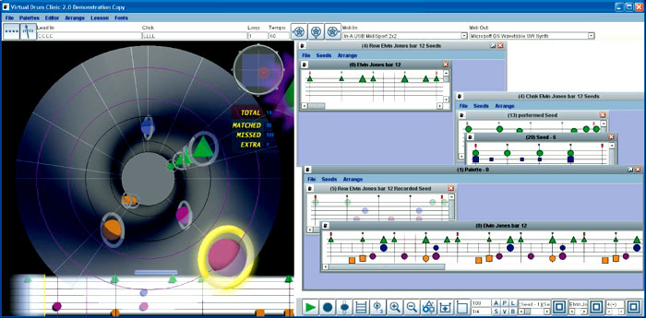
The Virtual Drum Clinic ™ is the first in a suite of products we are developing to leverage our patent-pending technologies. The Virtual Drum Clinic is a full-featured multi-media application that enables the user to become proficient at learning all aspects of the drum set. It offers a powerful set of tools that are adaptable to all skill levels. Simple enough to teach a beginner within a matter of hours and at the same time advanced enough to teach an experienced or professional drummer new musical ideas. The Virtual Drum Clinic provides users with a unique system to identify musical structures, offers customized feedback of performance, and utilizes an intuitive visualization of music to make learning musical concepts easy.

The Virtual Drum Clinic is currently running as a Windows software application. Due to the fact that much of the application development has been done in Java™ it is a fairly simple process to export the technology and rapidly develop applications for various other platforms and operating systems including Macintosh OSX or even an online browser based web application.

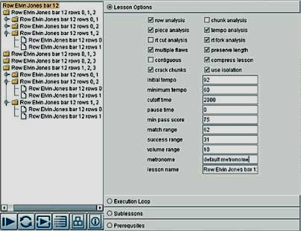
At the heart of the Virtual Drum Clinic is a system of structuring musical data as a set of recursive "Music Objects". These objects can be used to define layers of musical concepts within a rhythm to any degree of granularity, from long musical phrases to single notes. These object structures, which can be automatically generated or user-defined, serve as the basis for our real-time Lesson Analyzer. The Lesson Analyzer identifies the structures within a performance of a lesson that are the weakest, and then dynamically generates personalized lessons to provide the student with exactly what he or she needs to improve.

Tunnel Notation is an exciting method of presenting music visually and aurally to the musician. The traditional music staff is visualized as a 3-dimensional tunnel on which notes fly toward the musician. Because the notes are mapped to the layout of the drum set, the musician is able to see the music in an intuitive, understandable manner, allowing for the rapid comprehension of even advanced musical concepts. Key features of Tunnel Notation include:

- Instant interactive feedback that indicates when notes are hit correctly
- Color-coded notes that make it easy to see how to play patterns with the correct sticking
- Different sizes to indicate the volume of the notes
- Different shapes that visually separate different musical concepts
- Precise scoring system that indicates success of playing instruments at the correct time and volume
- Adjustable views that control the depth of the tunnel and the amount of information that can be seen at one time
- Visual metronome markers that allow multiple visual indications of rhythmic pulse and musical structure to make it easy to grasp the interplay of ideas among different limbs
- Accurate display of musical performance that allows a user to learn subtleties of dynamics and feel, and to model an actual performance, not merely an approximate transcription

The actual content component of the Virtual Drum Clinic is called the Lesson Module. These are pre-defined lessons that contain exact transcriptions of music performances, and detailed steps to present the musical concepts within these performances. We plan to offer a variety of ongoing series of Lesson Modules covering the most popular genres of music in order to attract the widest possible user base for the products. Lesson Modules are key components to the Virtual Drum Clinic and offer the company significant ongoing revenue and marketing opportunities.

A Lesson Module is authored in our proprietary Composition Editor. This powerful tool empowers creators of Lesson Modules with everything needed to develop curriculum for the Virtual Drum Clinic. Key features include:

- Analysis tools to identify and model a drummer's musical styles
- Tools to generate dynamic rhythms that mimic improvised musical logic
- Export and import to MIDI data from any other music software package or sequencer
- A configurable JavaScript engine for algorithmic composition
- Seamlessly integrates with Virtual Drum Clinic's Lesson Analyzer and Tunnel Notation

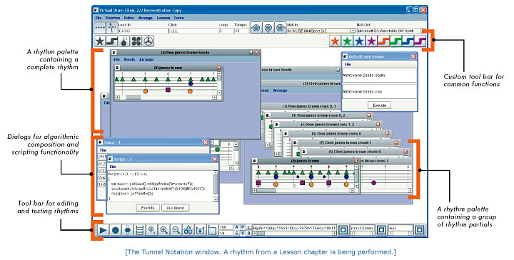

It is yet to be determined whether or not the Composition Editor will be productized and made available as a stand-alone product for educators to develop their own Lesson Modules or if Synaesthetic Software will keep this as a proprietary tool and control the overall opportunity to market Lesson Modules to it’s users.

cOMPETITION
Besides the actual musical instruments other products traditionally targeted at music education have been primarily printed method books and sheet music. As VHS and DVD machines gained wider market share music instruction/tutorial products featuring popular and respected musicians from companies like Homespun Video and DCI have became increasingly popular. Although many of these products provide extremely useful lessons and material the production quality tends to be low due to budgetary restrictions and more importantly they do not provide the user with any form of interactivity or personalized learning experience. Additionally, end-users can spend anywhere ranging from $25 up to $60 for a single lesson, which offers only limited usefulness once the student masters the material.

With advances in technology and the competitive pricing of personal computers in recent years various educational products and teaching systems have been introduced. These have ranged from basic CD-ROM’s for teaching basic blues guitar from companies like UbiSoft to complete music teaching labs installed at schools using the latest sound generation, digital audio and MIDI technologies from leading manufacturers like Roland, SoundTree (Korg USA) and Yamaha.

With all the current technology based music education products on the market today no company is offering software based interactive learning system to facilitate drum education for players of all levels. The Virtual Drum Clinic offers the power, interactivity, 3D visualization and expandability coupled with the potential to have personalized instruction and broad access to any possible musical style. This data has been validated by market research and discussions with key personnel at various levels of the musical instrument industry who are intimately knowledgeable of the music and multimedia software market. Below is a basic comparison chart of some popular drum education technology products currently available.

Company | Product | Type | Beginner | Pro | Educator | Visualization | Interactivity | Extensible | MSPR
Synaesthetic Software | Virtual Drum Clinic | Software | Y | Y | Y | Tunnel Notation | Y | Y | TBD
Voyetra | Teach Me Drums | DVD | Y | N | N | Clips/Standard Notation | N | N | 24.95
Yamaha | Stickmaster |  | Y | N | N | Basic | Y | N | 39.95
Alan-McAfee | Drum-O-Meter | Hardware | Y | Y | Y | LED | Basic | N | 149.95
Roland | Rhythm Coach | Hardware | Y | Y | Y | LED | N | Basic | 200.00
Hudson Music | Steve Smith | DVD | N | Y | Y | Clips/Notation | N | N | 49.95
Konami | DrumMania | Game | Y | N | N | Game / PS2 | Y | Y | ?
Harmonix | Amplitude | Game | Y | N | N | Game | Y | N | 40.00

mARKETING & dISTRIBUTION
Synaesthetic Software will focus its initial marketing and sales efforts on creating initial sources of sustainable business from two main channels.

- The promotion, sale and digital distribution of the Virtual Drum Clinic and Lesson Modules targeted at various levels of students and offering a variety of popular material covering multiple genres. Initial sales will be fulfilled factory-direct digitally and promoted via a Virtual Drum Clinic web site. Additional online distribution relationships may be developed with online retailers of music software/hardware and via promotional or affiliate relationships with other music or drum related web properties. Target MSRP pricing for the Virtual Drum Clinic is between $129.00 and $249.00. Lesson Modules will retail between $19.95 and $34.95 depending on the complexity and overall length of the musical piece.

- Synaesthetic Software will pursue a longer-term non-exclusive licensing strategy to create revenues as a technology and application-licensing firm. This flexibility will allow us to respond to rapidly changing market factors strictly from a technology development perspective and not need to focus on managing retail distribution channels and accounts receivables from a large distribution network. In such a model, Synaesthetic Software will license core technologies and applications to music publishers, software publishers, game developers and/or other musical instrument manufacturers. We anticipate each licensing deal to be structured by negotiating up-front licensing fees ranging from $50,000 to $250,000 for licenses and ongoing royalties based on unit sales. Additionally, we will charge for professional services that may include application development, product customization and integration.

Synaesthetic Software is currently working to establish strategic partnerships with music education organizations, key market influencers from both the performance and teaching communities, music manufactures and university music labs. We seek to discuss business opportunities, participation in standards committees, conferences, research grants companies and possibilities to license and co-develop products for musicians of today and the future.

fINANCIAL oVERVIEW

Five-Year Revenue Goal

(Thousands) FY2003 FY 2004 FY 2005 FY 2006 FY 2007

Product Sales Revenue* 240 350 565 850 1,275
License & Royalty Revenue 175 675 1,050 1680 2,520
Total Revenues 415 1,025 1,615 2,530 3,795

* Product Sales Revenue projections based on sales of Virtual Drum Clinic and Lesson Modules only. Does not include future products developed using our proprietary technologies.

investment opportunity & cAPTITAL rEQUIREMENTS
Over the past year an a half, the company has been personally funded by it’s founder Angus Forbes to the sum of approximately $150,000 the following purposes: formation of an LLC, attorney fees, submitting patent filings final development of core technologies, initial market and competitive research and hiring additional developer for development work on the Virtual Drum Clinic. Having successfully completed these milestones the company is now raising up to eight hundred thousand dollars ($800K) of financing to finalize development, beta-test the Virtual Drum Clinic and for basic business operations, small offices, conducting additional industry research, competitive analysis, interface design, product & technology marketing, building demos for games developers and prospecting key distribution and licensing targets. Specifically, over 60% of this financing will be applied directly to engineering, documentation and the testing resources required. We anticipate that we will have a commercially viable product and technology in six (6) months from the date of the investment and will begin offering initial product via a Virtual Drum Clinic web site.

Based on our very conservative growth models and forecasts we show that we will then require approximately one million dollars ($1 million) specifically for investments in increased business operations with an emphasis on marketing and in building the team required to support larger licensing deals and for launching additional versions of the Virtual Drum Clinic and offer a continually growing library of Lesson Modules. We forecast that should we elect to pursue the strategy of licensing only and based on various licensing models we should require a smaller second round of investment and reach profitability much quicker rate than if we were to ship and support our own commercial product.

EXIT STRATEGY

The professional audio and musical instrument marketplace has not been immune from the pattern of mergers and acquisitions changing the face of the business world. This pattern is evident in broadcast, the post production/studio community as well as in the guitar and drum-manufacturing world. Perhaps the most evident is within the digital media and software segment of the industry where convergence of audio and video applications has prompted the purchase of several leading audio/music software manufacturers by their larger counterparts in with primary interests in the video, production and personal computing markets.

Synaesthetic Software seeks to gain market share, brand equity and be profitable in the niche areas described above within two years from our formal launch. We will then be positioned to either: raise additional capital to fund new technology development and expansion or be acquired by a firm who seeks to gain access to our core technologies, products and soon to be established customer base.

Young children with developed rhythm skills perform better academically in early school years. Findings of a recent study showed that there was a significant difference in the academic achievement levels of students classified according to rhythmic competency. Students who were achieving at academic expectation scored high on all rhythmic tasks, while many of those who scored lower on the rhythmic test achieved below academic expectation.
Source: “The Relationship between Rhythmic Competency and Academic Performance in First Grade Children,” University of Central Florida, Debby Mitchell Did You Know?

MOST LIVES RESOUND WITH THE SOUND OF MUSIC
Nearly half of American households are enlivened by the sounds of instrumental music.
In 45% of US households, at least one person plays a musical instrument, according to a survey conducted by the Gallup Organization for the National Association of Music Merchants. One-fourth of those households have two musicians, and 10% can have ensembles with three or more players.
Whether or not they play an instrument, Americans place a great deal of value on musical experience. About 95% of all adults surveyed say that music provides a means of self-expression helps develop poise and confidence and instills appreciation in arts and culture. Almost 90% also believe music education helps children in particular to develop intellectual and social skills.
Wall Street Journal

Appendix A – Team profiles
Angus Forbes, Founder and President
Mr. Forbes is the founder of Synaesthetic Software and the inventor of The Virtual Drum Clinic. Previously, Mr. Forbes was the Director of Module Development for the Advanced Technologies group at Micromuse, Inc., where he developed a set of algorithms that determined the physical and logical connectivity of disparate network devices for the telecommunications industry. In this role, he managed a team responsible for the implementation and customization of these technologies at a number of sites, including Sprint, SBC, Cox Communications, Marconi, JP Morgan Chase, and France Telecom, among others, leading to millions of dollars in sales. Prior to this, Mr. Forbes joined a start-up company, Calvin Alexander Networking as an executive officer and assisted in the creation and implementation of automatic network discovery software. Calvin Alexander Networking was acquired by Micromuse in December 1999 for $42 million, generating a 5:1 return for its investors. Mr. Forbes also worked as a developer at Metalab Communications. He was a teacher at the University of Utah, where he did graduate work in British and American Literature. Mr. Forbes is a musician and has performed and studied drums for over 10 years.

Michael Dillion, Lead Software Architect
Mr. Dillon is the head of software development at Synaesthetic Software. He is an expert in the mathematical foundations and implementation of digital signal processing (DSP), experienced especially in all current technologies to create, analyze, and manipulate audio data. Some of his past projects include: creating beat detection algorithms, software synthesizers, a variety of VST plug-ins for custom audio filters, and a dynamic beat generator application, among other things. Prior to joining Synaesthetic Software, Mr. Dillon was a co-founder of Antigravity Studios, where he developed a highly robust and scalable content management system that provides businesses with an intuitive system to update their web content, without requiring any knowledge of programming. He also worked as a developer and project manager at Annotate Technologies (formerly Annotate.net), where he created a series of data-mining algorithms to retrieve and categorize information over the Internet. Additionally, he managed developer relations with Inktomi, provider of search engine algorithms for Yahoo and other portals, interfacing with their technology and databases to create custom applications. Mr. Dillon is also a professional bass player and electronic musician who at the California Institute of the Arts studied extensively with jazz greats Charlie Haden and
Wadada Leo Smith.

Kal Dolgin, Business Development Advisor
Kal Dolgin owns and operates Gansevoort Marketing & Entertainment (GME) a sales and marketing consulting firm that provides services to clients in the audio, video and interactive technology arenas. He has over eighteen years of industry experience. Prior to starting GME Mr. Dolgin spearheaded new business opportunities at Lightningcast, Inc. a leading provider of ad insertion technology for streaming media. Before Lightningcast he was Licensing Director at Muze Inc. for the areas of broadcast, streaming media and consumer media applications. His efforts resulted in closed contracts and strategic partnerships with industry leaders such as MTV, E! Entertainment, MusicMatch and Clear Channel.

Mr. Dolgin also held Senior Sales positions at InterVU Inc. (Acquired by Akamai), US Web Corporation and was Director of Business Development for Hotz Interactive a developer of interactive music technologies co-founded by Mick Fleetwood. In each position he was responsible for managing sales processes, strategic planning and high-level client relationships. Earlier in his career, Kal worked at professional audio technology and musical instrument companies Unicord (now Korg USA), E-mu Systems Inc. and Ensoniq Corp where he held various sales and sales management positions both in the US and Europe. His accomplishments in Europe included a key management role in the development of E-mu’s European sales and distribution channels, which led to major increases in sales revenues, market share and the subsequent acquisition of the company by Creative Technologies Ltd. He was also the founder of International Networking Associates a London based firm that provided sales representation, product marketing and export consulting services to companies in the audio and musical products industries. His clients have included E-mu, Lexicon, Aphex Systems, Novation Electronic Music Systems, Prosonus, Digital Music Corp, Stirling Audio Systems Ltd and Waldorf GmbH.

Mr. Dolgin studied Business and Communications at the State University of New York, Brockport and also attended the Musicians Institute in both London and Los Angeles.

