**ST.XAVIER,S COLLEGE**

**Maitighar, Kathmandu**



**Database Management System Assignment #**

Yub Raj Basnet

013BScCSIT048 (4th Semester)

**Submitted to**

|  |  |
| --- | --- |
| Er. Sanjya Kumar Yadav  (Lecturer, St.Xavier’s College ) |  |

Update statement, alter;

Update tablename set age=’’,’’… where id=

Table (student):

Create table:

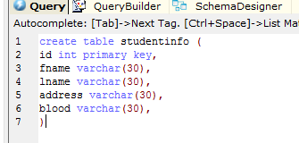

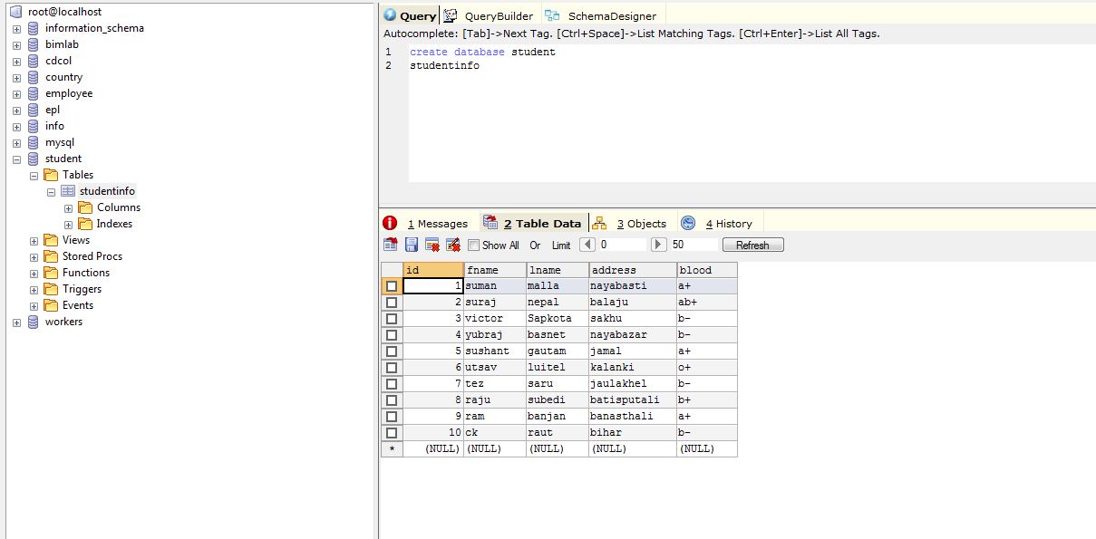

Alter(Add table column)

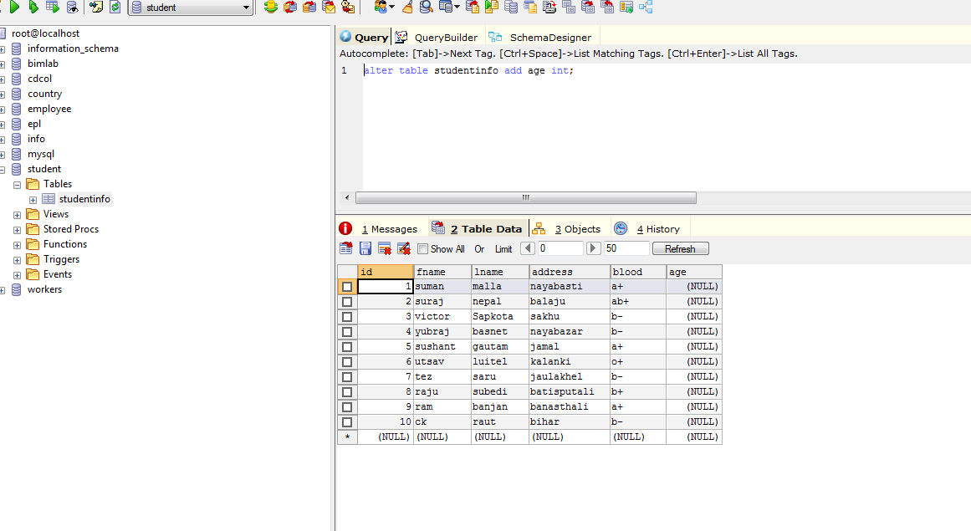



Update table:

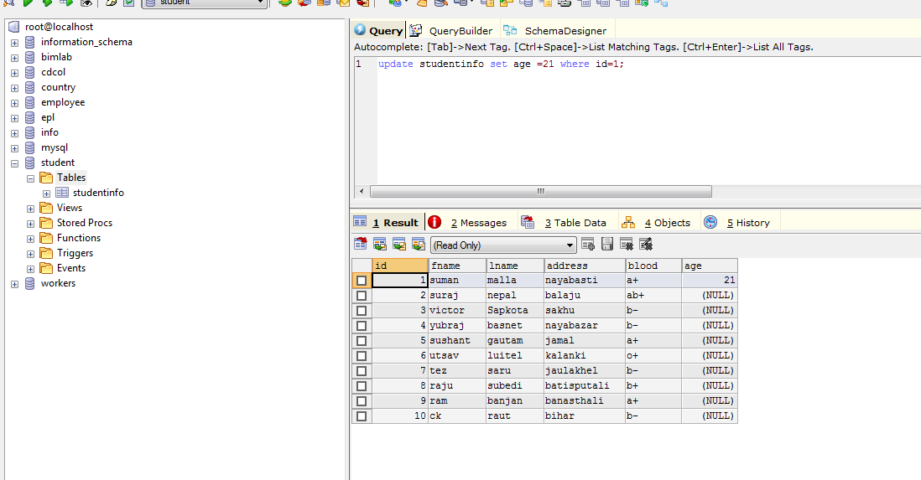



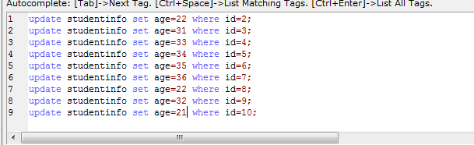

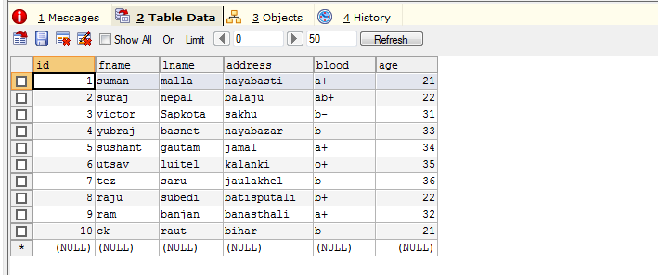

Drop Table:

