ST. XAVIER’S COLLEGE

**(Affiliated to Tribhuvan University)**

**Maitighar, Kathmandu**



**Database Management System**

**Lab Assignment #7**

**SUBMITTED BY:**

Siddhant Rimal

013BSCCSIT039

**SUBMITTED TO**

|  |  |
| --- | --- |
| **Er. Sanjay Kr. Yadav**  **( Lecturer )** |  |
| **Department of Computer Science** | |

Conditionally expressing pre-existing data from a table

Syntax:  
  
a. To logically compare number  
  
select [Attribute1],[Attribute2]..[AttributeN] from [Table_Name]   
where [logical expression of Numeric_Attribute];  
 *example:* select Eno, Ename, Salary from Employee where salary>4000;

b. To compare text/string

select [Attribute1],[Attribute2]..[AttributeN] from [Table_Name]   
where [String_Attribute]=”[Desired_String]”;  
 *example:* select Eno, Ename, Salary from Employee where Ename=”Hari”;  
  
c. To add multiple conditions {The AND/OR operator}

select [Attribute1],[Attribute2]..[AttributeN] from [Table_Name]   
where [String_Attribute]=”[Desired_String]” AND [logical expression of Numeric_Attribute];  
 *example:* select Eno, Ename, Salary from Employee where Ename=”Hari” and salary>4000;  
  
select [Attribute1],[Attribute2]..[AttributeN] from [Table_Name]   
where [String_Attribute]=”[Desired_String]” OR [logical expression of Numeric_Attribute];  
 *example:* select Eno, Ename, Salary from Employee where Ename=”Hari” OR salary>4000;  
  
d. Filter certain columns from desired table  
  
select [Attribute1]..[AttribueN] from [TableName];

example: select address from Employee;

e. Filter certain columns from desired table without duplication {distinct keyword}

example: select distinct address from Employee;

f. Range Specification  
  
select [Attribute1],[Attribute2]…[AttributeN] from [TableName]

where [Numeric_Attribute]<=[Lower Range] and [Numeric_Attribute]>=[Upper Range];

example: select Eno, Ename, Age from Employee where age>=24 and age<=28;

g. String Lookup

select [Attribute1],[Attribute2]…[AttributeN] from [TableName]

where [String_Attribute] like ‘ABC%’

1. Find Eno and Name of Employee whose salary>4000  
   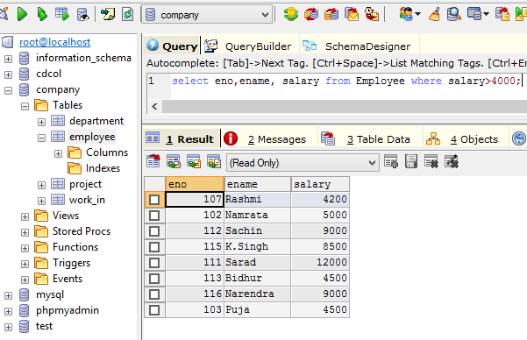

Fig : Employee number and Name of Employee whose salary is greater than 4000

1. Find the ename, salary of the employees whose salary is >5000 and job status is professor  
   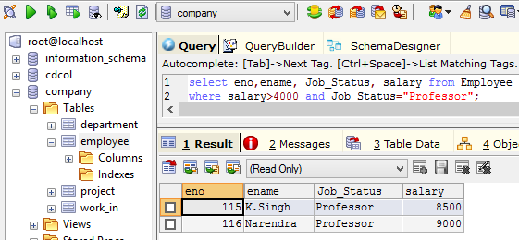

Fig : Employee number, Name, Job Status and Salary of Employee whose salary   
is greater than 5000 and job status is Professor

1. Removing Duplicates   
   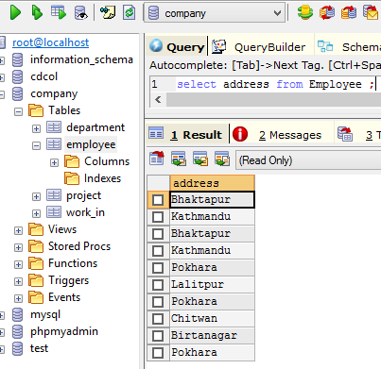

Fig : Employee addresses with duplicate values

select distinct address from Employee  
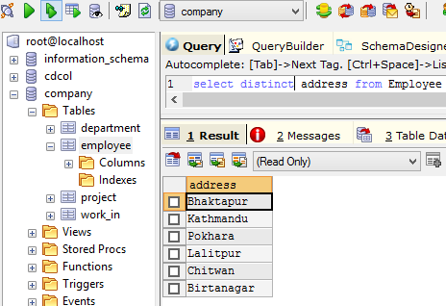

Fig : Employee addresses without duplicate values

1. Find the Eno, Ename, Salary, of the employee whose department number is 20 or job status Research Field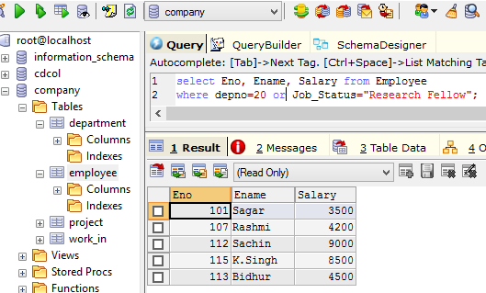

Fig : Employee Number, Name and Salary of Employee who works in   
Department No. 20 and has job status Research Fellow

1. Range Specification (In and Between)  
   Find the Eno, Ename, Age, Salary from the Employee where the age is between 24 and 28  
   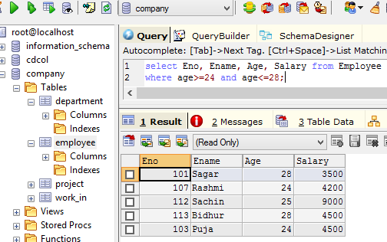

Fig : Employee Number, Name, Age and Salary of Employee whose  
ages are between 24 to 28

1. All strings that start with ABC  
   ‘ABC%’; example ABCD , ABCABC both satisfy the condition  
     
   All strings that end with XYZ  
   ‘%XYZ’;eg WXYZ, ZZXYZ etc  
     
   All strings that have the string AN in between   
    %AN%; eg: BANANA, ANAMIKA, MAN, etc  
     
   Find Eno, Ename with starting letter SA  
   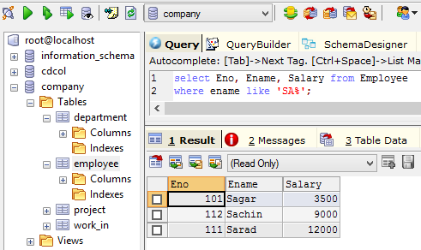

Fig : Employee Number, Name and Salary of Employee whose   
Ename consist of the substring ‘SA’ in prefix

1. List all employee names with their project names  
   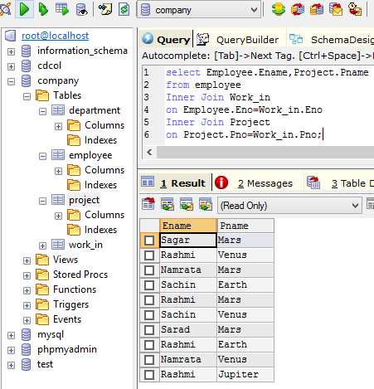
2. List name of all employee and their salary who are working in project MARS or VENUS  
   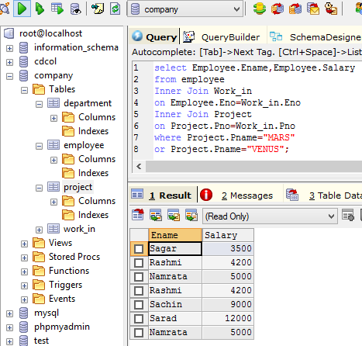
3. List Name of All Employees and their salary who are working in project EARTH and VENUS

1. List name and address of all employees who works in department which is located in Pokhara  
   