ST. XAVIER’S COLLEGE

**(Affiliated to Tribhuvan University)**

**Maitighar, Kathmandu**



**Database Management System Lab Assignment**

**SUBMITTED BY:**

**Bishal Pandey**

**013BSCCSIT016**

**SUBMITTED TO:**

|  |  |
| --- | --- |
| **Er. Sanjay Kr. Yadav**  Lecturer |  |
| **Department of Computer Science** | |

**Submission date:** October 9, 2015

Inserting to table college

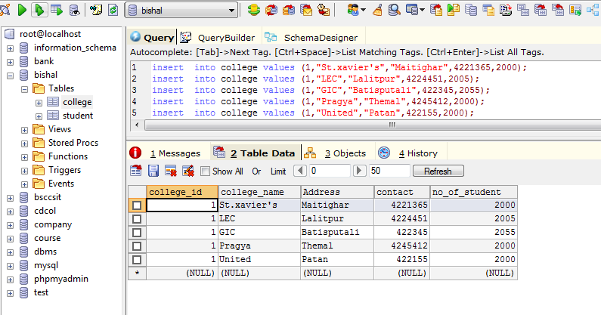

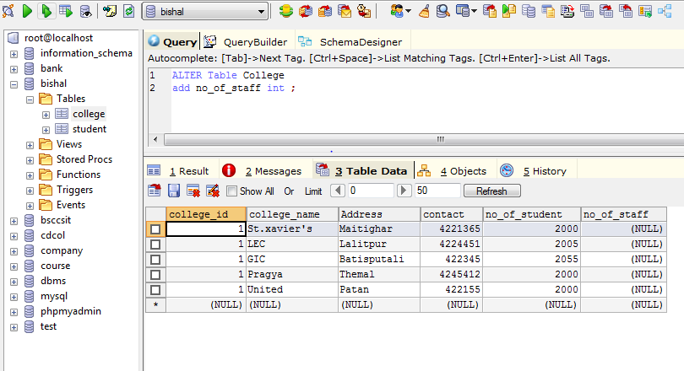  
updating

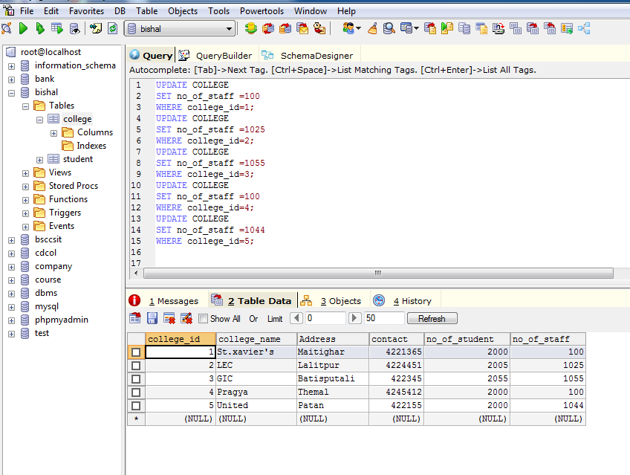

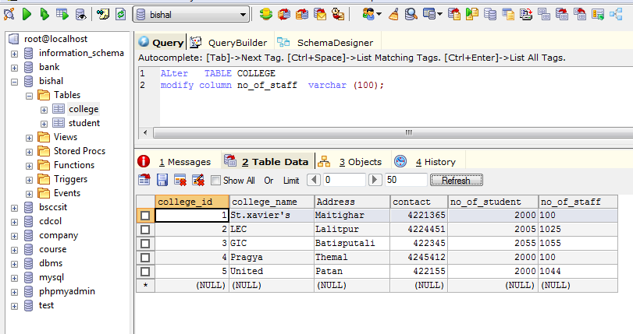

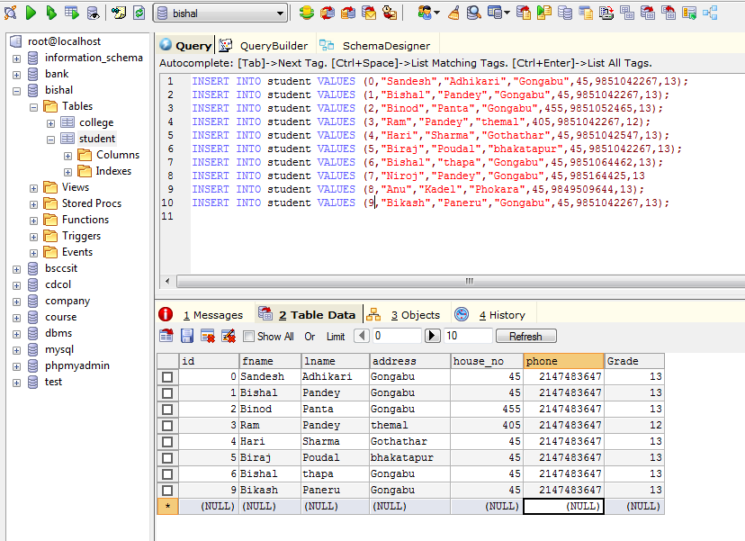

Fig creating table student

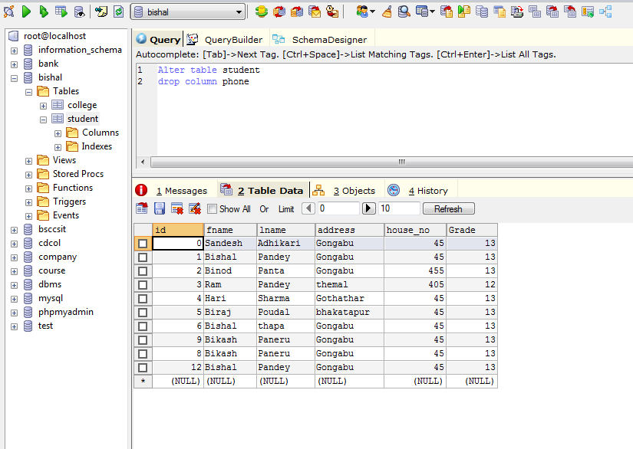

Fig:drop column Phone

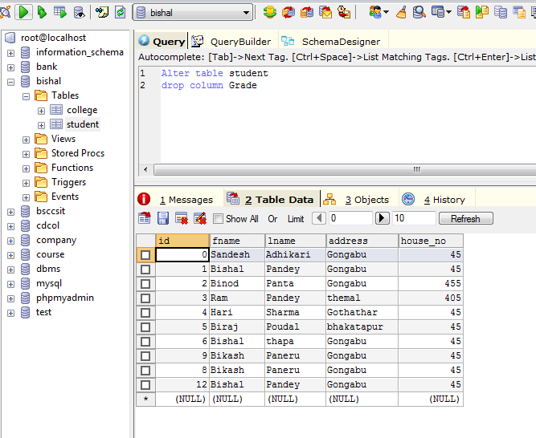

Fig:drop column grade