# ST.XAVIER’S COLLEGE

# MAITIGHAR, KATHMANDU



**ASSIGNMENT ON**

**Database Management System**

**Submitted By:**

Shaurabh Chapagain

013BSCCSIT037

**Submitted To:**

Er. Sanjay Kumar Yadav

Lecturer

Department of Computer Science

St. Xavier’s College

**INSERT** data into the table:

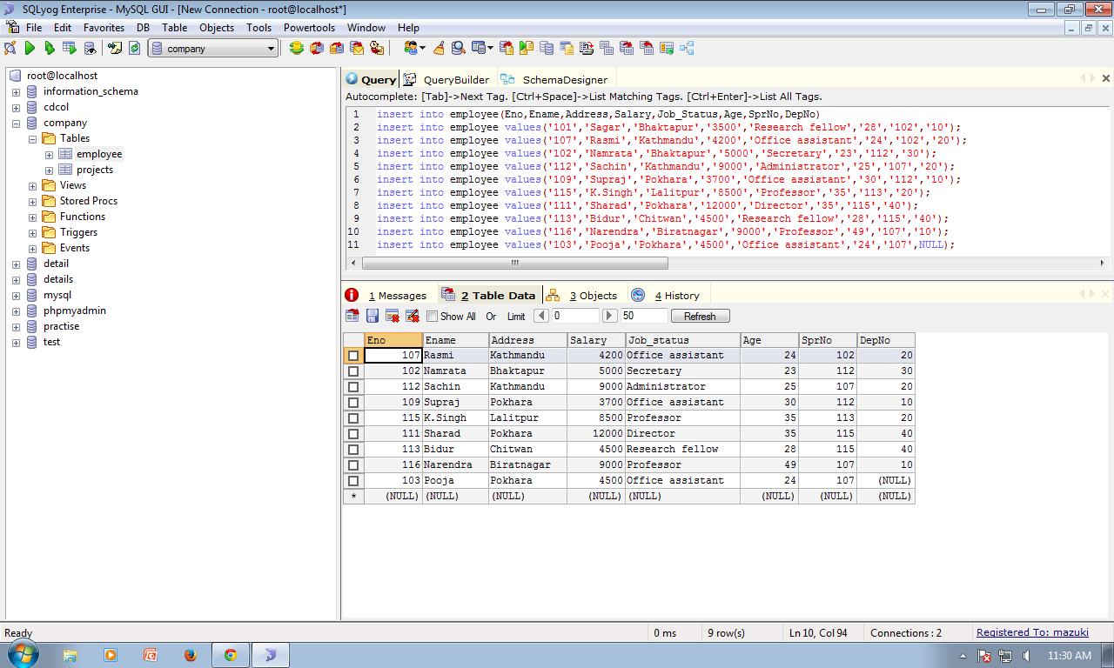

Create new column using **ALTER**:

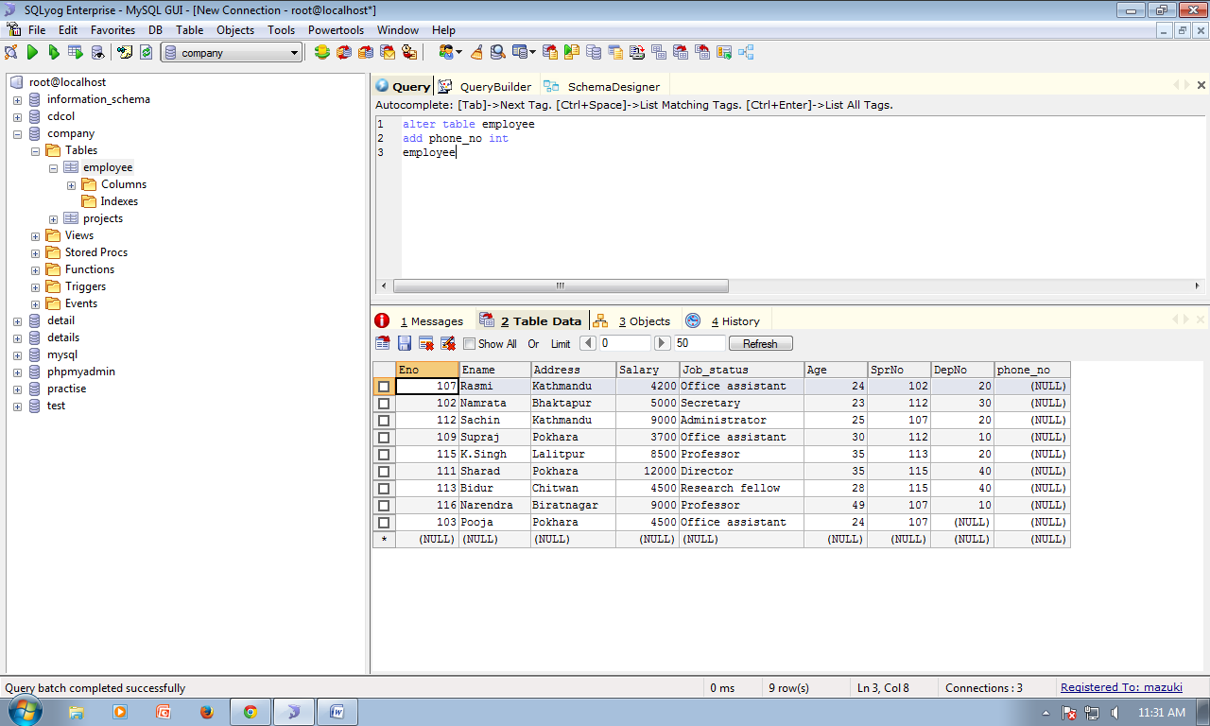

Insert value into new column using **UPDATE**:

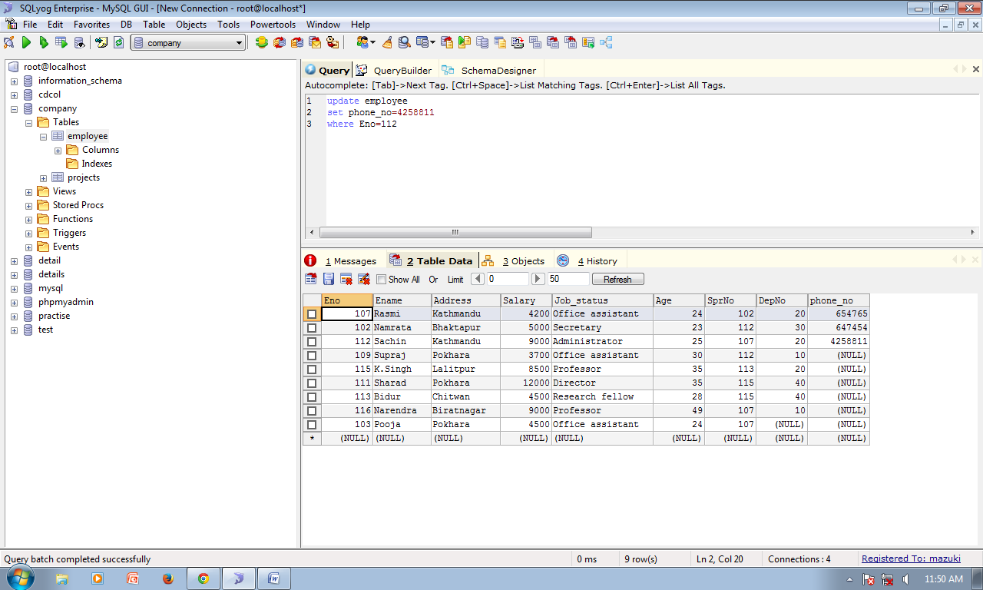

Change data type **ALTER** table and **MODIFY** column datatype:

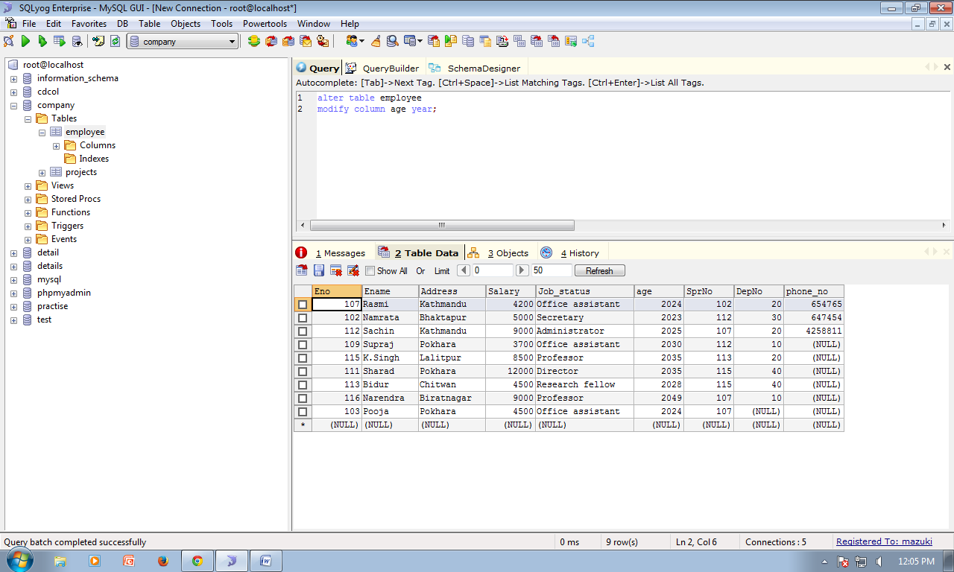

**CREATE** new table and **INSERT** data:

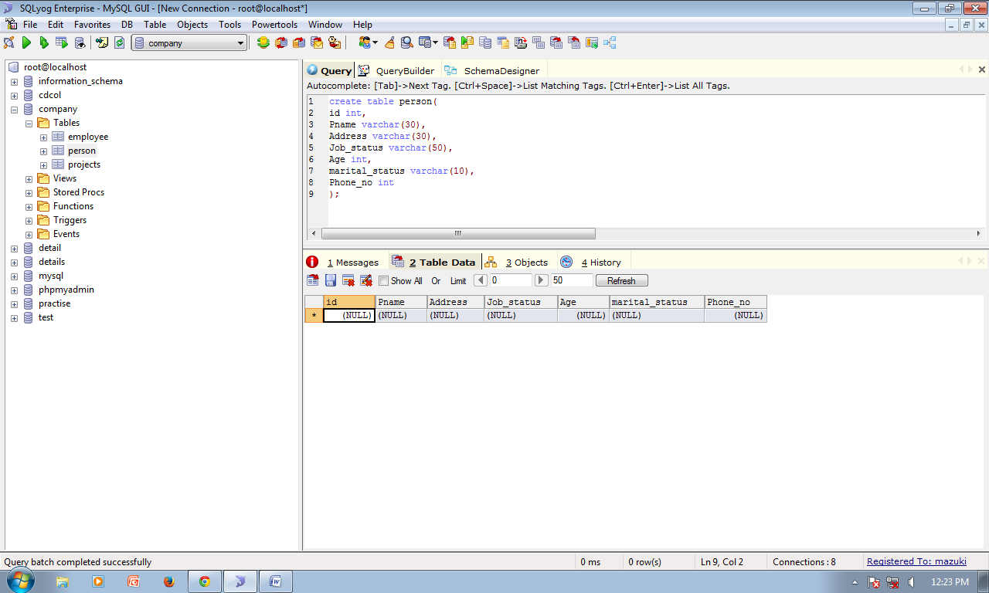

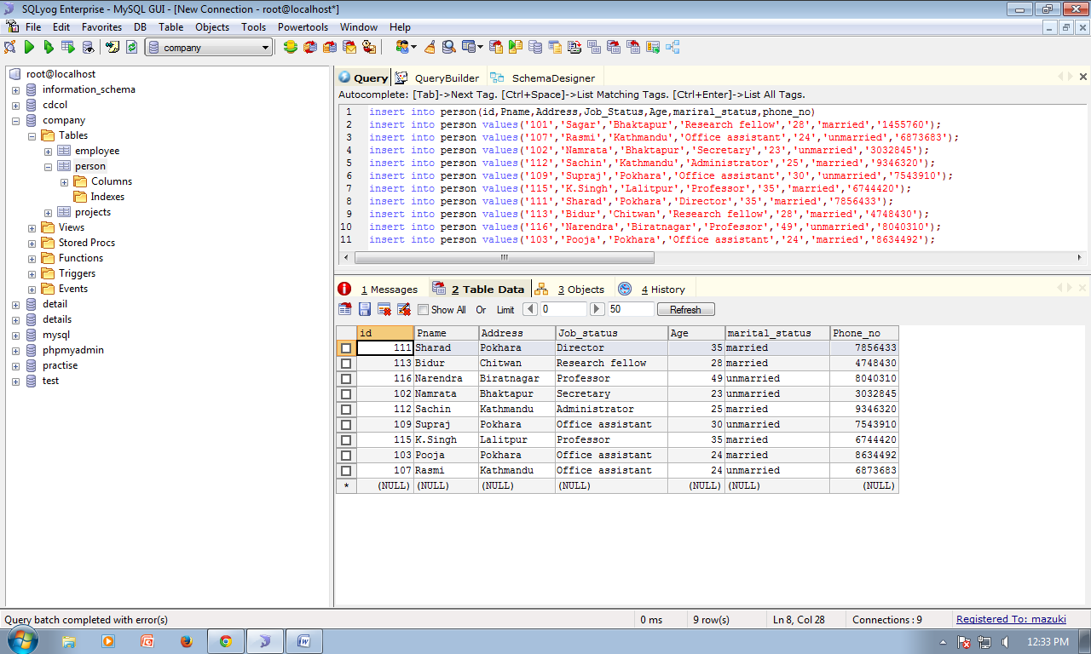

Drop column in a table using **DROP:**

