ST. XAVIER’S COLLEGE

**(Affiliated to Tribhuvan University)**

Maitighar, Kathmandu



**DBMS Lab #1**

**Submitted by:**

Pankaj Niroula  
013BSCCSIT025

**Submitted to:**

|  |  |
| --- | --- |
| Er. Sanjay K. Yadav  Lecturer Department of Computer Science |  |

**Date of Submission: October 9, 2015**

Creating an initial table ‘book’ with five attributes

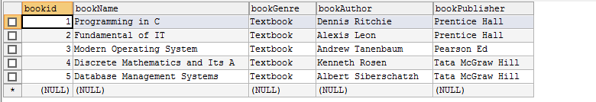

Adding an attribute to ‘book’



Result of adding ‘published’ attribute

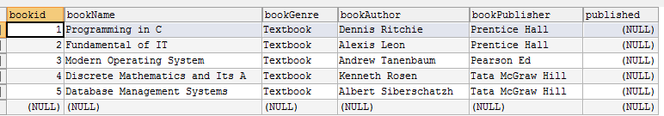

Updating value of ‘published’ in first row



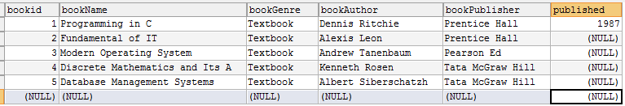

Updating value of ‘published’ in second row



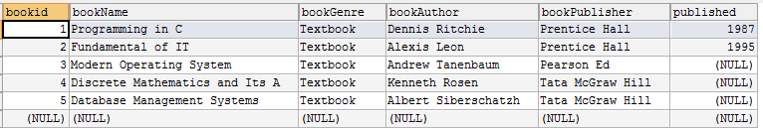

Updating value of ‘published’ in third row



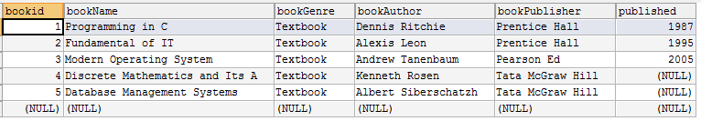

Updating value of ‘published’ in fourth row



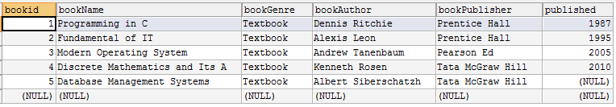

Updating value of ‘published’ in fifth row



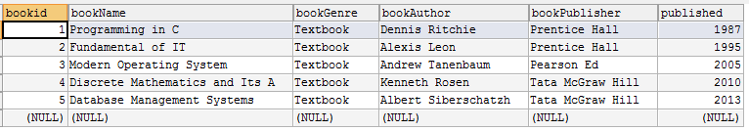

Changing the data type of published from year to date



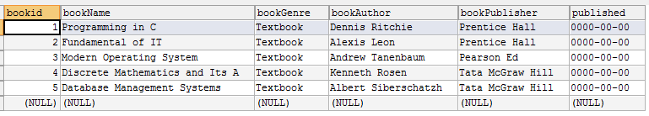

A table ‘movie’ with 7 attributes

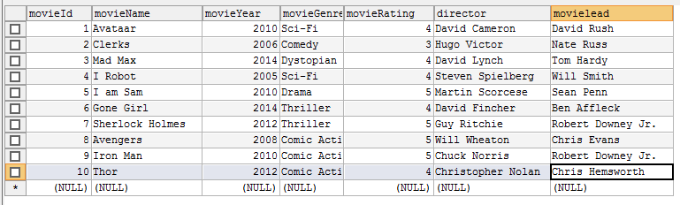

Dropping the column ‘movielead’



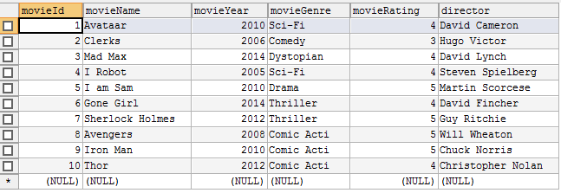

Dropping the column ‘director’



