ST. XAVIER’S COLLEGE

**(Affiliated to Tribhuvan University)**

**Maitighar, Kathmandu**



**Database Management System**

**Lab Report #3**

**SUBMITTED BY:**

**Siddhant Rimal**

**013BSCCSIT039**

**SUBMITTED TO**

|  |  |
| --- | --- |
| **Er. Sanjay Kr. Yadav**  **( Lecturer )** |  |
| **Department of Computer Science** | |

Submission Date: August 25th 2015

**3.1. Syntax for various operations**

**3.1.1. Inserting data into table**

Insert into table_name

values(value1,value2,….,valueN);

**3.1.2. Inserting specific data into table**

Insert into table_name(attribute1,attribute2,….,attributeN)

values(value1,value2,….,valueN);

**3.1.3. Inserting timestamp value into table**

Insert into table_name(Attribute1, Attribute2,.. AttributeN, Timestamp_Column) values(Value1, Value2, …. ValueN,current_timestamp);

**3.1.4. Inserting autonumber value into table**

**3.1.4.1. First insert the starting value i.e.1**

Insert into table_name(Autonumber_Column, Attribute2,.. AttributeN)

values(1, Value2, …. ValueN,current_timestamp);

**3.1.4.2. Then from 2nd step onwards, insert 0 only**

Insert into table_name(Autonumber_Column, Attribute2,.. AttributeN)

values(0, Value2, …. ValueN,current_timestamp);

**3.2. Screenshot**

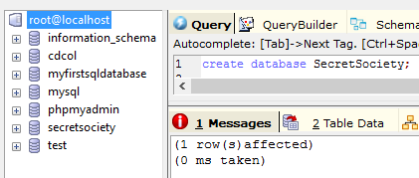

Fig 1: Creating a database

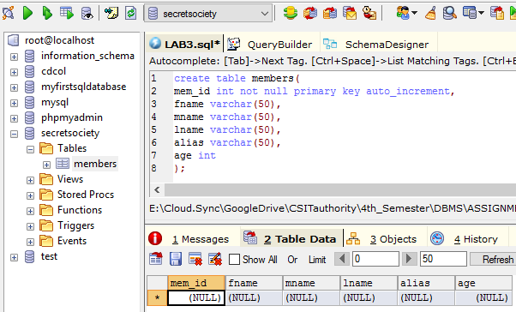

Fig 2: Creating a table

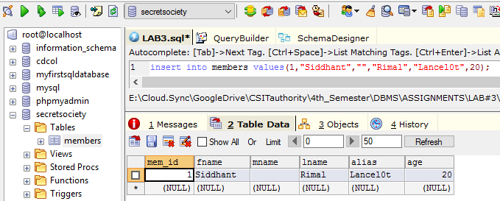

Fig 3: Inserting data into table

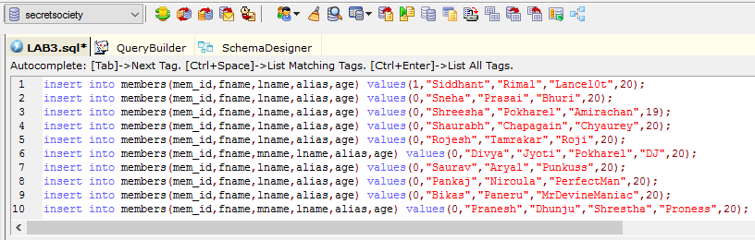

Fig 4: Inserting multiple data into desired columns in the desired table

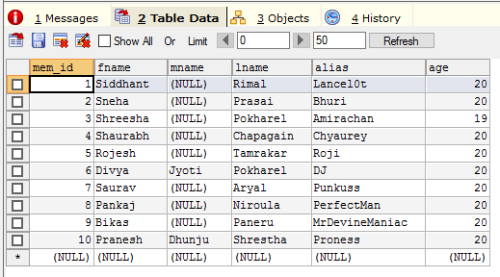

Fig 5: Demonstrating auto-increment property while inserting data

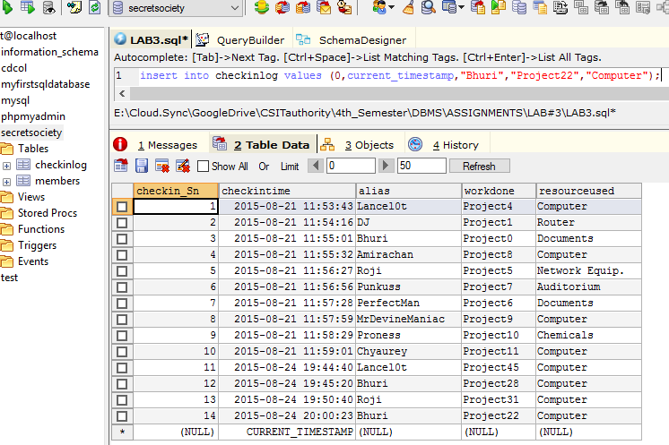

Fig 5: Inserting single data into the desired table

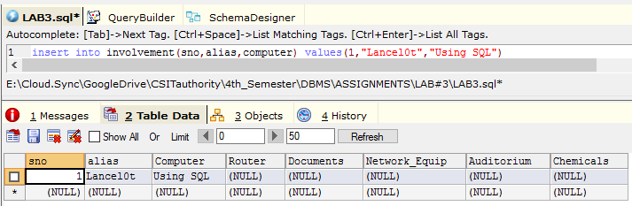

Fig 6: Inserting specific data into a specific column of the desired table

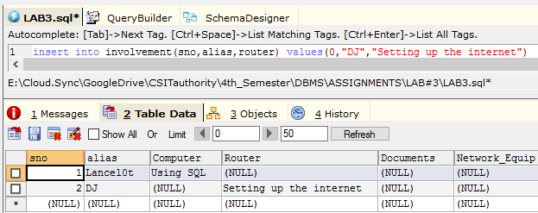

Fig 7: Inserting next specific data into a specific column of the desired table

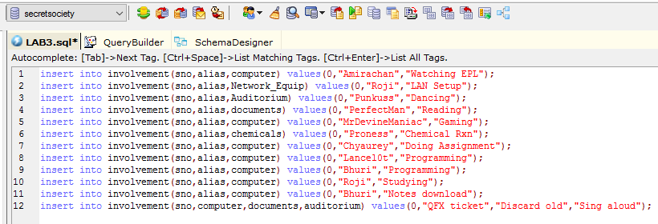

Fig 8: Inserting multiple specific data into a specific columns of the desired table

**Commands executed:**

insert into involvement(sno,alias,computer) values(0,"Amirachan","Watching EPL");

insert into involvement(sno,alias,Network_Equip) values(0,"Roji","LAN Setup");

insert into involvement(sno,alias,Auditorium) values(0,"Punkuss","Dancing");

insert into involvement(sno,alias,documents) values(0,"PerfectMan","Reading");

insert into involvement(sno,alias,computer) values(0,"MrDevineManiac","Gaming");

insert into involvement(sno,alias,chemicals) values(0,"Proness","Chemical Rxn");

insert into involvement(sno,alias,computer) values(0,"Chyaurey","Doing Assignment");

insert into involvement(sno,alias,computer) values(0,"Lancel0t","Programming");

insert into involvement(sno,alias,computer) values(0,"Bhuri","Programming");

insert into involvement(sno,alias,computer) values(0,"Roji","Studying");

insert into involvement(sno,alias,computer) values(0,"Bhuri","Notes download");

insert into involvement(sno,computer,documents,auditorium)

values(0,"QFX ticket","Discard old","Sing aloud");

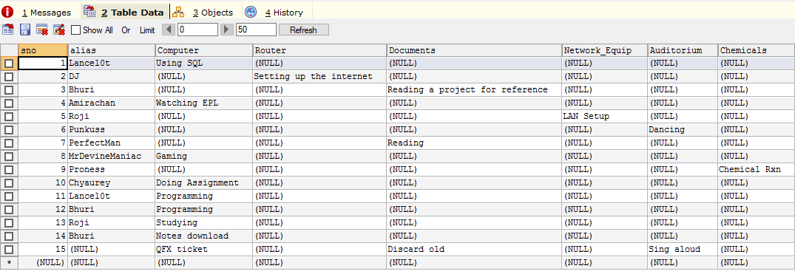

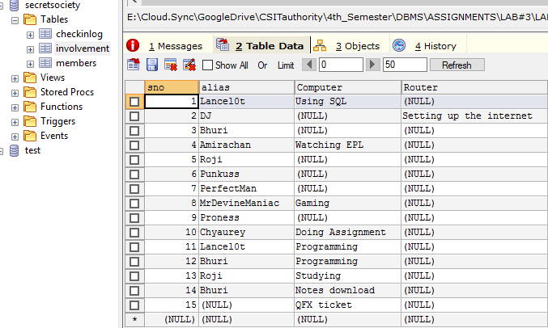

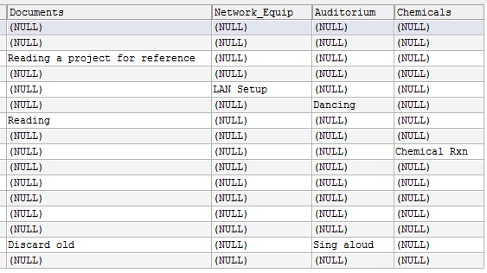

Fig 9: Data inserted in specific columns of the desired table

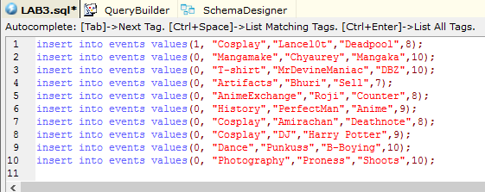

Fig 10: Data inserted in 4th table

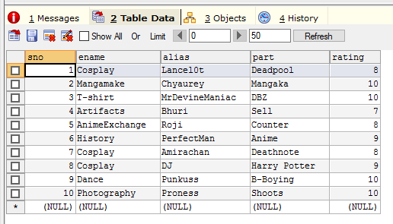

Fig 11: Data inserted in 4th table

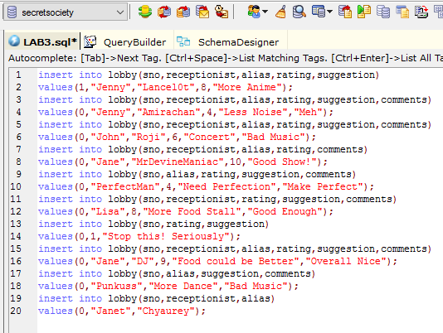

Fig 12: Data inserted in 5th table

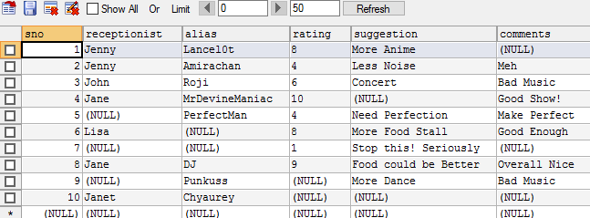

Fig 13: Data inserted in 5th table

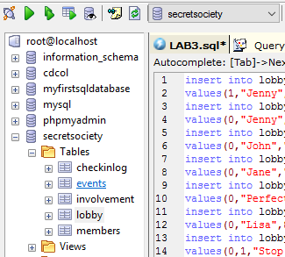

Fig 15: Tables and database involved

**3.3. CONCLUSION**

As mention herein, different kinds of commands can be used in SQL to create and drop table or database, add fields, insert timestamps to table, or even query the table with respect to the current time and date. There are also specific commands to add data in all or selected columns of desired table.

**3.4 References**

1. ”Introduction to SQL”, Wikibooks, Internet url: <https://en.wikibooks.org/wiki/Structured_Query_Language/Introduction_to_SQL> 2015 [20/08/2015]
2. Er. Sanjay Kr. Yadav, “Introduction to SQL”, Lecture, St. Xavier’s College 20/08/2015 [20/08/2015]