ST. XAVIER’S COLLEGE

**Maitighar, Kathmandu**

**(Affiliated to Tribhuvan University)**



**Database Management System**

**Lab Assignment #11**

**Submitted By**

Alok Shrestha

013BSCIT005

B.Sc. CSIT Year II/IV Semester

**Submitted To**

Er. Sanjay Kumar Yadav

Lecturer

Department of Computer Science

St. Xavier’s College

Maitighar, Kathmandu

**Submitted On**

October 2015

**The ALTER TABLE Statement**

The ALTER TABLE statement is used to add, delete, or modify columns in an existing table.

**SQL ALTER TABLE Syntax**

To add a column in a table, use the following syntax:

ALTER TABLE table_name

ADD column_name datatype

To delete a column in a table, use the following syntax (notice that some database systems don't allow deleting a column):

ALTER TABLE table_name

DROP COLUMN column_name

To change the data type of a column in a table, use the following syntax:

**SQL Server / MS Access:**

ALTER TABLE table_name

ALTER COLUMN column_name datatype

**My SQL / Oracle (prior version 10G):**

ALTER TABLE table_name

MODIFY COLUMN column_name datatype

**Oracle 10G and later:**

ALTER TABLE table_name

MODIFY column_name datatype

**Examples**

Initially,

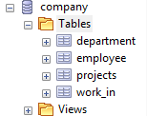

**Add a new Table**

CREATE table person (

id int,

pname varchar(20),

paddress varchar(20),

age int,

phone int);

After Adding Table,

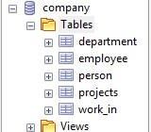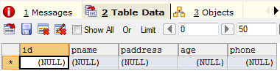

**Inserting Data into the table**

insert into person values (1, "Ram", "Ltp", 18, 551234);

insert into person values (2, "Talkjung", "Bara", 24, 120356);

insert into person values (3, "Rameshwor", "Siraha", 20, 985562);

insert into person values (4, "Tulke", "Acham", 40, 654765);

insert into person values (5, "Sukbinder", "Mahottari", 32, 576854);

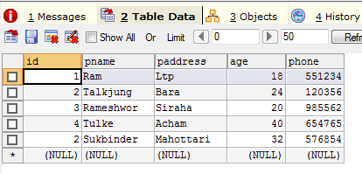

**Adding a column**

ALTER table person

add gender varchar(6);

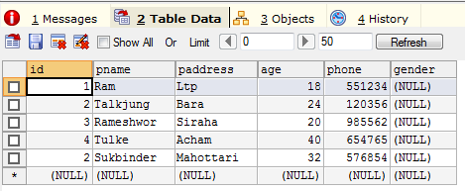

**Adding the column value to the added column**

UPDATE person SET gender="Male" WHERE id=1;

UPDATE person SET gender="Male" WHERE id=2;

UPDATE person SET gender="Male" WHERE id=3;

UPDATE person SET gender="Male" WHERE id=4;

UPDATE person SET gender="Male" WHERE id=5;

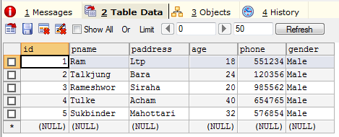

**Changing column’s datatype**

ALTER table person

MODIFY column id varchar(4);

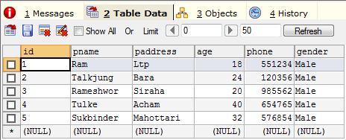

**Dropping column**

**Creating a table**

CREATE table abcd(

a int, b int, c int, d int ,e int, f int, g int

);

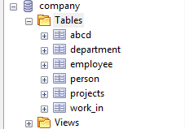

**Data insertion**

INSERT INTO abcd VALUES (1,2,3,4,5,6,7);

INSERT INTO abcd VALUES (1,2,3,4,5,6,7);

INSERT INTO abcd VALUES (1,2,4,5,6,7,5);

INSERT INTO abcd VALUES (1,2,3,4,5,6,0);

INSERT INTO abcd VALUES (1,2,3,4,5,6,8);

INSERT INTO abcd VALUES (1,2,3,9,5,6,7);

INSERT INTO abcd VALUES (1,2,5,9,2,6,7);

INSERT INTO abcd VALUES (1,2,3,4,5,5,7);

INSERT INTO abcd VALUES (1,0,3,4,5,6,7);

INSERT INTO abcd VALUES (1,2,3,4,9,3,7);

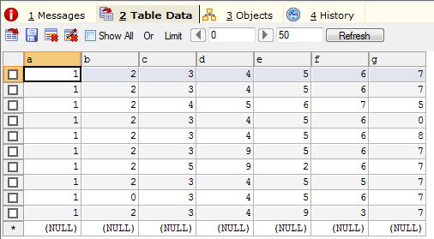

**Dropping column**

ALTER TABLE abcd

DROP COLUMN g;

ALTER TABLE abcd

DROP COLUMN g;

