ST. XAVIER’S COLLEGE

**Maitighar,Kathmandu**

**(Affiliated to Tribhuvan University)**



**Database Management System**

**Lab Assignment #11**

**Submitted By**

Ajita Khatiwada

B.Sc. CSIT

Year II/IV Semester

013BSCIT004

**Submitted To**

Er. Sanjay Kumar Yadav

Lecturer,

Department of Computer Science

St. Xavier’s College

Maitighar, Kathmandu

**Submitted On**

October 9, 2015

**#Update statement**

**Syntax:** update table_name

Set column_name=value where column=value ;

Eg: update persons

set age=25,where id=001

**#Alter statement**

**Syntax:** alter table table_ name

Add column_name datatype

**# Drop statement**

**Syntax :** alter table table_name

Drop column column_name ;

Before applying the alter statement the database was created and a new table info was created with the attributes as mentioned in the picture below:

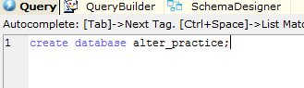

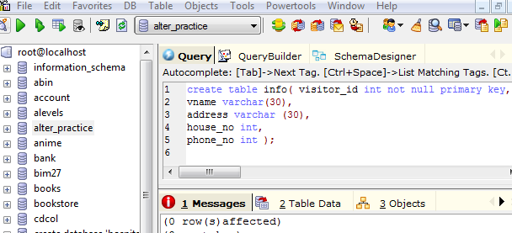

**#Data insertion :**

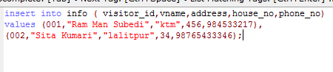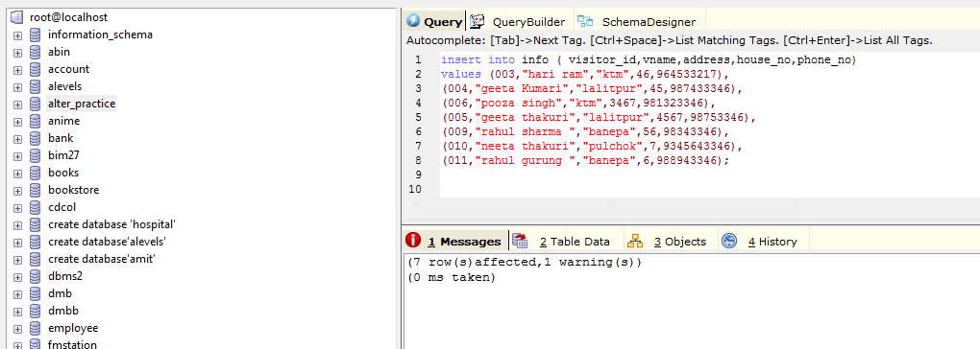

**#Alter**

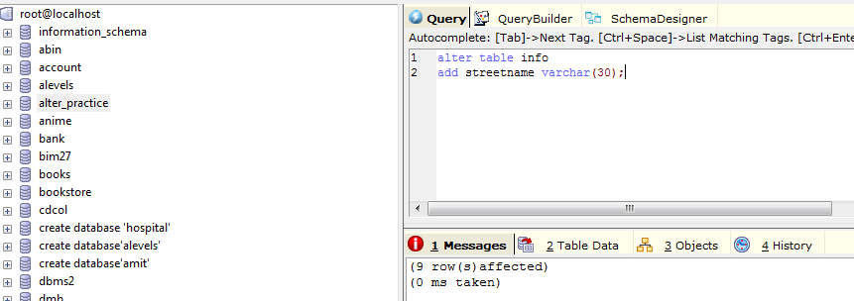

The result obtained is the new column streetname in the existing table info. 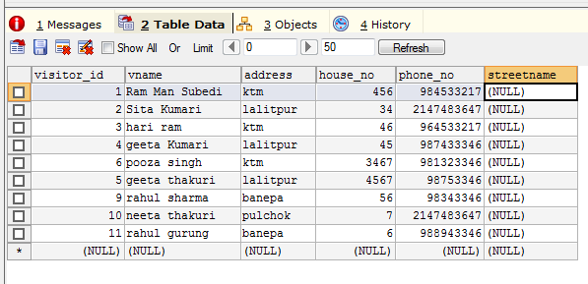

#**Update**

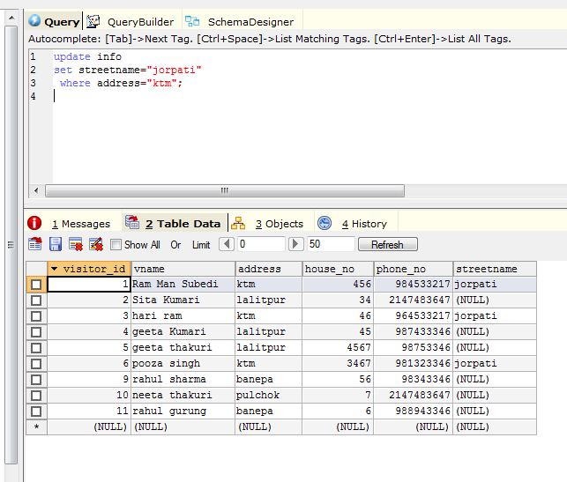

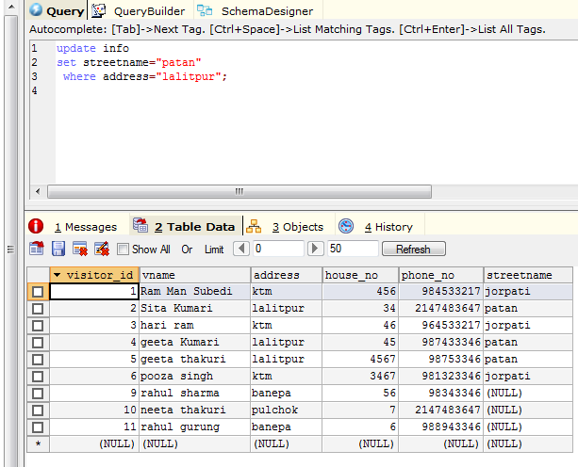

Similarly ,

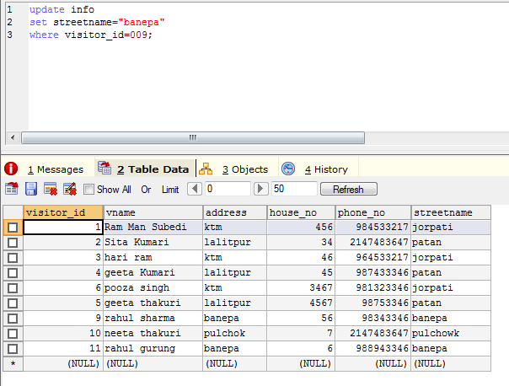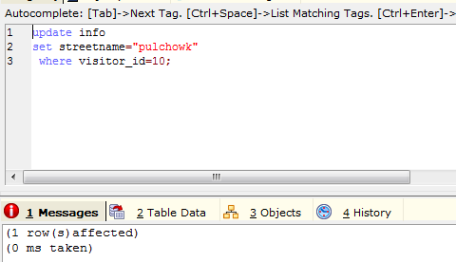

Finally the table obtained is :

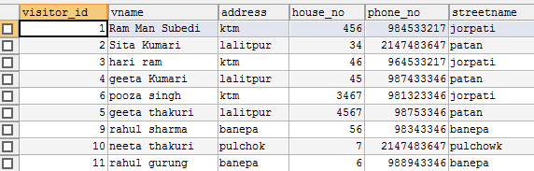

#**Creation of new table course and data insertion on it :**

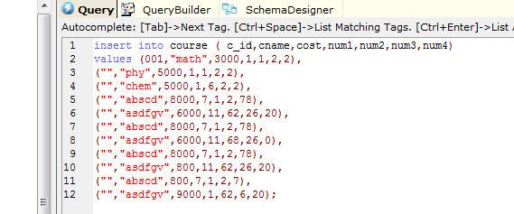

**Table data :**

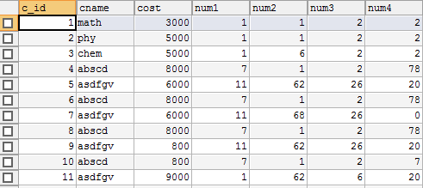

#**dropping last two columns :**

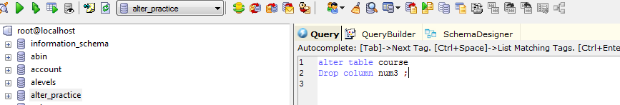

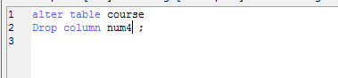

Finally the table obtained after dropping two columns is :

