**(Affiliated to Tribhuvan University)**

**Maitighar, Kathmandu**



**Database Management System**

**Lab Assignment**

**SUBMITTED BY:**

Sneha Prasai

013BSCCSIT040

**SUBMITTED TO**

|  |  |
| --- | --- |
| **Er. Sanjay Kr. Yadav**  **( Lecturer )** |  |
| **Department of Computer Science** | |

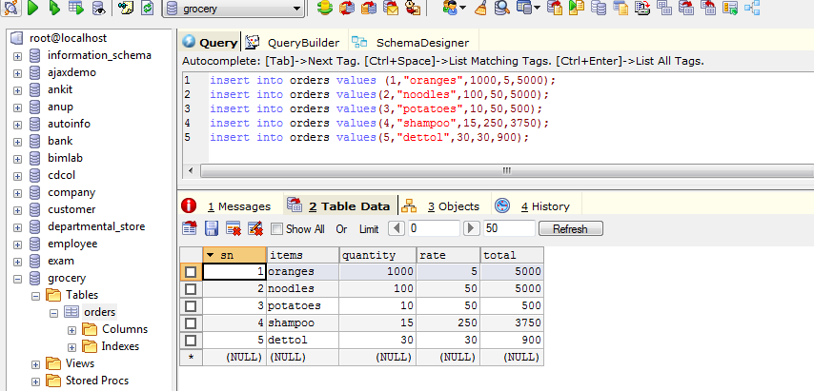

Alter statement:

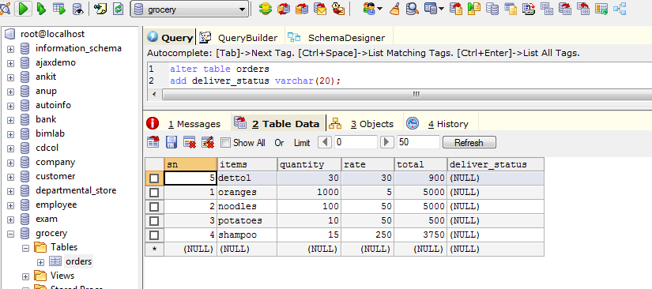

Update statement:

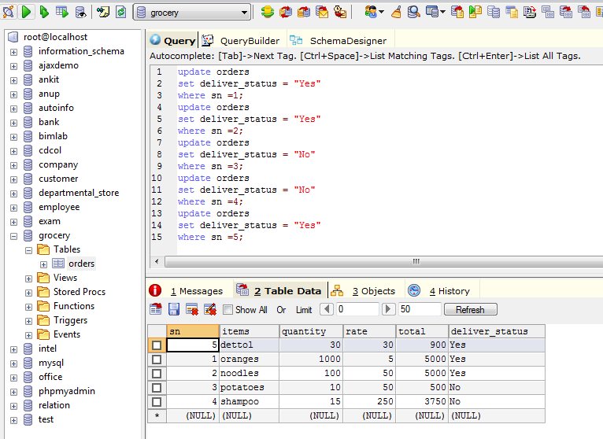

Change data type

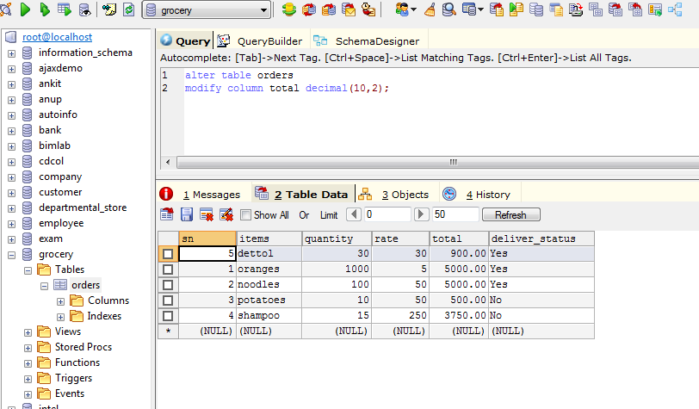

Drop Column

