ST. XAVIER’S COLLEGE

**(Affiliated to Tribhuvan University)**

Maitighar, Kathmandu



**Database Management System**

**Lab Assignment**

**Submitted by:**

Binod Marikhu  
013BSCCSIT013

**Submitted to:**

|  |  |
| --- | --- |
| Er. Sanjay Kumar Yadav Lecturer, St. Xavier’s College |  |

**Date of Submission: October 9, 2015**

**CREATE TABLE**

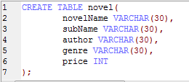

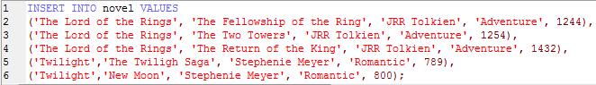

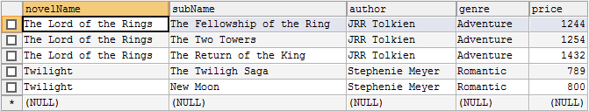

**ALTER**



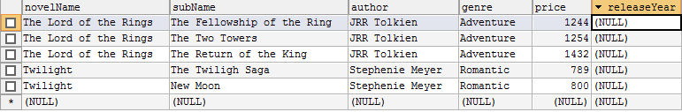

**update**



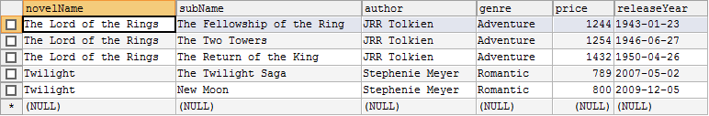

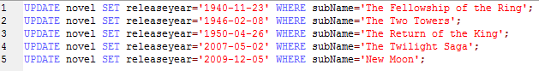

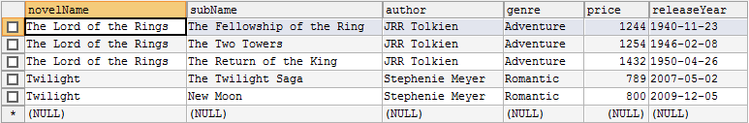

**Change the datatype**



**DROP COLUMN**

