ST. XAVIER’S COLLEGE

**(Affiliated to Tribhuvan University)**

**Maitighar, Kathmandu**



**Database Management System**

**Lab Assignment**

**SUBMITTED BY:**

Ronak Agrawal

013BSCCSIT033

**SUBMITTED TO**

|  |  |
| --- | --- |
| **Er. Sanjay Kr. Yadav**  **( Lecturer )** |  |
| **Department of Computer Science** | |

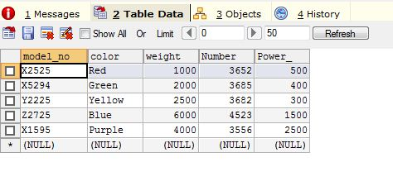

**Fig: table named “Bike” having model no, color, weight, number and power as attributes**

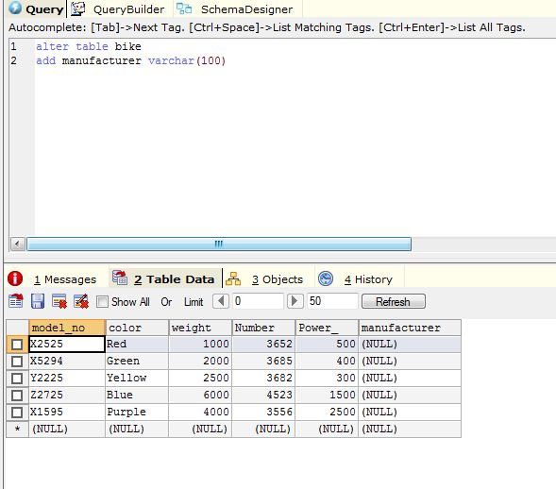



**Fig: adding a new column named “manufacturer” using alter statement**

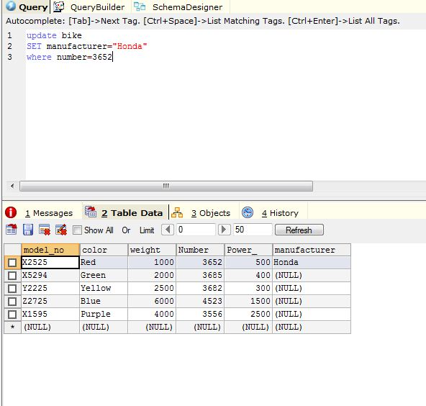



**Fig: inserting data in the first row of manufacturer column using update statement**

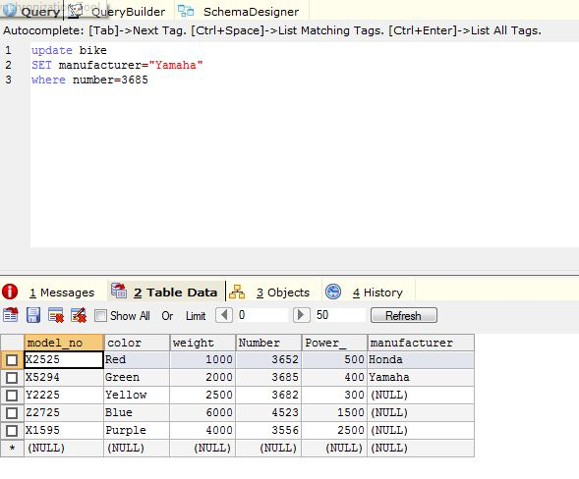



**Fig: inserting data in the second row of manufacturer column using update statement**

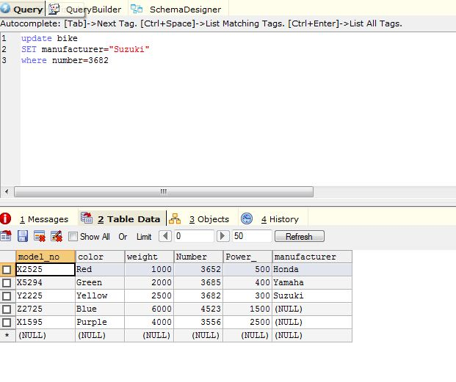



**Fig: inserting data in the third row of manufacturer column using update statement**

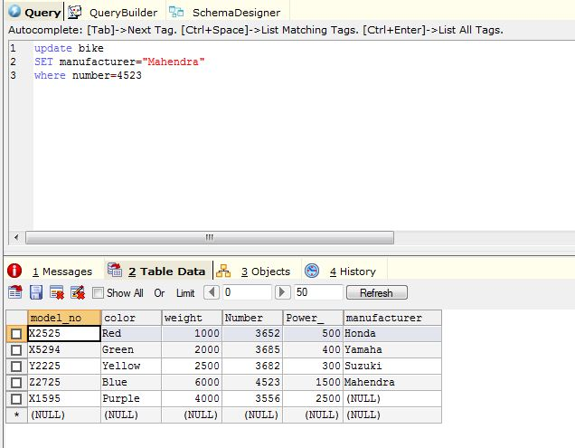



**Fig: inserting data in the fourth row of manufacturer column using update statement**

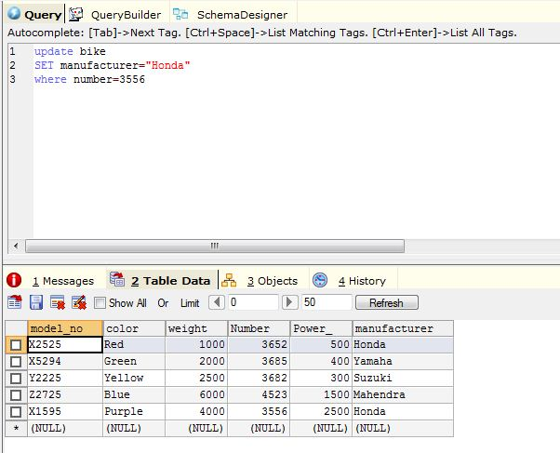



**Fig: inserting data in the fifth row of manufacturer column using update statement**

