ST. XAVIER’S COLLEGE

**Maitighar,Kathmandu**

**(Affiliated to Tribhuvan University)**



**Database Management System**

**Lab Assignment**

**Submitted By**

Suman Malla

013BSCIT041

**Submitted To**

Er. Sanjay Kumar Yadav

Lecturer,

Department of Computer Science

St. Xavier’s College

Maitighar, Kathmandu

**Submitted On**

Friday, October 09, 2015

Table Created:

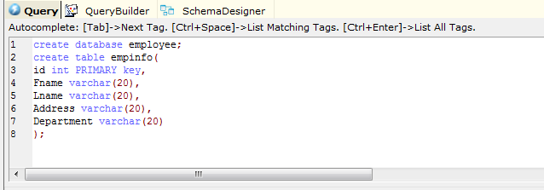

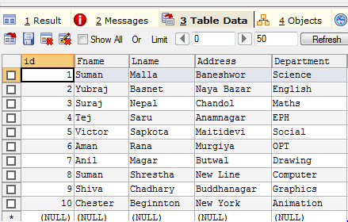

Alter (Adding column Age):

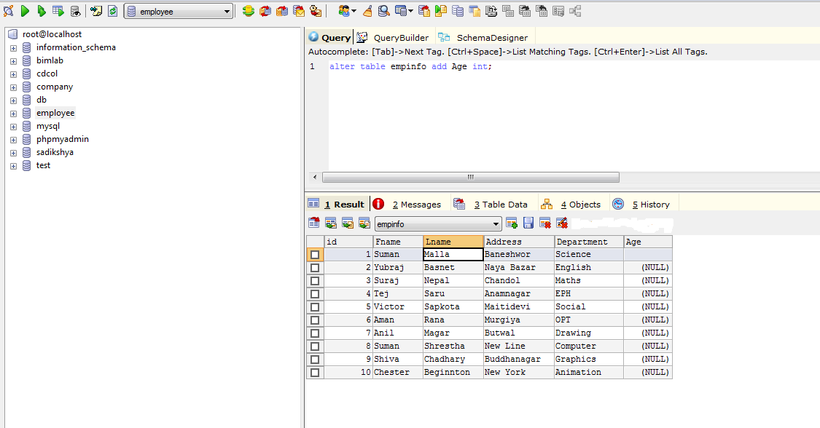

Update info to the column Age:

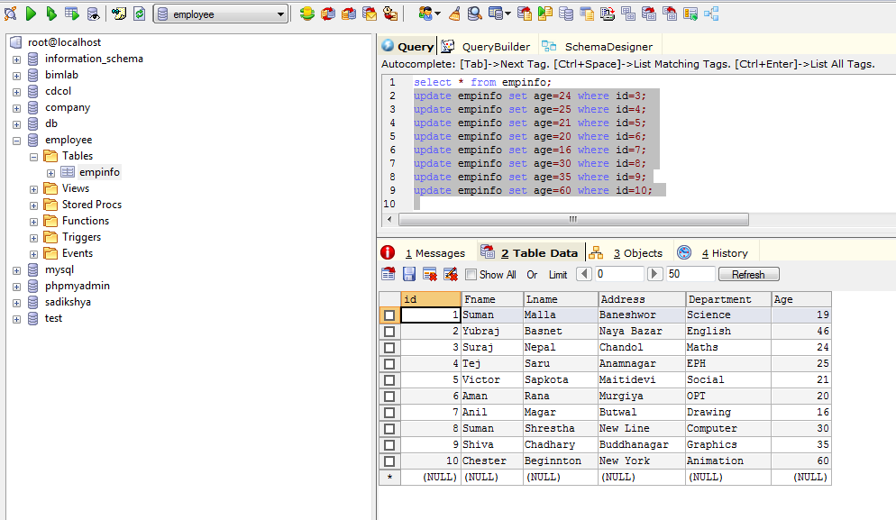

Drop Table:-

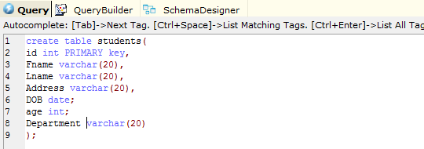

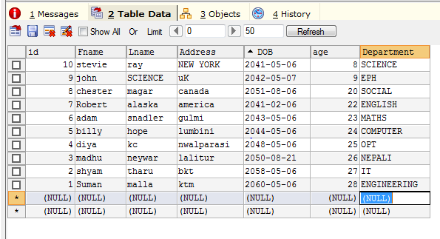

Droping table Age:

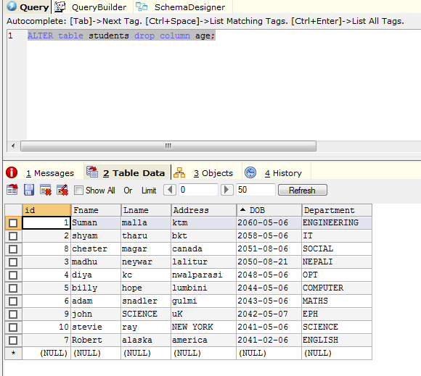

Droping Table Department

