ST. XAVIER’S COLLEGE

**(Affiliated to Tribhuvan University)**

**Maitighar, Kathmandu**



**Database Management System**

**Lab Assignment**

**SUBMITTED BY:**

**Prashraya Hada**

**013BSCCSIT027**

**SUBMITTED TO**

|  |  |
| --- | --- |
| **Mr. Sanjay Kr. Yadav**  **( Lecturer )** |  |
| **Department of Computer Science** | |

Submission Date: October 9th, 2015

Creating table:

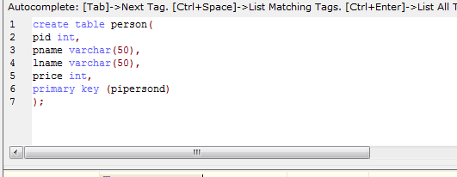

Data filled in the person:

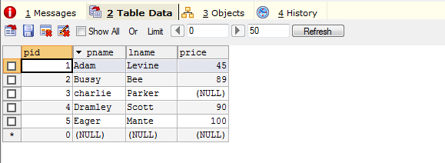

Alter table by inserting new column:

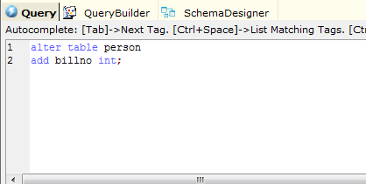

Data field view after altering the table:

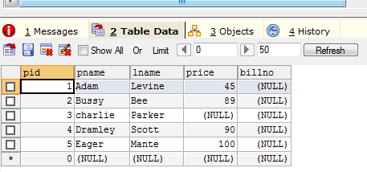

Updating the data in new field:

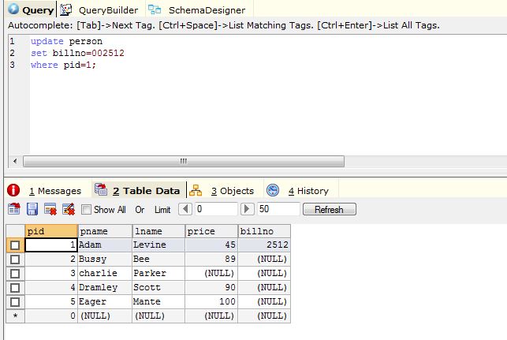

Altering the data type in a given table: Y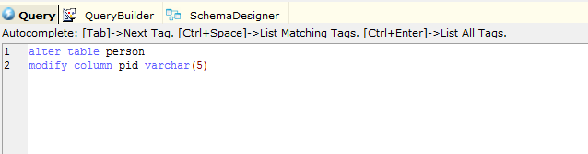

Updating data in the new data type 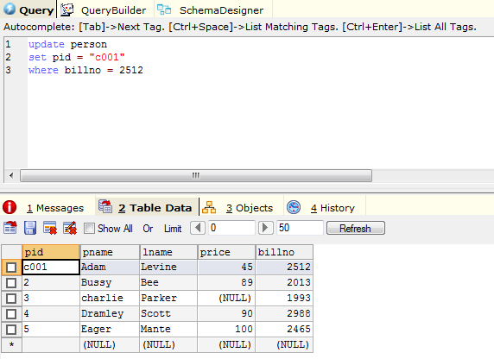

Final table with data

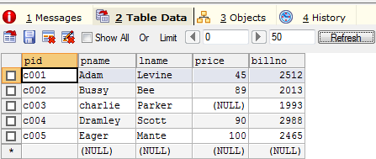

New table for deleting a column

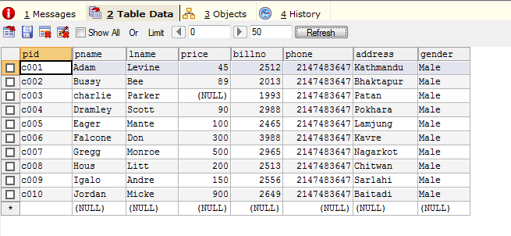

Dropping a column

