Create TABLE motorbikes

(

S_No int not null primary key,

Bike_Name varchar(20),

CC int,

Gear int,

Price int

);

Insert into motorbikes values (1, “Gixxer”, 155, 5, 236000), (2, “Gixxer SF”, 155, 5, 274000), (3, “Pulsar AS”, 150, 5, 234000), (4, “Pulsar AS”, 200, 5, 284000), (5, “R15”, 200, 6, 315000), (6, “Fz V2.0”, 200, 6, 295000)

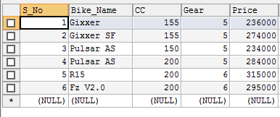

**ALTER**

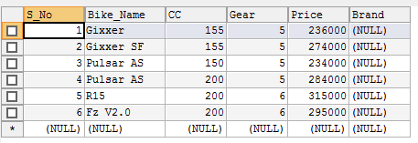

Update



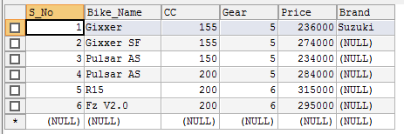

update motorbikes

set Brand = "Suzuki"

where S_No = 2

update motorbikes

set Brand = "Bajaj"

where S_No = 3

update motorbikes

set Brand = "Bajaj"

where S_No = 4

update motorbikes

set Brand = "Yamaha"

where S_No = 5

update motorbikes

set Brand = "Yamaha"

where S_No = 6

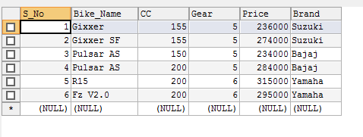

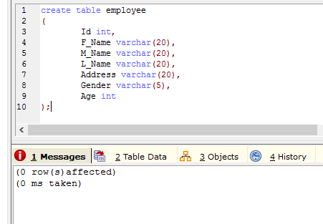

insert into employee values (1, "Samrat", "Prasad", "Maskey", "BKt", "M", 22), (2, "Ronak", "", "Agrawal", "KTM", "M", 22), (3, "Pratibha", "", "Panta", "Patan", "F", 21), (4, "Tezz", "Bahadur", "Saru", "Syanja", "M", 22), (5, "Saurav", "Dhar", "Bajracharya", "Ktm", "M", 21), (6, "Sazjan", "Kumar", "Neujane", "KTM", "M", 24), (7, "Ajita", "", "Khatiwada", "BKt", "F", 20), (8, "Anu", "", "Kadel", "Patan", "F", 20), (9, "Hemanchal", "", "Joshi", "Patan", "F", 21), (10, "Divya", "Jyoti", "Pokharel", "BKt", "M", 23)

