1. Find Eno and Name of Employee whose salary>4000

Select Eno, Ename, Salary from Employee where salary>4000

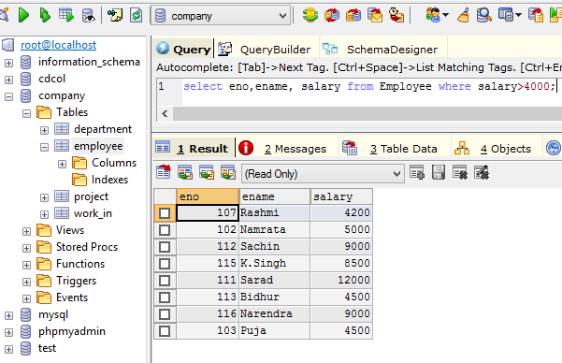

1. Find the ename salary of the employees whose salary is >5000 and job status is profession  
     
   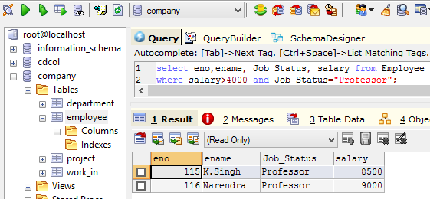
2. Removing Duplicates   
   {Select address from Employee  
     
   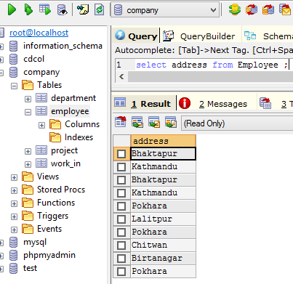  
     
   select distinct address from Employee  
   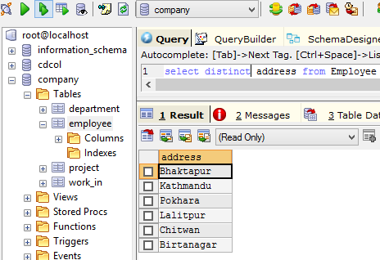
3. Find the Eno, Ename, Salary, of the employee whose department number 20 or job status Research Fellow  
   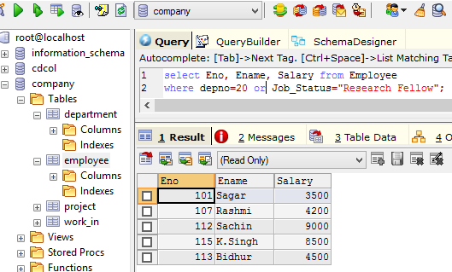
4. Range Specification (In and Between)  
   { Cond Between 30 and 40  
     
   Find the Eno, Ename, Age, Salary from the Employee where the age is between 24 and 28  
   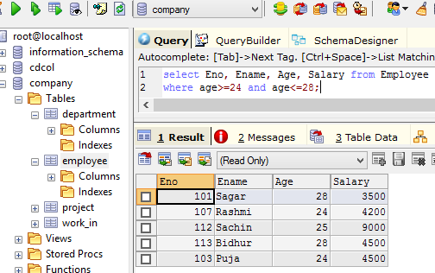
5. All strings that start with ABC  
   {‘ABC%’; example ABCD , ABCABC both satisfy the condition  
     
   All strings that end with XYZ  
   {‘%XYZ’;eg WXYZ, ZZXYZ etc  
     
   All strings that have the string AN in between   
   { %AN%; eg: BANANA, ANAMIKA, MAN, etc  
     
   Find Eno, Ename with starting letter SA  
     
   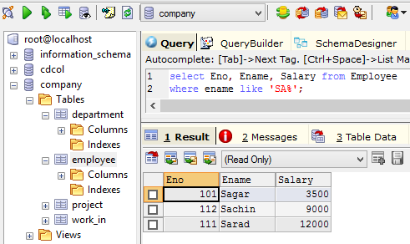
6. List all employee names with their project names  
     
   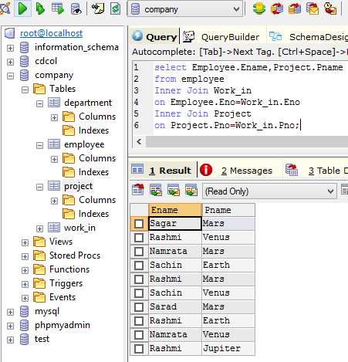
7. List name of all employee and their salary who are working in project MARS or VENUS  
   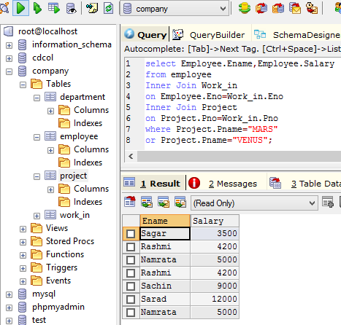
8. List Name of All Employees and their salary who are working in project EARTH and VENUS
9. List name and address of all employees who works in department which is located in pokhara  
     
   