# ST.XAVIER’S COLLEGE

# MAITIGHAR, KATHMANDU



**LAB ASSIGNMENT**

**Database Management System**

**Submitted By:**

Pratibha Panta

013BSCCSIT028

4th Sem, 2nd Year

**Submitted To:**

______________________

Er. Sanjay Kumar Yadav

Department of Computer Science

Lecturer

1. Creating a table

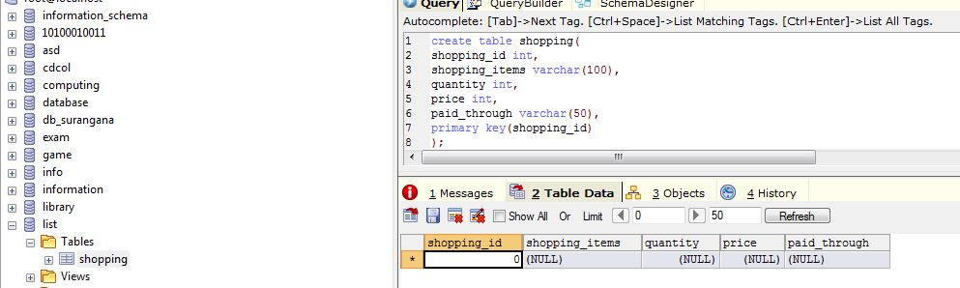

2. Inserting values in table

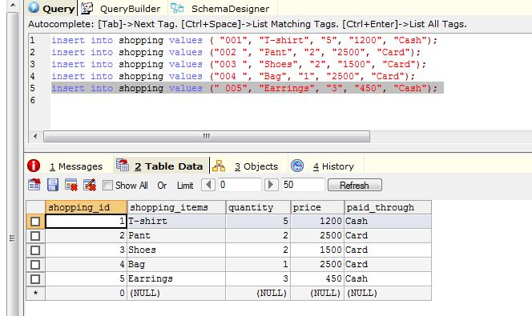

**Alter Statement:**

Alter table table_name

ADD column_name datatype

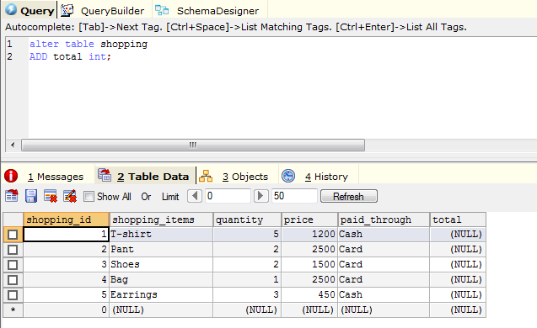

**Update Statement**

Syntax

update table_name

set column_name=table value,

where primary key=value

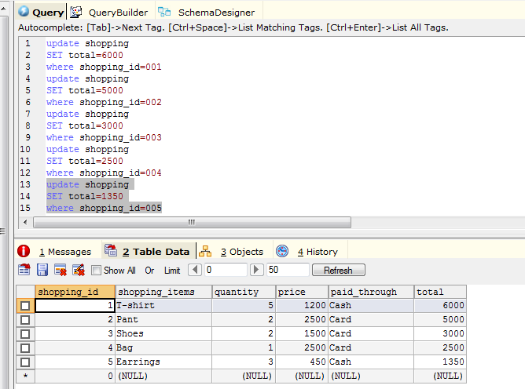

**Change data type**

Alter table table_name

modify column old_name new_name

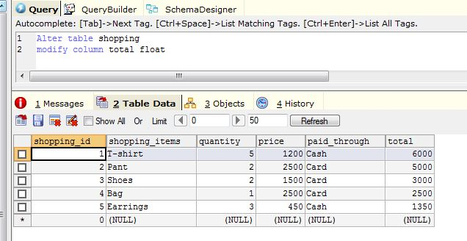

Drop Column

Alter table table_name

Drop column_name

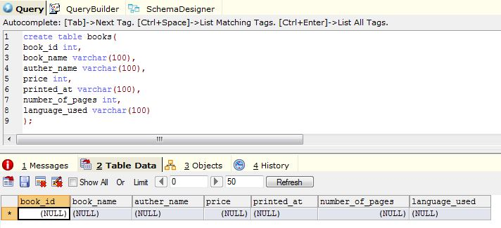

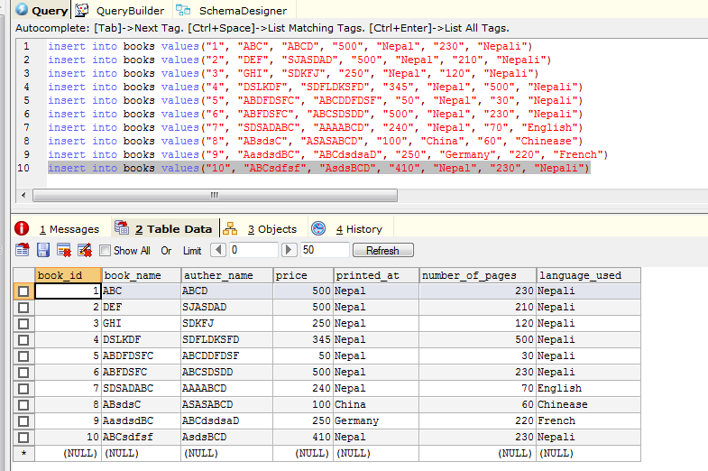

Dropping column language_used

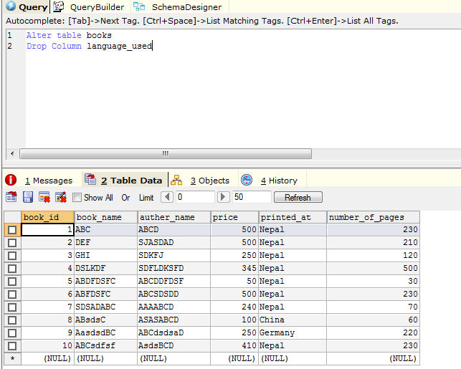

Dropping table number_of_pages

