**ST. XAVIER’S COLLEGE**

**MAITIGHAR, KATHMANDU**



**Database Management System**

**Lab Assignment #11**

**Submitted by:**

Anu Kadel

013BSCIT007

**Submitted to:**

|  |  |
| --- | --- |
| **Er. Sanjay Kumar Yadav** |  |

Lecturer

Department of Computer Science

St. Xavier’s College, Maitighar

**LAB ASSIGNMENT#11**

**CREATING NEW TABLE MyBank**

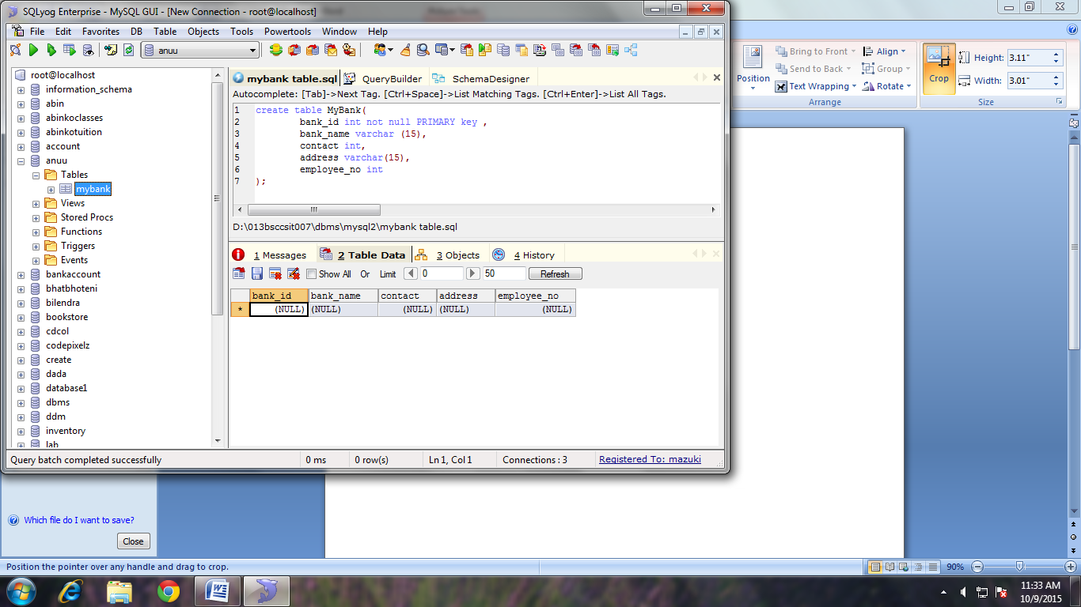

**INSERTING VALUE TO TABLE MyBank**

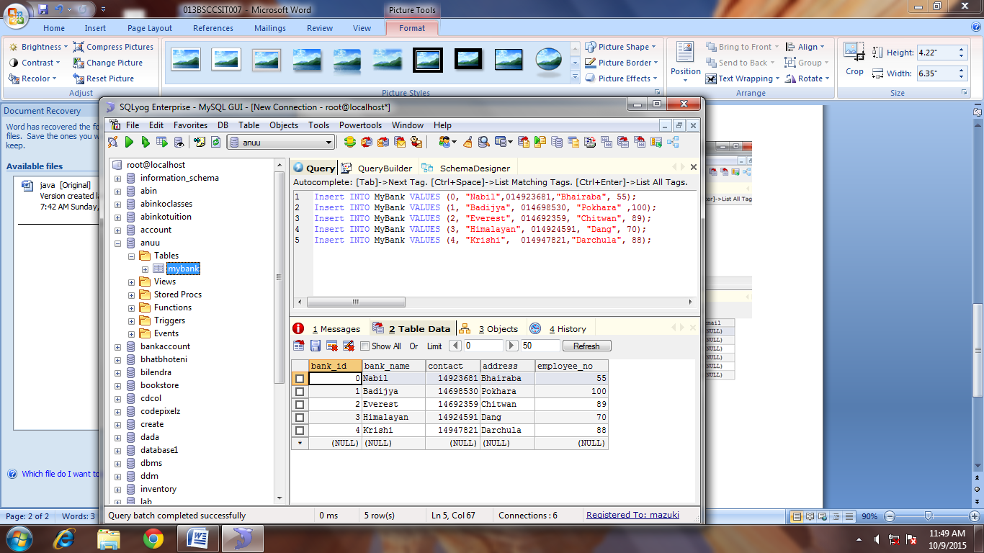

**ALTER TABLE;**

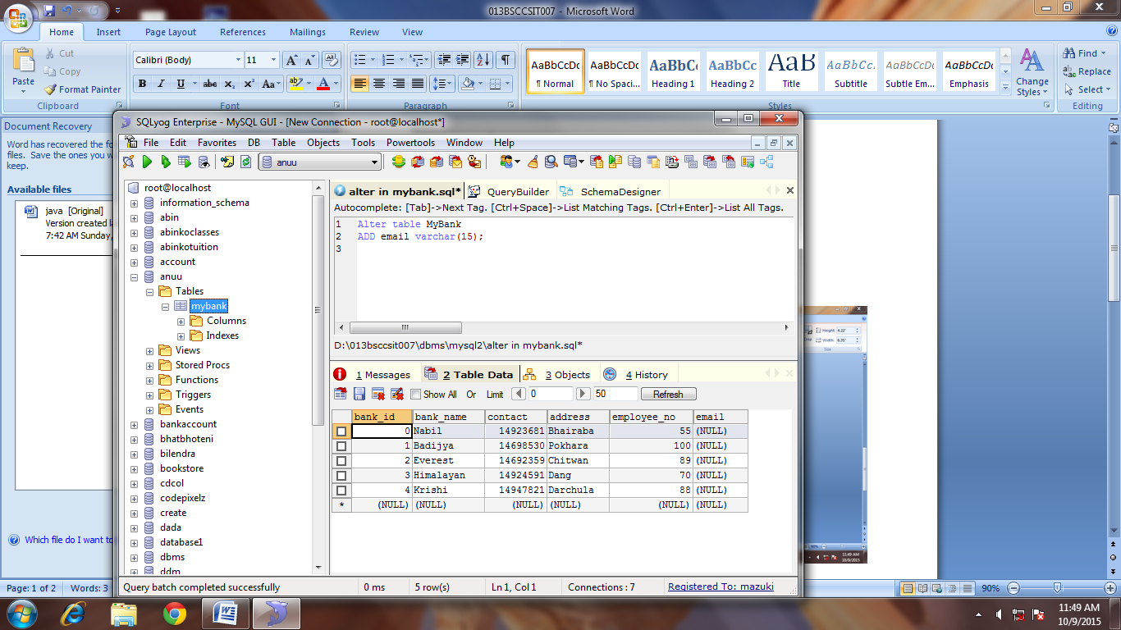

**UPDATE:**

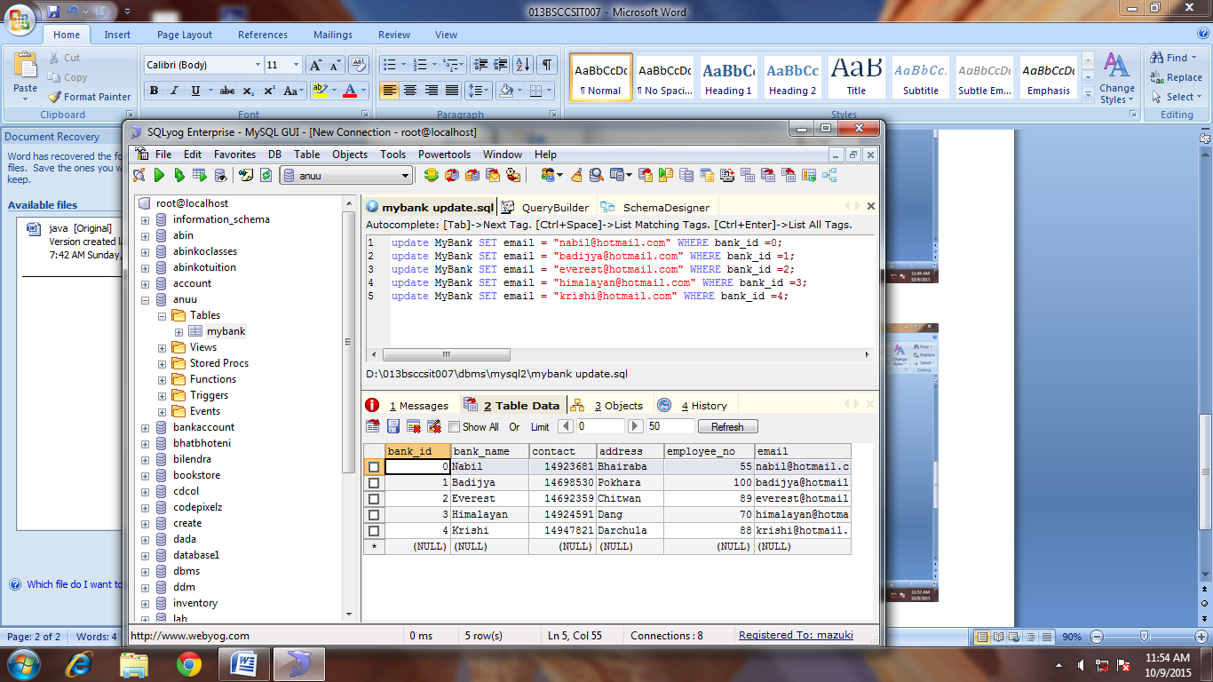

**CHANGE DATA TYPE**

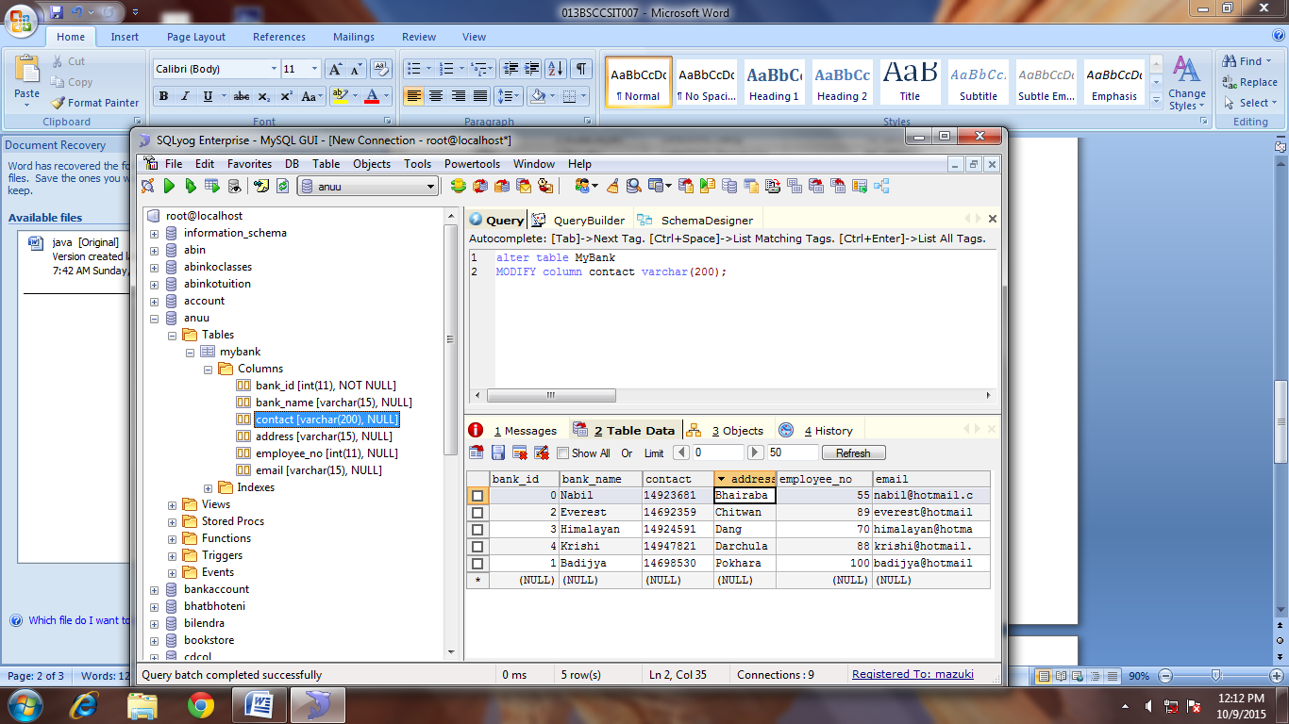

**CREATE TABLE EMPLOYEE**

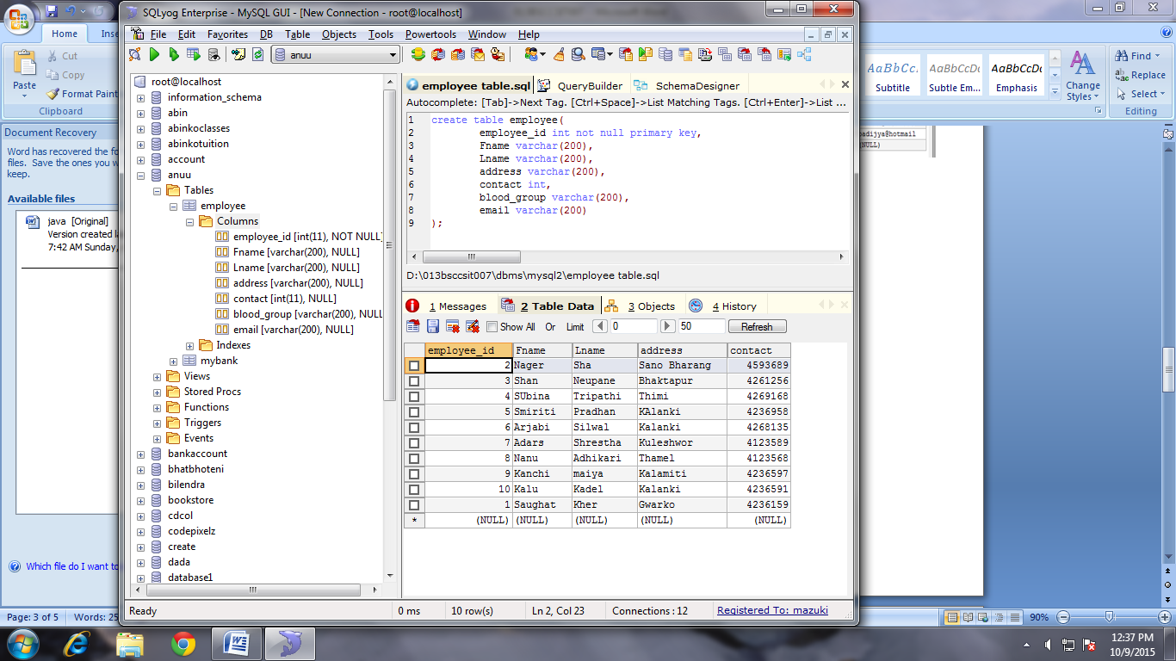

**INSERT VALUES IN TABLE EMPLOYEE:**

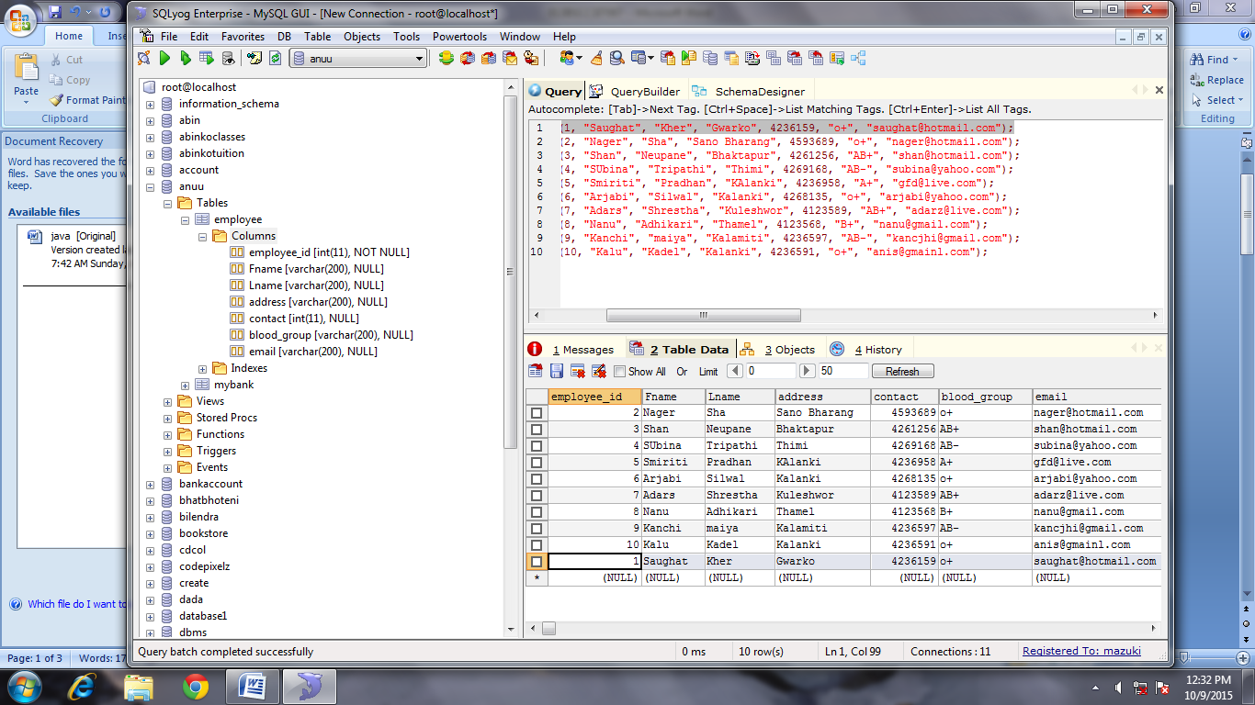

**DROP TABLE**

