**ST. XAVIER’S COLLEGE**

**(Affiliated to Tribhuvan University)**

Maitighar, Kathmandu



**Database Management System**

**lab Assignment # lab 1**

**Submitted by:**

PRANESH DHUNJU SHRESTHA  
013BSCCSIT026

**Submitted to:**

|  |  |
| --- | --- |
| **Er. Sanjay Kumar Yadav**  Lecturer  St. Xavier’s College |  |

**Date of Submission:** October 9, 2015

**SYNTAX**

* To add a column in a table, use the following syntax:

ALTER TABLE table_name  
ADD column_name datatype

* To delete a column in a table, use the following syntax

(notice that some database systems don't allow deleting a column):

ALTER TABLE table_name  
DROP COLUMN column_name

* To modify a data type of a attribute. use the following syntax

ALTER TABLE table_name  
MODIFY COLUMN column_name datatype

Creating a new table students under database alternate

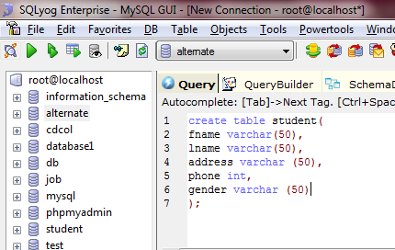

Data inserted in the table students before alter.

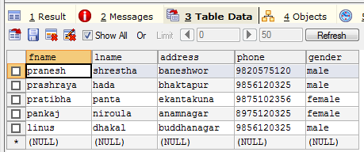

Adding new attribute “age” on the existing table students using alter and add.

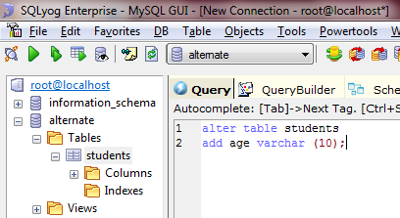

Table after alter command before adding data.

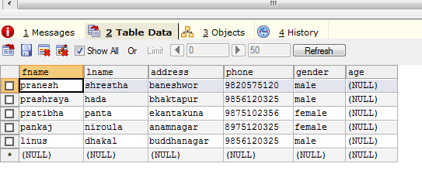

Query and table for adding data on newly added attribute age using update , set and where.

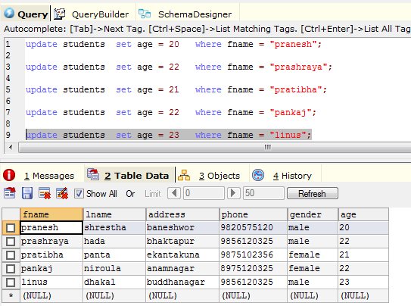

Change of data type of column “phone “ from int to varchar using alter and modify.

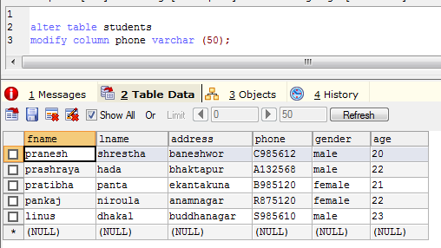

**Deleting an existing column.**

Creating a new table “employees”

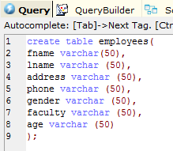

Data inserted in the table “employees”with 7 attributes.

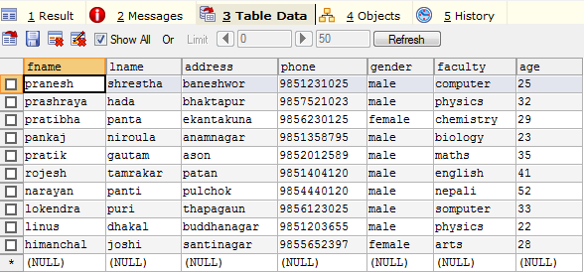

Query and table for Removing a column “age” using alter and drop.

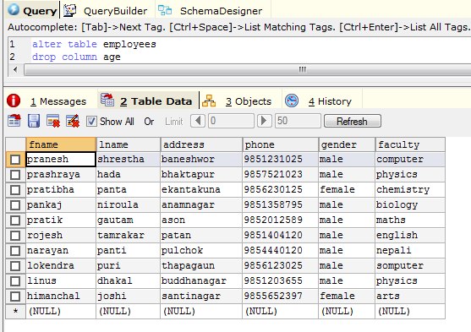

Query and table for emoving a column “gender” using alter and drop.

