ST. XAVIER’S COLLEGE

**(Affiliated to Tribhuvan University)**

**Maitighar, Kathmandu**



**Database Management System**

**Lab Assignment #1**

**SUBMITTED BY:**

**Siddhant Rimal**

**013BSCCSIT039**

**SUBMITTED TO**

|  |  |
| --- | --- |
| **Mr. Sanjay Kr. Yadav**  **( Lecturer )** |  |
| **Department of Computer Science** | |

Submission Date: August 9th 2015

**STATEMENT 1: Create an Access database to define one-to-one, one-to-many and many-to-many relationship between entities.**

1. **RELATIONSHIPS**

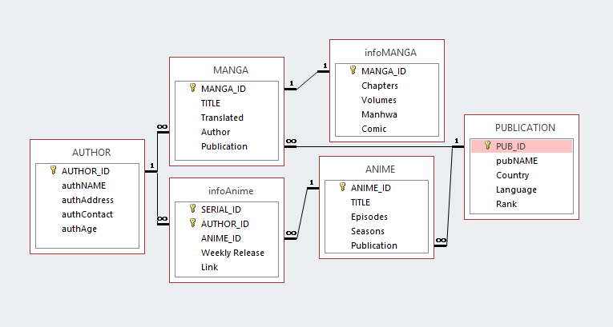

Fig. 1.1: Relationship between various entities in a database about Anime and Manga

The information provided about the relation between different entities of a database about Anime and Manga records shows the use of various types of relationships like one-to-one, one-to-many and many-to-many. Access does not have a direct option for many-to-one threby, it is upon the user to create a database which interprets data as such.

* 1. **One-to-One (1:1) Relationship**

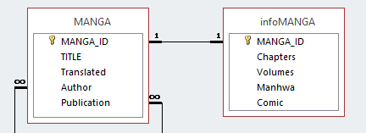

Fig.1.1.1: One-to-One Relationship

The relationship between the entities MANGA and infoMANGA is a one-to-one type of relationship. Both entities share a common primary key as an attribute with which they’re bound in this relationship. The one-to-one relationship ensures that both entities have no more than one matching attribute in their relationship. In practical terms, one-to-one relationships allow additional data something to be stored in a separate entity so that database can be easily used.

* 1. **One-to-Many(1:M) Relationship**

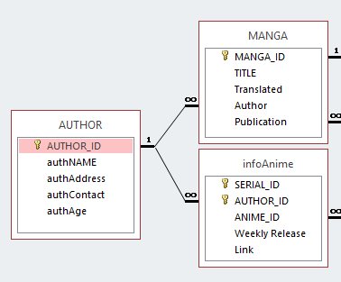

Fig.1.1.2: One to Many Relationship between Author and their contributions as Anime makers and Manga Artists.

An Author first creates a manga, then serializes it as an anime. Thereby, Author is related to both Manga and Anime. The entity AUTHOR has the attribute AUTHOR_ID linked with similar related attribute in other entities.

Many-to-one relationship: By default, Access does not have any many-to-one relationship option available. It is upon the user to interpret the one-to-many relationship amongst entity attributes to interpret as such. [1]

* 1. **Many-to-Many(M:N) Relationship**

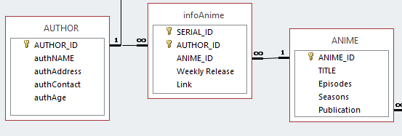

Fig.1.1.3: Many-to-many relationship between Authors and Anime

Many Authors can work on a single anime. But it is also possible that one author can create several anime series. The relationship can be interpreted as ‘Many authors can create many anime series’. It is certainly possible because one author will certainly make at least one anime series.

1. **DATA**

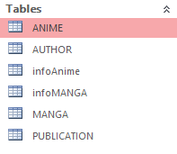

Fig.1.2: Tables involved in the database

The tables involved in this database were ANIME, AUTHOR, infoAnime, infoMANGA, MANGA and PUBLICATION. The Tables held respective relevant data to organize the data in the database. The information present in the tables were made available to each other with the help of relationships as shown in fig 1.1.

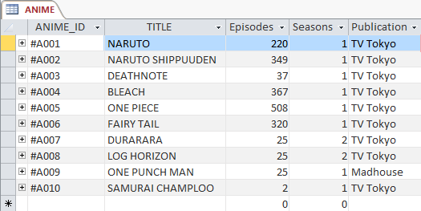

Fig.1.2.1: Data in ANIME table

The ANIME table used normal data entry for most attributes but lookup for Publication from the PUBLICATION table. This is used to store basic information about any Anime Series. It has ANIME_ID attribute as the primary key as Anime series is unique in itself.

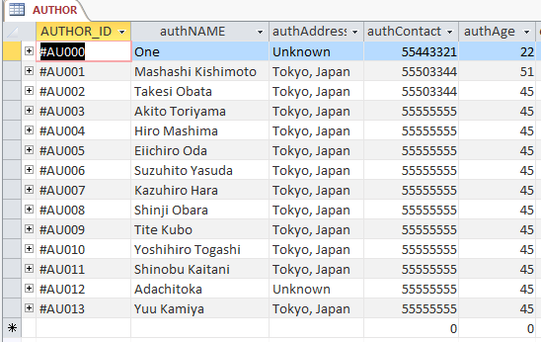

Fig.1.2.2: Data in AUTHOR table

The AUTHOR table has direct data entry with AUTHOR_ID as primary key.

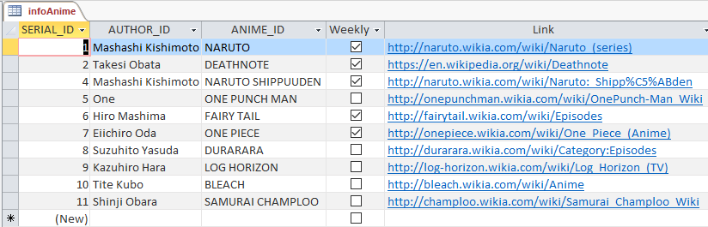

Fig.1.2.3: Data in infoAnime table

The infoAnime table provides additional information like hyperlinks to an anime series. It uses Autonumber to serialize primary key SERIAL_ID and lookup function for AUTHOR_ID and ANIME_ID attributes. AUTHOR_ID is also a primary key.

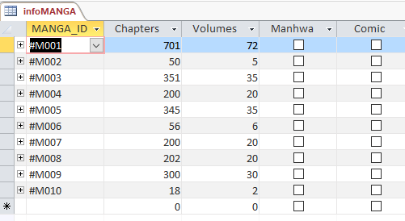

Fig.1.2.4: Data in infoMANGA table

The infoMANGA table stores additional information about any manga enlisted in the MANGA table. Users can specify number of chapters and volumes by direct input. There is also a YES/NO option to specify whether the enlisted are Manhwa (Korean Comics) or Comics (Non-Japanese). The data for MANGA_ID is looked up from its respective data in MANGA table.

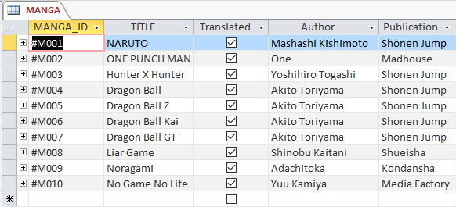

Fig.1.2.5: Data in MANGA table

The MANGA table collects primary information about all manga. It uses lookup function to obtain Author and Publication information from their respective tables. Here, MANGA_ID is a unique ID given to each manga title manually by the user. It is a primary key thereby negating duplication.

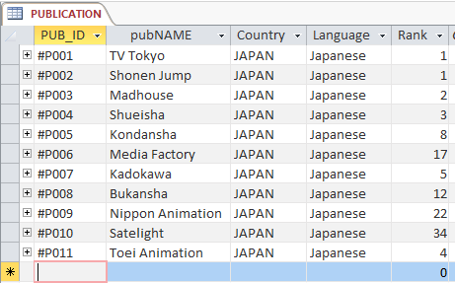

Fig.1.2.6: Data in PUBLICATION table

The PUBLICATION table holds all information about the publication house of the respective Anime or Manga. All data are manually inserted by the user here and data from this table are looked up by other tables for easy reference. The tables that lookup values in this table have some or the other form of relationship with this table.

1. **CONCLUSION**

It is possible to create various relationships in Ms. Access database such that entities and their respective attributes associate with each other in different ways to make sense. Also, the use of lookup function is most helpful to reference necessary data with ease.

1. **REFERENCE**
2. “How to define relationships between tables in an Access database”.   
   Internet. url: <https://support.microsoft.com/en-us/kb/304466> 2015 [08/08/2015]