ST. XAVIER’S COLLEGE

**(Affiliated to Tribhuvan University)**

**Maitighar, Kathmandu**



**Database Management System**

**Lab Report #8**

**SUBMITTED BY:**

**Siddhant Rimal**

**013BSCCSIT039**

**SUBMITTED TO**

|  |  |
| --- | --- |
| **Er. Sanjay Kr. Yadav**  **( Lecturer )** |  |
| **Department of Computer Science** | |

Submission Date: August 25th 2015

**Syntax:**

**Adding a column to desired table:**

Alter table <table_name> add <column_name> <datatype>;

Example: alter table persons add age int;

**Deleting a column from desired table:**

Alter table <table_name> drop column <column_name>;

Example: alter table members drop mDOB;

**Change datatype of desired column in table:**

Alter table <table_name> modify column <column_name> <datatype>;

Example: alter table persons modify column age year;

**Updating values in a column of a desired table:**

Update <table_name> set <column_name>=<desired value> where <condition>;

Example: update persons set age=25, date=’2015-10-09’ where pid=”M101”;

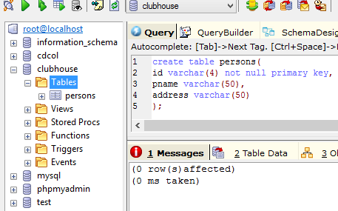

**Fig: Creating a table**

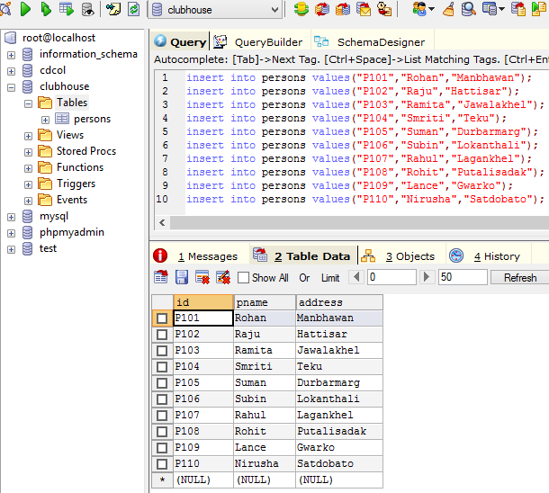

**Fig: Inserting Values**

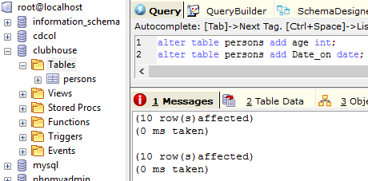

**Fig: Adding two more columns to the table**

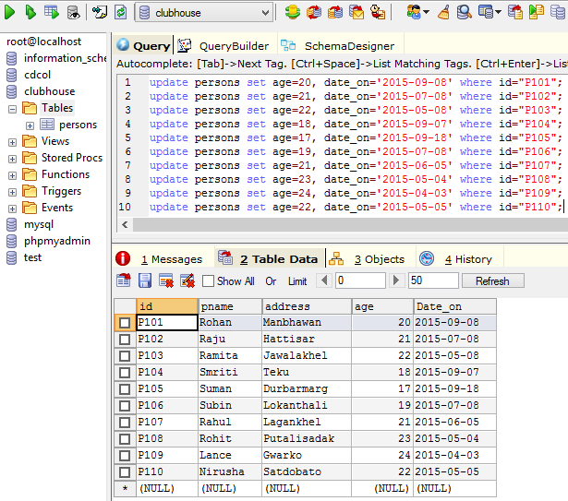

**Fig: Updaating values of age and date_on in table**

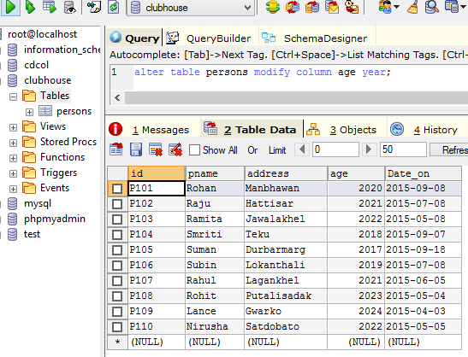

**Fig: Changing datatype of column age from into to year**

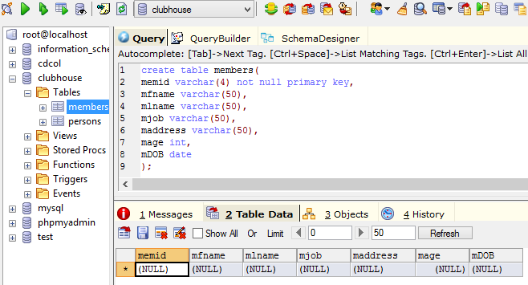

**Fig: Creating table ‘members’ with 7 columns**

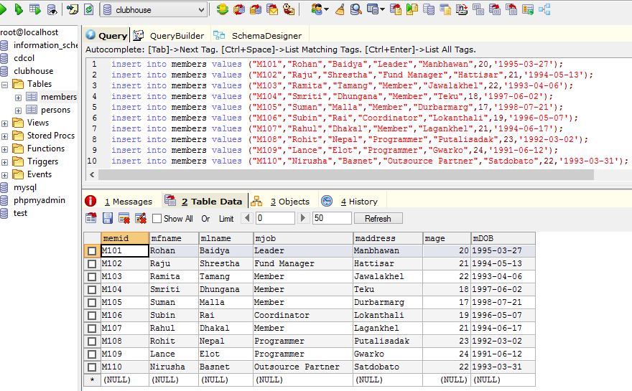

**Fig: Inserting values in table ‘members’**

**Commands:**

insert into members

values ("M101","Rohan","Baidya","Leader","Manbhawan",20,'1995-03-27');

insert into members

values ("M102","Raju","Shrestha","Fund Manager","Hattisar",21,'1994-05-13');

insert into members

values ("M103","Ramita","Tamang","Member","Jawalakhel",22,'1993-04-06');

insert into members

values ("M104","Smriti","Dhungana","Member","Teku",18,'1997-06-02');

insert into members

values ("M105","Suman","Malla","Member","Durbarmarg",17,'1998-07-21');

insert into members

values ("M106","Subin","Rai","Coordinator","Lokanthali",19,'1996-05-07');

insert into members

values ("M107","Rahul","Dhakal","Member","Lagankhel",21,'1994-06-17');

insert into members

values ("M108","Rohit","Nepal","Programmer","Putalisadak",23,'1992-03-02');

insert into members

values ("M109","Lance","Elot","Programmer","Gwarko",24,'1991-06-12');

insert into members

values ("M110","Nirusha","Basnet","Outsource Partner","Satdobato",22,'1993-03-31');

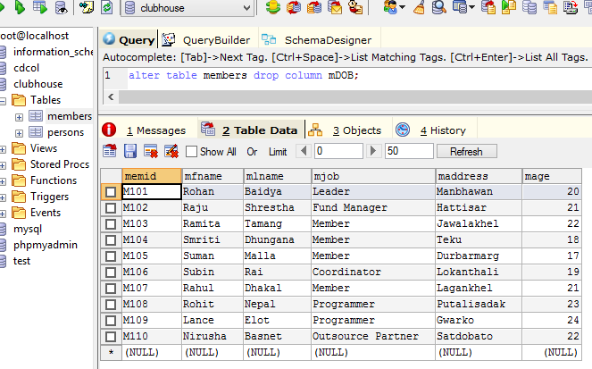

**Fig: Deleting a column from table ‘members’**