ST. XAVIER’S COLLEGE

**(Affiliated to Tribhuvan University)**

Maitighar, Kathmandu



**Database Management System**

**Lab Report**

**Submitted by:**

Rojesh Tamrakar  
013BSCCSIT032

**Submitted to:**

|  |  |
| --- | --- |
| Er. Sanjay Kumar Yadav Lecturer, St. Xavier’s College |  |

**Date of Submission: October 9, 2015**

Create Table Patients:

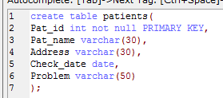

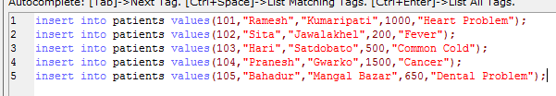

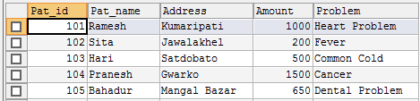

Alter Statement

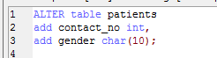

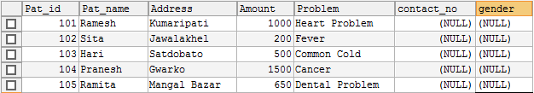

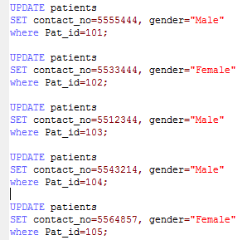

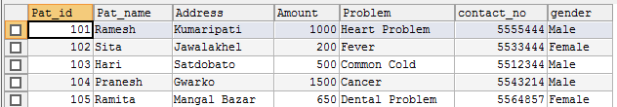

Change Data Types:

F:\Snapshots\first wala\8.PNG

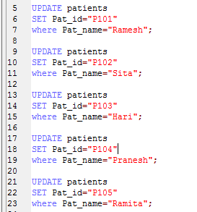

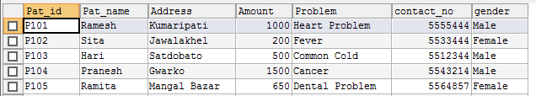

Drop Column

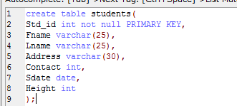

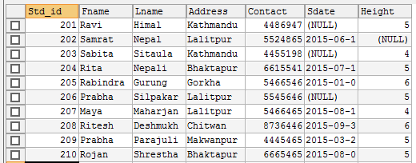

F:\Snapshots\drop lai\3.PNG

