ST. XAVIER’S COLLEGE

**(Affiliated to Tribhuvan University)**

**Maitighar, Kathmandu**



**Database Management System**

**Lab Assignment # 11**

**SUBMITTED BY:**

Anlisha Maharjan

013BSCCSIT006

**SUBMITTED TO:**

|  |  |
| --- | --- |
| **Er. Sanjay Kr. Yadav**  **Lecturer** |  |

Submission Date: October 9, 2015

CREATE TABLE COLLEGE

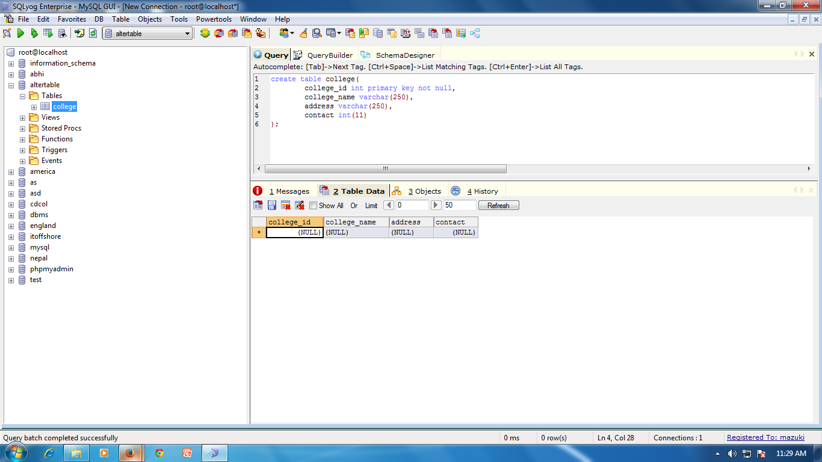

INSERT DATA INTO TABLE COLLEGE

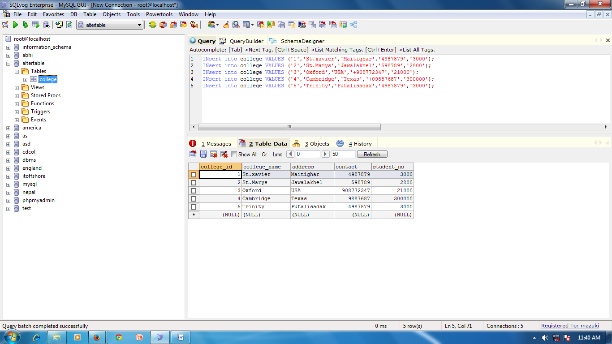

ALTER TABLE COLLEGE

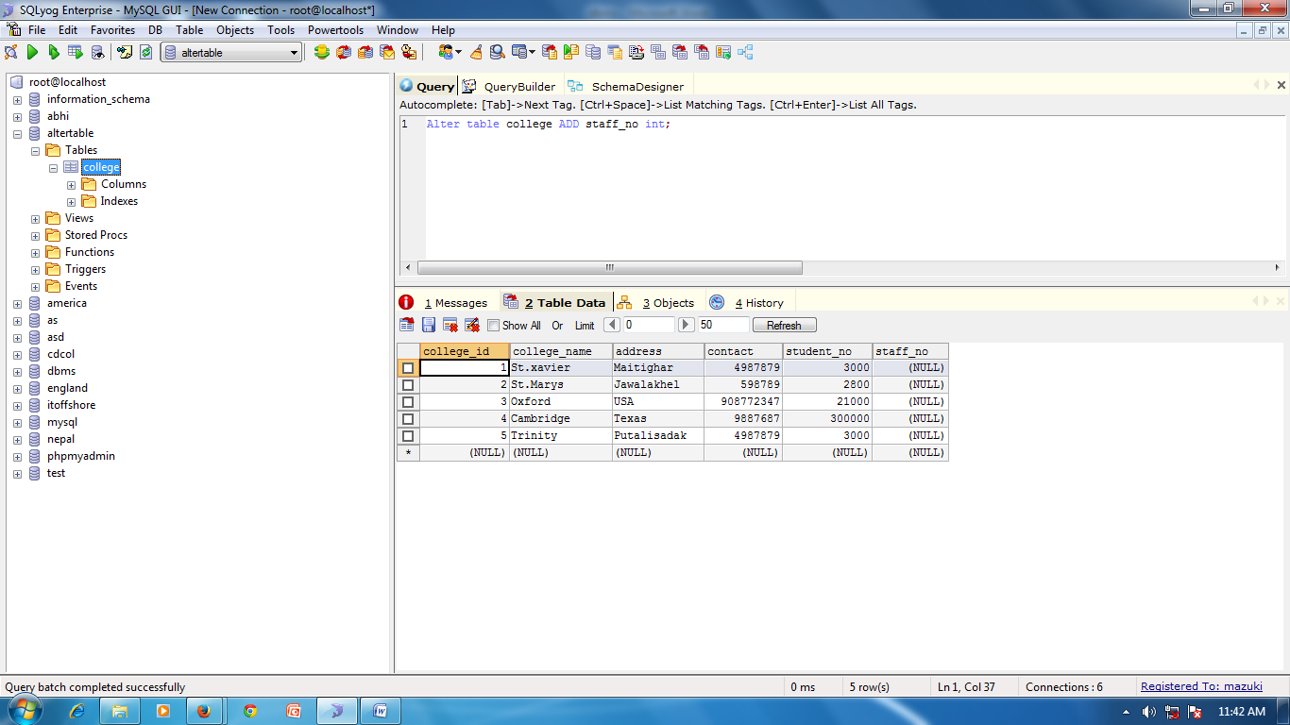

UPDATE DATA IN TABLE COLLEGE

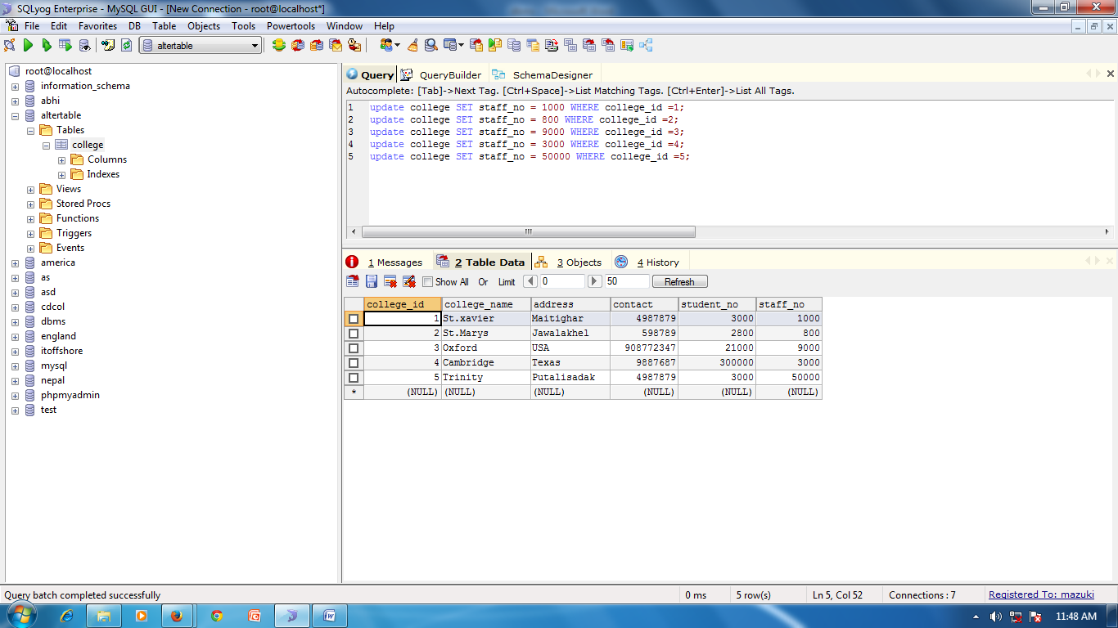

CHANGE DATATYPE OF CONTACT FROM ‘INT’ TO ‘VARCHAR’

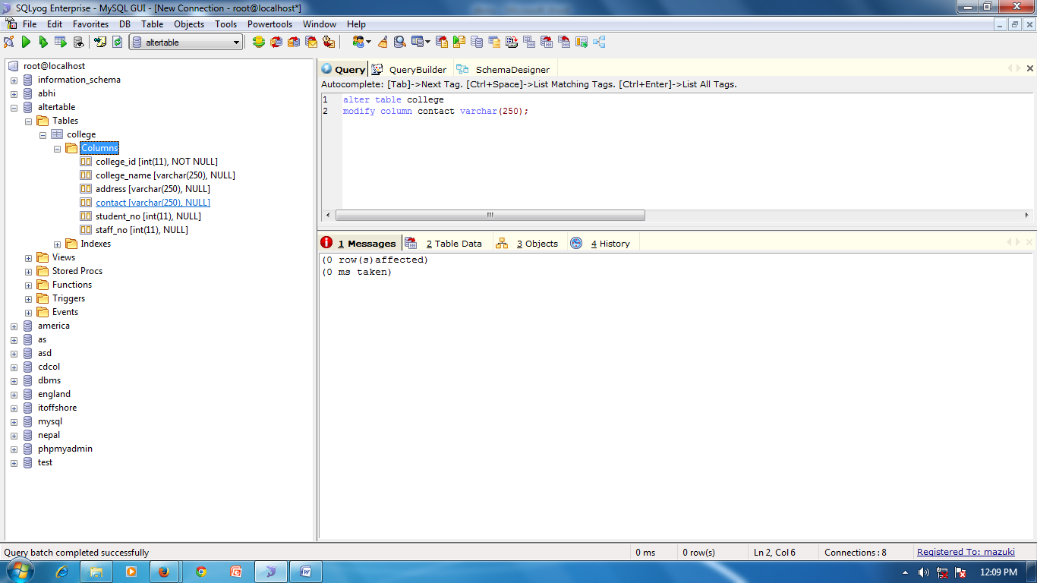

CREATE TABLE COLLEGE_DESCRIPTION

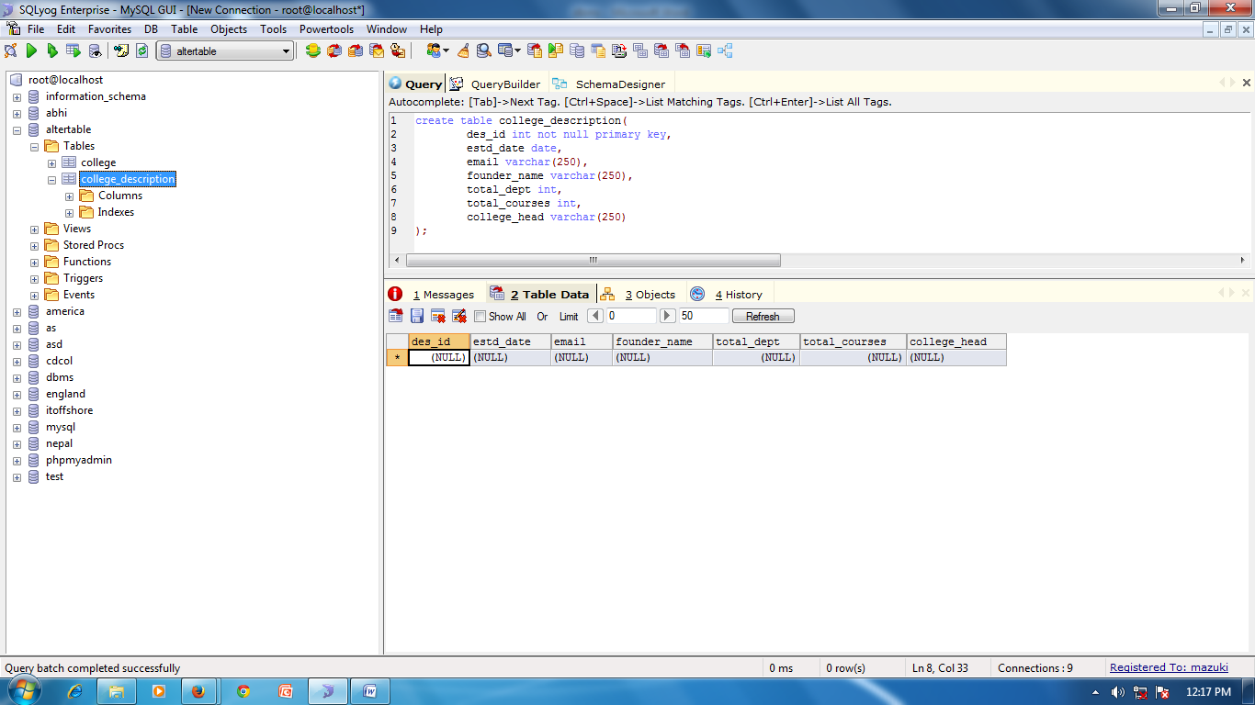

INSERT DATA INTO COLLEGE_DESCRIPTION

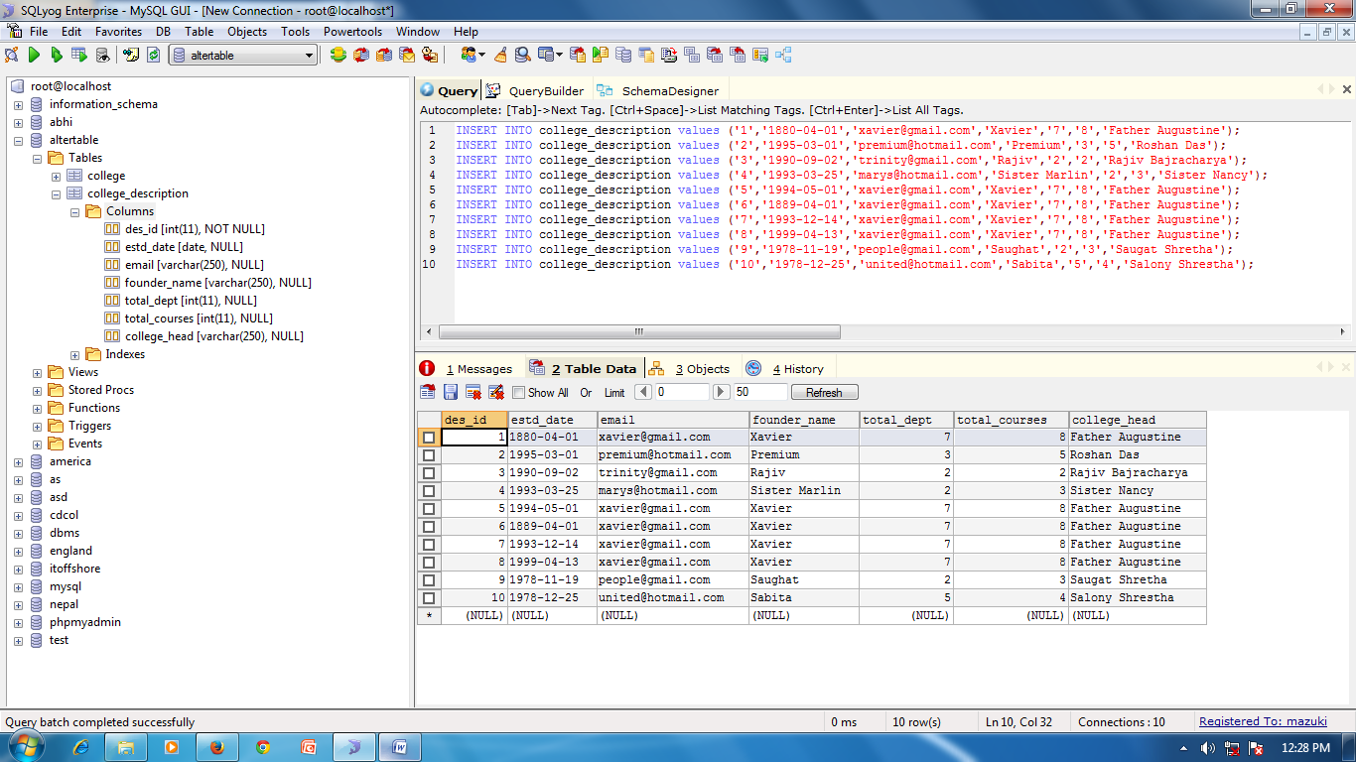

DROP COLUMN FOUNDER_NAME

