ST. XAVIER’S COLLEGE

**(Affiliated to Tribhuvan University)**

Maitighar, Kathmandu



DATABASE MANAGEMENT SYSTEM

LAB ASSIGNMENT ON ALTER STATEMENT

**Submitted by:**

Linus Dhakal  
013BSCCSIT022

**Submitted to:**

|  |  |
| --- | --- |
| Er. Sanjay Kumar Yadav  Lecturer  Department of Computer Science |  |

Date of Submission: October 9, 2015

# CREATION OF DATABAE

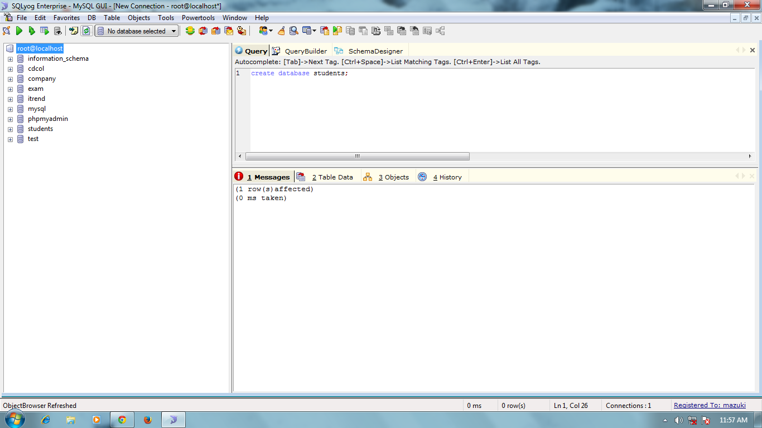

# CREATION OF TABLE CSIT

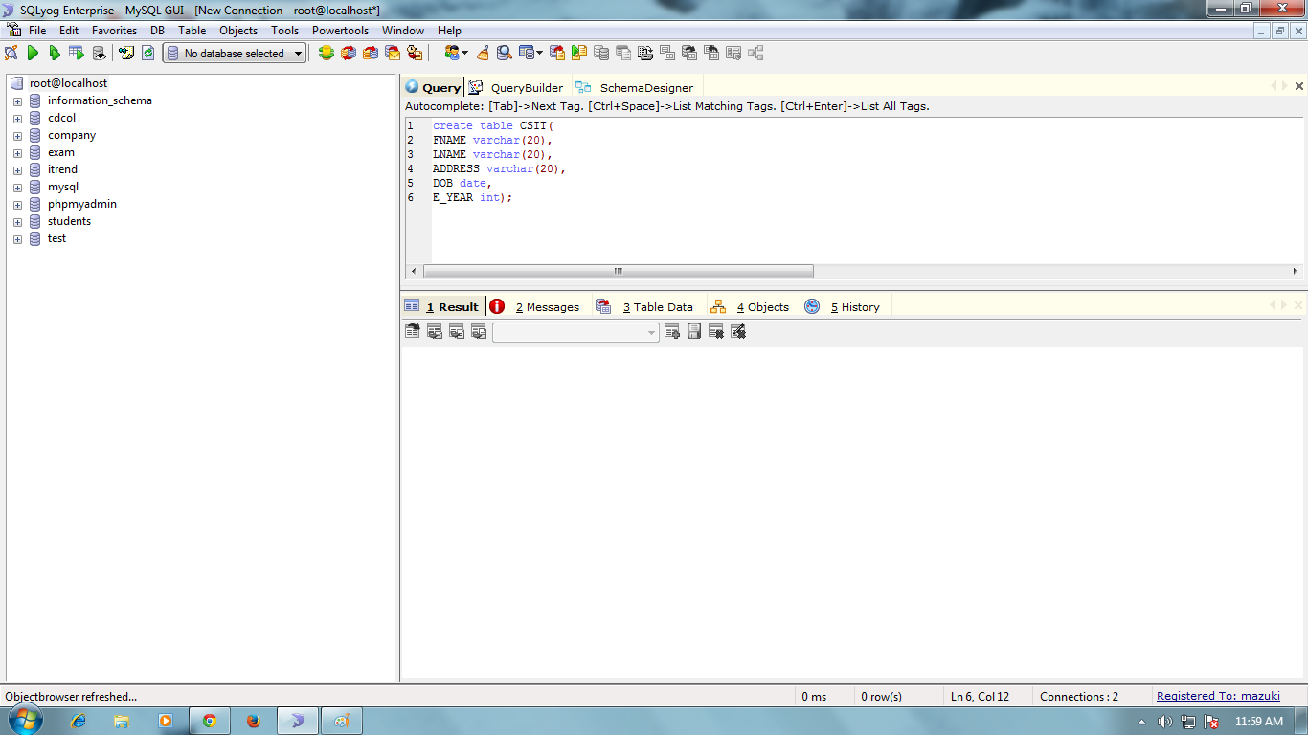

# DATA INSERTION INTO TABLE CSIT

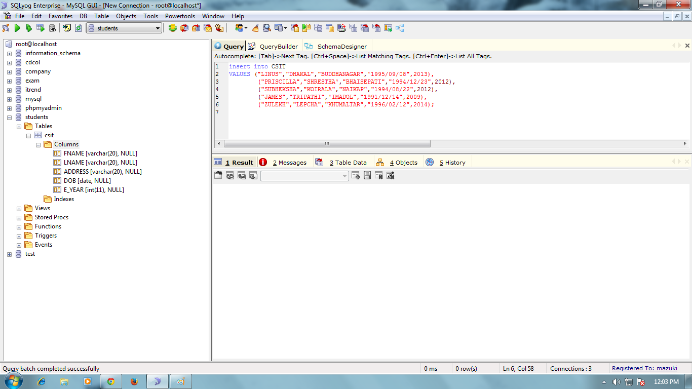

# ADING COLUMN GENDER

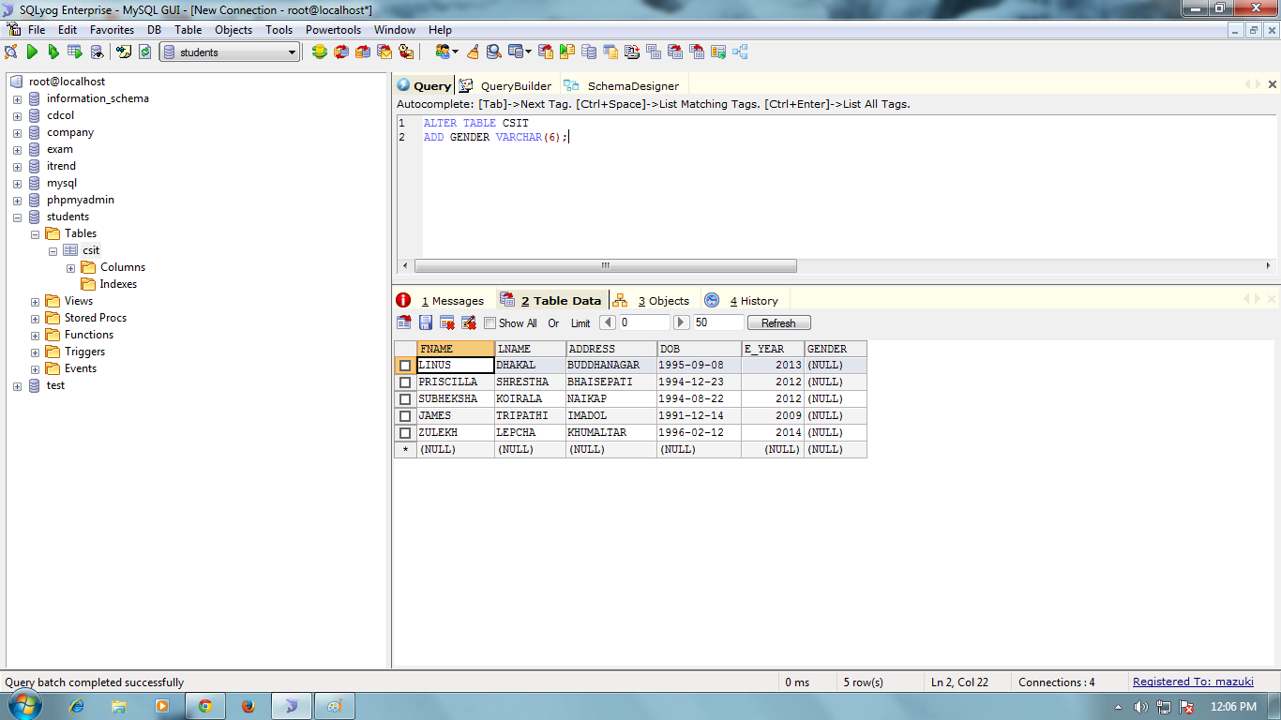

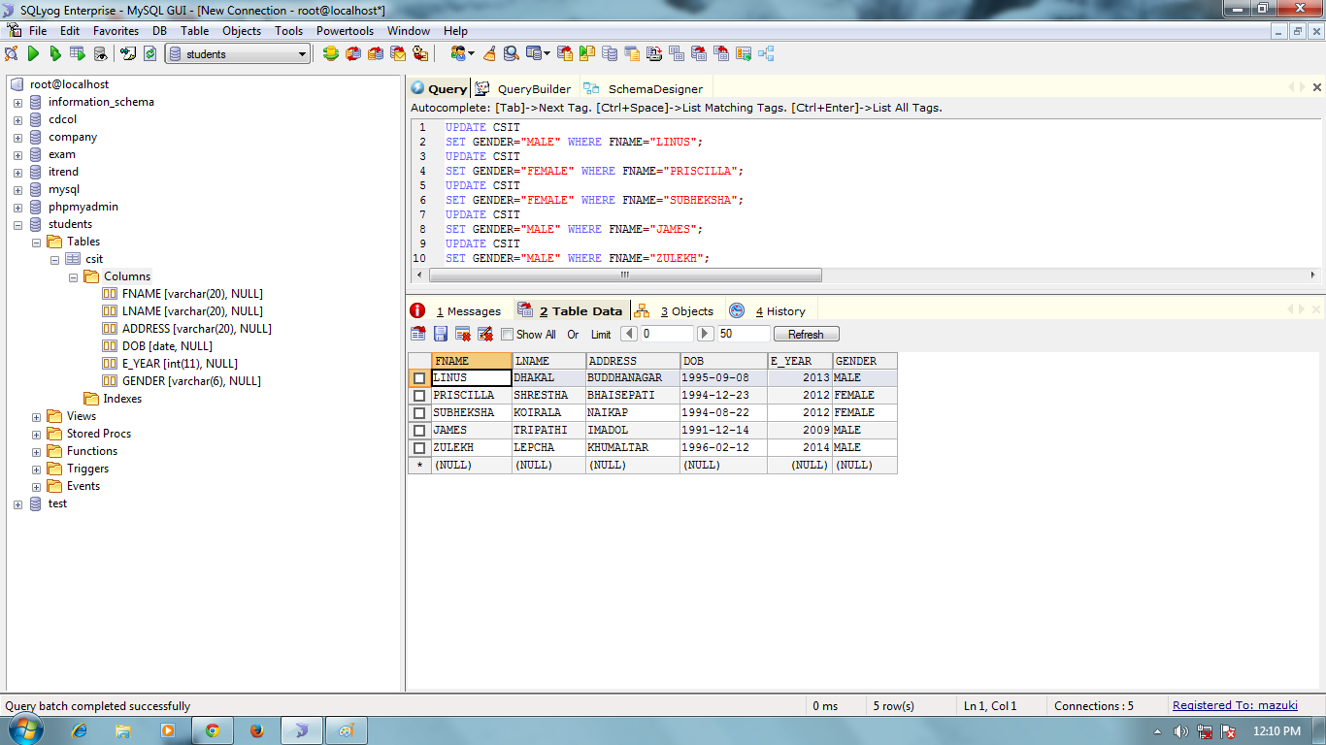

# CREATING TABLE BSW

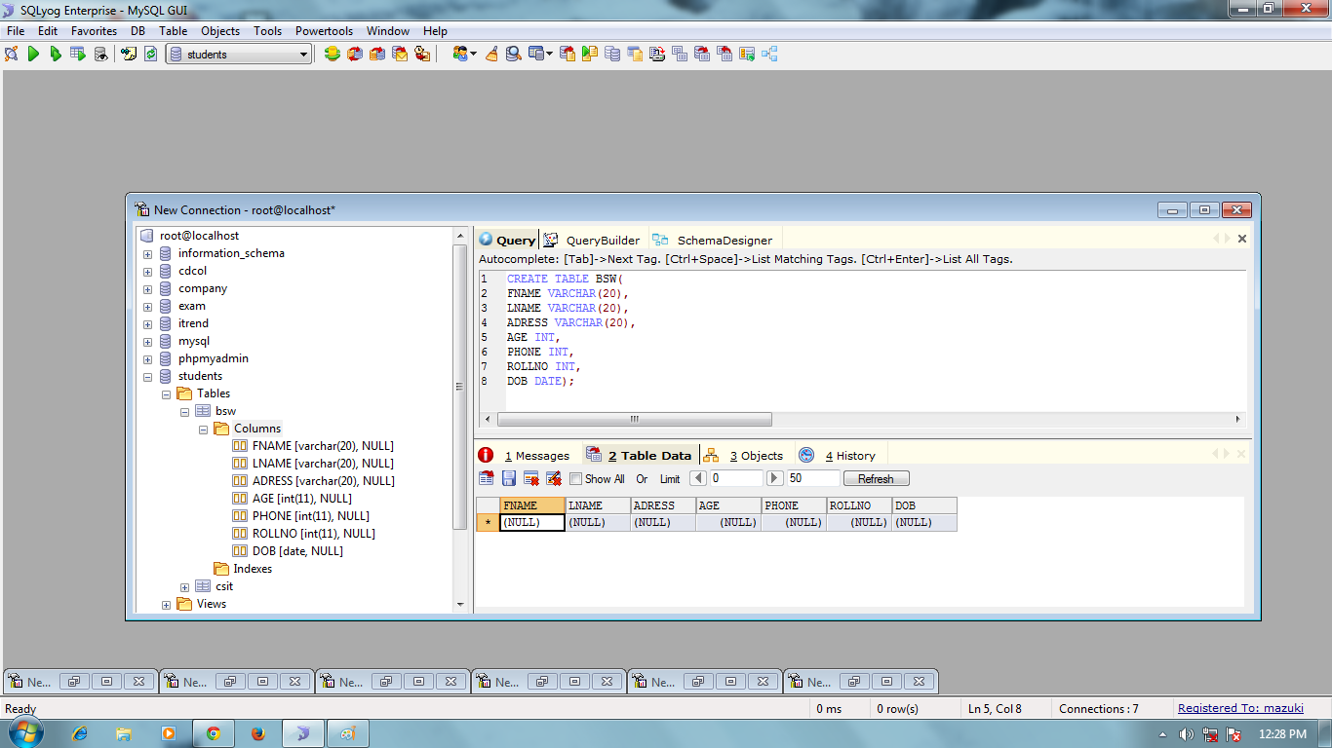

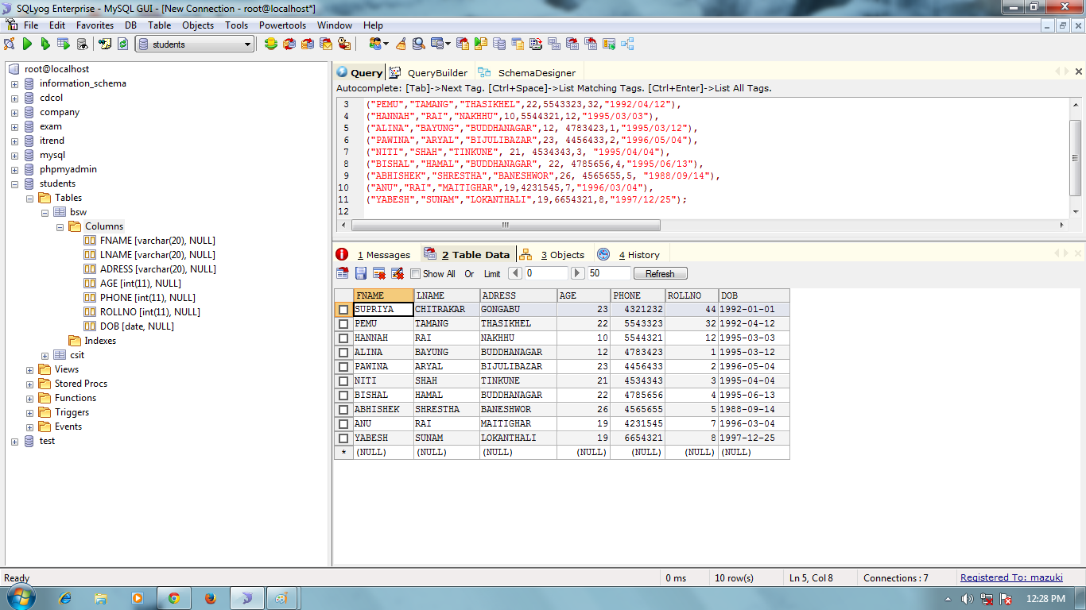

# DROPPING COLUMNS AGE AND ROLL NO

