ST. XAVIER’S COLLEGE

**(Affiliated to Tribhuvan University)**

**Maitighar, Kathmandu**



**Database Management System**

**Lab Assignment #9**

**SUBMITTED BY:**

Siddhant Rimal

013BSCCSIT039

**SUBMITTED TO**

|  |  |
| --- | --- |
| **Er. Sanjay Kr. Yadav**  **( Lecturer )** |  |
| **Department of Computer Science** | |

Submission Date: 6th November 2015

Syntax:

1. Finding average value  
   select AVG(<Attribute>) from <TABLE>;
2. Finding maximum value  
   select MAX(<Attribute>) from <TABLE>;
3. Finding minimum value  
   select MIN(<Attribute>) from <TABLE>;
4. Finding total sum value  
   select SUM(<Attribute>) from <TABLE>;
5. Finding count value  
   select COUNT(<Attribute>) from <TABLE>;
6. Using in conditional statements

select AVG(<Attribute>) from <TABLE> where <condition>;

Steps:  
  
1.Creating a Database

Create database stationeryshop;

2. Creating a Table

create table store(

p_no int not null AUTO_INCREMENT primary key,

p_name varchar(20) not null,

p_cost int not null,

p_qty int not null,

p_amount int

);

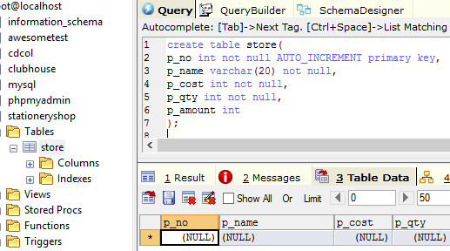

Fig: Creating a Table, Store

3. Inserting data into table

insert into store values("","A4Notebook",70,100,7000);

insert into store values("","Steel Scale",30,500,1500);

insert into store values("","Gel Pen",25,200,5000);

insert into store values("","HB Pencil",10,100,1000);

insert into store values("","Eraser",15,100,1500);

insert into store values("","Stapler",65,100,7000);

insert into store values("","Paper Clips",1,2000,2000);

insert into store values("","DVD-RW",40,100,4000);

insert into store values("","Paste-it Notepad",55,100,5500);

insert into store values("","Sharpener",10,100,1000);

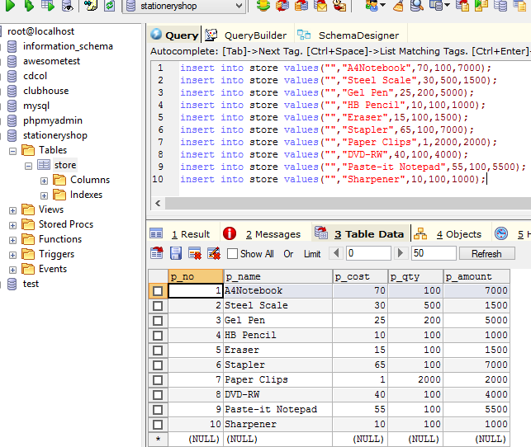

Fig: Inserting data into database

4. Finding average cost value from a number of products

select AVG(p_cost) from store

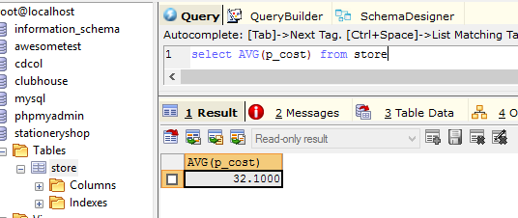

Fig: Finding the average cost value for all products

5. Finding average cost value from products whose quantity is less than 1000

select AVG(p_cost) from store

where p_qty<=1000;

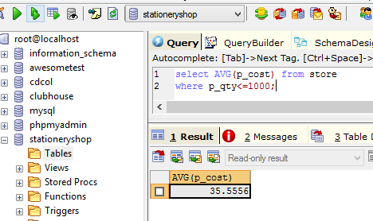

Fig: Finding the average cost value for all products whose quantity is less than 1000

1. Finding the maximum cost value for all products whose name starts with S

select MAX(p_cost) from store

where p_name like 'S%';

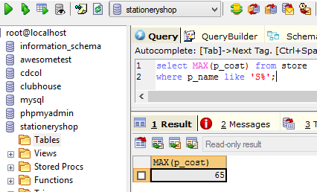

Fig: Finding the costliest product price of all products whose name starts with S

1. Finding the minimum cost among all products

select MIN(p_cost) from store;

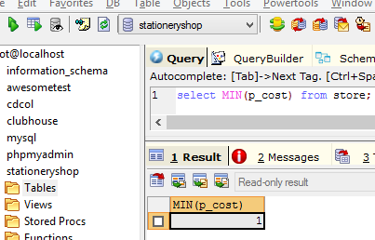

Fig: Finding the cost of the least expensive product

1. Show the sum of the amounts of all products

select SUM(p_amount) from store;

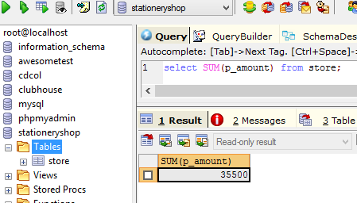

Fig: Finding the total sum of all product amount

1. Count the number of items in the table(i.e return row count)

select COUNT(p_name) from store;

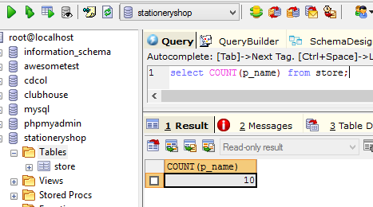

Fig: Finding the total number of products