ST. XAVIER’S COLLEGE

**(Affiliated to Tribhuvan University)**

Maitighar, Kathmandu



**Database Management System**

**SUBMITTED BY:**

Divya Jyoti Pokharel

013BSCCSIT019

**SUBMITTED TO:**

|  |  |
| --- | --- |
| **Er. Sanjay Kumar Yadav**  Lecturer  St. Xavier’s College |  |

**Date of Submission:** October 9, 2015

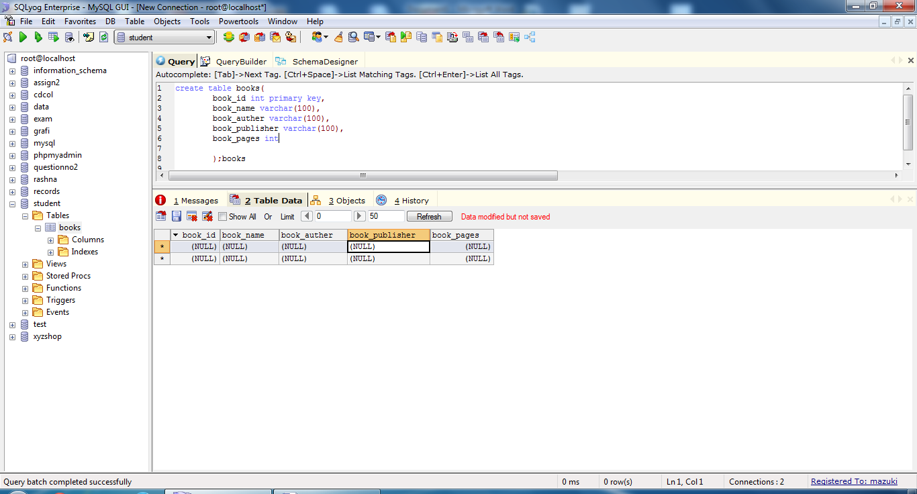

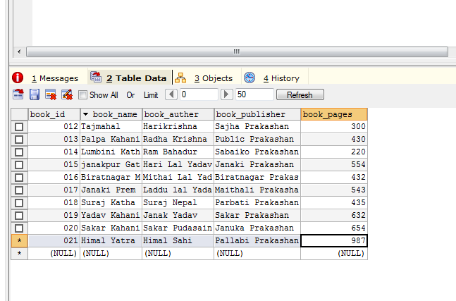

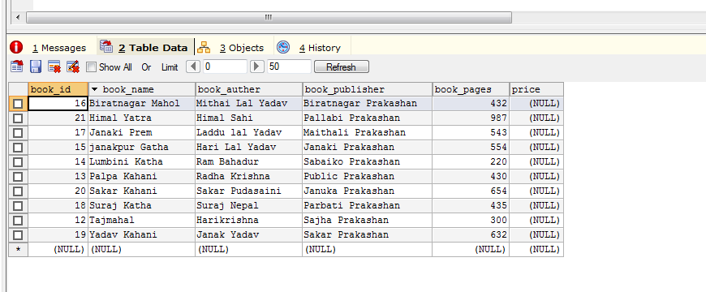

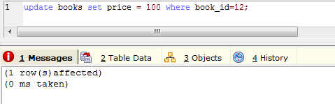

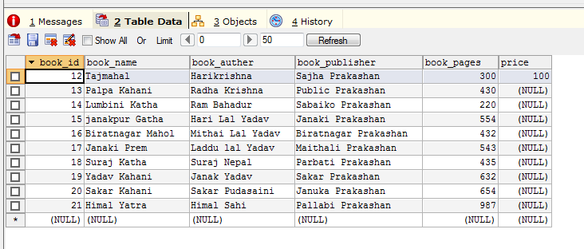

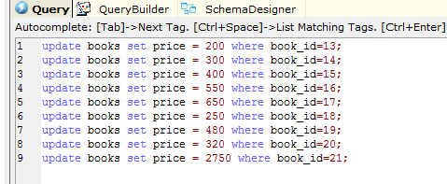

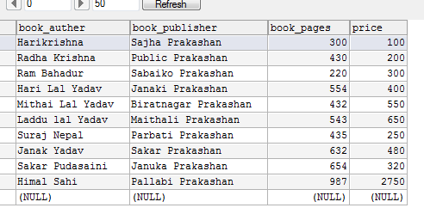

Next assignment

