ST. XAVIER’S COLLEGE

**(Affiliated to Tribhuvan University)**

Maitighar, Kathmandu



DATABASE MANAGEMENT SYSTEM

LAB ASSIGNMENT

**Submitted by:**

Lokendra Puri  
013BSCCSIT023

**Submitted to:**

|  |  |
| --- | --- |
| Er. Sanjay Kumar Yadav  Lecturer |  |

Department of Computer Science

Date of Submission: October 9, 2015

**ALTER statement:**

Alter table table-name

Add column-name datatype

……

….

….

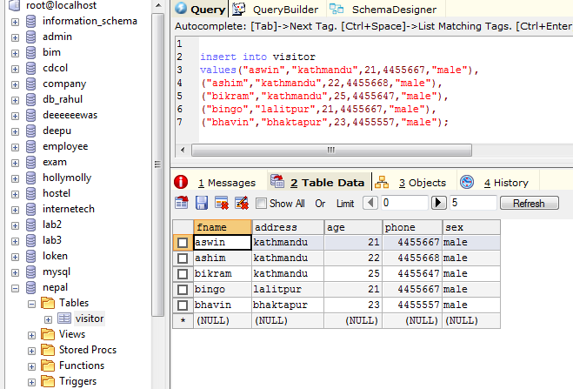

**Adding new column**

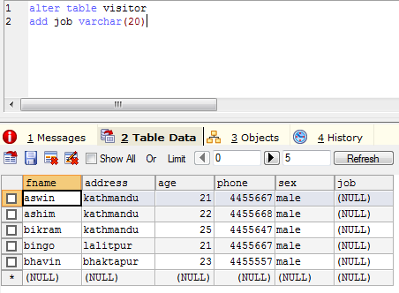

**Inserting values into new column:**

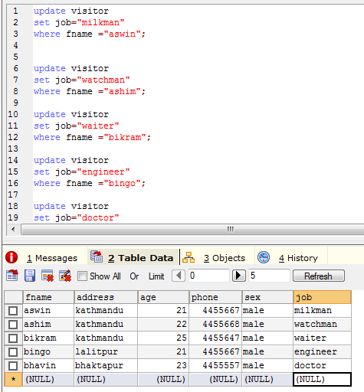

To change datatype:

modify table persons

Alter column age year

Update statement:

Update persons

Set age=25

Where id=001

**TO DELETE COLUMN FROM TABLE:**

ALTER TABLE TABLENAME

DROP COLUMN AGE

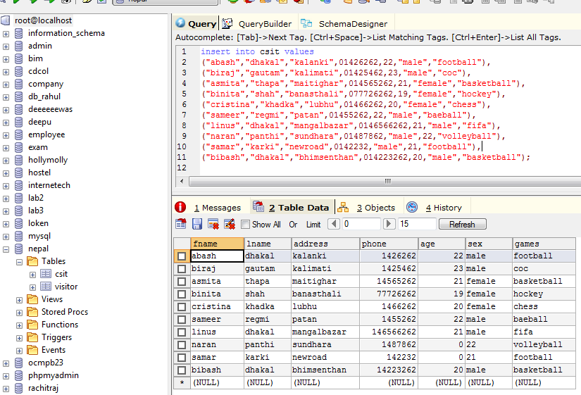

DROPPED TABLE:

