­ ST. XAVIER’S COLLEGE

**(Affiliated to Tribhuvan University)**

Maitighar, Kathmandu



**Database Management System**

**Lab assignment**

**Submitted by:**

Arjun Neupane

013BSCCSIT009

**Submitted to:**

|  |  |
| --- | --- |
| Er. Sanjay K. Yadav  Lecturer, St. Xavier’s College |  |

Date of submission: October 9, 2015

**ALTER statement:**

To add a column in a table.

Syntax:

ALTER table table_name

ADD column_name datatype

Eg:

Alter table person

Add age data

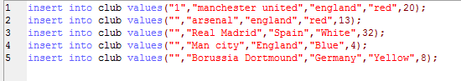

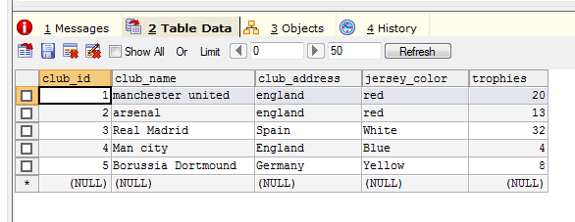

Alter:



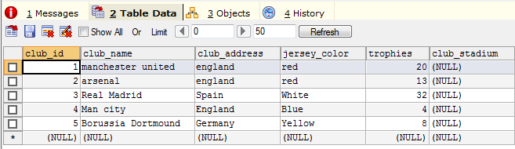 Update:

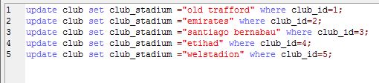

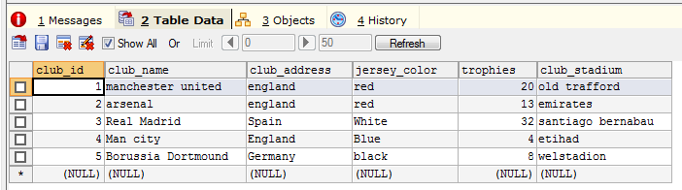

Update statement:

Eg:

Update persons

SET age=25,

Where id=001

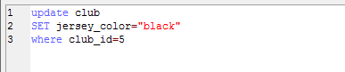

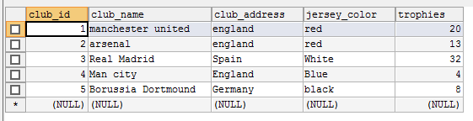

Change data type:

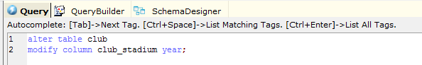

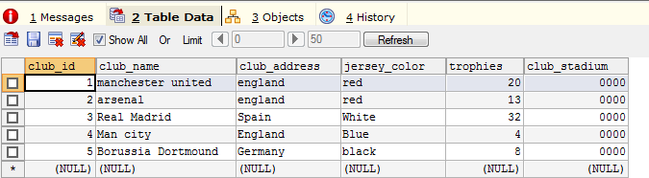

**Creation of new table “players ”**

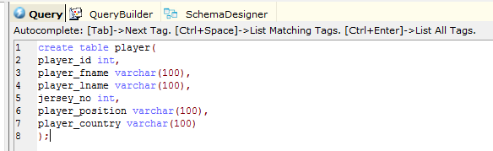

**Data insertion:**

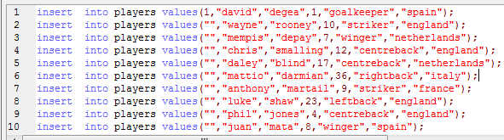

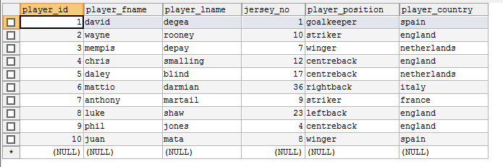

**Drop column of column name “player_country”**



