Inserting to table college

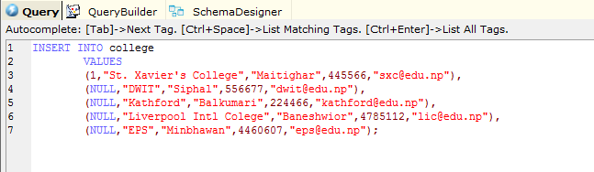

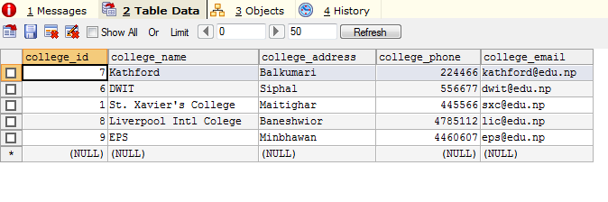

Adding new column **no_of _students**

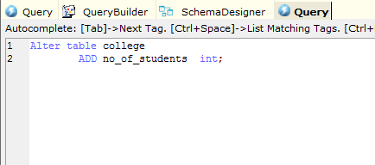

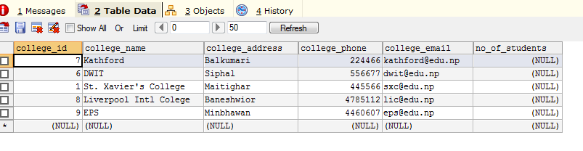

Adding new data in no_of_students

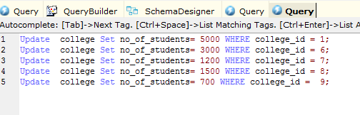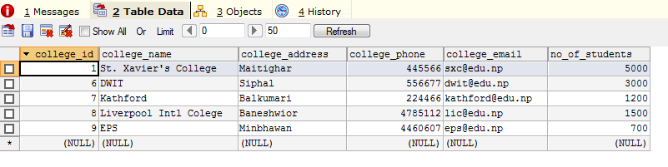

Adding new column established _year

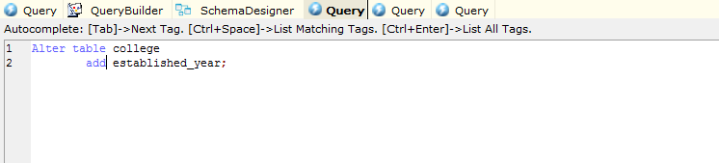

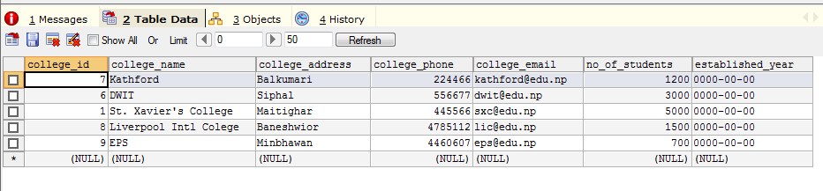

Alter data type of established _year

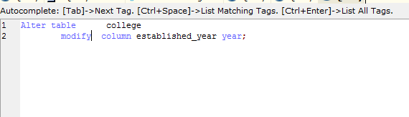

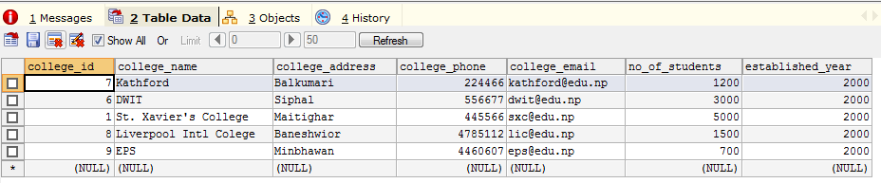

Add new data on it

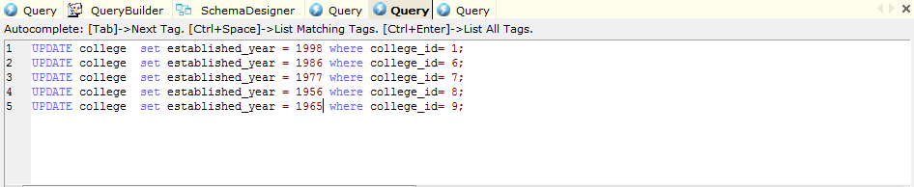

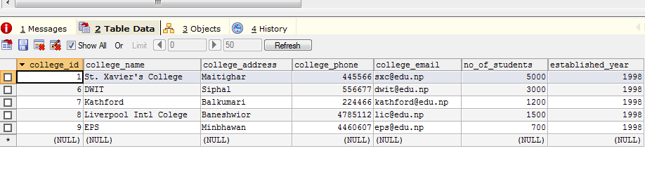

Creating table student

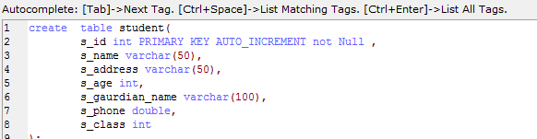

\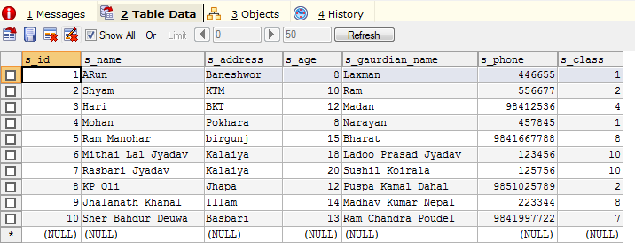

Drop two columns of student



