ST. XAVIER’S COLLEGE

**(Affiliated to Tribhuvan University)**

**Maitighar, Kathmandu**



**Database Management System**

**Lab Report #2**

**SUBMITTED BY:**

**Siddhant Rimal**

**013BSCCSIT039**

**SUBMITTED TO**

|  |  |
| --- | --- |
| **Mr. Sanjay Kr. Yadav**  **( Lecturer )** |  |
| **Department of Computer Science** | |

Submission Date: August 16th 2015

**2.1 Introduction to SQL**

[SQL](https://en.wikipedia.org/wiki/SQL) or Structured Query Language, is a language to request data from a database, to add, update, or remove data within a database, or to manipulate the metadata of the database [1].

* It is a declarative language in which the expected result or operation is given without the specific details about how to accomplish the task [1].
* The steps required to execute SQL statements are handled transparently by the SQL database [1].
* Sometimes SQL is characterized as non-procedural because procedural languages generally require the details of the operations to be specified, such as opening and closing tables, loading and searching indexes, or flushing buffers and writing data to file systems.
* Therefore, SQL is considered to be designed at a higher conceptual level of operation than procedural languages because the lower level logical and physical operations aren't specified and are determined by the SQL engine or server process that executes it [1].

Instructions are given in the form of statements, consisting of a specific SQL statement and additional parameters and operands that apply to that statement. SQL statements and their modifiers are based upon official SQL standards and certain extensions to that each database provider implements [1].

**2.1.1. DDL**

A data definition language or data description language (DDL) is a syntax similar to a computer programming language for defining data structures, especially database schemas.

**2.1.2. DML**

A data manipulation language (DML) is a family of syntax elements similar to a computer programming language used for selecting, inserting, deleting and updating data in a database. Performing read-only queries of data is sometimes also considered a component of DML.

**2.1.3. Table name and Field**

Tables give unique identity to an entity in a database. Similarly, fields are attributes of the entity which are represented by table columns. There are four types of tables:

* Normal
* With auto increment
* With time stamp
* Automatic now

**2.1.4. Difference between varchar and char**

|  |  |
| --- | --- |
| Varchar | Char |
| Varchar dynamically allocates all remaining unused space to other attributes so that database occupies least possible data storage space. | Char follows a static data storage approach whereby the predefined storage space is completely allocated for a single attribute regardless of its utilization. |

**2.1.5. Different operations**

Commonly used statements are grouped into the following categories:

**2.1.5.1. Data Query Language (**[**DQL**](https://en.wikipedia.org/wiki/Data_Query_Language)**)**

* SELECT - Used to retrieve certain records from one or more tables [1].

**2.1.5.2. Data Manipulation Language (**[**DML**](https://en.wikipedia.org/wiki/Data_Manipulation_Language)**)**

* INSERT - Used to create a record.
* UPDATE - Used to change certain records.
* DELETE - Used to delete certain records [1].

**2.1.5.3. Data Definition Language (**[**DDL**](https://en.wikipedia.org/wiki/Data_Definition_Language)**)**

* CREATE - Used to create a new table, a view of a table, or other object in database.
* ALTER - Used to modify an existing database object, such as a table.
* DROP - Used to delete an entire table, a view of a table or other object in the database [1].

**2.1.5.4. Data Control Language (**[**DCL**](https://en.wikipedia.org/wiki/Data_Control_Language)**)**

* GRANT - Used to give a privilege to someone.
* REVOKE - Used to take back privileges granted to someone [1].

**2.1.6. Syntax**

**2.1.6.1. For creating database [3]**

create database database_name;

**2.1.6.2. For creating table [3]**

create table table_name(

field1_name datatype not primary key; *// to create primary key*  
field2_name datatype, *//to store data of desired datatype normally*  
field3_name timestamp *//to insert data entry time and date automatically*  
);

**2.1.6.3. For deleting database [3]**  
drop database database_name;

**2.1.6.4. For deleting table [3]**

drop table table_name;

**2.1.6.5. For using now() operation [4]**

Select attribute1, attribute2,…,attributeN, now() as New_Attribute_Name for Target_Table;

**2.2 ADVANTAGE OF USING SQL**

SQL can do the following things:

* execute queries against a database
* retrieve data from a database
* insert records in a database
* update records in a database
* delete records from a database
* create new databases
* create new tables in a database
* create stored procedures in a database
* create views in a database
* set permissions on tables, procedures, and views [2]

**2.3 Use of SQL**

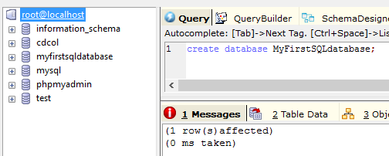

Fig 2.3.1: Creating a Database in SQL [3]

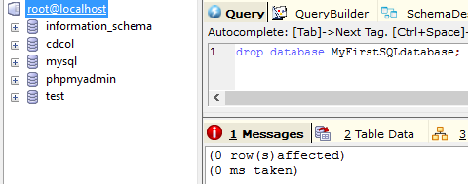

Fig 2.3.2: Deleting a database in SQL [3]

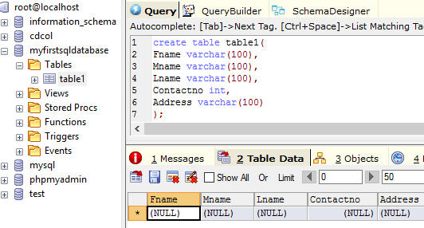

Fig 2.3.3: Creating a table in SQL [3]

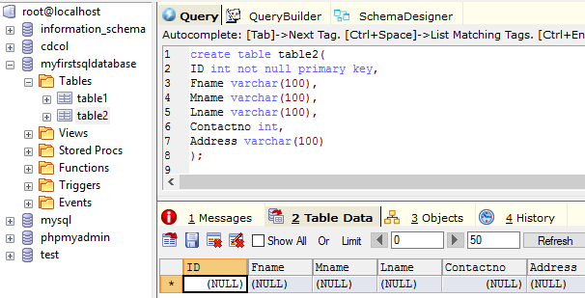

Fig 2.3.4: Creating a table with primary key in SQL [3]

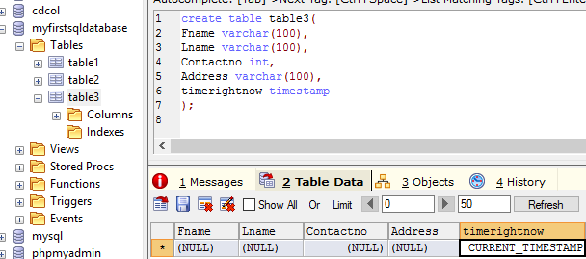

Fig 2.3.5: Creating a table with timestamp in SQL [3]

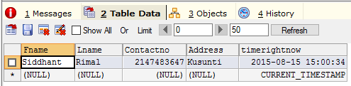

Fig 2.3.6: Inserting Data to show the use of timestamp [3]

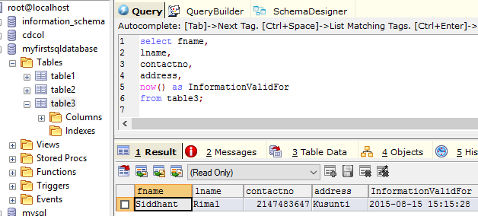

Fig 2.3.7: Using Now() function to query currently valid data from a table [4]

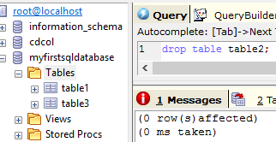

Fig 2.3.8: Deleting a Table [3]

**2.4 Conclusion**

As mention herein, different kinds of commands can be used in SQL to create and drop table or database, add fields, insert timestamps to table, or even query the table with respect to the current time and date.

**2.5 Refrerences**

1. ”Introduction to SQL”, Wikibooks, Internet url: <https://en.wikibooks.org/wiki/Structured_Query_Language/Introduction_to_SQL> 2015 [13/08/2015]
2. “SQL Intro”, w3schools, Internet url: <http://www.w3schools.com/sql/sql_intro.asp> 2015 [13/08/2015]
3. Er. Sanjay Kr. Yadav, “Introduction to SQL”, Lecture, St. Xavier’s College 13/08/2015 [13/08/2015]
4. “SQL Now() Function”, w3schools, Internet url: <http://www.w3schools.com/sql/sql_func_now.asp> 2015 [13/08/2015]