ST.XAVIER’S COLLEGE

**Maitighar, Kathmandu**



**DBMS LAB ASSIGNMENT**

**Submitted By:**

**Narayan Panthi**

013BSCCSIT024

**Submitted To:**

**Er. Sanjay Kumar Yadav** ………..…………….

**Lecturer**

**Department of Computer Science**

**Date of Submission:- *2015 -*** *__****_-*** *___*

# Creating Database:

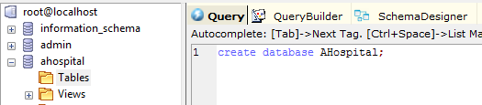

# Creating table:

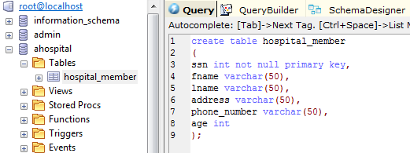

# Inserting Data into tables:

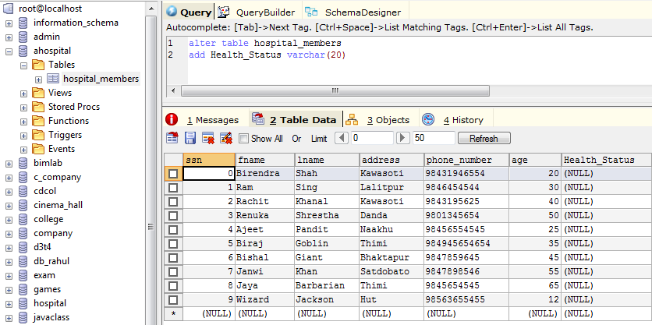

# Inserting Data from update Statement:

### The SQL UPDATE Statement

The UPDATE statement is used to update existing records in a table.

### SQL UPDATE Syntax

UPDATE table_name  
SET column1=value1,column2=value2,...  
WHERE some_column=some_value;

**the WHERE clause in the SQL UPDATE statement!**  
The WHERE clause specifies which record or records that should be updated.

If we omit the WHERE clause, all records will be updated!

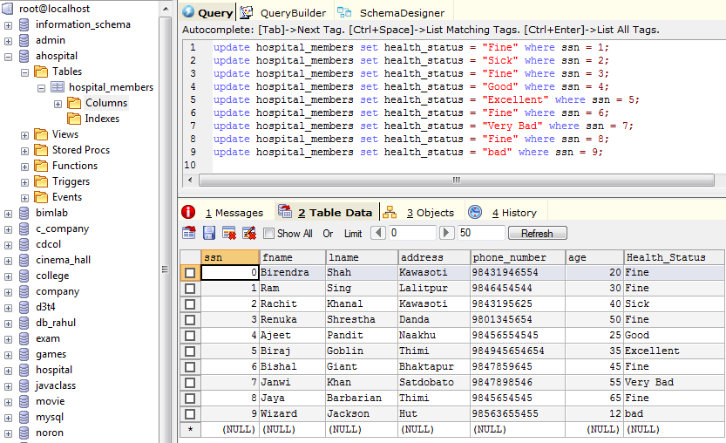

# Creating Database:

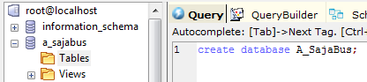

# Creating table:

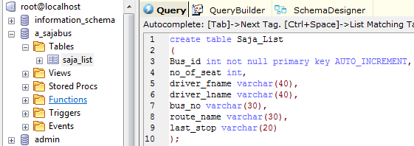

# Inserting Data into tables:

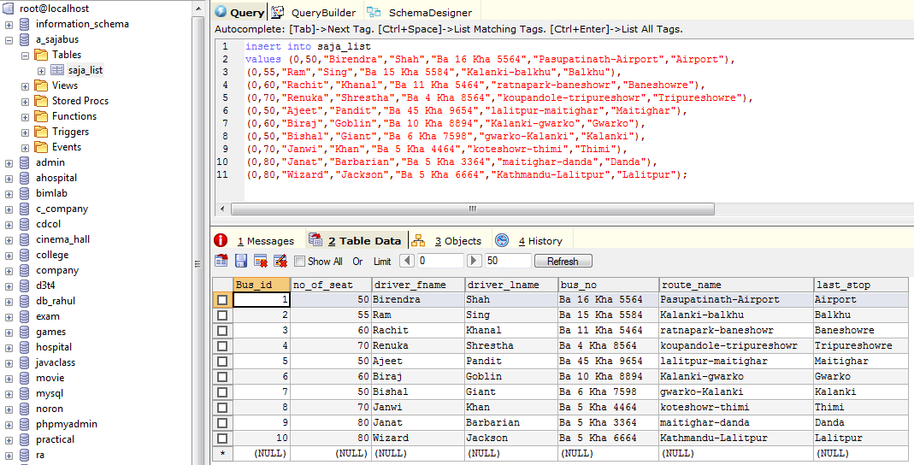

# Dropping Column:

#### The DROP INDEX Statement

The DROP INDEX statement is used to delete an index in a table.

### SQL DROP Syntax

Alter table table_name

Drop Column column_name

