**ST. XAVIER’S COLLEGE**

**(Affiliated to Tribhuvan University)**

Maitighar, Kathmandu



**Database Management System Lab Assignment s**

**Submitted by:**

Sazjan Neupane

013BSCCSIT036

**Submitted to:**

|  |  |
| --- | --- |
| Er. Sanjay Kumar Yadav  Lecturer, St. Xavier’s College |  |

**Date of Submission:** 9th October, 2015

Alter Statement

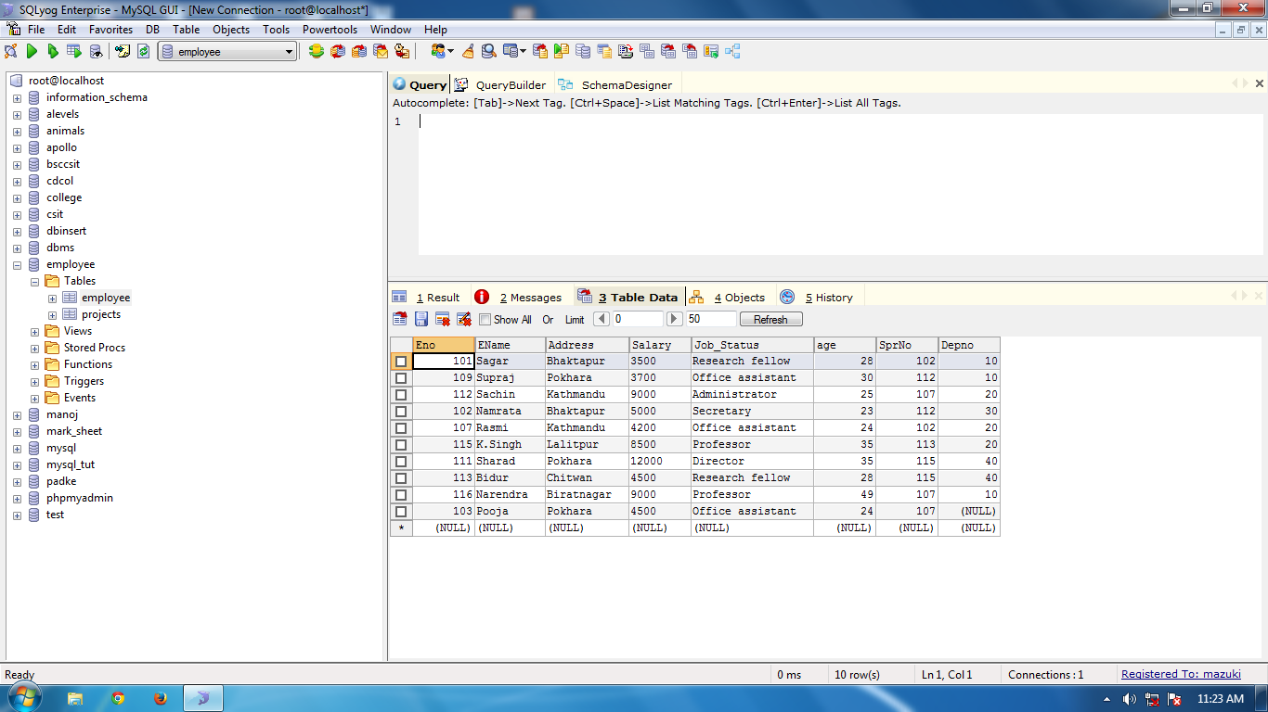

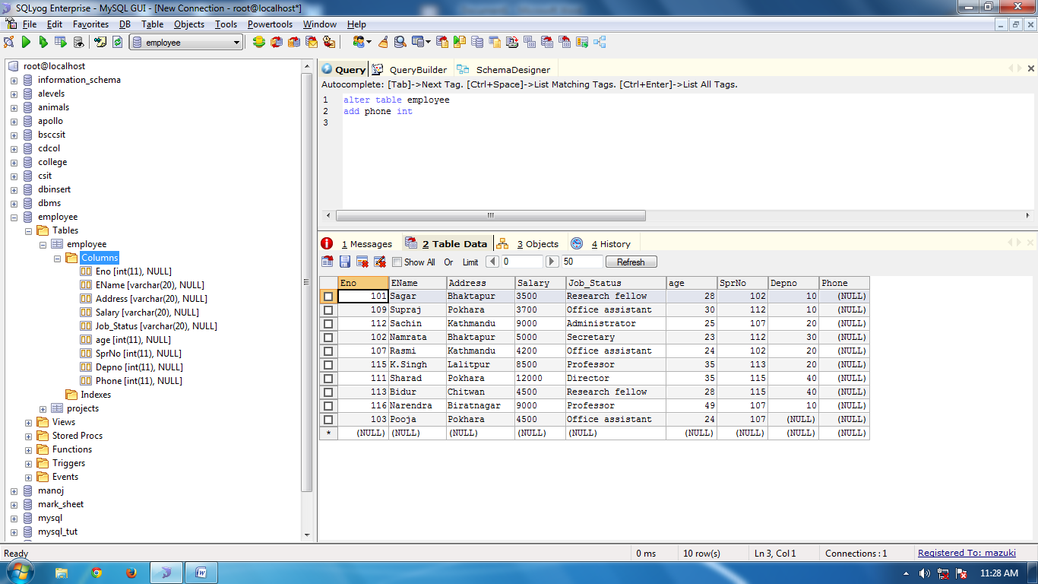

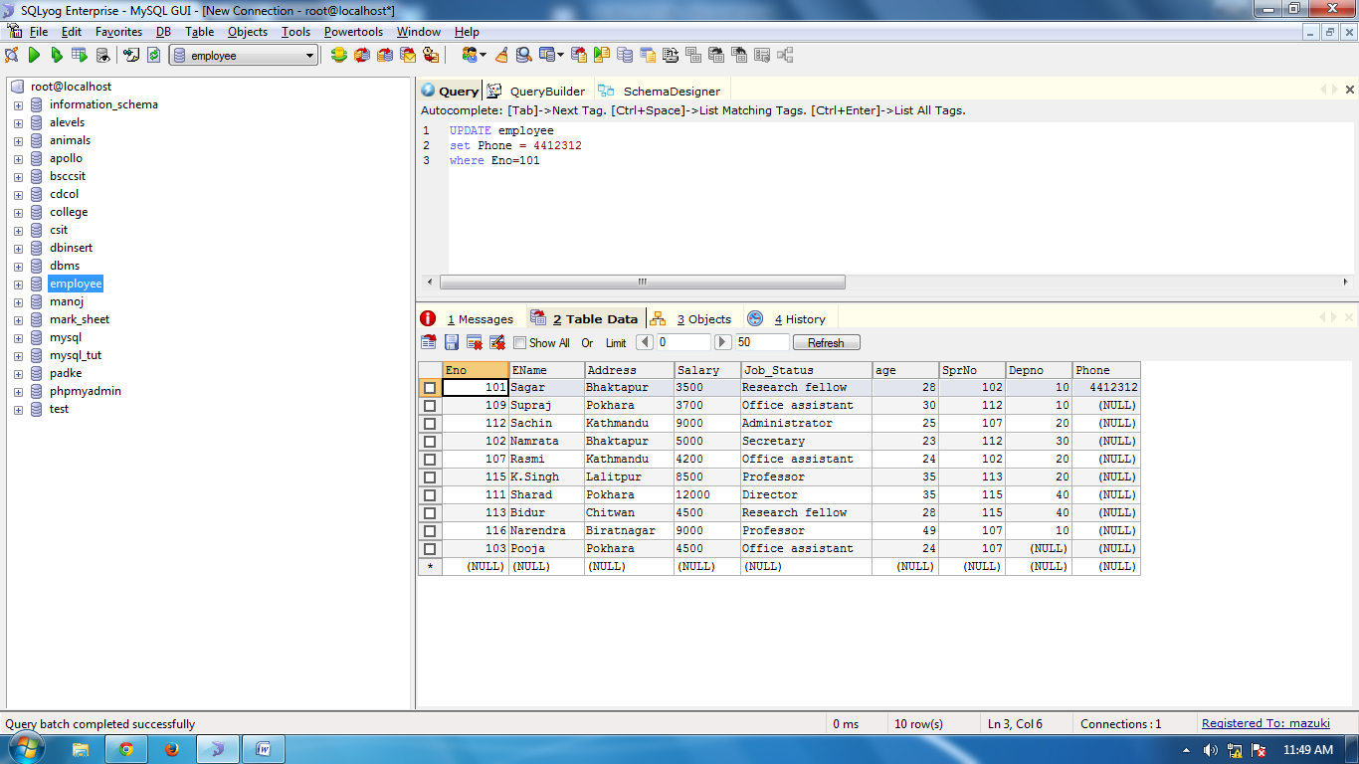

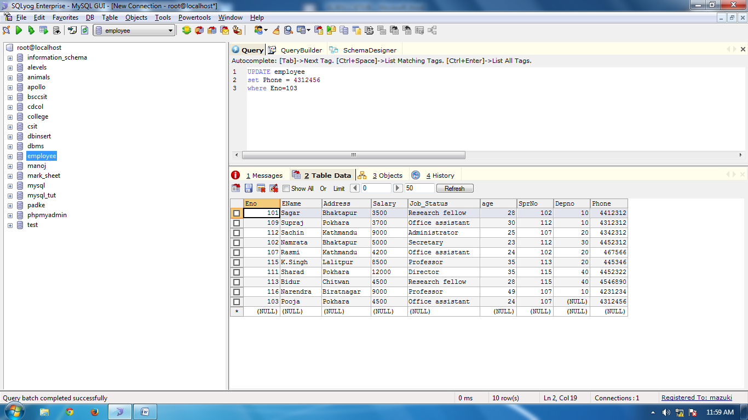

**Change data type**

*Syntax:*

Alter table <table_name>

Modify Column <column_name> <data_type>

**Update Statement**

*Syntax:*

Update <table_name>

Set <column_name>= value

Where <column_attribute>= value

**Creating Table:**

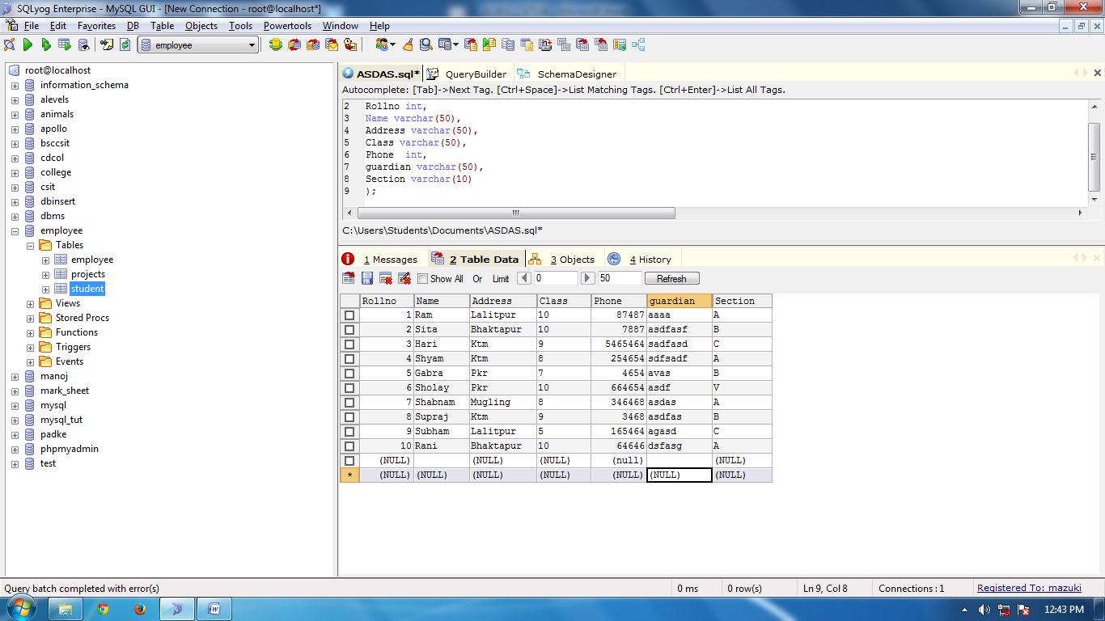

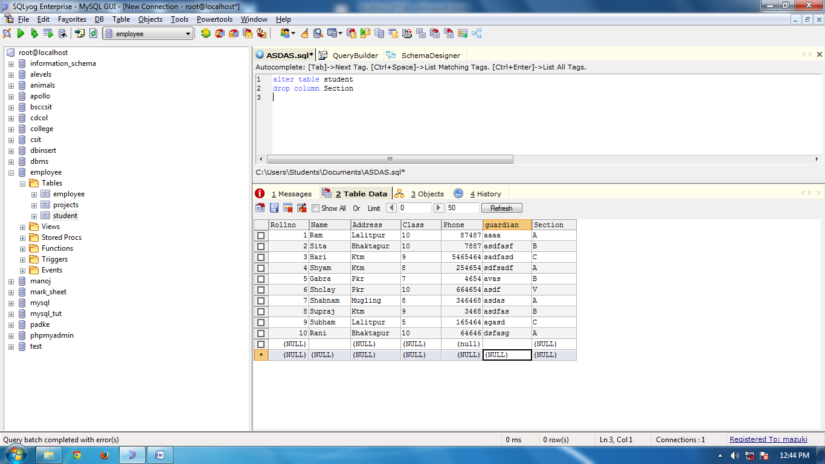

**Dropping Table Columns**

Drop Statement

*Syntax:*

Alter table <table_name>

Drop column <column_name>

