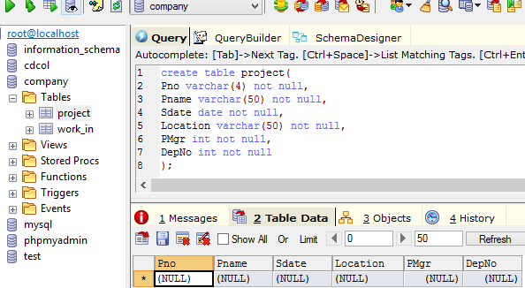

Fig: Creating table project in company database

Commands:

create table project(Pno varchar(4) not null, Pname varchar(50) not null, Sdate date not null, Location varchar(50) not null, PMgr int not null, DepNo int not null);

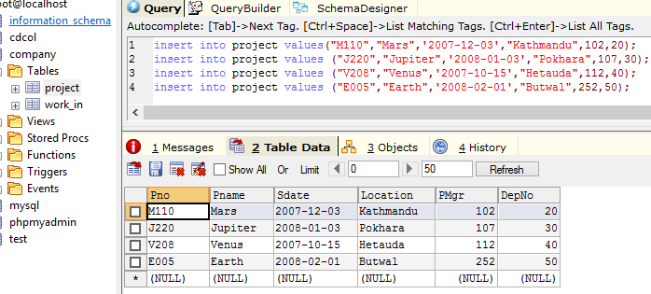

Fig: Inserting values into project table

Commands:

insert into project values("M110","Mars",'2007-12-03',"Kathmandu",102,20);

insert into project values ("J220","Jupiter",'2008-01-03',"Pokhara",107,30);

insert into project values ("V208","Venus",'2007-10-15',"Hetauda",112,40);

insert into project values ("E005","Earth",'2008-02-01',"Butwal",252,50);

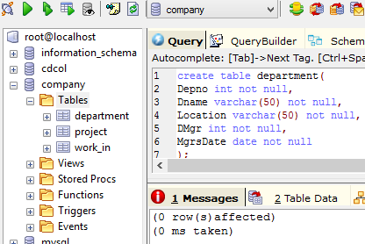

Fig: Creating table department in company database

Commands:  
create table department(Depno int not null, Dname varchar(50) not null, Location varchar(50) not null, DMgr int not null, MgrsDate date not null);

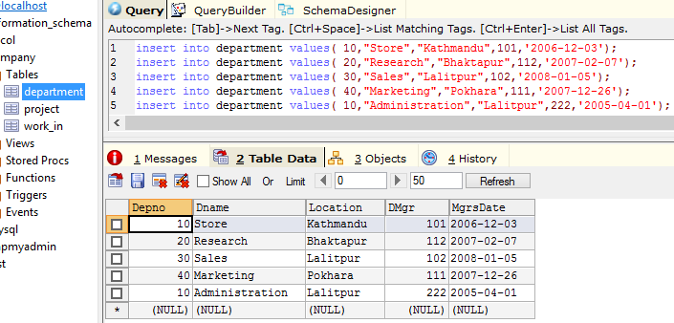

Fig: Inserting data into department table in company database

Commands:

insert into department values( 10,"Store","Kathmandu",101,'2006-12-03');

insert into department values( 20,"Research","Bhaktapur",112,'2007-02-07');

insert into department values( 30,"Sales","Lalitpur",102,'2008-01-05');

insert into department values( 40,"Marketing","Pokhara",111,'2007-12-26');

insert into department values( 10,"Administration","Lalitpur",222,'2005-04-01');

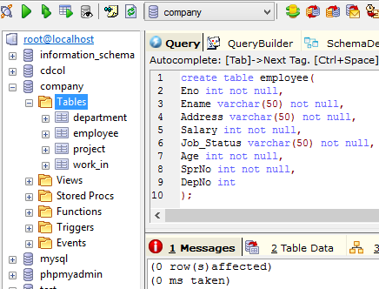

Fig: Creating Table employee in company database

Commands:

create table employee(Eno int not null,Ename varchar(50) not null, Address varchar(50) not null, Salary int not null, Job_Status varchar(50) not null, Age int not null, SprNo int not null, DepNo int);

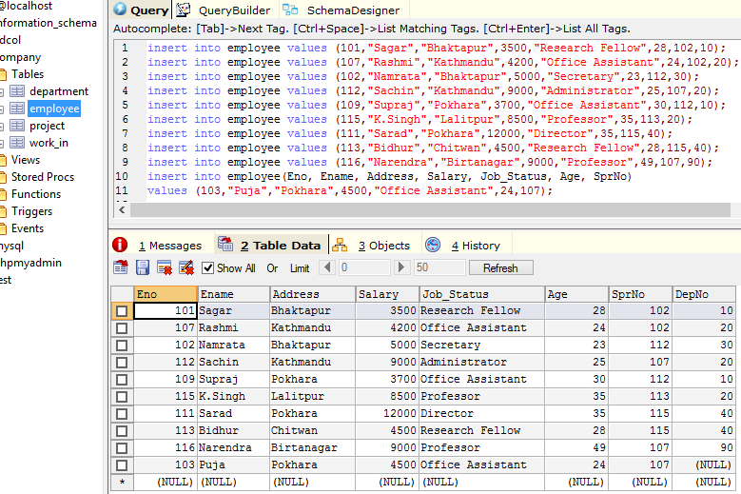

Fig: Inserting data into employee table in company database

Commands:

insert into employee values (101,"Sagar","Bhaktapur",3500,"Research Fellow",28,102,10);

insert into employee values (107,"Rashmi","Kathmandu",4200,"Office Assistant",24,102,20);

insert into employee values (102,"Namrata","Bhaktapur",5000,"Secretary",23,112,30);

insert into employee values (112,"Sachin","Kathmandu",9000,"Administrator",25,107,20);

insert into employee values (109,"Supraj","Pokhara",3700,"Office Assistant",30,112,10);

insert into employee values (115,"K.Singh","Lalitpur",8500,"Professor",35,113,20);

insert into employee values (111,"Sarad","Pokhara",12000,"Director",35,115,40);

insert into employee values (113,"Bidhur","Chitwan",4500,"Research Fellow",28,115,40);

insert into employee values (116,"Narendra","Birtanagar",9000,"Professor",49,107,90);

insert into employee(Eno, Ename, Address, Salary, Job_Status, Age, SprNo)

values (103,"Puja","Pokhara",4500,"Office Assistant",24,107);

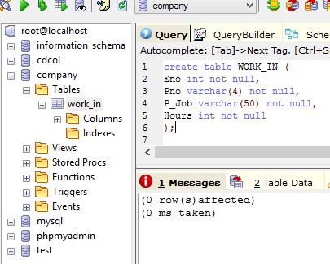

Fig: Creating table WORK_IN

Commands:

create table WORK_IN (Eno int not null, Pno varchar(4) not null, P_Job varchar(50) not null, Hours int not null);

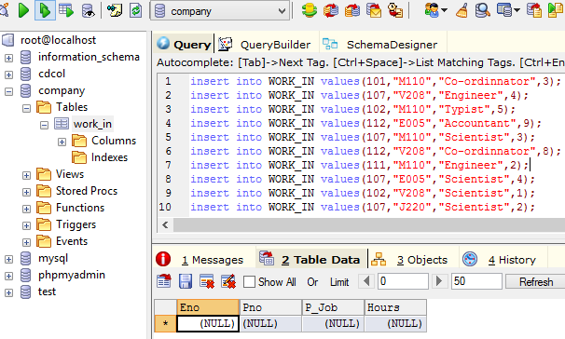

Fig: Inserting data into table WORK_IN

Commands:

insert into WORK_IN values(101,"M110","Co-ordinnator",3);

insert into WORK_IN values(107,"V208","Engineer",4);

insert into WORK_IN values(102,"M110","Typist",5);

insert into WORK_IN values(112,"E005","Accountant",9);

insert into WORK_IN values(107,"M110","Scientist",3);

insert into WORK_IN values(112,"V208","Co-ordinnator",8);

insert into WORK_IN values(111,"M110","Engineer",2);

insert into WORK_IN values(107,"E005","Scientist",4);

insert into WORK_IN values(102,"V208","Scientist",1);

insert into WORK_IN values(107,"J220","Scientist",2);

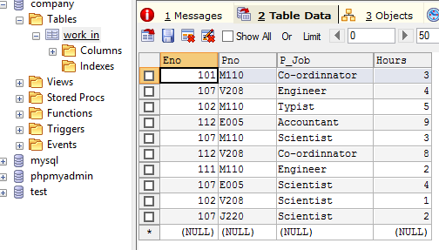

Fig: After data insertion in table WORK_IN