ST. XAVIER’S COLLEGE

**(Affiliated to Tribhuvan University)**

**Maitighar, Kathmandu**



**Database Management System Lab Assignment**

**SUBMITTED BY:**

**Hemanchal Joshi**

**013BSCCSIT021**

**SUBMITTED TO:**

|  |  |
| --- | --- |
| **Er. Sanjay Kr. Yadav**  Lecturer |  |
| **Department of Computer Science** | |

**Submission date:** October 9, 2015

1. **CREATING A TABLE**

**Step 1:**

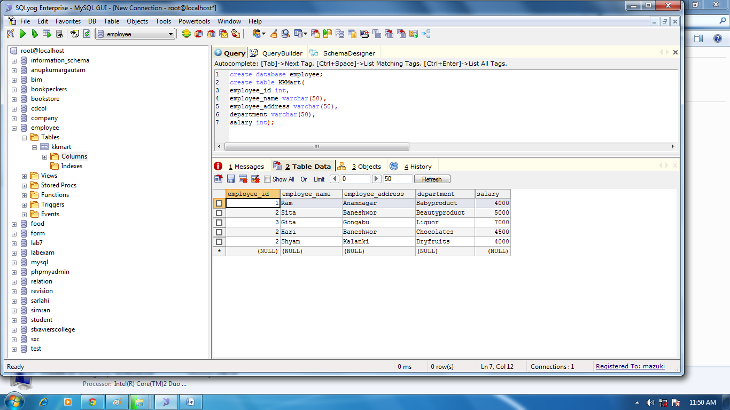

**Step 2:**

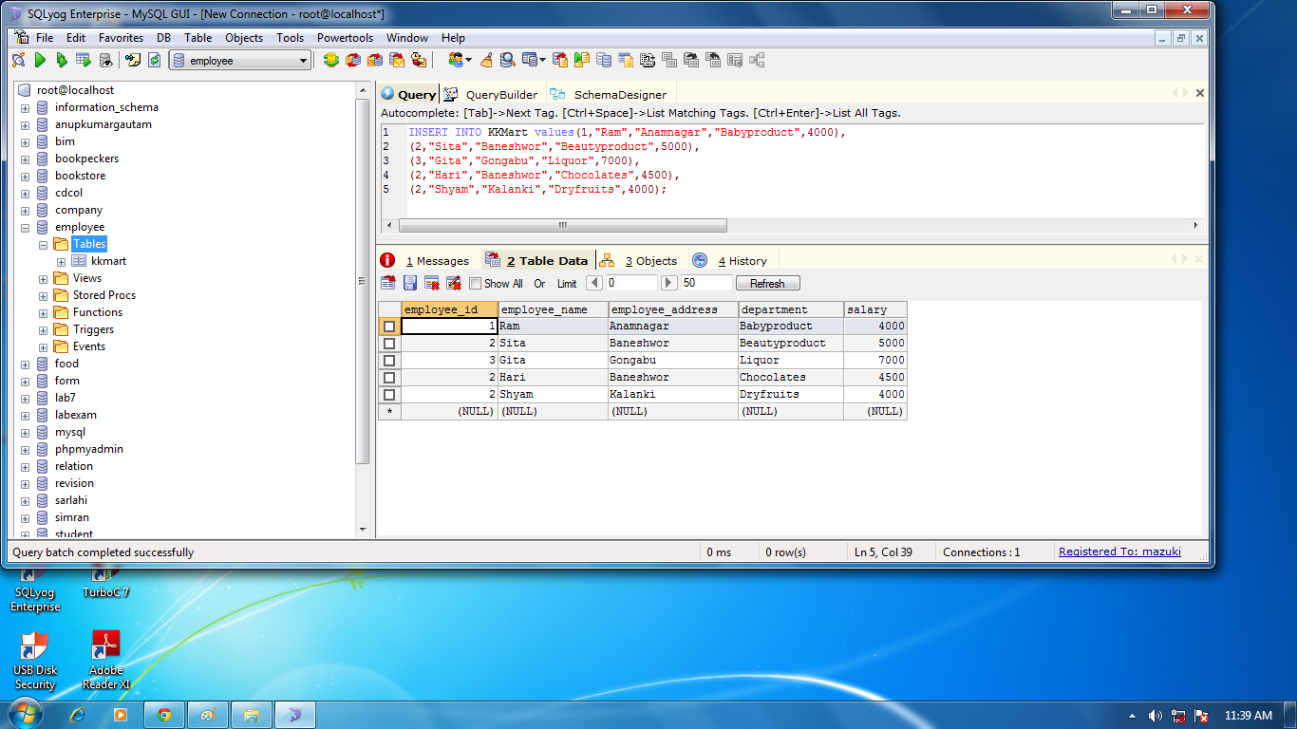

**ALTER STATEMENT**

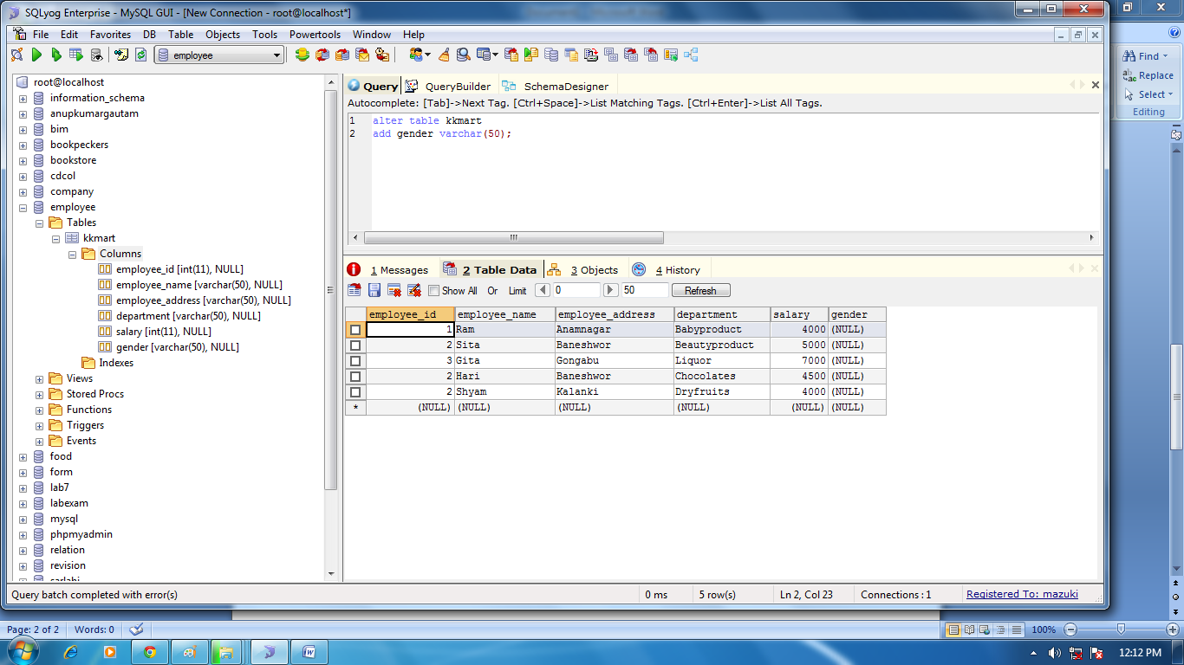

**UPDATE STATEMENT:**

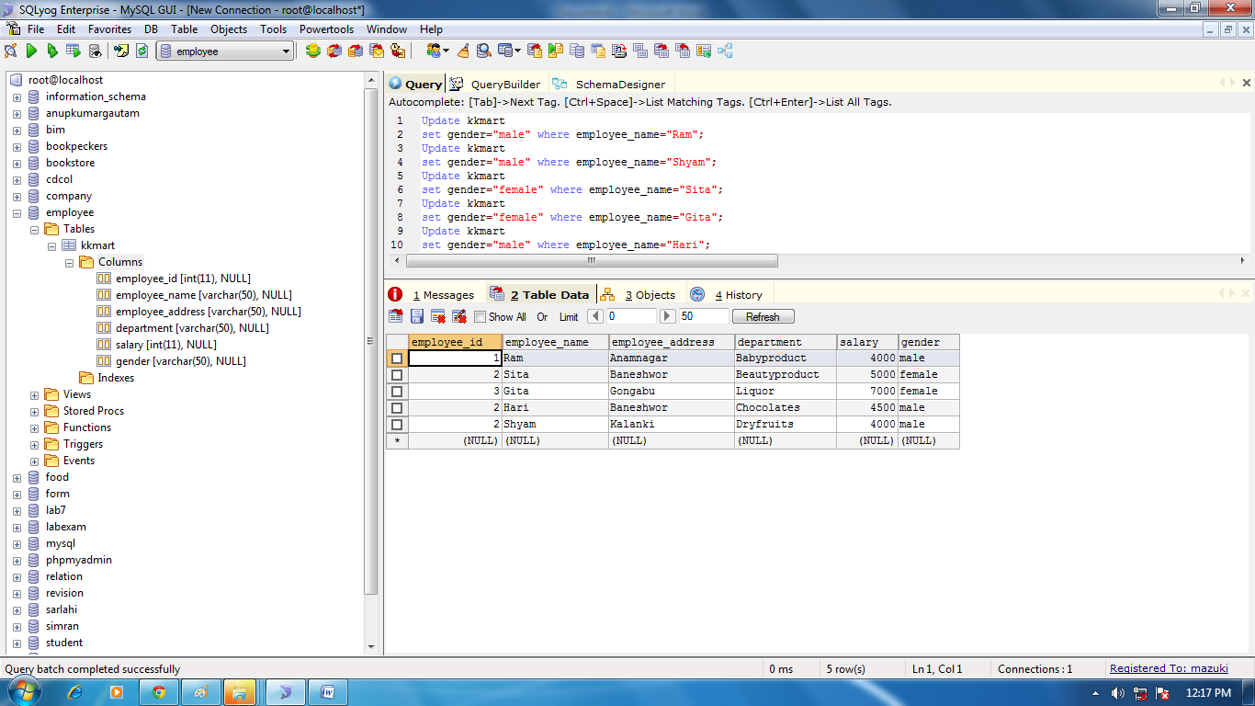

1. **CREATING A TABLE**

**Step 1:**

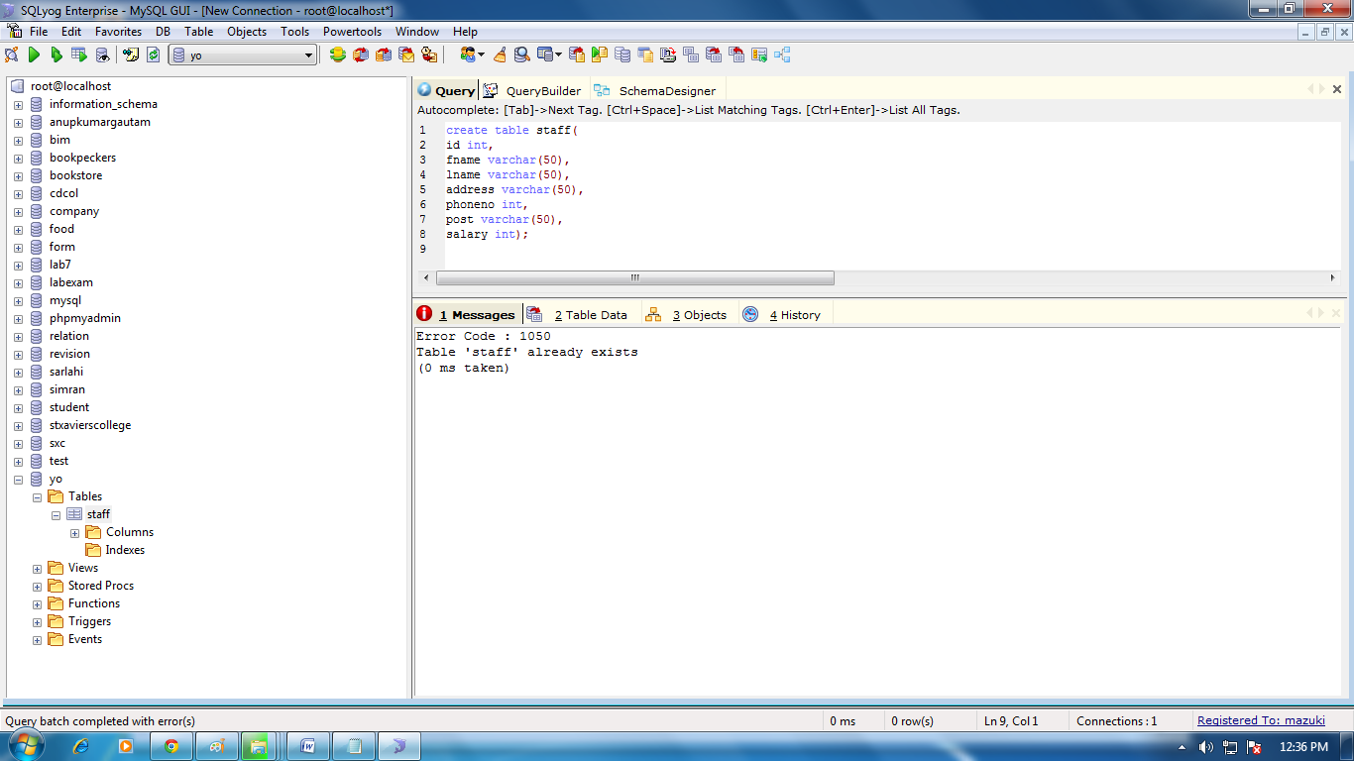

**Step 2:**

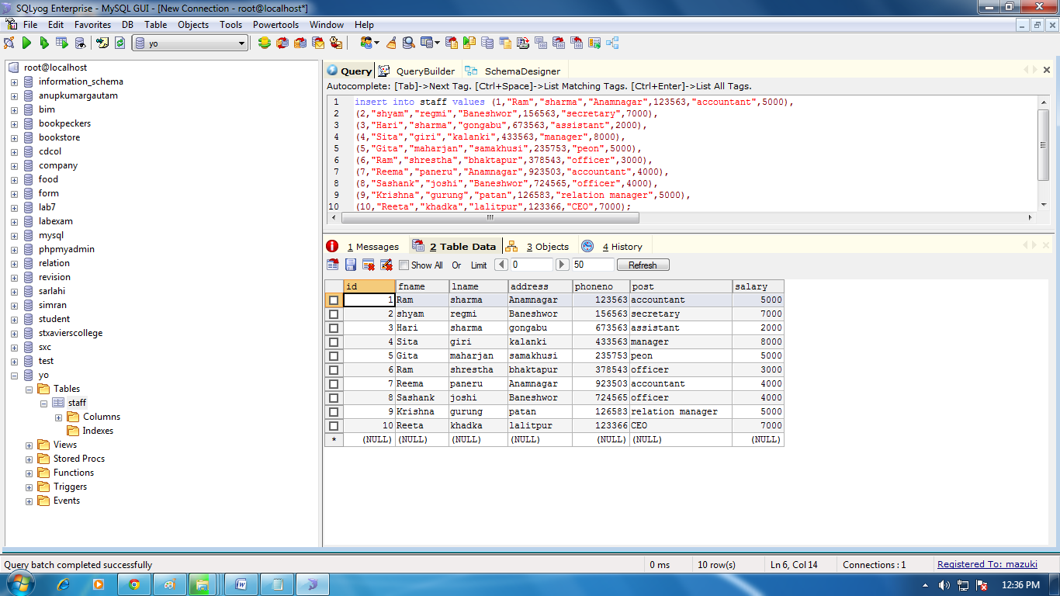

**DROP COLUMN**

