ST. XAVIER’S COLLEGE

**Maitighar,Kathmandu**

**(Affiliated to Tribhuvan University)**



**Database Management System**

**Lab Assignment #11**

**Submitted By**

Aashish Raj Shrestha

B.Sc. CSIT

Year II/IV Semester

013BSCIT002

**Submitted To**

Er. Sanjay Kumar Yadav

Lecturer,

Department of Computer Science

St. Xavier’s College

Maitighar, Kathmandu

**Submitted On**

October 9, 2015

**ALTER Statement:**

The SQL **ALTER TABLE** command is used to add, delete or modify columns in an existing table.

You would also use ALTER TABLE command to add and drop various constraints on an existing table.

1. **ALTER IN ADDING THE COLUMN/ATTRIBUTES:**

**SYNTAX:**

ALTER TABLE table_name

ADD column_name datatype

**EXAMPLE:**

|  |  |  |
| --- | --- | --- |
| Info | | |
| ID | Name | Address |
| 1 | Ram | Kapan |
| 2 | Sita | Janakpur |

Suppose we want a new attribute / Column. We use ALTER statement.

**TO ADD A COLUMN IN A TABLE**

**EXAMPLE:**

Alter Table Persons

Add age int

|  |  |  |  |
| --- | --- | --- | --- |
| Info | | | |
| ID | Name | Address | Age |
| 1 | Ram | Kapan | 12 |
| 2 | Sita | Janakpur | 13 |

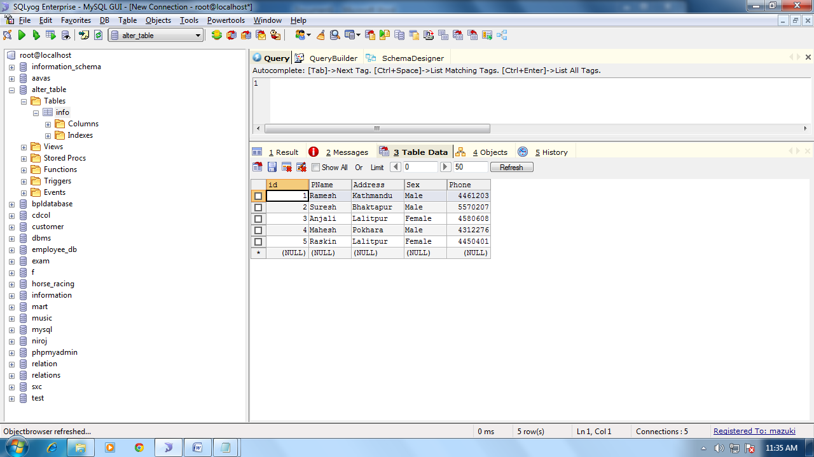

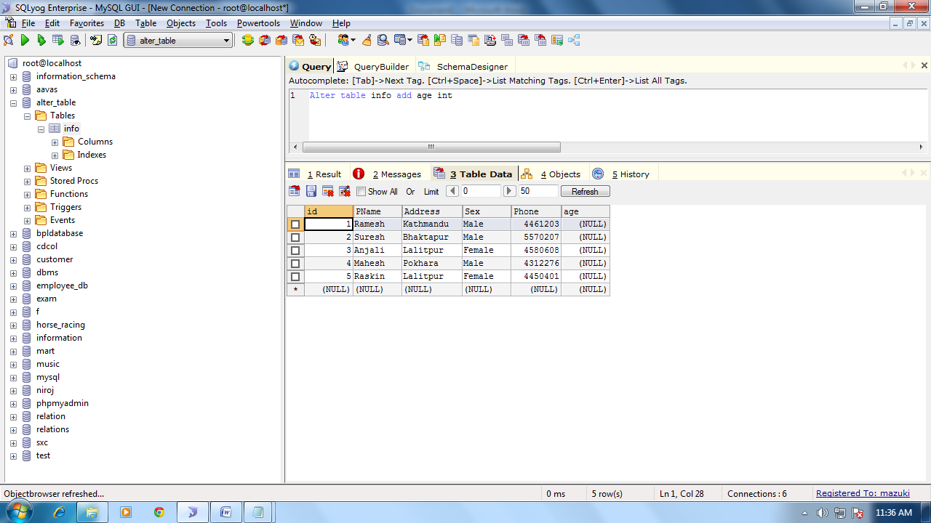

1. **UPDATE Statement with ALTER:**

Update the given values in the given Table.

**SYNTAX:**

UPDATE Table_name

SET Column_name = Value

WHERE <CONDITION>

**EXAMPLE:**

UPDATE info

SET age=25

WHERE id=001;

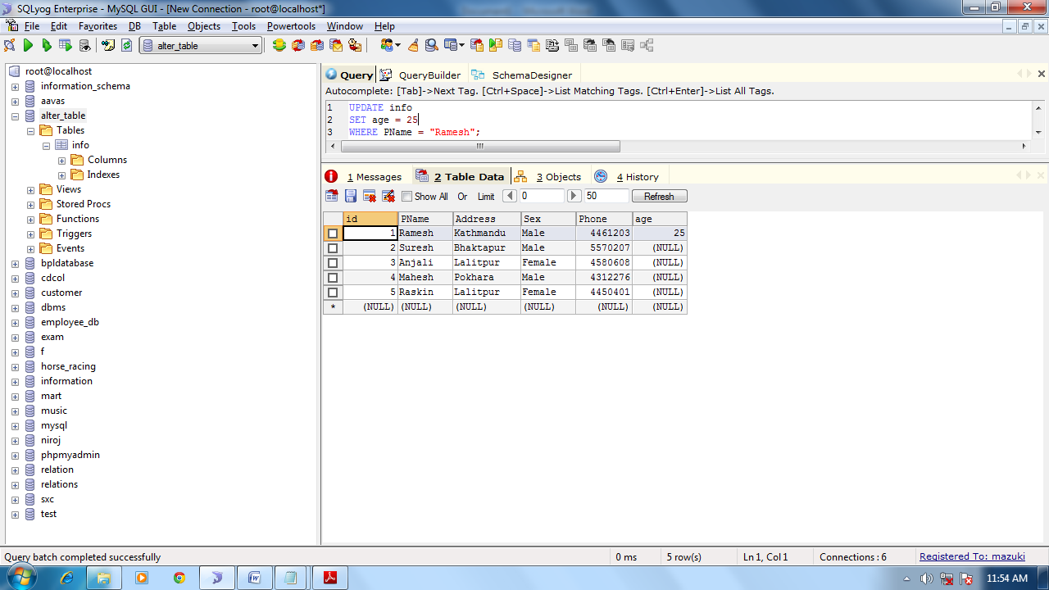

We can update any values of the column.

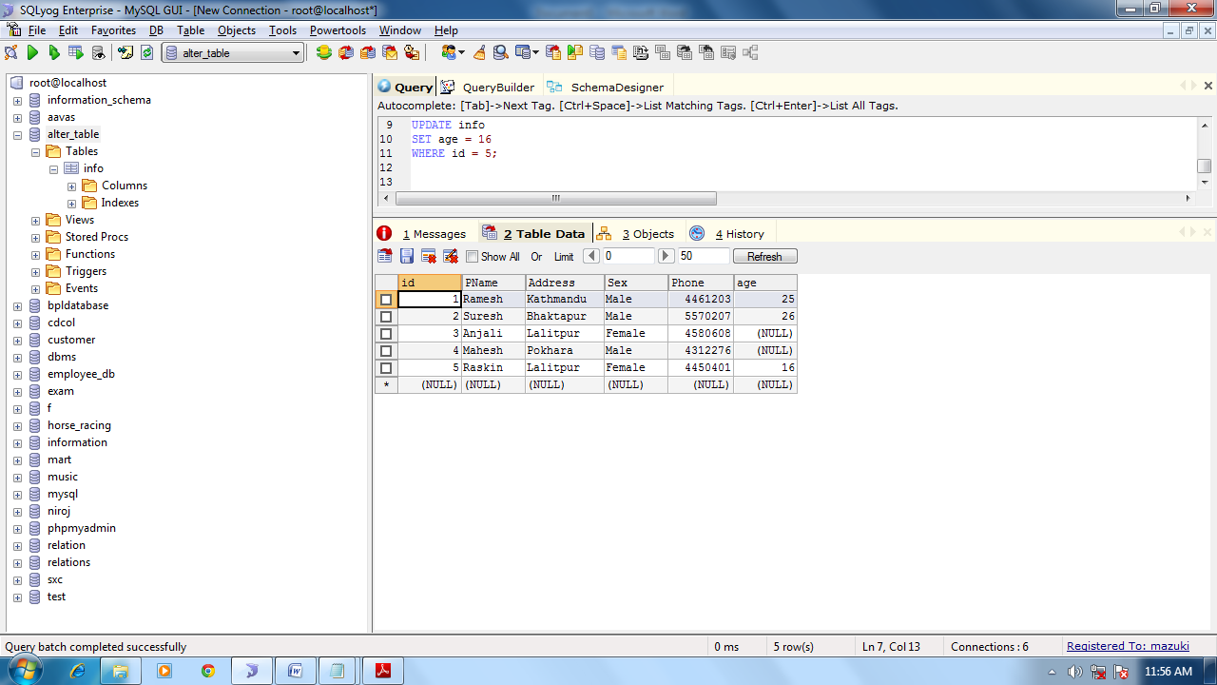

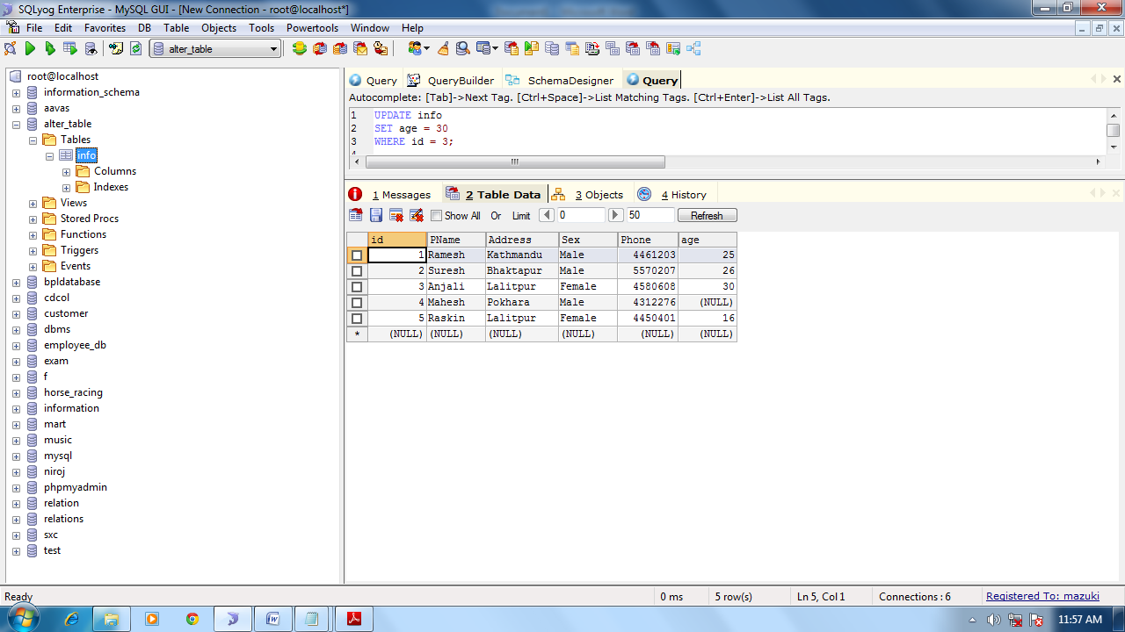

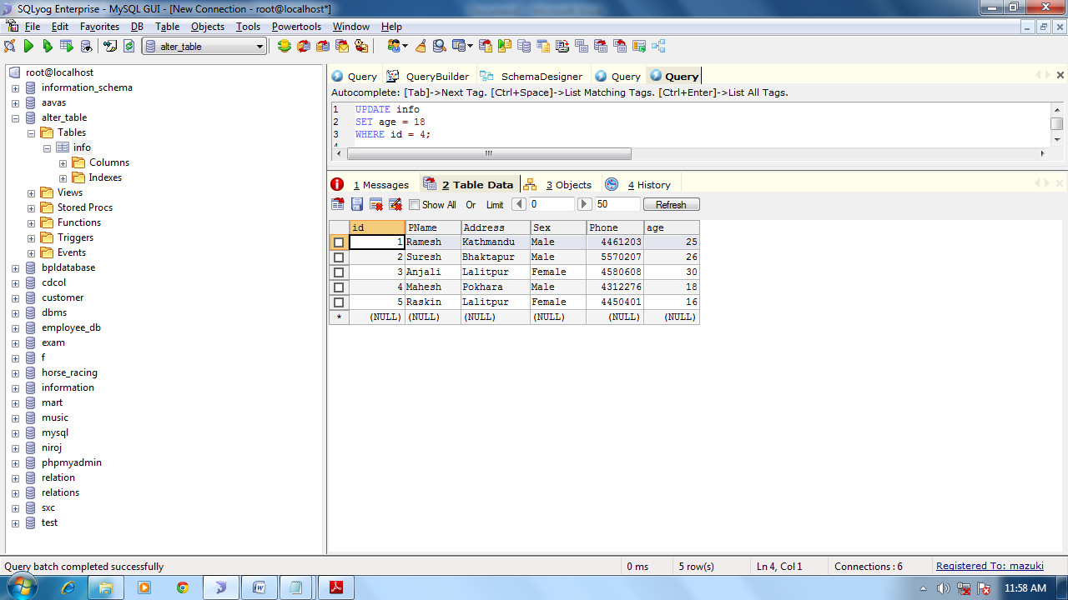

**CHANGING DATA TYPE WITH ALTER:**

We can change the data type if we mistakenly assigned different data type to that specific attribute.

**SYNTAX:**

Alter Table table_name

Alter column column_name datatype;

**EXAMPLE:**

ALTER Table Info

Alter Column Age Year;

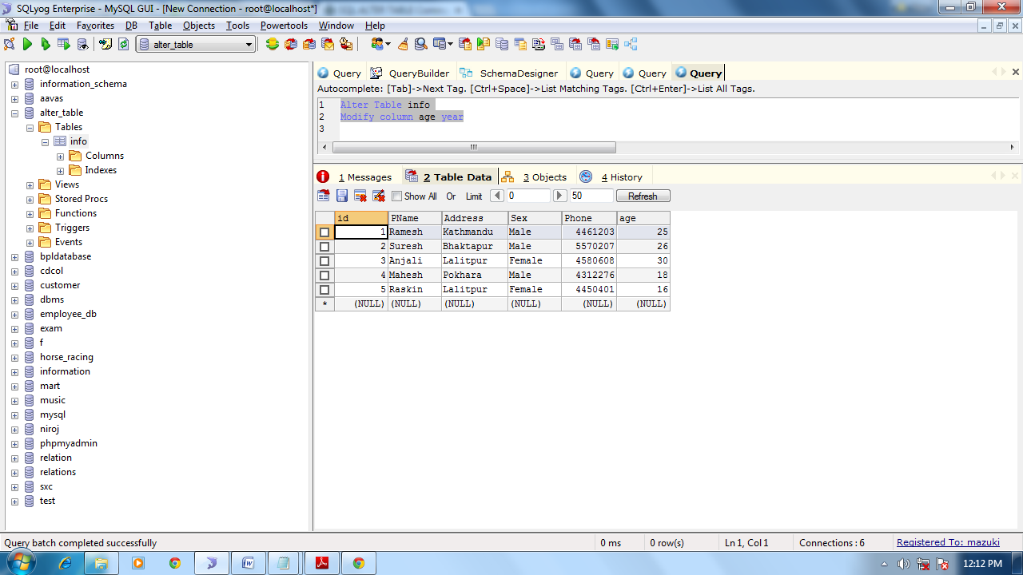

1. **DROP Statement with ALTER:**

Drop any unwanted or unused column/ attribute from the table.

**SYNTAX:**

ALTER TABLE Table_name

DROP COLUMN Column_name

**EXAMPLE:**

ALTER TABLE Info

DROP Column Age

7 attribute , 10 data, drop 2 columns

