ST. XAVIER’S COLLEGE

**Maitighar, Kathmandu**

**(Affiliated to Tribhuvan University)**



**Database Management System**

**Lab Report**

**Submitted By**

Pratik Gautam

013BSCIT029

B.Sc. CSIT Year II/IV Semester

**Submitted To**

Er. Sanjay Kumar Yadav

Lecturer

Department of Computer Science

St. Xavier’s College

Maitighar, Kathmandu

**BASIC THEORY**

**1) Update new column**

**Syntax:**

*alter table <table name>*

*add <new attribute name1> <data type1>, ….. < new attribute name n> <data type n>;*

**2) Update entry to any column**

*update <table name>*

*set <attribute name1 =value>,….. <attribute name n=value>*

*where <condition(s)>;*

**3) Drop column**

*Alter table <table name>*

*Drop column <column name1>, ……. <column name n>;*

**SQL WORKOUT**

1) A table with five attributes and some entries

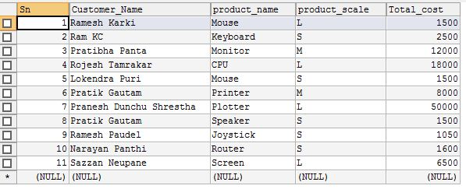

2) Updating a column in the table

SQL statement

E:\New folder\New folder\Capture0.5.JPG

Output

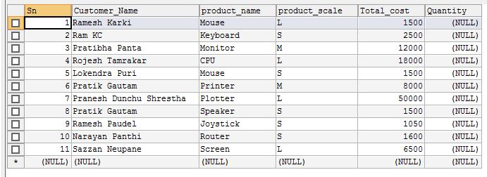

3) Updating entries to newly added column

SQL statement

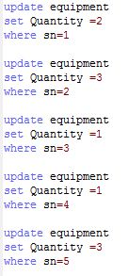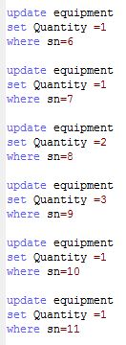

Output

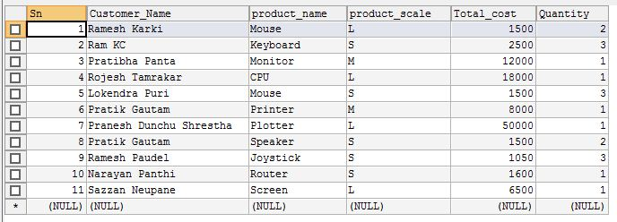

4) A table with eight attributes and some entries

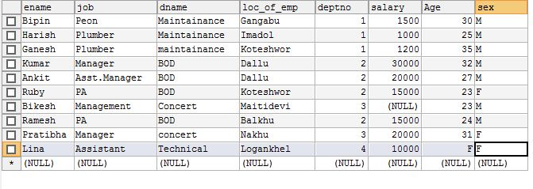

5) Deleting two columns from above table 4.

SQL statement

E:\New folder\New folder\Capture3.5.JPG

Output

