**ST. XAVIER’S COLLEGE**

**MAITIGHAR, KATHMANDU**



**database management system**

**LAb Report#4**

**Submitted By:**

Abhishek Tamrakar

013BSCIT003

**Submitted To:**

|  |
| --- |
| Er. Sanjay Kumar Yadav |
|  |

Department of Computer Science

St. Xavier’s College, Maitighar

Lecturer

ALTER OPERATION:

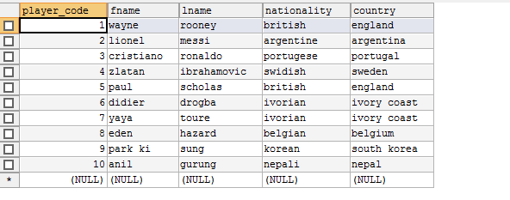

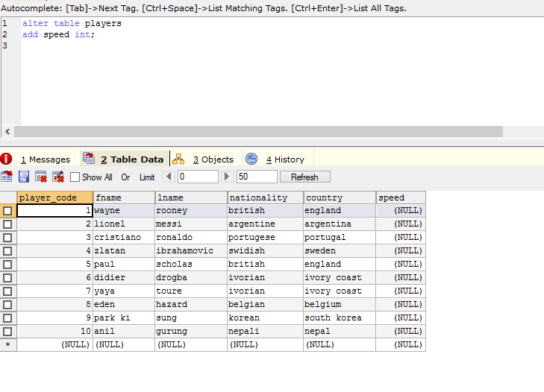

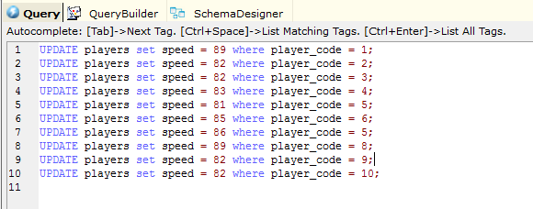

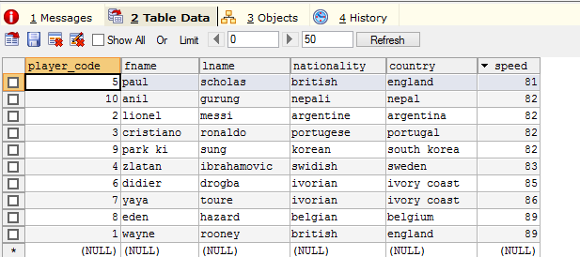

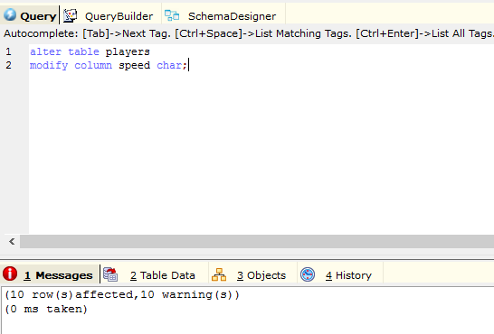

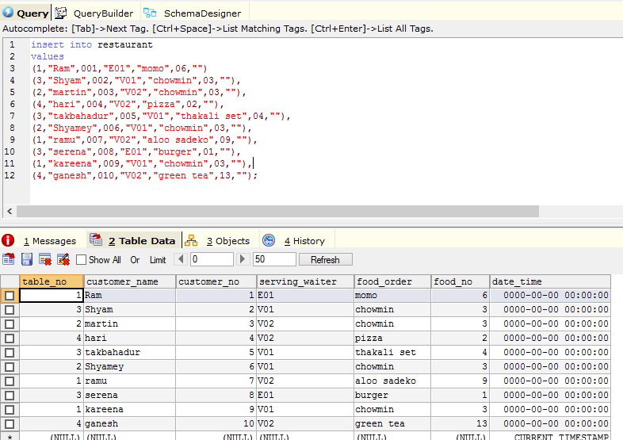

DROP OPERATION:

