**ST. XAVIER’S COLLEGE**

**(Affiliated to Tribhuvan University)**

Maitighar, Kathmandu



**Database Management System**

**Lab Assignment #11**

**Submitted by:**

BIRAJ POUDYAL

013BSCCSIT015

**Submitted to:**

|  |  |
| --- | --- |
| **Er. Sanjay Kumar Yadav**  Lecturer  St. Xavier’s College |  |

**Date of Submission:** August 27, 2015

**Making of table student with following attributes:**

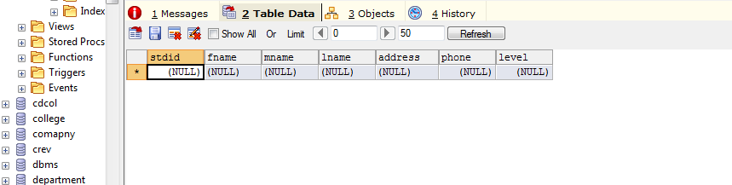

**Insertion of the values in the following attributes:**

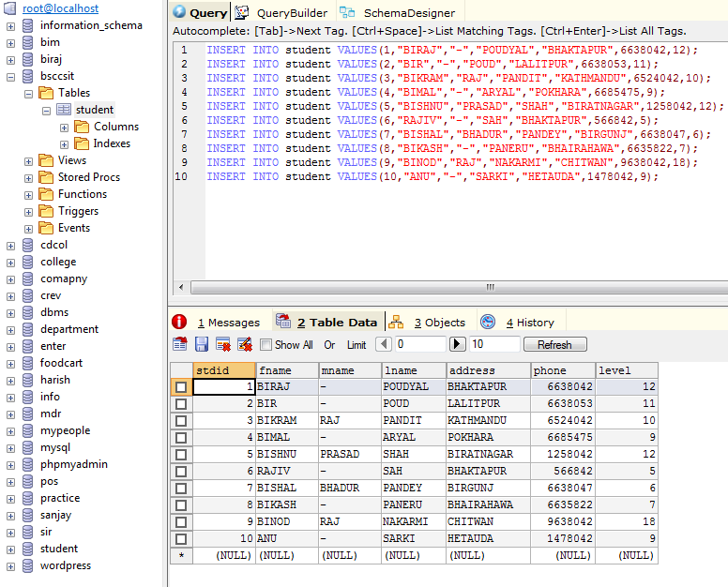

**Dropping of the column named level and phone**

