**ST.XAVIER’S COLLEGE**

MAITIGHAR, KATHMANDU



Database Management System

Assignment #5

Submitted By:

Aabhash Dhakal

013BSCCSIT001

2nd year/ 4th semester

Submitted to:

|  |  |
| --- | --- |
| Er. Sanjay Kumar Yadav  Lecturer  Department of Computer Science |  |

# What do you mean by entity-relationship diagram? Explain.

An entity-relationship diagram is a data modeling technique that creates an illustration of an information system's entities and the relationships between those entities.

There are 3 ingredients in a standard entity-relationship diagram:

* **Entities**, which represent people, places, items, events, or concepts.
* **Attributes**, which represent properties or descriptive qualities of an entity. These are also known as data elements.
* **Relationships**, which represent the link between different entities.

Entities, attributes, and relationships can be represented in one of three ways: with a **conceptual model**, **logical model**, or **physical model**.

# Define entity and give an example.

The word entity is used to identify units, whether concrete things or abstract ideas, that have no ready name or label. In database terms, for example, an entity is a single person, place, or thing about which data can be stored. So, any person, vehicle, building can be an entity.

Information about an entity is captured in the form of attributes and/or relationships. If something is a candidate for being an entity and it has no attributes or relationships, it isn't an entity.

# Explain the differences between an entity class and an entity instance.

An entity class is a group of entities of the same type, i.e. VEHICLE or BUILDING. An entity instance is a particular entity, i.e. TOYOTA Model No.432372, Car No. 2345, BUILDING No. 542.

# Define attributes and its types.

Each entity is made up of a number of attributes that represent that entity. An attribute describes the facts, details or characteristics of an entity.

There are various types of attributes that are commonly used in Database management systems, which are:

* Single and Composite Attributes: Attributes that cannot be further divided into factions which hold a meaning of their own are known as single attributes whereas, attributes that can be further divided into factions that do hold a meaning on their own are known as composite attributes.
* Single values and multi-valued attributes: A single value attribute can only have one value which the multi valued attribute can store multiple data in them.
* Stored and Derived attributes

# What are derived attributes?

A derived attribute is a type of attribute where one attribute is calculated from another attribute. The derived attribute may not be stored in the database but can rather be calculated using a separate algorithm.

1. **Define relationship and give an example.**

A relationship can be defined as the association among various entities. For example, VEHICLE has a relationship with OWNER

1. **Explain the difference between a relationship class and a relationship instance.**

A relationship class is an association among entity classes; a relationship instance is an association among entity instances.

1. **Define degree of relationship.**

Degree is the number of entities that participate in a relationship. The relationship ASSIGNMENT associates a CLIENT with an ATTORNEY with a TASK.

1. **List and give an example of the three types of binary relationships. Draw an E-R diagram for each.**

The three types of binary relationships are listed as:

* One to one relationship : CUSTOMER to ADDRESS

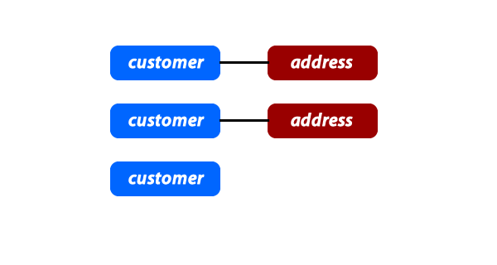

* One to many relationship : CUSTOMER to ORDER

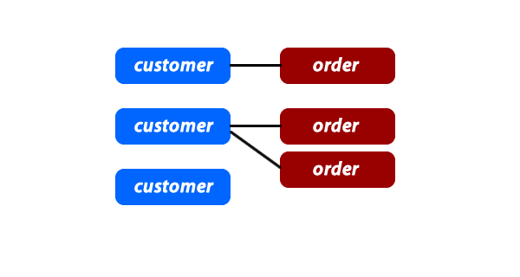

* Many to many relationship: ORDER to ITEM

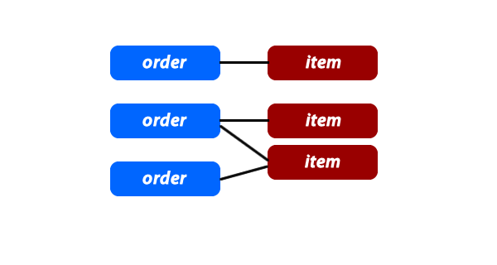

1. **Define the terms maximum cardinality and minimum cardinality.**

Maximum cardinality is the maximum number of instances of an entity that can participate in an instance of a relationship.

Minimum is the least number of instances of an entity that can participate in an instance of a relationship.

1. **Explain the distinctions among the terms; primary key, candidate key and super key.**

* Primary Key is a key that is selected as the identifier for an entity type, and hence, cannot be repeated.
* A Candidate Key is an attribute, or a group of attributes, that uniquely identifies each instance of an entity type.
* A superkey is a combination of columns that uniquely identifies any row within a relational database management system (RDBMS) table.

1. **What are the main building modules of the entity relationship model? Discuss each one.**
2. **What is composite attributes, when it is used?**

Attributes that can be further divided into factions that do hold a meaning on their own are known as composite attributes.

1. **Explain the difference between single-value attributes and simple attributes.**

A single -valued attribute is one that can have only one value. For example, a person has only one first name and only one social security number.

A simple attribute is one that cannot be decomposed into its component pieces. For example, a person's sex is classified as either M or F and there is no reasonable way to decompose M or F. Similarly, a person's first name cannot be decomposed into meaningful components. (In contrast, if a phone number includes the area code, it can be decomposed into the area code and the phone number. And a person's name may be decomposed into a first name, an initial, and a last name.)

1. **Discuss the difference between a composite key and a composite attribute. How would each be indicated in an E-R diagram?**

A composite key is one that consists of more than one attribute. If the ER diagram contains the attribute names for each of its entities, a composite key is indicated in the ER diagram by the fact that more than one attribute name is underlined to indicate its participation in the primary key.

A composite attribute is one that can be subdivided to yield meaningful attributes for each of its components. For example, the composite attribute CUS_NAME can be subdivided to yield the CUS_FNAME, CUS_INITIAL, and CUS_LNAME attributes. There is no ER convention that enables us to indicate that an attribute is a composite attribute.

1. **What two courses of action are available to a designer when a multivalued attribute is encountered?**
2. **Explain the various terms of an E-R model and how are they represented in an E-R model?**
3. **Explain the concept of dependent entities? Give example.**
4. **What is the difference total and partial participation? Explain.**
5. **What do you mean by mapping cardinalities? Explain various types of cardinalities.**
6. **What is the difference between single-value and multivalued attributes? Explain**
7. **Explain the concept of participation constraints.**
8. **Difference the binary relationship with ternary relationship with example.**
9. **Explain the difference between weak and strong entity set.**
10. **Define the components of extended E-R features.**
11. **Define the concept of aggregation. Give two examples of where this concept is useful.**
12. **Explain the distinction between disjoint and overlapping constraints.**
13. **Explain the distinction between total and partial constraints.**
14. **Write short notes on:**

**· Specialization**

**· Generalization**

**· Aggregation**